AthleteIQ
Multi-Sport Athlete Database Management System

Database Lab Project

Project Team

Ismail Khan

Rayan Alam
LAB Instructor: Mr. Ali Hasan

School of Computer Sciences & IT
Institute of Management Sciences, Peshawar


Milestones | Version | Date | Remarks
- Created Schema and Designed ERD | V 1.0 | 23/4/26

- Database Schema

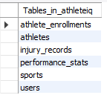

1.1 Athletes Table
Description: Stores the personal details and profile information of each athlete.
Attributes:
- athlete_id (PK)
- full_name
- date_of_birth
- gender
- nationality
- contact_info
- status
- created_at

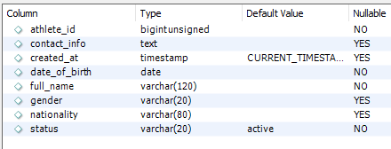

1.2 Sports Table
Description: List of all available sports and their categories.
Attributes:
- sport_id
- name
- category

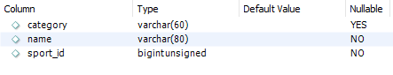

1.3 Athlete_Enrollments Table
Description: Records which athletes are enrolled in what sport and when.
Attributes:
- sport_id (FK)
- athlete_id (FK)
- enrolled_on
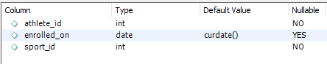

1.4 Injury_Records Table
Description: Records injury history, severity and recovery status of every athlete.
Attributes:
- injury_id (PK)
- athlete_id (FK)
- injury_type
- severity
- date_occured
- recovery_status
- notes

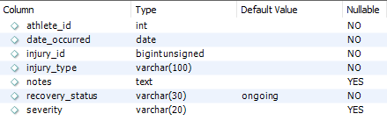

1.5 Performance_Stats Table
Description: Logs measurable performance metrics for athletes across sports over time.
Attributes:
- stat_id (PK)
- athlete_id (FK)
- sport_id (FK)
- metric_name
- value
- recorded_on

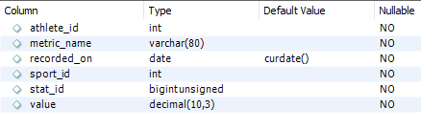

1.6 Users Table
Description: Manages system login credentials for admins, coaches or staff.
Attributes:
- user_id (PK)
- username
- password_hash
- created_at

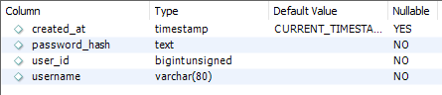

- Entity Relationship Diagram (ERD)

