# CogItemUsage

This package does two things:

- It provides a datatype that will list all the other documents where the document is referenced. This could be a link in a multi tree node picker or an internal link in a piece of content.

- It overrides the default delete method to show a dialog displaying these referencing documents and asks the user to confirm.

Settings

After installing the package, create a new data type of type “umbraco user control wrapper”

To enable the usage data when deleting content, name the new data type   
“Item Usage Datatype”

Point the usercontrol field to usercontrols/ItemUsageDatatype.ascx and click save. This will present the following properties:

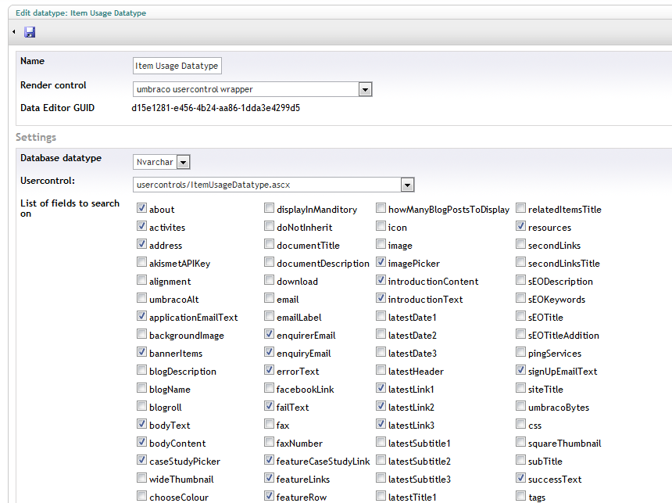

|  |  |  |
| --- | --- | --- |
| Field Name | Comments |  |
| List of fields to search on | This will default to choose all properties that are of a datatype that uses a rich text field, a content picker or a multinode tree picker. |  |
| Header text for listing table | The text to display before results |  |
| No results found message | The message to display where no message |  |
| Show on load | If set to 1 then every time a page is viewed the find usage query will run. If set to 0 then a button will show and user will need to click to get list of items using current item |  |

After setting up the datatype you can create a property on a document that uses this datatype to display where the document is used.

The delete menu item on context menu will automatically show a dialog displaying this data before the user can delete it.

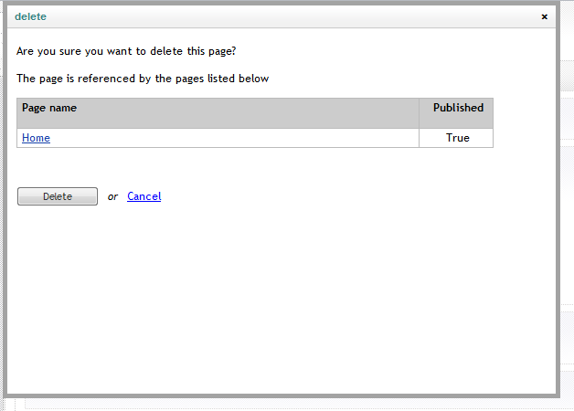

The final step is to rebuild your internal index to ensure the package can search for references.