**CSE3055-Database Systems**

**Term Project Step 3**

**Database Application for Building Managements**

**Prepared By:**

**150119516 - İsmail ÖKSÜZ**

**150119816 - Ömür Tarık GÖKKURT**

**524121013 - Melih ŞEN**

**150119860 - Onur KAYA**

**Description of the Project**

The main objective of that project is to create a database system that will be used by building managements.

**Changes**

In the ER diagram that we created in project step 2, the database diagram had 2 more subtype-supertype relationships. After planning, we decided to combine those 2 different subtypes with their supertypes. Outdoor and garage, which were subtypes of a parking lot combined with ParkingLot. And subtypes of bills that we think to create (NaturalGas, water, electricity, aidat, internet) were have been declined to creating and combined with its supertype.

**Data Requirements**

Personal information about the residents, owners and employees such as SSN, full name etc. are required. SSN is obligatory as a primary key. Information about the building such as building address, block numbers, door numbers of the residences are required. Information about the cars are required in order to validate their rights of parking lot and garage usage.

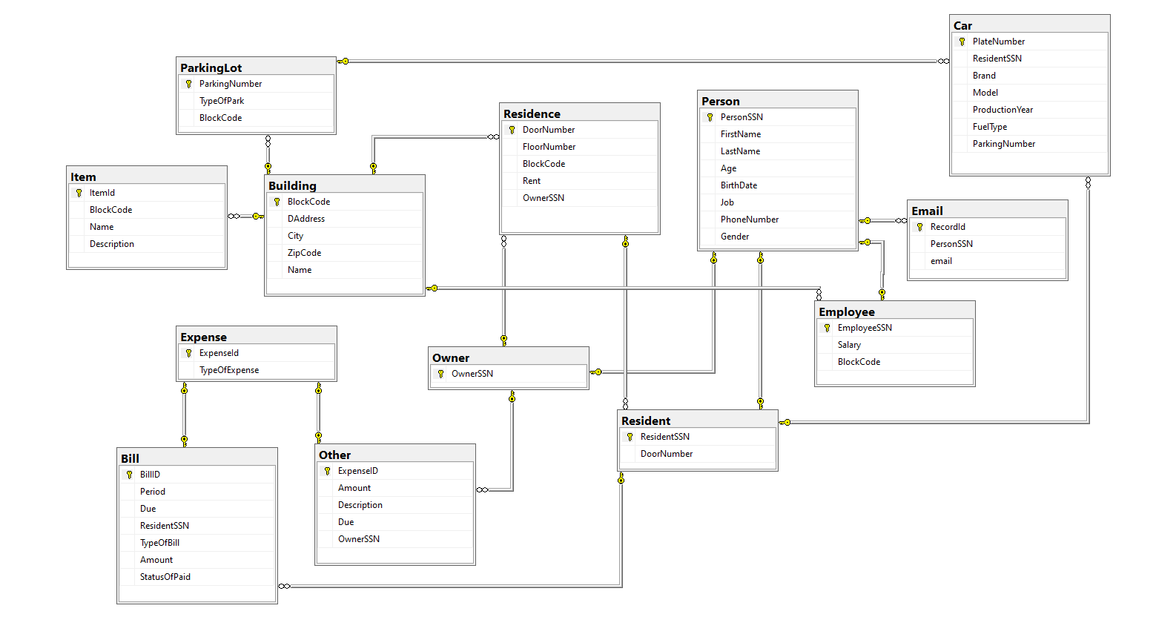**Diagram of the Database**

**Tables**

13 Tables have been created for the project.

**-Person:** Represents every people, necessary information’s who work in that site, who lives in that site or who have house/houses in that site.

Names, primary key and the data types of the columns in person table:

-Person primary key is PersonSSN.

-Person does not have any foreign key.

-The Age column is derived from birthdate.

**-Resident:** Represents every people, necessary information who lives in that site.

Names, primary key and the data types of the columns in resident table:

-Primary key of Resident is ResidentSSN.

-Resident have 2 foreign keys. DoorNumber and ResidentSSN.

**-Owner:** Represents every people, necessary information who have house/houses in that site.

Name, primary key and the data type of the column in owner table:

-Owner has OwnerSSN as a primary key and foreign key.



**-Employee:** Represents every people, necessary information who works in that site.

Names, primary key and the data types of the columns in employee table:

-Primary key is EmployeeSSN.

-Employee has 2 foreign keys and it is BlockCode and EmployeeSSN.

**-Email:** Represents every email address of persons. One person may have more than one email address as he/she may not have any.

Names, primary key and the data types of the columns in email table:

-Record id is identity and primary key of Email.

-Email has PersonSSN as a foreign key.

-Email column is unique as business rule.

**-Residence:** Represents every necessary information about flats/residences belongs to that site.

Names, primary key and the data types of the columns in residence table:

-Primary key is DoorNumber column.

-Residence has 2 foreign keys. BlockCode and OwnerSSN.

**-Building:** Represents every necessary information about apartments/buildings in that site.

Names, primary key and the data types of the columns in building table:

-Primary key of Building is BlockCode.

-Building does not have any foreign key.

**-Item:** Represents every necessary information about items which belongs to common use areas in that site.

Names, primary key and the data types of the columns in item table:

-Primary key is ItemId and it is Identity.

-Item has BlockCode as a foreign key.

**-Car:** Represents every necessary information about cars which belongs to the residents who lives in that site.

Names, primary key and the data types of the columns in car table:

-PlateNumber is primary key.

-Car has 2 foreign keys. ParkingNumber and ResidentSSN

**-ParkingLot:** Represents every necessary information about car parking areas in that site.

Names, primary key and the data types of the columns in parkinglot table:

-ParkingNumber is primary key.

-ParkingLot has BlockCode as a foreign key.

**-Expense:** Represents every necessary information about expenses which belongs to residents and owners.

Names, primary key and the data types of the columns in expense table:

-ExpanseId is primary key and identity start from 1000.

-Expense does not have any foreign key.

**-Bill:** Represents every necessary information about bills which belongs to residents.

Names, primary key and the data types of the columns in bill table:

-BillID is primary key and it comes from Expense table.

-Bill have BillID and ResidentSSN as the foreign key. There is a trigger associated with this table.

**-Other:** Represents every necessary information about expenses which belongs to owners.

Names, primary key and the data types of the columns in Other table:

-ExpenseID is primary key and it comes from Expense table.

-Other have ExpenseID and OwnerSSN as the foreign key. There is a trigger associated with this table.

**Views**

**ABlockResidents:** Shows residents that live in block A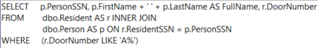

Output:

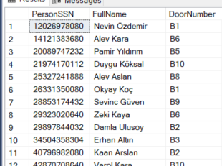**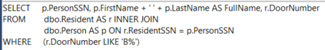BBlockResidents:** Shows residents that live in block B  
  
Output:

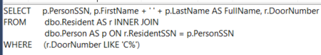**CBlockResidents:** Shows residents that live in block C   
  
  
  
  
  
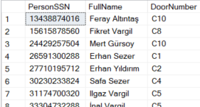Output:  
  
  
  
  
  
  
  
  
  
  
**CarOwners:** Shows people that owns cars and the general information about the cars  
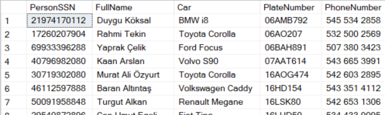Output:   
  
  
  
  
  
  
  
  
  
  
**UnpaidBills:** Shows unpaid bills   
  
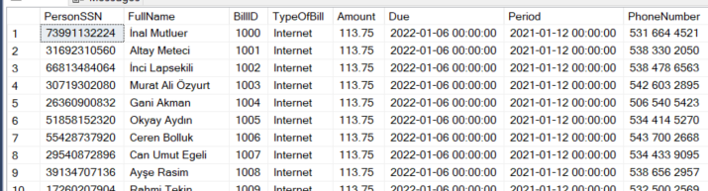Output:   
  
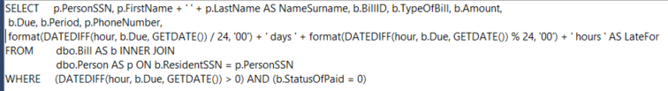**UnpaidDueLate:** Shows unpaid bills that are late on due.   
  
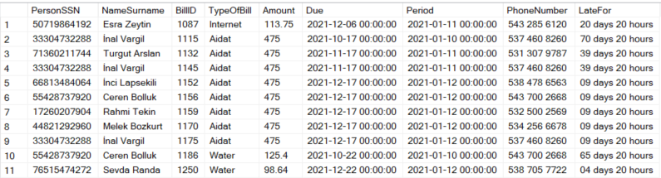Output:   
  
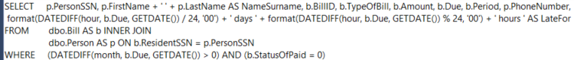**UnpaidDueLate1Month:** Shows bills that are still unpaid after a month later than due date  
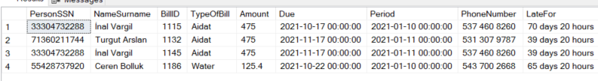Output:   
  
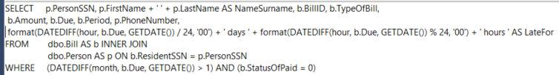**UnpaidDueLate2Month:** Shows bills that are still unpaid after 2 months later than due dateOutput:   
**UnpaidTotalAmount:** Shows total amount of unpaid bills  
  
  
  
Output:

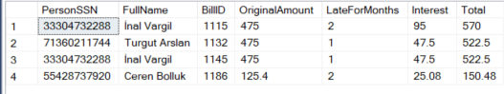**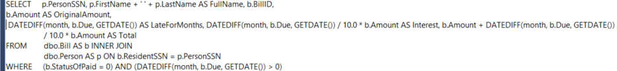InterestPunishment:** Calculates the punishment interest with a 10% rate for every unpaid month Output:

**Procedures**

**delete_carby_platenum**: Deletes the car using the PlateNumber

BEFORE

AFTER (34BBN865 is deleted)

**delete_carby_residentssn**: Deletes car using the ResidentSSN

BEFORE

AFTER (34BC5530 is deleted)

**delete_emailby_email:** Deletes given email

BEFORE

AFTER (eakyol… deleted)

**delete_emailby_personssn:** Deletes email by PersonSSN

BEFORE

AFTER (ilapsekili… deleted)

BEFORE

AFTER (ilapsekili… added)

**update_rentby_doornum**: Updates the rent value of the Residence with the given DoorNumber

BEFORE

AFTER (The rent of A7 updated to 10000)

**insert_item**: Inserts a new item

BEFORE

AFTER (Playstation 5 is added)

**delete_itemby_itemid:** Deletes the item with the corresponding ItemID  
  
BEFORE

AFTER (Playstation5 is deleted)

**insert_bill**: Inserts a new bill. As a business new bill get id from Expense table. So, procedure inserts expense firstly and by this id insert bill.

BEFORE (BILL TABLE)

(EXPENSE TABLE)

AFTER (New value added) (BILL TABLE)

AFTER (EXPENSE)

**insert_other**: Inserts a new Other entry. It works as like bill insert.

BEFORE (OTHER)

BEFORE (EXPENSE)

AFTER (OTHER)

AFTER(EXPENSE)

**insert_car**: Inserts a new car by controlling our business rule.

BEFORE

AFTER (54AOG247 ADDED)

WE HAVE BUSINESS RULE

**insert_owner**: Inserts a new Owner. If this person new in person table, procedure inserts owner firstly to Person table.

**insert_resident**: Inserts a new resident. Same as Owner.

**insert_employee**: Inserts a new Employee. Same as owner.

**DeletePersonBySSN**: Deletes the Person with the given PersonSSN. Delete child tables records just deleting parent table. Foreign keys created as cascade.

**Triggers**

**trg_DeleteByExpirationDateOther:** Other type Expense’s are deleted after 2 years. This is works when other table has an insert.

**trg_updatebyExpirationDate:** PaidBill’s are deleted after it has been 3 months from the due date. This trigger works after a record inserted to Bill table.

