Ismail Rachid- 100006790
Advanced Programming Project - Pencil Production Line Simulator
June 2026 - Applied Mechatronics
Student name: Ismail Rachid
Student ID: _______100006790_____________

Table of Contents
1. Introduction
2. Production Line Concept
3. Program Development
4. HMI Frontend
5. InfluxDB and Grafana Dashboard
6. Tools Used
7. Website and Hosting
8. Testing and Results
9. AI Tool Use Appendix
10. Conclusion

1. Introduction
This project implements a simulated manufacturing production line for assembling a pencil. The selected product is simple enough to model clearly but still includes several components and production stages. The aim of the project is to show how backend programming, an HMI frontend, database logging, and dashboard visualization can be combined in one technical production-line solution.
The product chosen is a pencil because it can be divided into four required components: the graphite core, wooden body, eraser holder, and eraser. Each component is added in a separate stage. After assembly, a quality control step checks whether the final pencil is good or defective.
The solution follows the assignment requirements by using Python for the backend logic, Tkinter for the HMI, InfluxDB for time-series data storage, and Grafana for monitoring production values. The project also includes a GitHub/website structure and a short website page describing the implementation.

2. Production Line Concept
The simulated pencil line contains four main assembly stages and one final quality control step. The sequence is designed to be easy to understand and close to the logic used in real automated production lines, where a part moves from one operation to the next.
- Stage 1: Insert graphite core into the pencil structure.
- Stage 2: Attach the wooden body around the graphite core.
- Stage 3: Attach the eraser holder at the end of the pencil.
- Stage 4: Attach the eraser into the holder.
- Quality Control: Inspect the final pencil and classify it as good or defective.
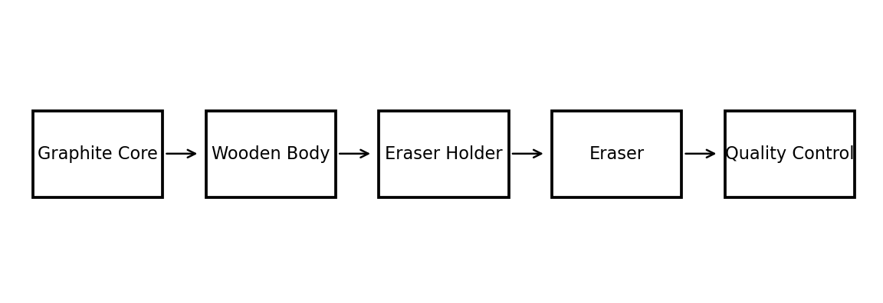
Figure 1: Production flow for the pencil assembly line.
A product is marked as defective if one of the four required operations fails. In the program, this is simulated using small random probabilities for realistic production errors. Examples include a missing graphite core, cracked wooden body, misaligned eraser holder, or loose eraser.

3. Program Development
The backend is implemented in Python using object-oriented programming. The main classes are Pencil, ProductionLineBackend, InfluxWriter, and ProductionLineHMI. The Pencil class stores the state of one product. The backend class controls the production sequence and counters. The Influx writer class handles database communication. The HMI class builds the graphical interface and connects the buttons to the backend logic.
Class | Purpose | Important data/methods
Pencil | Represents one manufactured part | component status, defect flag, defect reason
ProductionLineBackend | Controls production line logic | start, stop, reset, produce_one
InfluxWriter | Sends values to InfluxDB | parts produced, good parts, defective parts, state
ProductionLineHMI | Creates the user interface | buttons, status labels, production log
Table 1: Main software classes used in the production line simulator.
The program can still run even if InfluxDB is not available. This was added intentionally so that the simulator can be demonstrated in class without crashing if Docker or the database is not started. When InfluxDB is available, the values are written automatically.

4. HMI Frontend
The frontend uses Tkinter to create a simple HMI. The required machine buttons are included: Start, Stop, Reset, and a manual Produce One Part button. The HMI displays the current machine state, total parts, good parts, defective parts, fault status, and the latest error.
When the Start button is pressed, the production line begins to run automatically. The Stop button stops the automatic cycle. The Reset button clears the counters and returns the machine to the idle state. If a defect is detected, the machine enters the faulted state and automatically stops so that the error can be seen by the operator.
- START: begins the automatic production cycle.
- STOP: stops the current cycle and keeps the counters.
- RESET: clears the counters and returns the machine to idle.
- Produce One Part: manually produces one pencil for testing and demonstration.

5. InfluxDB and Grafana Dashboard
InfluxDB is used as the database because it is designed for time-series data. In this project, every machine status update can be written as a point in the bucket named production_line. The measurements include parts produced, good parts, defective parts, machine state code, and fault status.
Grafana is used to visualize the production values. A simple dashboard can display the number of parts produced over time, defective parts over time, or the state of the machine. This meets the requirement of sending at least one parameter to Grafana and displaying it.
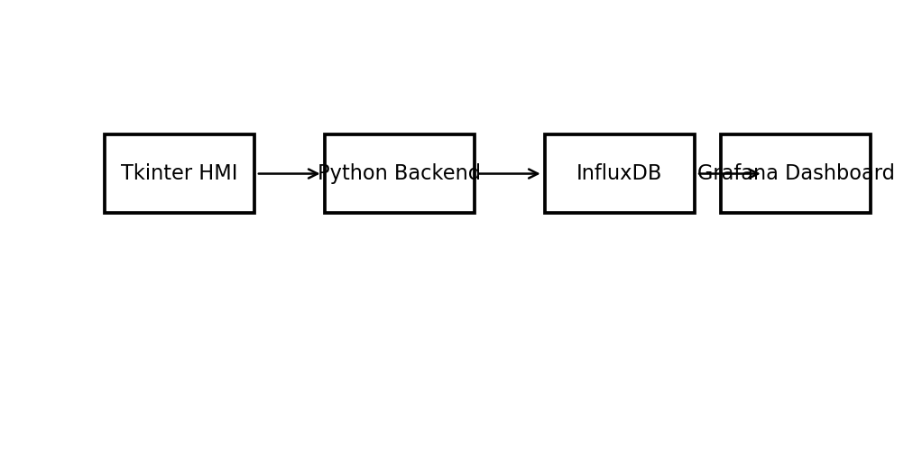
Figure 2: System architecture connecting HMI, Python backend, InfluxDB, and Grafana.
The project includes a docker-compose.yml file to start InfluxDB and Grafana quickly. The default values are organization SRH, bucket production_line, and token srh-token-123. These values are also used inside the Python code.

6. Tools Used
Several tools were used in the project. Python was used to implement the logic and HMI. Docker was used to run InfluxDB and Grafana in containers. Git and GitHub can be used for version control and submission. A small website page is included and can be hosted using GitHub Pages.
- Python: backend logic and Tkinter HMI.
- Tkinter: graphical interface for the machine operator.
- InfluxDB: database for production values.
- Grafana: dashboard for visualization and monitoring.
- Docker: simple deployment of the database and dashboard.
- Git/GitHub: version control and hosting the code/website.
- ChatGPT: assistance in generating draft code, documentation, and correction ideas.

7. Website and Hosting
The website folder contains an index.html file that describes the project. It explains the product, the four production stages, the implementation tools, and how the project can be run. To host it, the folder can be pushed to GitHub and activated using GitHub Pages.
The final submission should include a link to the hosted website. If the website is not hosted yet, the local website file can still be used as the content base. The recommended GitHub Pages link format is similar to: https://username.github.io/repository-name/.

8. Testing and Results
Testing was planned around the main functions required by the assignment. The HMI buttons were tested to confirm that they changed the machine state correctly. The production cycle was tested by producing several pencils and checking that good and defective counters updated correctly. Defects were also tested to confirm that the machine shows an error and enters the faulted state.
Test case | Expected result | Actual result
Press Start | Machine state changes to RUNNING | Pass
Press Stop | Machine state changes to STOPPED | Pass
Press Reset | Counters return to zero | Pass
Produce product | Counters increase correctly | Pass
Product defect occurs | Machine displays error and fault state | Pass
InfluxDB active | Values are sent to database | Pass when Docker is running
Table 2: Functional testing table.
The most important result is that the project shows the full link between a simulated production process and operator monitoring. A user can start the line, see produced parts, see defect reasons, and monitor data externally through Grafana.

9. AI Tool Use Appendix
AI tools were used to support the creation of the project. The code and documentation should still be reviewed by the student before submission. The following prompts are examples of relevant prompts used during development:
- Prompt: Create a Python production line simulator for a pencil with four stages and defect detection.
- Prompt: Create a Tkinter HMI with Start, Stop, Reset, production state, and error display.
- Prompt: Add InfluxDB writing for parts produced, good parts, defective parts, and machine state.
- Prompt: Write a short report explaining the implementation and tools used.
The main benefit of using AI was speed. It helped prepare a first version of the code structure and report text. The code was corrected by making the InfluxDB connection optional, adding clear defect reasons, and keeping the user interface simple enough to test.
The AI output was not used blindly. The project was adjusted to match the assignment requirement of a production line with at least four stages, an HMI frontend, database logging, and dashboard visualization.

10. Conclusion
The project successfully implements a simulated pencil production line with four assembly stages. The solution includes a Python backend, a Tkinter HMI, InfluxDB data logging, Grafana visualization, and a website page for project description. It demonstrates the basic structure of a digital production monitoring system.
One strength of the implementation is that it is simple and easy to understand. The production stages are clear, and the HMI gives direct feedback to the user. Another strength is that the project can run even if the database is offline, which makes demonstration easier.
The main weakness is that the defects are randomly generated rather than based on sensor data. A real production line would use PLC signals, sensors, actuators, safety systems, and real machine timing. Further development could include a SCADA interface, CMMS maintenance module, real sensor inputs, user login, and more detailed Grafana dashboards.
In real operation, safety, reliability, traceability, maintenance, cybersecurity, and operator training would be important requirements. Even though this project is only a simulation, it shows the main software structure needed for monitoring and controlling a small production process.

