TETR College of Business
Data Science Portfolio Assignment — Group Project
Predicting Customer Churn for a Telecom Provider
Problem Statement — Option A
Group members | Ismail Shaltuni (bmt_28127)  Ilia Macuka ([ID])  Thashen Naidoo ([ID])  Izmina Pujoor ([ID])
Chosen problem | Option A: Predicting Customer Churn for a Telecom Provider
Dataset | IBM Telco Customer Churn (Kaggle: blastchar/telco-customer-churn)
Instructor | Mr Ayush Jain
Date of submission | 16 October 2026
Document version | v1.1 — 16 October 2026 (v1.0 created 16 October 2026; v1.1 adds team names)
Word count | ≈ 2,750 (excluding cover page, tables, figure captions and references)

1. Executive Summary
Acquiring a telecom subscriber costs several times more than keeping one (Reichheld & Sasser, 1990). This project asks whether a provider can identify, in advance, which customers are about to cancel, and what it should do with that knowledge.
We analysed the IBM Telco Customer Churn dataset of 7,043 customers (BlastChar, 2018), of whom 26.5 % churned. After cleaning the data and engineering six features, we trained and compared Logistic Regression, Random Forest and Gradient Boosting. All three reached the same ceiling (ROC-AUC ≈ 0.84). Gradient Boosting was selected for its calibrated probabilities; at a tuned threshold of 0.31 it catches 74 % of churners with 54 % precision and 76 % accuracy.
Three findings matter for the business. Churn is concentrated in a describable segment: first-year, month-to-month, fibre-optic customers paying by electronic check, more than half of whom leave. A retention policy that ranks customers by expected value (churn probability × customer value − offer cost) reaches 86 % of churners while contacting about half the base, the highest net benefit of every policy tested. And the model is not yet fair enough to automate: it catches only 55 % of at-risk customers with dependents versus 79 % without. We recommend a 90-day pilot with a control group, using the model only to allocate benefits, with recall monitored by demographic group.

2. Introduction
Customer churn is the rate at which subscribers cancel or lapse. For a telecom provider it is the largest leak in the revenue bucket: every lost customer must be replaced at acquisition cost, and the replacement starts again at tenure zero, where risk is highest. Profit-driven churn research shows that modest improvements in targeting translate into large financial gains because retention offers are cheap relative to customer lifetime value (Verbeke et al., 2012).
The analytical problem is harder than it looks. A technically accurate model is not necessarily useful: it must produce probabilities a retention team can act on, must not waste offers on customers who would have stayed, and must not systematically overlook any group. The brief also asks whether the features that predict churn are the ones that cause it, which decides whether a company can change its churn rate by changing its product.
The dataset is IBM's Telco Customer Churn sample, distributed on Kaggle (BlastChar, 2018). Each of its 7,043 rows is one customer with 21 attributes: demographics (gender, senior-citizen status, partner, dependents), subscribed services (phone, internet type, six add-ons), account details (tenure, contract, paperless billing, payment method, monthly and total charges) and the target, whether the customer churned in the last month. It is the information a real retention team would hold in its CRM.
Our group worked through the full lifecycle in one Jupyter notebook: cleaning, exploration, feature engineering, modelling, threshold tuning, business translation and a fairness audit. The notebook, trained model and all supporting files are in the project's GitHub repository.

3. Data Description and Preprocessing
The raw file loads with 7,043 rows and 21 columns: three numeric (tenure, MonthlyCharges, SeniorCitizen) and the rest text. There are no duplicate rows or customer IDs and no explicitly missing values, but two issues hid beneath that clean surface.
TotalCharges is stored as text. Eleven cells contain a blank string, which forces the whole column to load as text. All eleven belong to customers with tenure of zero: they joined this month and have not yet been billed, and none churned. This is structurally missing data rather than a recording error, so we set their TotalCharges to zero. Imputing a median would invent a bill that was never issued; dropping the rows would delete exactly the brand-new customers a retention team cares about most. After conversion, TotalCharges correlates at 0.9996 with tenure × MonthlyCharges, confirming internal consistency.
SeniorCitizen is coded 0/1. It is a category, not a quantity, so we mapped it to No/Yes so that it is one-hot encoded rather than scaled. We also stripped whitespace from text columns and encoded the target as a 0/1 flag.
Every categorical column was checked label by label; no misspellings were found. Six add-on columns use a third value, No internet service, and MultipleLines uses No phone service. These record why an add-on is absent, so they were kept rather than collapsed into No. Numeric ranges are plausible (tenure 0–72 months, monthly charges $18–$119, total charges up to $8,685) and no outliers required treatment. No rows were removed; the cleaned dataset retains all 7,043 customers.

4. Exploratory Data Analysis
About one customer in four churned (1,869 of 7,043, or 26.5 %). The imbalance is moderate but important: a model predicting no churn at all would be 73.5 % accurate and useless, so accuracy cannot be the main yardstick (notebook Figure 1).
Account characteristics separate churners from stayers far more sharply than demographics (Figure 2). Contract type is the strongest signal: 42.7 % of month-to-month customers churned, against 11.3 % on one-year and 2.8 % on two-year contracts. Fibre-optic customers churned at 41.9 %, more than double the DSL rate of 19.0 %, while customers with no internet service hardly churned (7.4 %). Customers paying by electronic check churned at 45.3 % against 15–19 % for every other method, with the two automatic methods lowest.
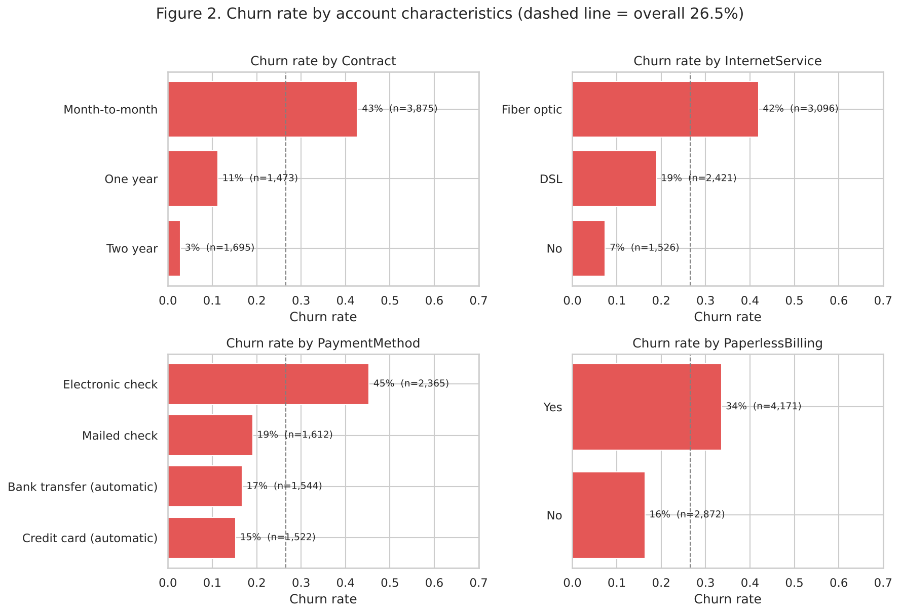
Figure 2. Churn rate by account characteristics (dashed line = overall 26.5 %).
Tenure adds the time dimension (Figures 3 and 4). Almost half of first-year customers churned (47.4 %), falling to 28.7 % in the second year, 20.4 % in years three to four and 9.5 % beyond. Churners also cluster at monthly bills of $70–$100, precisely the fibre-optic price band, whereas the $20–$30 phone-only band is very loyal.
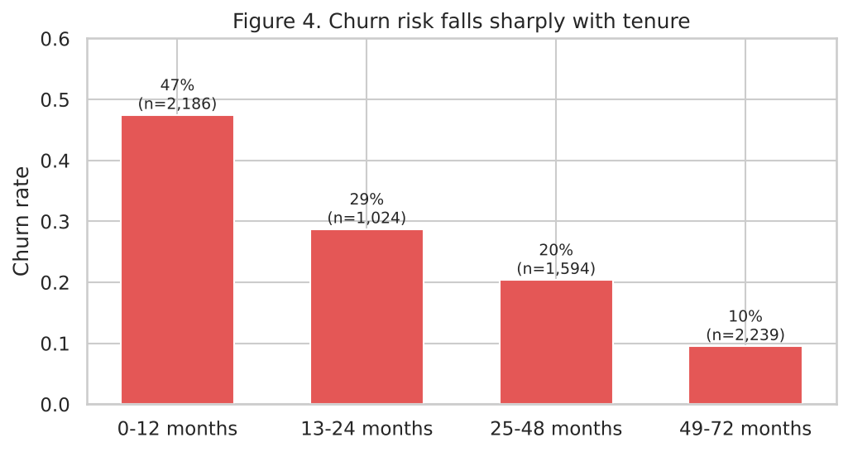
Figure 4. Churn risk falls sharply with tenure.
Demographics matter less (Figure 5). Gender makes no difference (26.9 % versus 26.2 %). Senior citizens churn more (41.7 % versus 23.6 %), as do customers without a partner (33.0 % versus 19.7 %) or dependents (31.3 % versus 15.5 %). These differences are real but modest, and they return in the fairness audit.
Add-on services reveal a protective pattern (Figure 6). Among internet customers, churn falls steadily as add-ons increase, and the effect concentrates in two services: customers with OnlineSecurity churn at 14.6 % and with TechSupport at 15.2 %, less than half the 31.8 % rate of internet customers overall. Streaming add-ons barely move the rate. The correlation matrix (Figure 7) confirms that TotalCharges is largely a product of tenure (r = 0.83) and MonthlyCharges (r = 0.65), a redundancy addressed in feature engineering.

5. Modelling Approach

5.1 Feature engineering
Every engineered feature was motivated by a pattern in the exploration rather than added speculatively:
Feature | Definition | Justification
NumAddOnServices | Count of the six add-ons set to Yes (0–6) | Figure 6: churn falls monotonically with add-on count; captures depth of relationship in one number
HasSecurityOrSupport | 1 if OnlineSecurity or TechSupport = Yes | These two add-ons had by far the lowest churn
AvgMonthlySpend | TotalCharges ÷ tenure | Cleaner spend measure than TotalCharges, which mostly proxies tenure (Figure 7)
ChargeRatio | MonthlyCharges ÷ AvgMonthlySpend | > 1 flags a recent price or plan increase, a classic churn trigger
IsNewCustomer | 1 if tenure ≤ 12 | Figure 4: the first year is a distinct risk regime
AutoPay | 1 if payment is automatic (bank/card) | Figure 2: automatic payers churn far less; collapses four methods into one signal

customerID was dropped as an identifier and TotalCharges was replaced by AvgMonthlySpend to reduce multicollinearity. The four demographic columns were deliberately kept so that the fairness audit could measure whether the model treats groups differently; removing a sensitive column does not remove bias if other features act as proxies, and measuring is better than hiding.

5.2 Pipeline, models and evaluation protocol
The data were split 80/20 with stratification on the target, giving 5,634 training and 1,409 test customers, each with the same 26.5 % churn rate. All preprocessing (standardisation of numeric features, one-hot encoding of categorical ones) lives inside a scikit-learn Pipeline (Pedregosa et al., 2011), so it is fitted on the training fold only and the exported model can accept raw customer records.
Three classifiers were chosen to be deliberately different. Logistic Regression is the interpretable baseline whose coefficients explain why a customer is flagged. Random Forest (Breiman, 2001) captures non-linear interactions such as fibre × month-to-month with little tuning. Gradient Boosting (Friedman, 2001) is typically the strongest tabular learner and, trained without class reweighting, produces well-calibrated probabilities. The first two used class_weight = balanced to counter the imbalance; the third handled imbalance through threshold tuning instead, keeping its probabilities honest. Hyper-parameters were modest hand-set values; the dataset is small enough that aggressive tuning would mainly overfit the cross-validation folds.
Models were compared with 5-fold stratified cross-validation on the training set and then refitted and scored once on the untouched test set using accuracy, precision, recall, F1 and ROC-AUC, plus the Brier score to measure calibration. Decision thresholds were tuned on out-of-fold predictions from the training set only, so the test set was never used for any modelling choice.

6. Results and Discussion

6.1 Model comparison
Model | Threshold | Accuracy | Precision | Recall | F1 | ROC-AUC | Brier
Logistic Regression | 0.50 | 0.740 | 0.506 | 0.775 | 0.612 | 0.841 | 0.167
Random Forest | 0.50 | 0.749 | 0.519 | 0.781 | 0.623 | 0.839 | 0.164
Gradient Boosting | 0.50 | 0.795 | 0.647 | 0.500 | 0.564 | 0.838 | 0.139
Logistic Regression | 0.58 (tuned) | 0.767 | 0.546 | 0.727 | 0.624 | 0.841 | —
Random Forest | 0.55 (tuned) | 0.764 | 0.541 | 0.730 | 0.621 | 0.839 | —
Gradient Boosting (selected) | 0.31 (tuned) | 0.760 | 0.535 | 0.743 | 0.622 | 0.838 | —
Table 1. Held-out test set (1,409 customers, 374 churners). Cross-validation ROC-AUC was 0.845–0.846 for all three models.
The three models are statistically indistinguishable on ROC-AUC, around 0.84 in both cross-validation and on the test set (Figure 9). This is close to the known ceiling for this dataset: the available features simply do not capture everything that drives a cancellation, such as competitor offers, outages or life events. Where the models differ at the default 0.5 threshold is how they spend that discriminative power. The two class-weighted models trade accuracy for recall, catching about 78 % of churners while only half their flags are correct. Gradient Boosting is the most accurate (79.5 %) and precise (64.7 %) but catches only half the churners, because its honest probabilities rarely exceed 0.5 for a 26 % base rate.
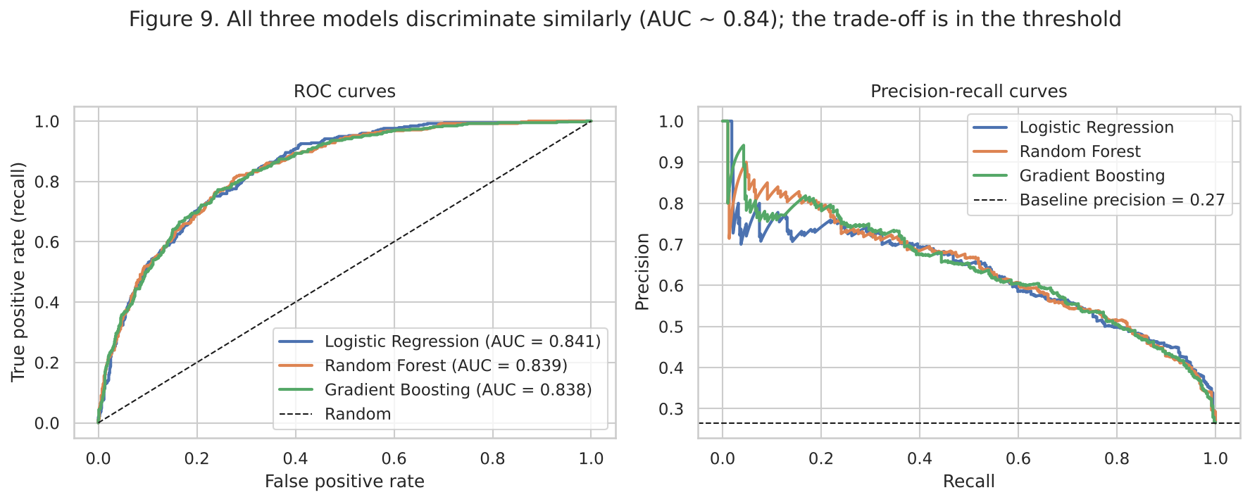
Figure 9. ROC and precision–recall curves on the test set.
Once each model's threshold is tuned for F1, the apparent differences vanish: all three land at F1 ≈ 0.62 with accuracy and precision within a point of each other (Figure 10, left). We selected Gradient Boosting for two reasons. Its Brier score of 0.139, against 0.164–0.167 for the others, and its position closest to the diagonal of the calibration plot (Figure 10, right) mean that when it says 70 % it is right about 70 % of the time, which the business analysis below depends on. And at its tuned threshold it has the highest recall of the three (74.3 %) at essentially the same precision, so it misses the fewest churners for the same number of wasted offers. Logistic Regression is retained as the explanation model.
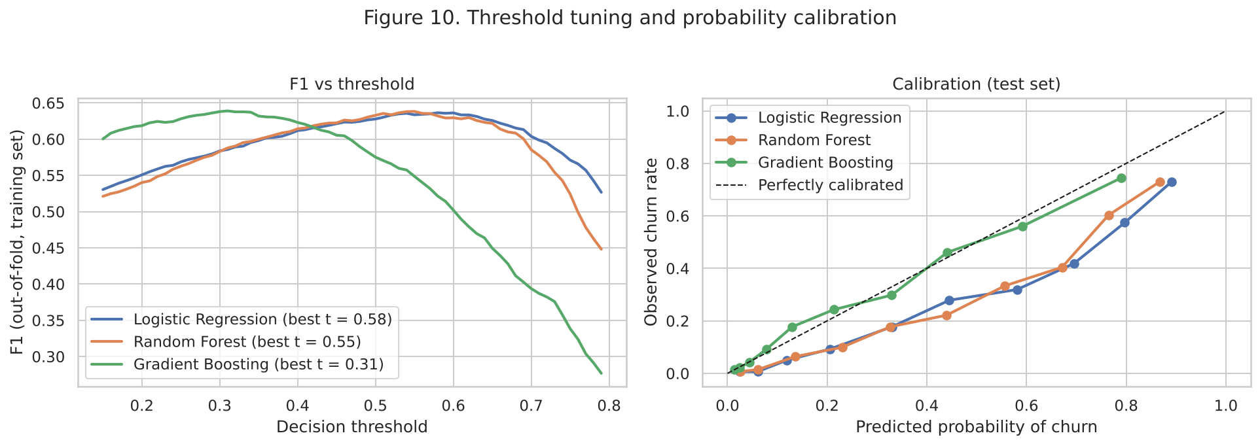
Figure 10. Threshold tuning (out-of-fold F1) and probability calibration on the test set.

6.2 What drives churn, and is it causal?
Both the logistic coefficients (Figure 11) and permutation importance for the selected model (Figure 12) rank tenure and contract type far above everything else, followed by spend level, internet type and the security and support add-ons. But a feature that predicts churn is not necessarily a lever the company can pull, and the brief asks us to wrestle with that.
Does contract type cause churn, or do churn-prone customers simply choose short contracts? Month-to-month customers are also newer, so we checked whether the gap survives within tenure bands (Figure 13). It does: even among customers with four to six years of tenure, month-to-month churn (26 %) is double the one-year rate (13 %) and eight times the two-year rate (3 %). The effect is not a tenure artefact, but it still does not prove causation, because two mechanisms are confounded. A two-year contract carries an early-termination fee that mechanically suppresses churn (causal lock-in), yet customers who are unsure about the service also self-select into month-to-month, and their churn reflects that uncertainty rather than the contract. The data record neither why a customer chose a contract nor what happens when a locked-in term ends. The honest conclusion: contract type is an excellent predictor and plausibly a partial cause, so a migrate-to-annual offer is worth testing, but its true effect must come from an A/B test.
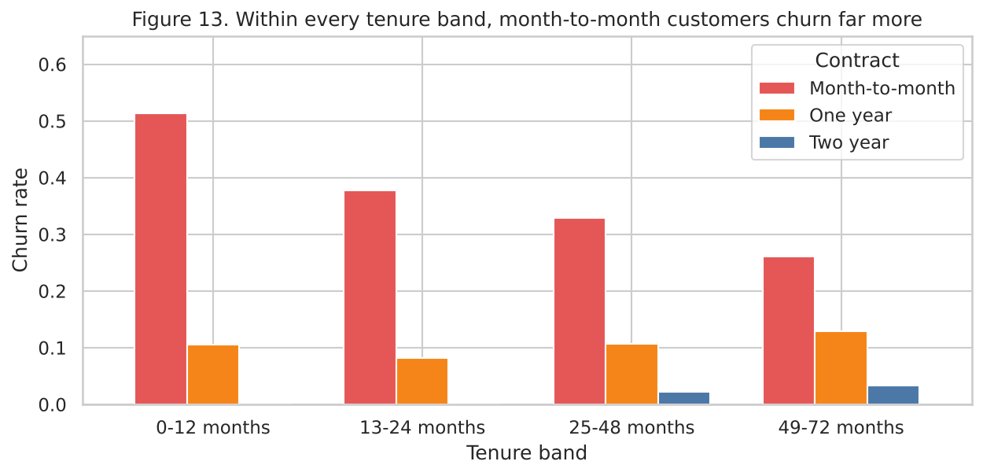
Figure 13. Within every tenure band, month-to-month customers churn far more.
Fibre optic is a second example. Fibre customers churn at 42 %, but fibre is unlikely to be a worse product than DSL. It is the premium product (median bill $92 versus $56), so its customers are those for whom a cheaper competitor is most tempting. The feature is best read as high-value, price-sensitive segment rather than fibre causes churn. Likewise, nothing about paying by electronic check makes people leave; it proxies for customers who avoid automatic payments, a weaker commitment signal, and possibly for a demographic the data do not measure.

6.3 From predictions to decisions
A model that flags 500 customers is only useful if the company knows what to do with them. We built an expected-value rule with three labelled assumptions, kept separate from the formula so a retention team can substitute real figures: a saved customer is worth twelve more months of their current bill, an intervention (a call plus a one-off credit) costs $30, and 30 % of genuinely at-risk customers stay after an offer. The expected value of contacting customer i is p(churn) × 0.30 × 12 × MonthlyCharges − $30; the customer is contacted only when it is positive. This prioritises customers who are both likely to leave and worth keeping: a 60 %-risk customer on a $20 phone-only plan is not worth a $30 offer, while a 35 %-risk customer on a $105 fibre bundle is.
Policy (test set, 1,409 customers) | Contacted | Churners reached | Cost ($) | Revenue saved ($) | Net benefit ($)
A. Expected-value rule (EV > 0) | 748 | 323 (86 %) | 22,440 | 89,833 | 67,393
B. Flag everyone above tuned threshold 0.31 | 520 | 278 (74 %) | 15,600 | 74,701 | 59,101
C. Flag everyone above 0.5 | 289 | 187 (50 %) | 8,670 | 51,847 | 43,177
D. Contact every customer | 1,409 | 374 (100 %) | 42,270 | 97,974 | 55,704
E. Random selection, same budget as A | 740 | 193 (52 %) | 22,200 | 49,937 | 27,737
Table 2. Retention policies compared under the stated assumptions. Bold = best.
The expected-value rule produces the highest net benefit, about $67,000 on the test set alone, by contacting roughly half the base and reaching 86 % of churners. It beats contacting everyone (which wastes $30 on 1,035 loyal customers) and more than doubles the return of a random campaign of the same size; scaled to the full 7,043-customer base, the gap between model-driven and random targeting is close to $200,000 a year. If the budget allows only 500 contacts, ranking by expected value captures 261 of 374 churners (70 %), against roughly 133 for random targeting (Figure 14).
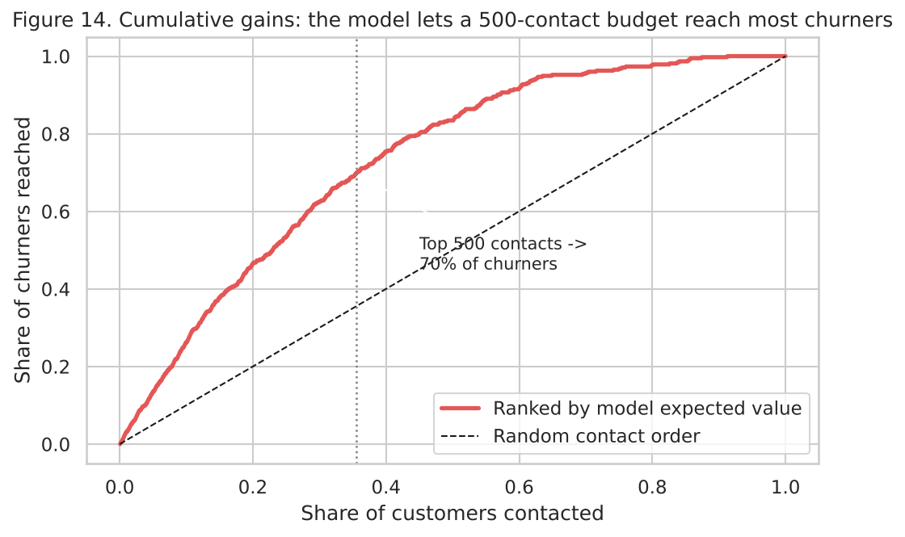
Figure 14. Cumulative gains: a 500-contact budget ranked by the model reaches 70 % of churners.
We translated the ranking into a four-tier playbook. Tier 1 (167 customers, 68 % actual churn, average bill $86): a personal retention call and an offer to migrate to a one-year contract with a loyalty discount. Tier 2 (264 customers, 50 % churn): an automated nudge such as a free trial of Online Security or Tech Support, or an auto-pay incentive, the strongest protective factors in the data. Tier 3 (33 high-risk, low-bill customers): no paid offer, because $30 exceeds a year of their margin. Tier 4 (945 customers, 12 % churn): leave alone, since reminding happy customers that they could leave can itself prompt churn.

6.4 Fairness audit
The brief asks whether it is a problem if the model flags one group more than another. We measured, for gender, senior-citizen status, partner and dependents, the share of each group flagged, the recall (share of a group's actual churners caught, the equal-opportunity criterion of Hardt et al., 2016) and precision (Figure 15).
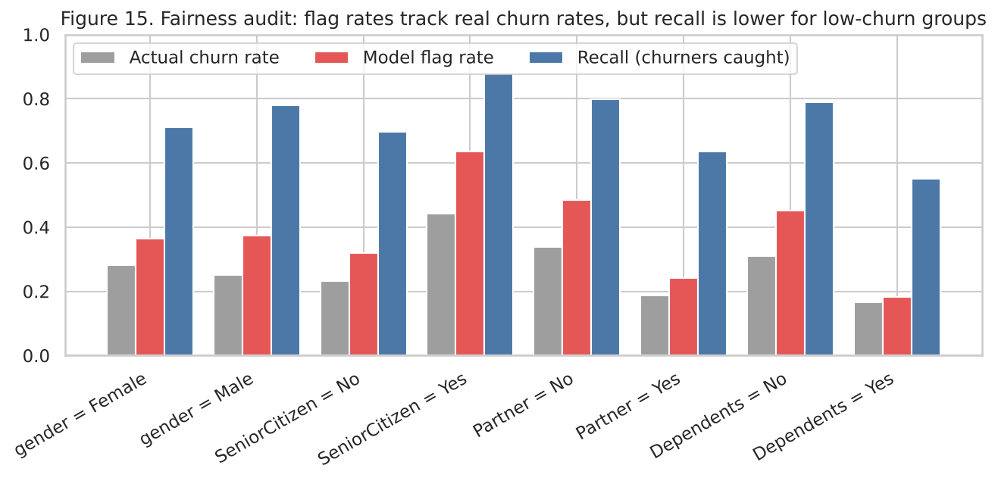
Figure 15. Fairness audit on the test set at the tuned threshold.
Gender shows no concern: flag rates are 36 % versus 37 % and churn rates are similar. Seniors, customers without a partner and customers without dependents are flagged far more often (seniors 64 % versus 32 %), but each of these groups also churns more in reality, so the model reflects a real difference rather than inventing one. The real finding is in recall. The model catches 88 % of at-risk seniors but 70 % of at-risk non-seniors, 80 % of at-risk customers without a partner but 64 % with one, and 79 % of at-risk customers without dependents but only 55 % with them. This is a known side-effect of a single global threshold: a group with a lower base rate receives lower scores on average, so fewer of its genuine churners cross the cut-off.
Whether this is a problem depends on what a flag triggers. If a flag delivers a benefit, flagging seniors more is defensible, because help goes where risk is; the failure is the mirror image, that at-risk customers with families are under-served, receiving an offer only about half the time. If the same score were ever used to disadvantage flagged customers, for instance by withholding promotions from people deemed likely to leave anyway, the higher flag rate for seniors would be discriminatory, and age is a protected characteristic in most consumer-protection regimes. We recommend three guard-rails: the score allocates retention benefits only and never restricts service; recall by demographic group is reported monthly, with no group more than ten points below the overall figure; and if the gap persists, the team tests group-aware thresholds or adds features, such as household size or service-call history, that explain churn among family customers better than the current data can.

7. Conclusion and Recommendations
The main insight is that churn in this telecom is overwhelmingly a first-year, month-to-month, fibre-optic, electronic-check phenomenon, and that the strongest protective factors, longer contracts, automatic payment and security or support add-ons, are all things the company can offer. Retention is therefore as much a product-design problem as a prediction problem. The model itself is sound but ordinary: three different algorithms reached the same 0.84 ceiling, and the value we added came from calibrating probabilities, tuning the threshold for the actual base rate, and converting scores into an expected-value decision rule that weighs who is likely to leave against who is worth keeping.
Asked by a product manager whether the model is ready to deploy, we would answer: as a pilot, yes; as an automated system, not yet. We recommend the following next steps.
- Run a 90-day forward-looking pilot. The data is a single snapshot in which churn means left last month; we cannot yet prove the model predicts weeks ahead rather than describing customers who had already decided. Score customers today, measure churn over the next 60–90 days, and hold out a random control group so the assumed 30 % save rate becomes a measured one.
- Deploy the tiered playbook, with the expected-value rule as the gate. Replace the retention team's current assumptions with their real cost and save-rate figures; the formula is unchanged.
- A/B-test the two levers the data points to: migration from month-to-month to annual contracts, and bundled Online Security or Tech Support for fibre customers. These are predictors; whether they are causes is an experiment, not an inference.
- Govern fairness. Use the score only to allocate benefits, monitor recall by demographic group monthly, and close the recall gap for customers with dependents before scaling.
- Add the data that would lift the ceiling: customer-service call logs, network-quality metrics, competitor pricing and cancellation-reason codes. Retrain quarterly and re-check calibration, because pricing changes or a new competitor would invalidate the learned relationships.
Done this way, the model becomes less a crystal ball than a budgeting tool: it tells the company where each retention dollar does the most good, and it does so transparently enough that a manager can see, and challenge, every assumption behind the number.

References
BlastChar. (2018). Telco customer churn [Data set]. Kaggle. https://www.kaggle.com/datasets/blastchar/telco-customer-churn
Breiman, L. (2001). Random forests. Machine Learning, 45(1), 5–32. https://doi.org/10.1023/A:1010933404324
Friedman, J. H. (2001). Greedy function approximation: A gradient boosting machine. The Annals of Statistics, 29(5), 1189–1232. https://doi.org/10.1214/aos/1013203451
Hardt, M., Price, E., & Srebro, N. (2016). Equality of opportunity in supervised learning. Advances in Neural Information Processing Systems, 29, 3315–3323.
Harris, C. R., Millman, K. J., van der Walt, S. J., Gommers, R., Virtanen, P., Cournapeau, D., Wieser, E., Taylor, J., Berg, S., Smith, N. J., Kern, R., Picus, M., Hoyer, S., van Kerkwijk, M. H., Brett, M., Haldane, A., del Río, J. F., Wiebe, M., Peterson, P., … Oliphant, T. E. (2020). Array programming with NumPy. Nature, 585(7825), 357–362. https://doi.org/10.1038/s41586-020-2649-2
Hunter, J. D. (2007). Matplotlib: A 2D graphics environment. Computing in Science & Engineering, 9(3), 90–95. https://doi.org/10.1109/MCSE.2007.55
McKinney, W. (2010). Data structures for statistical computing in Python. In S. van der Walt & J. Millman (Eds.), Proceedings of the 9th Python in Science Conference (pp. 56–61). https://doi.org/10.25080/Majora-92bf1922-00a
Pedregosa, F., Varoquaux, G., Gramfort, A., Michel, V., Thirion, B., Grisel, O., Blondel, M., Prettenhofer, P., Weiss, R., Dubourg, V., Vanderplas, J., Passos, A., Cournapeau, D., Brucher, M., Perrot, M., & Duchesnay, É. (2011). Scikit-learn: Machine learning in Python. Journal of Machine Learning Research, 12, 2825–2830.
Reichheld, F. F., & Sasser, W. E. (1990). Zero defections: Quality comes to services. Harvard Business Review, 68(5), 105–111.
Verbeke, W., Dejaeger, K., Martens, D., Hur, J., & Baesens, B. (2012). New insights into churn prediction in the telecommunication sector: A profit driven data mining approach. European Journal of Operational Research, 218(1), 211–229. https://doi.org/10.1016/j.ejor.2011.09.031
Waskom, M. L. (2021). seaborn: Statistical data visualization. Journal of Open Source Software, 6(60), 3021. https://doi.org/10.21105/joss.03021

