

FINAL PROJECT REPORT
OBJECT ORIENTED PROGRAMMING- FALL 2025

Name, Surname | İsmail TATLI
Student ID | 220303044
Name of the Project | Car Rental System

PROJECT DESCRIPTION

This project is a simple Car Rental System developed using Java in order to demonstrate object-oriented programming concepts. The main problem addressed by the system is managing car rentals in a structured and reliable way. In small car rental businesses, tracking available cars, customers, rental history, and payments manually can easily cause confusion and mistakes. This project provides a basic but organized solution to these problems.
The users of the system can be considered as car rental office staff. The application runs on a console-based interface where users can view available cars, register customers, rent cars for a selected number of days, return rented cars, and list all rental records. During each rental operation, a payment record is automatically created, ensuring that rental and payment information are always consistent.

UML DIAGRAMS

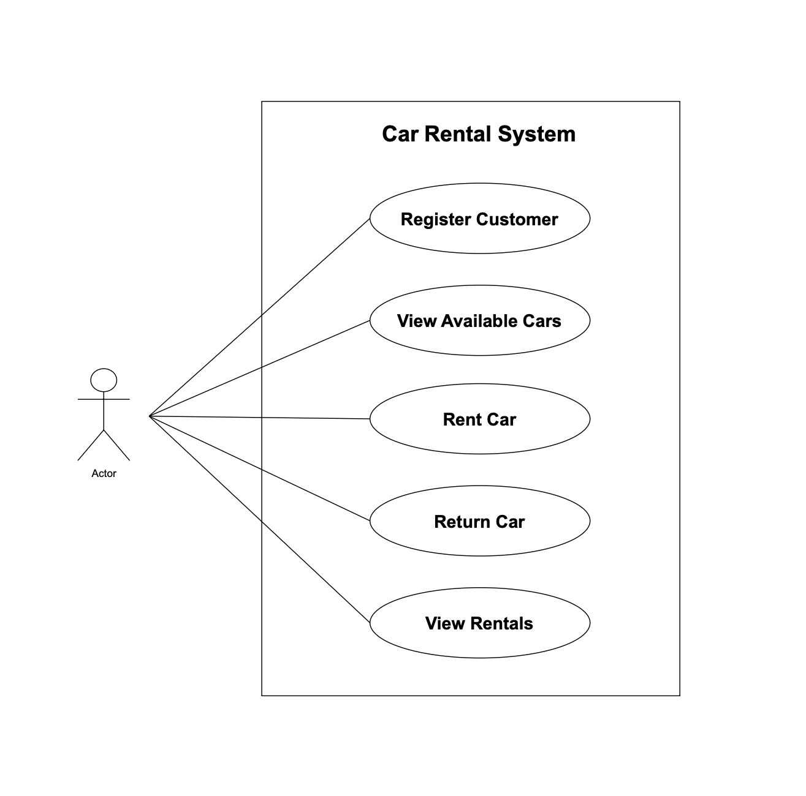
- Figure 1. Use case diagram illustrating the main actors and interactions in the Car Rental System.

- Figure 2. UML class diagram showing the core classes, relationships, and responsibilities.

SYSTEM DESIGN

Number of classes | 8
Number of interfaces | 1
Number of abstract classes (if any) | 1

- Additional supporting classes: CarInventory, RentalService, Main, Rentable (interface)

Short explanation of your classes:

Car, ElectricCar, GasCar | Car is an abstract base class that represents common properties of all vehicles such as id, brand, model, daily rental price, and availability status. ElectricCar and GasCar inherit from Car and override the rental fee calculation logic according to their own pricing rules. This structure clearly demonstrates inheritance and polymorphism.
Customer | The Customer class stores basic customer information such as customer id and full name. Customers must be registered in the system before renting a car, which allows rentals to be linked to specific users.
Rental | The Rental class represents a rental transaction. It stores information such as rental id, car id, customer id, rental duration, total rental fee, and return status. When a car is returned, the rental is marked as completed.
Payment | The Payment class stores payment information related to a rental, including payment id, rental id, payment amount, payment method, and payment time. Each rental operation generates exactly one payment record.

- Besides the 6 core domain classes, the project includes supporting classes (CarInventory, RentalService, Main) to separate business logic, data management, and user interaction.
Explain how did you accomplish the following:

Encapsulation | Encapsulation is achieved by keeping all class fields private and controlling access through constructors and getter methods. Important system data such as rental status and payment amount cannot be modified directly from outside the class, which helps protect data integrity.
Inheritance | Inheritance is implemented by creating ElectricCar and GasCar classes that extend the abstract Car class. Shared properties and behaviors are defined in the Car class, while each subclass provides its own rental fee calculation logic.
Polymorphism | Polymorphism is used when different car types are treated as Car objects. Although ElectricCar and GasCar calculate rental fees differently, the system uses the same method calls and the correct behavior is determined at runtime.
Interfaces | The Rentable interface defines a common contract for rental fee calculation. By using this interface, the system ensures that all rentable vehicle types follow the same calculation structure, making the system easier to extend.

UNIT TESTING

How many classes you’ve tested? | One main service class was tested: RentalService. This class contains the core business logic of the system. Unit tests verify successful rental operations, handling of unavailable cars, correct return behavior, payment creation, and edge cases such as invalid rental ids.

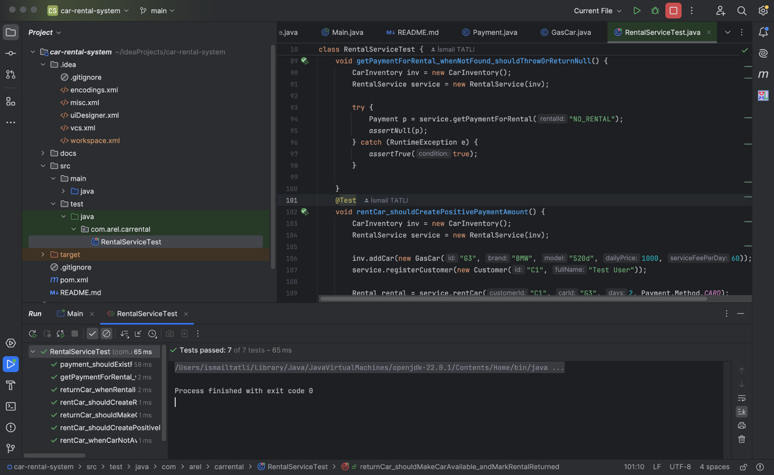

- Figure 3. JUnit test execution summary demonstrating successful test coverage of key workflows.

All JUnit tests were executed in IntelliJ IDEA and completed successfully with no failures. The test cases validate the core business logic of the system, including renting and returning cars, payment creation, and basic edge-case handling to ensure the workflow behaves correctly.

GIT & GITHUB

Github Repository Link: | https://github.com/ismailtatli/car-rental-system
Github Projects Link: | https://github.com/users/ismailtatli/projects/3

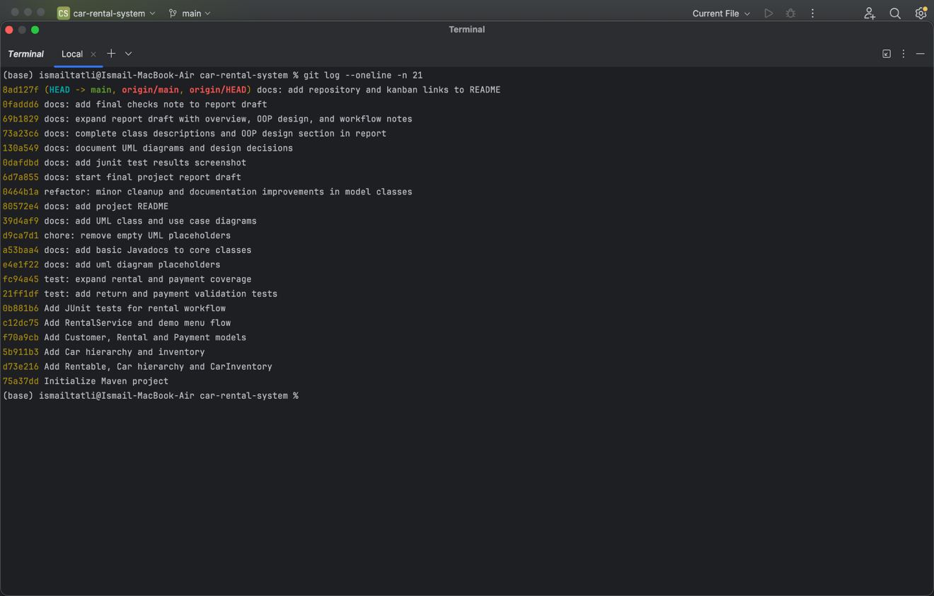

- Figure 4. Git commit history output (git log –oneline) showing the development progression.

This figure shows the git log --oneline output of the repository. The commit history demonstrates a consistent development process with meaningful commits across implementation, documentation, UML/report preparation, and final polishing stages.

