University of Tartu

Faculty of Mathematics and Computer Science

Institute of Computer Science

Project   
Scenario

MTAT.03.229 Enterprise System Integration

Authors:

Ardi Aasmaa

Kadri Oluwagbemi

Kristjan Veskimäe (A20792)

Polad Mahmudov

Tural Ismayilov

Supervisor:

Luciano García-Bañuelos

Tartu 2018

Table of Contents

Introduction 2

Part I: BuildIt 3

Domain model 3

Resource model 5

State models 6

Apiary blueprint 8

Part II: RentIt 9

Summary 10

# Introduction

Plant hiring is the equipment rental from specialized rental companies to construction companies. In this project, we model and implement the procurement process via interconnected enterprise systems in rental and building company, called respectively RentIt and BuildIt.

# Part I: BuildIt

In this first part, we present the models for building company domain.

## Domain model

First we present domain model in Figure 1.

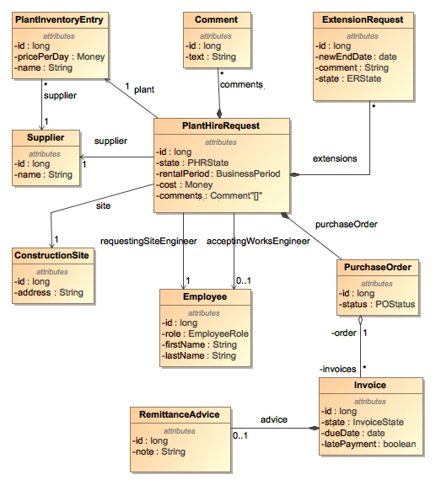

Figure BuildIt domain model

The corresponding data types for BuildIt are in Figure 2.

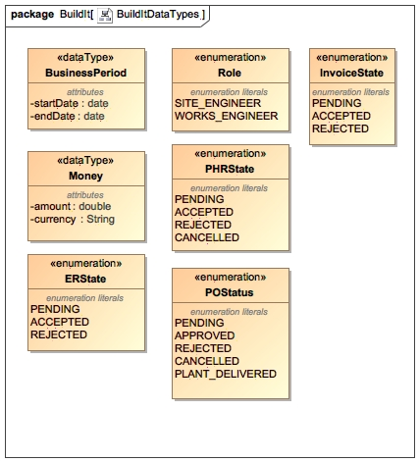

Figure BuildIt Data Types

## Resource model

Resource model helps designing RESTful applications. It is depicted in Figure 3 for BuildIt.

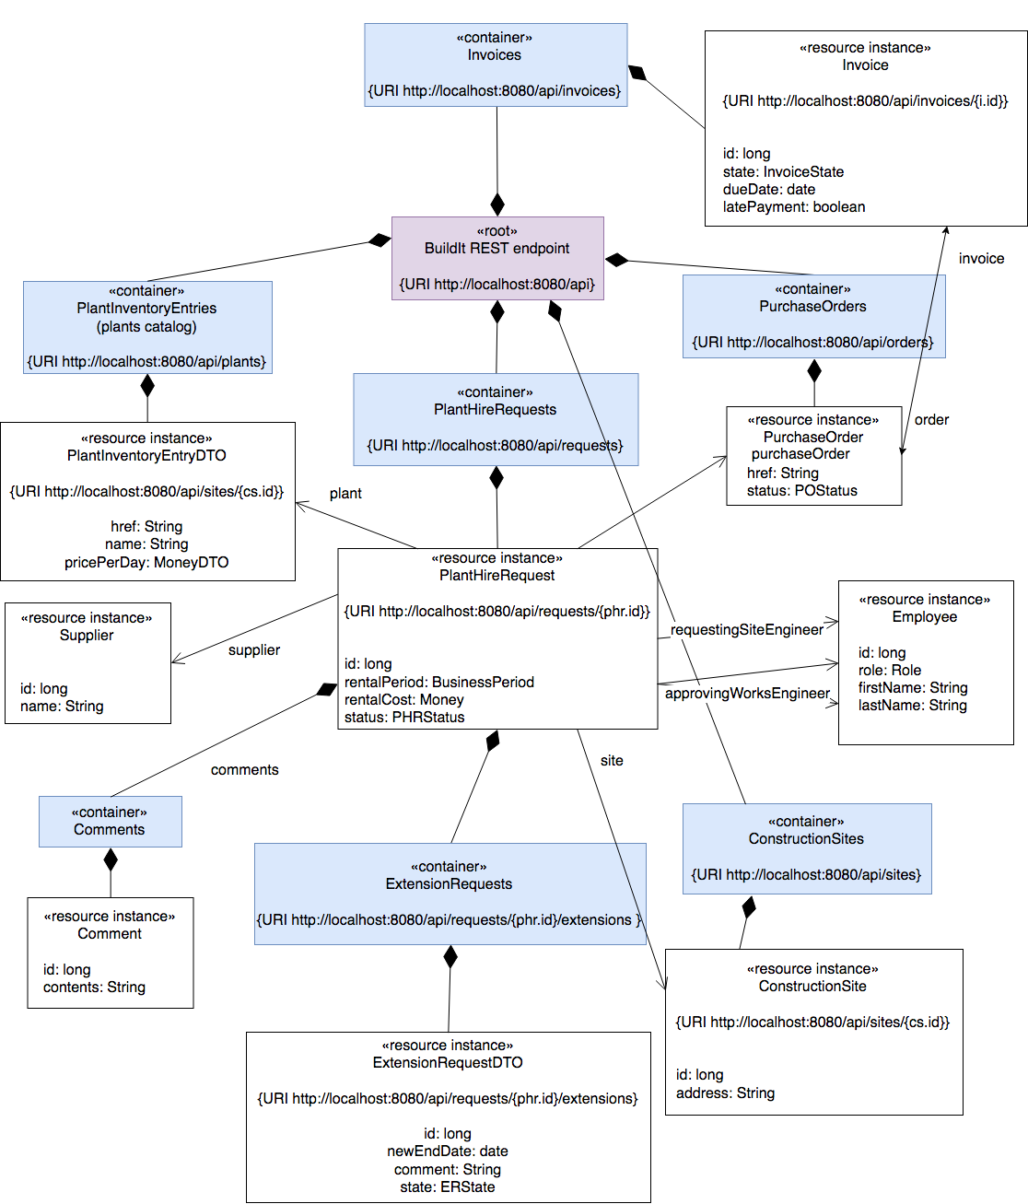

Figure BuildIt resource model

## State models

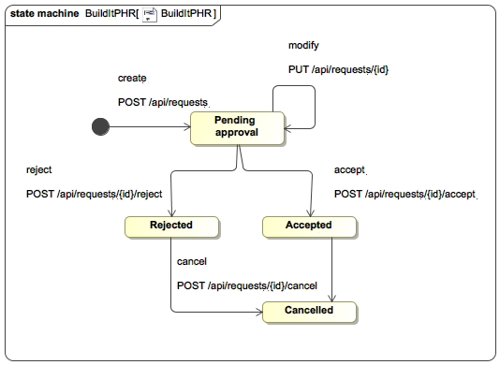

Figure State model for plant hire request

State model for plant hire request is depicted in Figure 4.

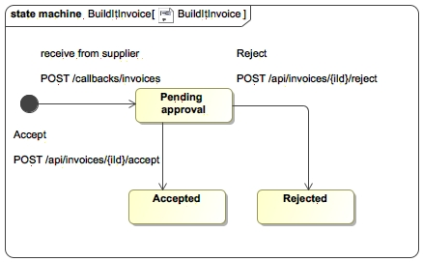

Figure State model for invoice

State model for invoice is depicted in Figure 5.

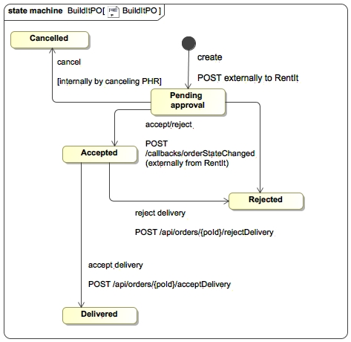

Figure State model for BuildIt Purchase Order

State model for purchase order is depicted in Figure 6.

## Apiary blueprint

The Apiary blueprint for BuildIt system is located at:

<https://buildit28.docs.apiary.io/>

BuildIt API exposes the following endpoints, with their function described:

* (CC1) Create Plant Hire Request (PHR)
  + Query plants catalog - site engineer can thereafter pick a plant to rent;
  + Retrieve list of construction sites;
  + Create Plant Hire Request (PHR) – by site engineer, JSON payload contains:
    - Plant ID with corresponding supplier ID (both can be retrieved from the chosen plant’s data transfer, for end-user the supplier is quite transparent in here);
    - Construction site (e.g. site engineer can select a site from drop-down in a plant hire request form)
    - Rental period
* View all PHRs / (CC4) one PHR by ID – both site and works engineer;
* (CC2, CC5) Modify PHR by ID – both engineers;
* Trigger operation on PHR:
  + (CC5) Accept/reject – by works engineer;
  + (CC3) cancel - by site engineer;
  + Comment – both engineers;
  + (CC8) Request extension – by site engineer;
* (CC7) View all Purchase Orders (PO) – both engineers;
* Calls from external partner RentIt:
  + (CC6) Receive PHR status update callback - from integrated RentIt partner;
  + (CC8) Receive extension status update callback - from integrated RentIt partner;
  + (CC9, CC10) Receive invoice - from integrated RentIt partner – it must contain the corresponding PO ID;
* Retrieve all invoices, optionally filtering by status – so they could be approved;
* (C11) Retrieve PO associated with an invoice
* (C11) Approve/reject invoice

# Part II: RentIt

TBD

# Summary

TBD