# Room Search – User Manual

## Ricardo dos Santos Alves de Souza

To access the Room Search feature from the system initial page, click on the Menu button option available in the top header. Then, click on the option “Room Search” to open the Room Search form. It is also possible to access the feature by clicking on the “Room Search” button available on the initial page body.

Once in the Room Search feature, a searching form is presented. The figure below describes the form elements:

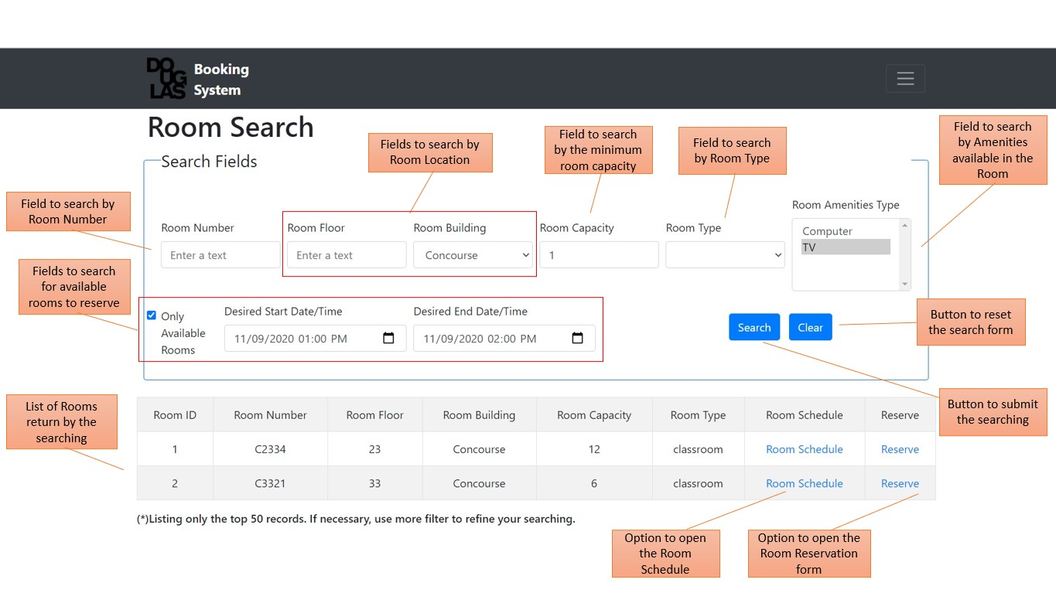

The room searching may be done using one or many of the available filtering fields. The system will return a list of room considering all the fields filled. The field “Room Capacity” is required and must be a number equal or greater than 1. In the field “Room Amenities Type”, it is possible to select none or many types simultaneously. To select more than one, press “Crtl” key and click on the desired types.

It is possible to search rooms filtering only the ones available to reserve in a desired period. To perform it, first, click on “Only Available Rooms” to enable the fields to inform the Start and End Date/Time of the desired period. Once selected to search form “Only Available Rooms”, it is required to fill both Start end End Date/Time fields. As a matter of consistency, the End field must be a date/time after the Start field.

After filling all the desired fields, press the button “Search” to submit the searching to the system. The system will process the submitted searching and return a list containing all the rooms the fit the searching filter below the Search Fields form. At any time, it is possible to reset the search form by clicking on the button “Clear”.

From the list of filtered rooms, it is possible to open the Room Schedule feature to check for room details. To do this, click on the option “Room Schedule” of the desired room.

Moreover, it is also possible to open the Room Reservation feature to directly reserve a filtered room. To do this, click on the option “Reserve” of the desired room.