Nama : Ismarianto
NPM : 201943579152

Tugas pengelolaan citra

- Operasi Penggabungan Citra
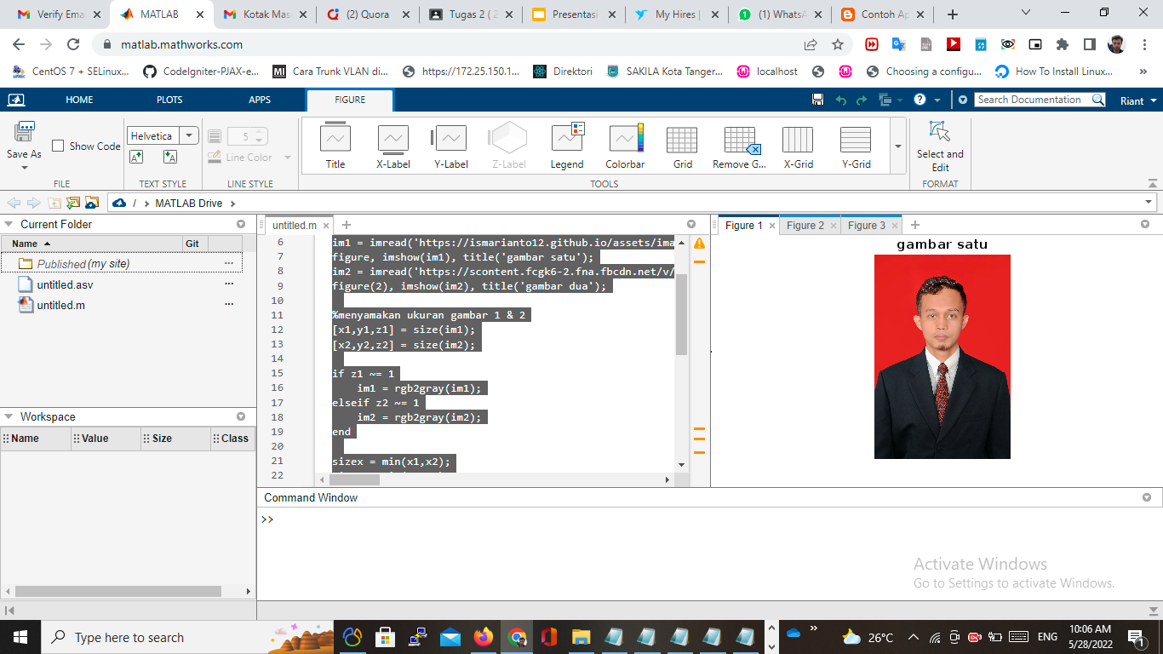

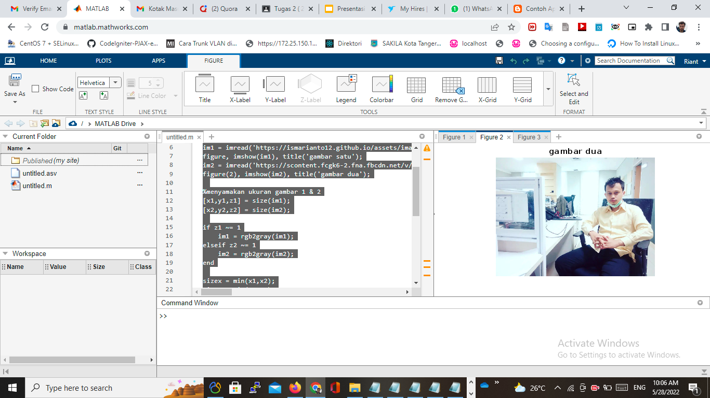
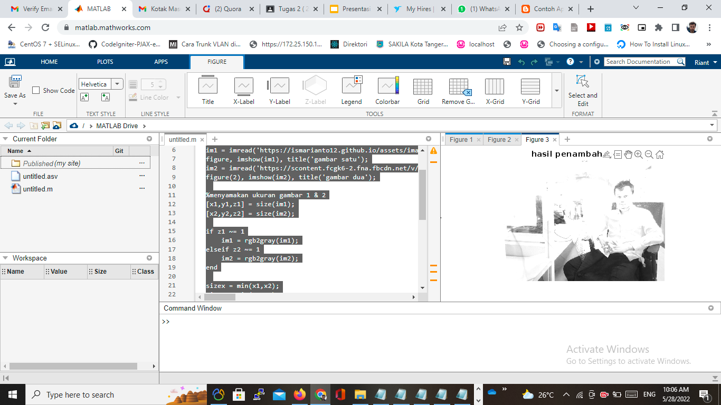
1 .Pengabungan Citra .
- Bobot Citra 0,5
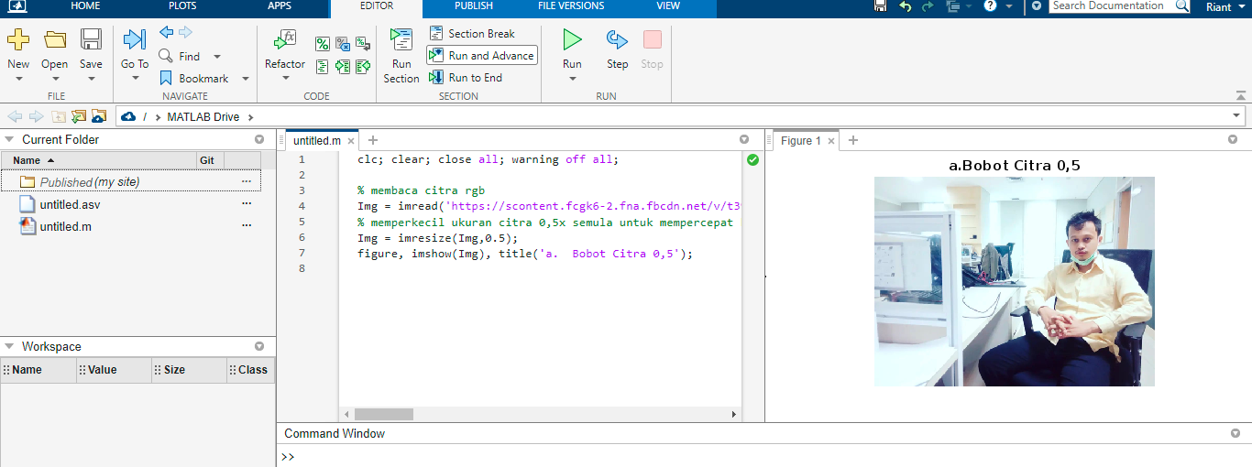

- bobot citra A=0,75 dan citra B=0,25

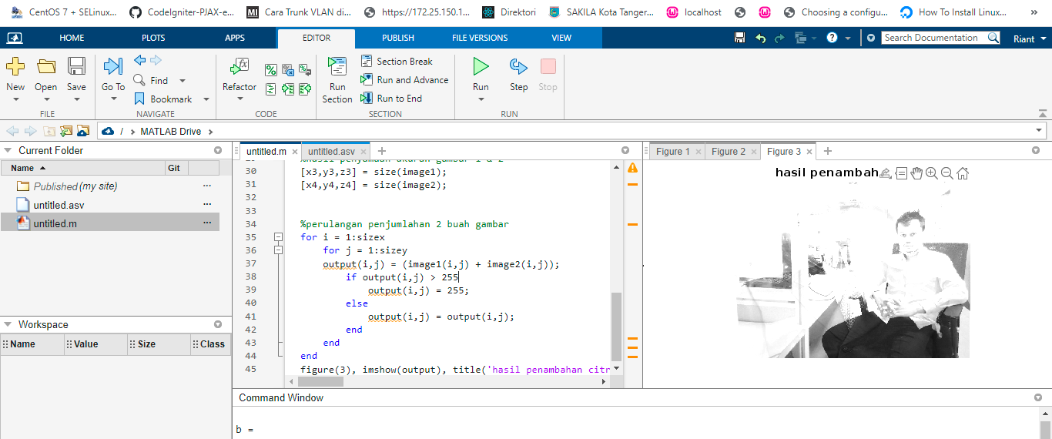

- clc
- clear all
- close all

- %membaca gambar 1 & 2
- im1 = imread('https://ismarianto12.github.io/assets/images/rian.jpg');
- figure, imshow(im1), title('gambar satu');
- im2 = imread('https://scontent.fcgk6-2.fna.fbcdn.net/v/t39.30808-6/280231688_4987059384735762_7900802599634670847_n.jpg?_nc_cat=106&ccb=1-7&_nc_sid=730e14&_nc_eui2=AeE2rM4ZZ-SeUkDs0m72hHWNchvBk9EQ8SpyG8GT0RDxKn-hCYK4TrEhlgzSmlObMX7LUgb_2shG0jMPukcokqEh&_nc_ohc=GElMhBVhMKMAX9xigII&_nc_ht=scontent.fcgk6-2.fna&oh=00_AT9gbmc-DHj2syctbU5IqyXEGz-AmYCorMnQ7YV7Hf_FAg&oe=6295CF8C');
- figure(2), imshow(im2), title('gambar dua');
- a = [0,75];
- b = [0,25]

- %menyamakan ukuran gambar 1 & 2
- [x1,y1,z1] = size(im1);
- [x2,y2,z2] = size(im2);

- if z1 ~= 1
- im1 = rgb2gray(im1);
- elseif z2 ~= 1
- im2 = rgb2gray(im2);
- end

- sizex = min(x1,x2);
- sizey = min(y1,y2);

- image1 = imresize(im1, [sizex,sizey]);
- image2 = imresize(im2, [sizex,sizey]);

- %hasil penyamaan ukuran gambar 1 & 2
- [x3,y3,z3] = size(image1);
- [x4,y4,z4] = size(image2);

- %perulangan penjumlahan 2 buah gambar
- for i = 1:sizex
- for j = 1:sizey
- output(i,j) = (image1(i,j) +a+ image2(i,j)) +b;
- if output(i,j) > 255
- output(i,j) = 255;
- else
- output(i,j) = output(i,j);
- end
- end
- end
- figure(3), imshow(output), title('hasil penambahan citra');

- bobot citra A=0,25 dan citra B=0,75
- clc
- clear all
- close all

- %membaca gambar 1 & 2
- im1 = imread('https://ismarianto12.github.io/assets/images/rian.jpg');
- figure, imshow(im1), title('gambar satu');
- im2 = imread('https://scontent.fcgk6-2.fna.fbcdn.net/v/t39.30808-6/280231688_4987059384735762_7900802599634670847_n.jpg?_nc_cat=106&ccb=1-7&_nc_sid=730e14&_nc_eui2=AeE2rM4ZZ-SeUkDs0m72hHWNchvBk9EQ8SpyG8GT0RDxKn-hCYK4TrEhlgzSmlObMX7LUgb_2shG0jMPukcokqEh&_nc_ohc=GElMhBVhMKMAX9xigII&_nc_ht=scontent.fcgk6-2.fna&oh=00_AT9gbmc-DHj2syctbU5IqyXEGz-AmYCorMnQ7YV7Hf_FAg&oe=6295CF8C');
- figure(2), imshow(im2), title('gambar dua');
- a = [0,75];
- b = [0,25]

- %menyamakan ukuran gambar 1 & 2
- [x1,y1,z1] = size(im1);
- [x2,y2,z2] = size(im2);

- if z1 ~= 1
- im1 = rgb2gray(im1);
- elseif z2 ~= 1
- im2 = rgb2gray(im2);
- end

- sizex = min(x1,x2);
- sizey = min(y1,y2);

- image1 = imresize(im1, [sizex,sizey]);
- image2 = imresize(im2, [sizex,sizey]);

- %hasil penyamaan ukuran gambar 1 & 2
- [x3,y3,z3] = size(image1);
- [x4,y4,z4] = size(image2);

- %perulangan penjumlahan 2 buah gambar
- for i = 1:sizex
- for j = 1:sizey
- output(i,j) = (image1(i,j) +a+ image2(i,j)) +b;
- if output(i,j) > 255
- output(i,j) = 255;
- else
- output(i,j) = output(i,j);
- end
- end
- end
- figure(3), imshow(output), title('hasil penambahan citra');

2. Operasi Deteksi Tepi metode Robert, Prewitt, Sobel dan Canny
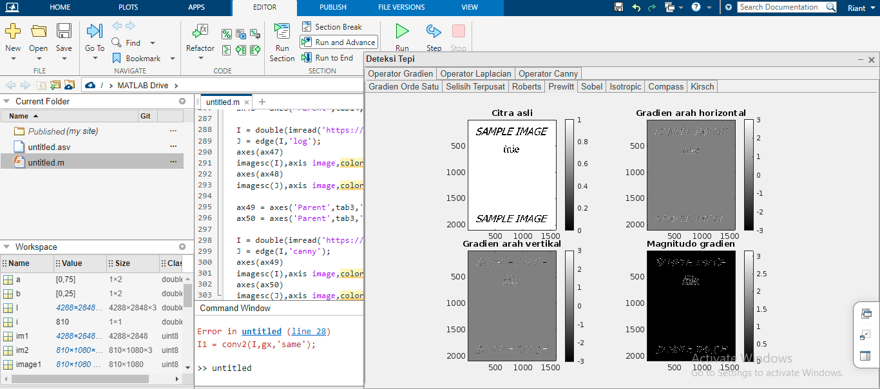

function deteksi_tepi
f = figure('Name','Deteksi Tepi','MenuBar','none',...
'ToolBar','none','NumberTitle','off','Position',[250 130 800 500]);

tgroup1 = uitabgroup('Parent', f);
tab1 = uitab('Parent', tgroup1, 'Title', 'Operator Gradien');
tab2 = uitab('Parent', tgroup1, 'Title', 'Operator Laplacian');
tab3 = uitab('Parent', tgroup1, 'Title', 'Operator Canny');

tgroup2 = uitabgroup('Parent', tab1);
tab4 = uitab('Parent', tgroup2, 'Title', 'Gradien Orde Satu');
tab5 = uitab('Parent', tgroup2, 'Title', 'Selisih Terpusat');
tab6 = uitab('Parent', tgroup2, 'Title', 'Roberts');
tab7 = uitab('Parent', tgroup2, 'Title', 'Prewitt');
tab8 = uitab('Parent', tgroup2, 'Title', 'Sobel');
tab9 = uitab('Parent', tgroup2, 'Title', 'Isotropic');
tab10 = uitab('Parent', tgroup2, 'Title', 'Compass');
tab11 = uitab('Parent', tgroup2, 'Title', 'Kirsch');

ax1 = axes('Parent',tab4,'Position',[.2 .53 .25 .4]);
ax2 = axes('Parent',tab4,'Position',[.55 .53 .25 .4]);
ax3 = axes('Parent',tab4,'Position',[.2 .1 .25 .4]);
ax4 = axes('Parent',tab4,'Position',[.55 .1 .25 .4]);

I = double(imread('https://www.alternatiff.com/sample.tif'));
% Gradien orde satu pada arah horizontal
gx = [-1 1];
I1 = conv2(I,gx,'same');
% Gradien orde satu pada arah vertikal
gy = [-1;1];
I2 = conv2(I,gy,'same');
% Magnitudo gradien
J = sqrt((I1.^2)+(I2.^2));
% Gambar hasil
axes(ax1)
imagesc(I ),axis image,colormap gray,colorbar,title('Citra asli');
axes(ax2)
imagesc(I1),axis image,colormap gray,colorbar,title('Gradien arah horizontal');
axes(ax3)
imagesc(I2),axis image,colormap gray,colorbar,title('Gradien arah vertikal');
axes(ax4)
imagesc(J ),axis image,colormap gray,colorbar,title('Magnitudo gradien');

ax5 = axes('Parent',tab5,'Position',[.2 .53 .25 .4]);
ax6 = axes('Parent',tab5,'Position',[.55 .53 .25 .4]);
ax7 = axes('Parent',tab5,'Position',[.2 .1 .25 .4]);
ax8 = axes('Parent',tab5,'Position',[.55 .1 .25 .4]);

I = double(imread('https://www.alternatiff.com/sample.tif'));
% Gradien orde satu pada arah horizontal
gx = [-1 0 1];
I1 = conv2(I,gx,'same');
% Gradien orde satu pada arah vertikal
gy = [-1;0;1];
I2 = conv2(I,gy,'same');
% Magnitudo gradien
J = sqrt((I1.^2)+(I2.^2));
% Gambar hasil
axes(ax5)
imagesc(I ),axis image,colormap gray,colorbar,title('Citra asli');
axes(ax6)
imagesc(I1),axis image,colormap gray,colorbar,title('Gradien arah horizontal');
axes(ax7)
imagesc(I2),axis image,colormap gray,colorbar,title('Gradien arah vertikal');
axes(ax8)
imagesc(J ),axis image,colormap gray,colorbar,title('Magnitudo gradien');

ax9 = axes('Parent',tab6,'Position',[.2 .53 .25 .4]);
ax10 = axes('Parent',tab6,'Position',[.55 .53 .25 .4]);
ax11 = axes('Parent',tab6,'Position',[.2 .1 .25 .4]);
ax12 = axes('Parent',tab6,'Position',[.55 .1 .25 .4]);

I = double(imread('https://www.alternatiff.com/sample.tif'));
% Konvolusi dengan operator Roberts
robertshor = [0 1; -1 0];
robertsver = [1 0; 0 -1];
I1 = conv2(I,robertshor,'same');
I2 = conv2(I,robertsver,'same');
J = sqrt((I1.^2)+(I2.^2));
% Gambar Hasil
axes(ax9)
imagesc(I ),axis image,colormap gray,colorbar,title('Citra asli');
axes(ax10)
imagesc(I1),axis image,colormap gray,colorbar,title('Gradien arah horizontal');
axes(ax11)
imagesc(I2),axis image,colormap gray,colorbar,title('Gradien arah vertikal');
axes(ax12)
imagesc(J ),axis image,colormap gray,colorbar,title('Magnitudo gradien');

ax13 = axes('Parent',tab7,'Position',[.2 .53 .25 .4]);
ax14 = axes('Parent',tab7,'Position',[.55 .53 .25 .4]);
ax15 = axes('Parent',tab7,'Position',[.2 .1 .25 .4]);
ax16 = axes('Parent',tab7,'Position',[.55 .1 .25 .4]);

I = double(imread('https://www.alternatiff.com/sample.tif'));
%Konvolusi dengan operator Prewitt
prewitthor = [-1 0 1; -1 0 1; -1 0 1];
prewittver = [-1 -1 -1; 0 0 0; 1 1 1];
I1 = conv2(I,prewitthor,'same');
I2 = conv2(I,prewittver,'same');
J = sqrt((I1.^2)+(I2.^2));
%Gambar Hasil
axes(ax13)
imagesc(I ),axis image,colormap gray,colorbar,title('Citra asli');
axes(ax14)
imagesc(I1),axis image,colormap gray,colorbar,title('Gradien arah horizontal');
axes(ax15)
imagesc(I2),axis image,colormap gray,colorbar,title('Gradien arah vertikal');
axes(ax16)
imagesc(J ),axis image,colormap gray,colorbar,title('Magnitudo gradien');

ax17 = axes('Parent',tab8,'Position',[.2 .53 .25 .4]);
ax18 = axes('Parent',tab8,'Position',[.55 .53 .25 .4]);
ax19 = axes('Parent',tab8,'Position',[.2 .1 .25 .4]);
ax20 = axes('Parent',tab8,'Position',[.55 .1 .25 .4]);

I = double(imread('https://www.alternatiff.com/sample.tif'));
%Konvolusi dengan operator Sobel
sobelhor = [-1 0 1; -2 0 2; -1 0 1];
sobelver = [-1 -2 -1; 0 0 0; 1 2 1];
I1 = conv2(I,sobelhor,'same');
I2 = conv2(I,sobelver,'same');
J = sqrt((I1.^2)+(I2.^2));
%Gambar Hasil
axes(ax17)
imagesc(I ),axis image,colormap gray,colorbar,title('Citra asli');
axes(ax18)
imagesc(I1),axis image,colormap gray,colorbar,title('Gradien arah horizontal');
axes(ax19)
imagesc(I2),axis image,colormap gray,colorbar,title('Gradien arah vertikal');
axes(ax20)
imagesc(J ),axis image,colormap gray,colorbar,title('Magnitudo gradien');

ax21 = axes('Parent',tab9,'Position',[.2 .53 .25 .4]);
ax22 = axes('Parent',tab9,'Position',[.55 .53 .25 .4]);
ax23 = axes('Parent',tab9,'Position',[.2 .1 .25 .4]);
ax24 = axes('Parent',tab9,'Position',[.55 .1 .25 .4]);

I = double(imread('https://www.alternatiff.com/sample.tif'));
%Konvolusi dengan operator isotropic
L1 = [-1 0 1; -sqrt(2) 0 sqrt(2); -1 0 1];
isover = [-1 -sqrt(2) -1; 0 0 0; 1 sqrt(2) 1];
I1 = conv2(I,L1,'same');
I2 = conv2(I,isover,'same');
J = sqrt((I1.^2)+(I2.^2));
%Gambar Hasil
axes(ax21)
imagesc(I ),axis image,colormap gray,colorbar,title('Citra asli');
axes(ax22)
imagesc(I1),axis image,colormap gray,colorbar,title('Gradien arah horizontal');
axes(ax23)
imagesc(I2),axis image,colormap gray,colorbar,title('Gradien arah vertikal');
axes(ax24)
imagesc(J ),axis image,colormap gray,colorbar,title('Magnitudo gradien');

ax25 = axes('Parent',tab10,'Position',[.08 .53 .25 .4]);
ax26 = axes('Parent',tab10,'Position',[.4 .53 .25 .4]);
ax27 = axes('Parent',tab10,'Position',[.72 .53 .25 .4]);
ax28 = axes('Parent',tab10,'Position',[.08 .1 .25 .4]);
ax29 = axes('Parent',tab10,'Position',[.4 .1 .25 .4]);
ax30 = axes('Parent',tab10,'Position',[.72 .1 .25 .4]);

I = double(imread('https://www.alternatiff.com/sample.tif'));
%Konvolusi dengan operator compass
L1 = [1 1 1; 1 -2 1; -1 -1 -1];
K2 = [-1 -1 -1; 1 -2 1; 1 1 1];
K3 = [-1 1 1; -1 -2 1; -1 1 1];
K4 = [1 1 -1; 1 -2 -1; 1 1 -1];
I1 = conv2(I,L1,'same');
I2 = conv2(I,K2,'same');
I3 = conv2(I,K3,'same');
I4 = conv2(I,K4,'same');
J = sqrt((I1.^2)+(I2.^2)+(I3.^2)+(I4.^2));
%Gambar Hasil
axes(ax25)
imagesc(I ),axis image,colormap gray,colorbar,title('Citra asli');
axes(ax26)
imagesc(I1),axis image,colormap gray,colorbar,title('Gradien arah utara');
axes(ax27)
imagesc(I2),axis image,colormap gray,colorbar,title('Gradien arah selatan');
axes(ax28)
imagesc(I3),axis image,colormap gray,colorbar,title('Gradien arah timur');
axes(ax29)
imagesc(I4),axis image,colormap gray,colorbar,title('Gradien arah barat');
axes(ax30)
imagesc(J ),axis image,colormap gray,colorbar,title('Magnitudo gradien');

ax31 = axes('Parent',tab11,'Position',[.03 .58 .15 .25]);
ax32 = axes('Parent',tab11,'Position',[.23 .58 .15 .25]);
ax33 = axes('Parent',tab11,'Position',[.43 .58 .15 .25]);
ax34 = axes('Parent',tab11,'Position',[.63 .58 .15 .25]);
ax35 = axes('Parent',tab11,'Position',[.83 .58 .15 .25]);
ax36 = axes('Parent',tab11,'Position',[.03 .13 .15 .25]);
ax37 = axes('Parent',tab11,'Position',[.23 .13 .15 .25]);
ax38 = axes('Parent',tab11,'Position',[.43 .13 .15 .25]);
ax39 = axes('Parent',tab11,'Position',[.63 .13 .15 .25]);
ax40 = axes('Parent',tab11,'Position',[.83 .13 .15 .25]);

I = double(imread('https://www.alternatiff.com/sample.tif'));
%Konvolusi dengan operator kirsch
L1 = [-3 -3 5; -3 0 5; -3 -3 5];
K2 = [-3 5 5; -3 0 5; -3 -3 -3];
K3 = [5 5 5; -3 0 -3; -3 -3 -3];
K4 = [5 5 -3; 5 0 -3; -3 -3 -3];
K5 = [5 -3 -3; 5 0 -3; 5 -3 -3];
K6 = [-3 -3 -3; 5 0 -3; 5 5 -3];
K7 = [-3 -3 -3; -3 0 -3; 5 5 5];
K8 = [-3 -3 -3; -3 0 5; -3 5 5];
I1 = conv2(I,L1,'same');
I2 = conv2(I,K2,'same');
I3 = conv2(I,K3,'same');
I4 = conv2(I,K4,'same');
I5 = conv2(I,K5,'same');
I6 = conv2(I,K6,'same');
I7 = conv2(I,K7,'same');
I8 = conv2(I,K8,'same');
J = sqrt((I1.^2)+(I2.^2)+(I3.^2)+(I4.^2)+(I5.^2)+(I6.^2)+(I7.^2)+(I8.^2));
%Gambar Hasil
axes(ax31)
imagesc(I ),axis off,colormap gray,title('Citra asli');
axes(ax32)
imagesc(I1),axis off,colormap gray,title('Timur');
axes(ax33)
imagesc(I2),axis off,colormap gray,title('Timur laut');
axes(ax34)
imagesc(I3),axis off,colormap gray,title('Utara');
axes(ax35)
imagesc(I4),axis off,colormap gray,title('Barat laut');
axes(ax36)
imagesc(I5),axis off,colormap gray,title('Barat');
axes(ax37)
imagesc(I6),axis off,colormap gray,title('Barat daya');
axes(ax38)
imagesc(I7),axis off,colormap gray,title('Selatan');
axes(ax39)
imagesc(I8),axis off,colormap gray,title('Tenggara');
axes(ax40)
imagesc(J ),axis off,colormap gray,title('Magnitudo gradien');

tgroup2 = uitabgroup('Parent', tab2);
tab11 = uitab('Parent', tgroup2, 'Title', 'Laplacian I');
tab12 = uitab('Parent', tgroup2, 'Title', 'Laplacian II');
tab13 = uitab('Parent', tgroup2, 'Title', 'Laplacian III');
tab14 = uitab('Parent', tgroup2, 'Title', 'Laplacian of Gaussian');

ax41 = axes('Parent',tab11,'Position',[.1 .23 .35 .6]);
ax42 = axes('Parent',tab11,'Position',[.55 .23 .35 .6]);

I = double(imread('https://www.alternatiff.com/sample.tif'));
%Konvolusi dengan operator laplacian
L1 = [0 -1 0; -1 4 -1; 0 -1 0];
I1 = conv2(I,L1,'same');
%Gambar Hasil
axes(ax41)
imagesc(I ),axis image,colormap gray,colorbar,title('Citra asli');
axes(ax42)
imagesc(I1),axis image,colormap gray,colorbar,title('Hasil deteksi tepi');

ax43 = axes('Parent',tab12,'Position',[.1 .23 .35 .6]);
ax44 = axes('Parent',tab12,'Position',[.55 .23 .35 .6]);

I = double(imread('https://www.alternatiff.com/sample.tif'));
%Konvolusi dengan operator laplacian
L2 = [-1 -1 -1; -1 8 -1; -1 -1 -1];
I2 = conv2(I,L2,'same');
%Gambar Hasil
axes(ax43)
imagesc(I ),axis image,colormap gray,colorbar,title('Citra asli');
axes(ax44)
imagesc(I2),axis image,colormap gray,colorbar,title('Hasil deteksi tepi');

ax45 = axes('Parent',tab13,'Position',[.1 .23 .35 .6]);
ax46 = axes('Parent',tab13,'Position',[.55 .23 .35 .6]);

I = double(imread('https://www.alternatiff.com/sample.tif'));
%Konvolusi dengan operator laplacian
L3 = [1 -2 1; -2 4 -2; 1 -2 1];
I3 = conv2(I,L3,'same');
%Gambar Hasil
axes(ax45)
imagesc(I ),axis image,colormap gray,colorbar,title('Citra asli');
axes(ax46)
imagesc(I3),axis image,colormap gray,colorbar,title('Hasil deteksi tepi');

ax47 = axes('Parent',tab14,'Position',[.1 .23 .35 .6]);
ax48 = axes('Parent',tab14,'Position',[.55 .23 .35 .6]);

I = double(imread('https://www.alternatiff.com/sample.tif'));
J = edge(I,'log');
axes(ax47)
imagesc(I),axis image,colormap gray,colorbar,title('Citra asli');
axes(ax48)
imagesc(J),axis image,colormap gray,colorbar,title('Hasil deteksi tepi');

ax49 = axes('Parent',tab3,'Position',[.1 .23 .35 .6]);
ax50 = axes('Parent',tab3,'Position',[.55 .23 .35 .6]);

I = double(imread('https://www.alternatiff.com/sample.tif'));
J = edge(I,'canny');
axes(ax49)
imagesc(I),axis image,colormap gray,colorbar,title('Citra asli');
axes(ax50)
imagesc(J),axis image,colormap gray,colorbar,title('Hasil deteksi tepi');

3. Operasi Penghalusan Citra (Image Smoothing) dengan mask 9 titik
clc; clear; close all; warning off all;

I = imread('https://ismarianto12.github.io/assets/images/rian.jpg');
Red = I(:,:,1);
Green = I(:,:,2);
Blue = I(:,:,3);
I_Red = cat(3,Red,Green*0,Blue*0);
I_Green = cat(3,Red*0,Green,Blue*0);
I_Blue = cat(3,Red*0,Green*0,Blue);

figure, imshow(I);
figure, imshow(I_Red);
figure, imshow(I_Green);
figure, imshow(I_Blue);

4.
clc; clear; close all; warning off all;

I = imread('https://ismarianto12.github.io/assets/images/rian.jpg');
Red = I(:,:,1);
Green = I(:,:,2);
Blue = I(:,:,3);
I_Red = cat(3,Red,Green*0,Blue*0);
I_Green = cat(3,Red*0,Green,Blue*0);
I_Blue = cat(3,Red*0,Green*0,Blue);

figure, imshow(I);
figure, imshow(I_Red);
figure, imshow(I_Green);
figure, imshow(I_Blue);
5. 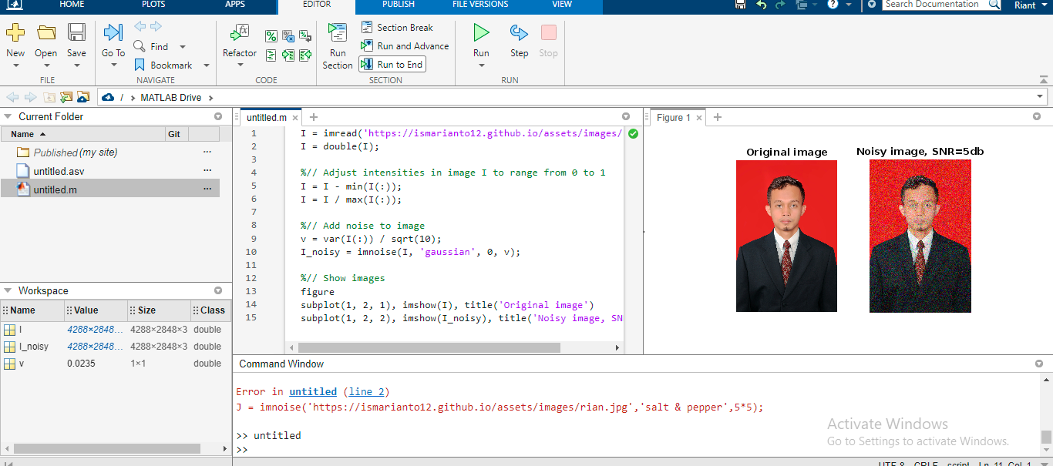

I = imread('https://ismarianto12.github.io/assets/images/rian.jpg');
I = double(I);

%// Adjust intensities in image I to range from 0 to 1
I = I - min(I(:));
I = I / max(I(:));

%// Add noise to image
v = var(I(:)) / sqrt(10);
I_noisy = imnoise(I, 'gaussian', 0, v);

%// Show images
figure
subplot(1, 2, 1), imshow(I), title('Original image')
subplot(1, 2, 2), imshow(I_noisy), title('Noisy image, SNR=5db')

6. Embosing result matlab

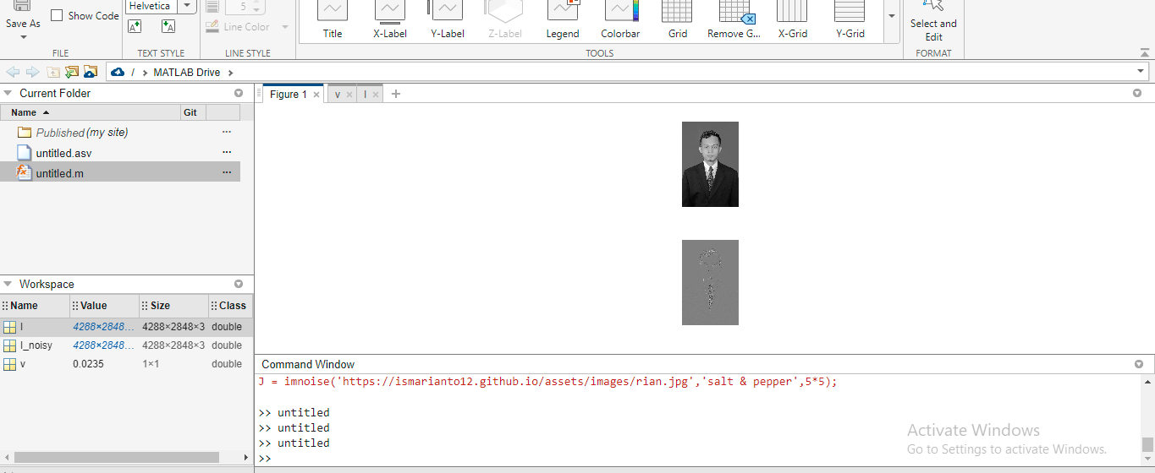

6.
function Embossing
%% read an image
img = imread('https://ismarianto12.github.io/assets/images/rian.jpg');

img = rgb2gray(img);
subplot(2,1,1);
imshow(img);

mask = [-1 0 0 ; 0 0 0 ; 0 0 1];
[rSize, cSize] = size(mask);

[nrow, ncol] = size(img);
img = cast(img, 'double');
newImg = zeros(nrow,ncol);

% Corners
subMask = mask(2:3,2:3);
i = 1;
j = 1;
subMat = img(i:i+1,j:j+1);
newImg(i,j) = sum(sum(subMask.*subMat)) + 128;

subMask = mask(1:2,1:2);
i = nrow;
j = ncol;
subMat = img(i-1:i,j-1:j);
newImg(i,j) = sum(sum(subMask.*subMat)) + 128;

% Edges
subMask = mask(2:3,1:3);
i = 1;
for(j = 2:ncol-1)
subMat = img(i:i+1,j-1:j+1);
newImg(i,j) = sum(sum(subMask.*subMat)) + 128;
end

subMask = mask(1:2,1:3);
i = nrow;
for(j = 2:ncol-1)
subMat = img(i-1:i,j-1:j+1);
newImg(i,j) = sum(sum(subMask.*subMat)) + 128;
end

subMask = mask(1:3,2:3);
j = 1;
for(i = 2:nrow-1)
subMat = img(i-1:i+1,j:j+1);
newImg(i,j) = sum(sum(subMask.*subMat)) + 128;
end

subMask = mask(1:3,1:2);
j = ncol;
for(i = 2:nrow-1)
subMat = img(i-1:i+1,j-1:j);
newImg(i,j) = sum(sum(subMask.*subMat)) + 128;
end

% Inner
for(i = 0.5*(rSize+1) : nrow - 0.5*(rSize+1))
for(j = 0.5*(cSize+1) : ncol - 0.5*(cSize+1))
subMat = img(i-1:i+1,j-1:j+1);
newImg(i,j) = sum(sum(subMat.*mask)) + 128;
end
end

subplot(2,1,2);
newImg = cast(newImg, 'uint8');
imshow(newImg);

end

7 .

8. Proses segmentasi citra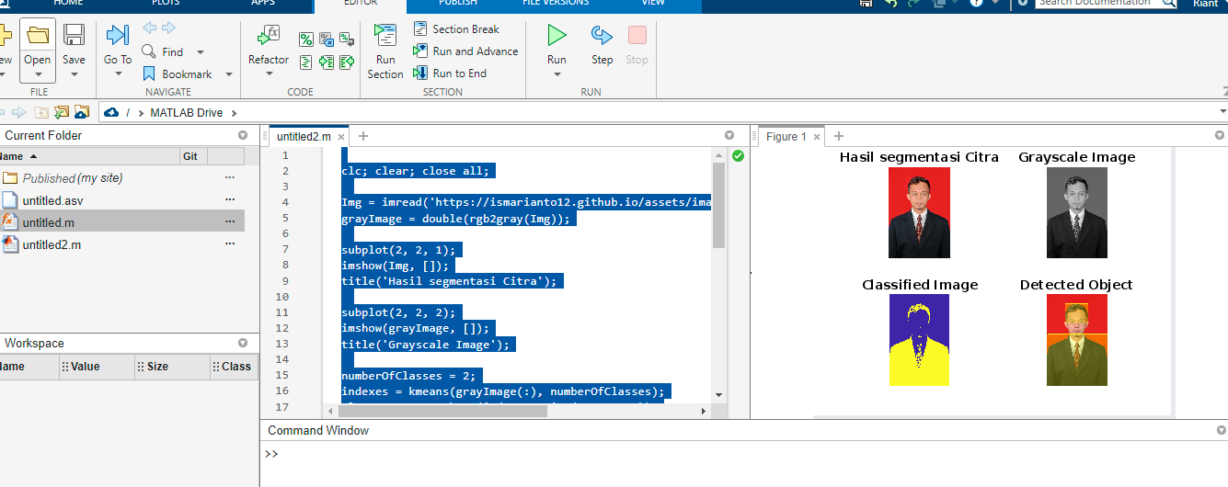

clc; clear; close all;

Img = imread('https://ismarianto12.github.io/assets/images/rian.jpg');
grayImage = double(rgb2gray(Img));

subplot(2, 2, 1);
imshow(Img, []);
title('Hasil segmentasi Citra');

subplot(2, 2, 2);
imshow(grayImage, []);
title('Grayscale Image');

numberOfClasses = 2;
indexes = kmeans(grayImage(:), numberOfClasses);
classImage = reshape(indexes, size(grayImage));

h = subplot(2, 2, 3);
imshow(classImage, []);
title('Classified Image');
colormap(h,parula);

class = zeros(size(grayImage));
area = zeros(numberOfClasses,1);

for n = 1:numberOfClasses
class(:,:,n) = classImage==n;
area(n) = sum(sum(class(:,:,n)));
end

[~,min_area] = min(area);

object = classImage==min_area;
bw = medfilt2(object,[5 5]);
bw = bwareaopen(bw,5000);
s = regionprops(bw,'BoundingBox');
bbox = cat(1, s.BoundingBox);
RGB = insertShape(Img, 'FilledRectangle', bbox, 'Color', 'yellow', 'Opacity', 0.3);
RGB = insertObjectAnnotation(RGB,'rectangle',bbox,'Object','TextBoxOpacity',0.9,'FontSize',18);
subplot(2, 2, 4);
imshow(RGB,[]);
title('Detected Object');

=================== Sekian terima kasih , mohon maaf pak hanya sesuai dengan kemampuan saya
Cman ini yang bisa saya buat , terima kasih

