[p1]:**a**:the largest number of hops:this one has the most information of switch

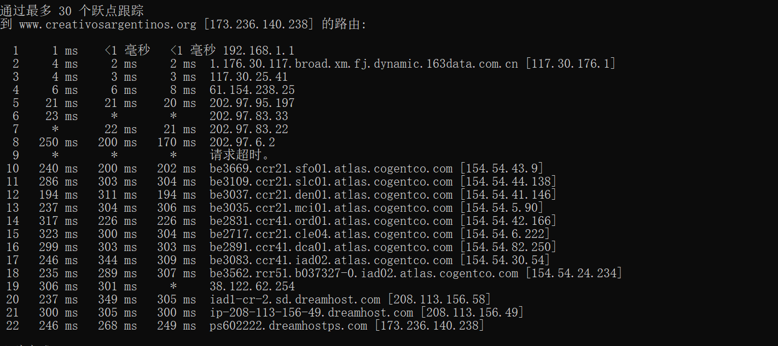

This one has the largest number but less information:

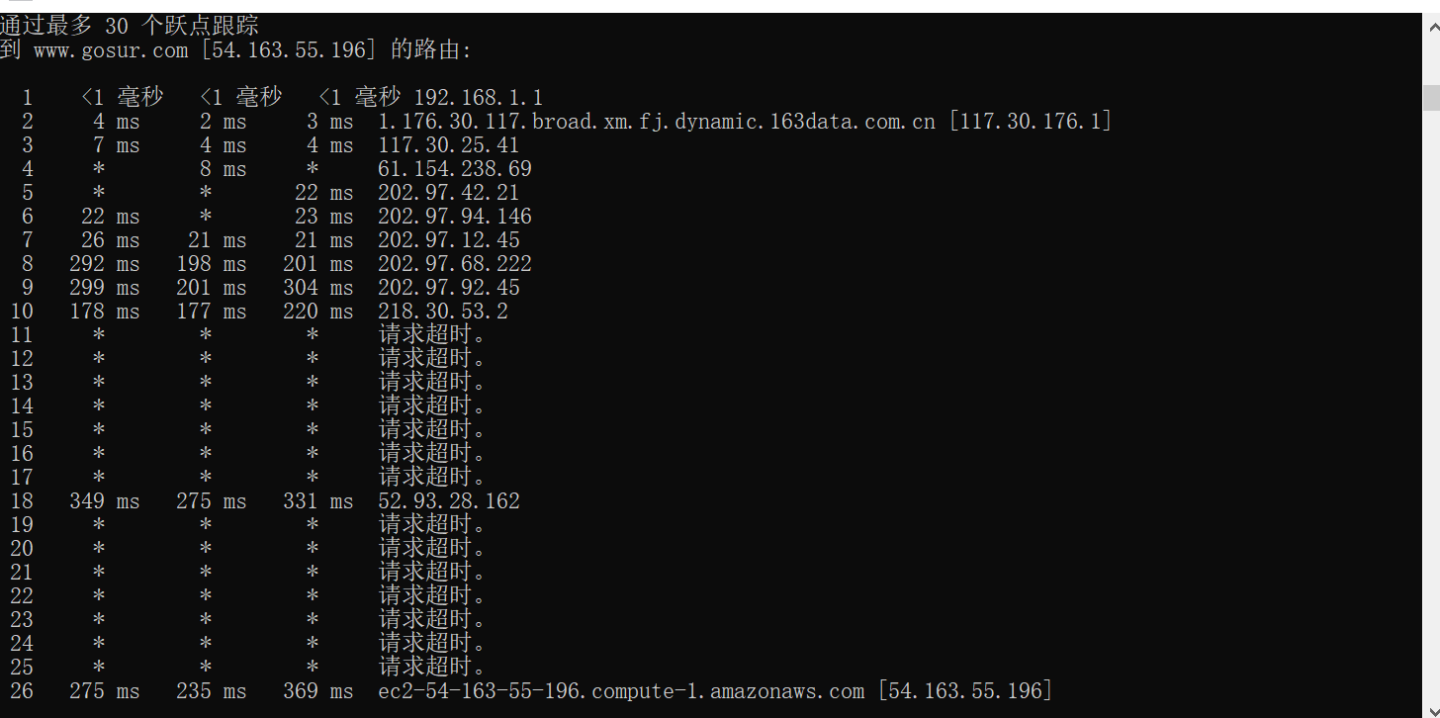

And this one is in the middle:

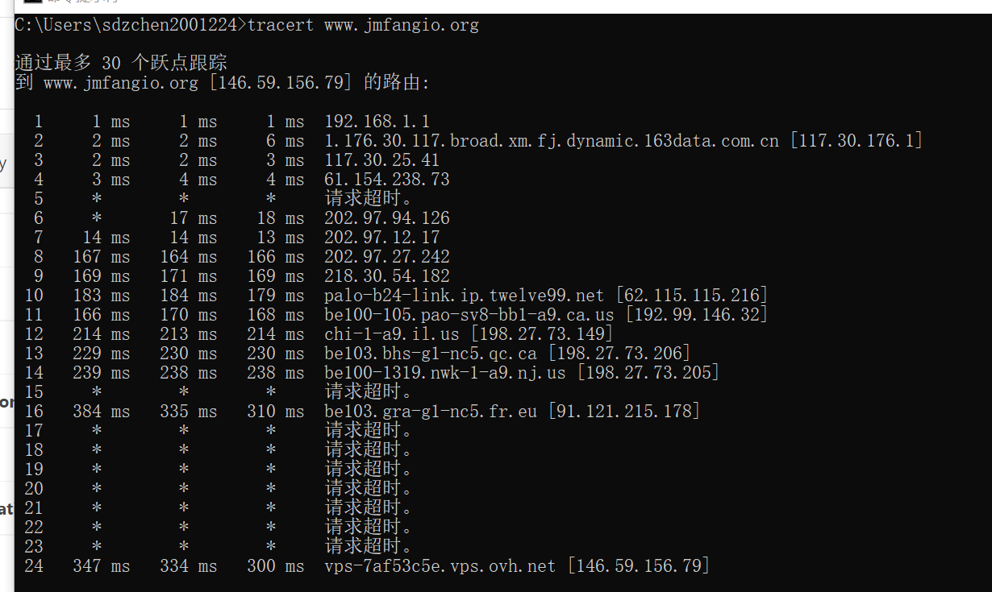

Strategy:find the country which has the longest distance to China and try the website of that country.

**B:**the largest number of ISPs:4 after several tries,I only find this number of different ISPs,China Telecom is necessary.

This one:1-10:China Telecom; 11,13:Telefonica Telxius;16:Gigared S.A.;17:Nut Host Srl

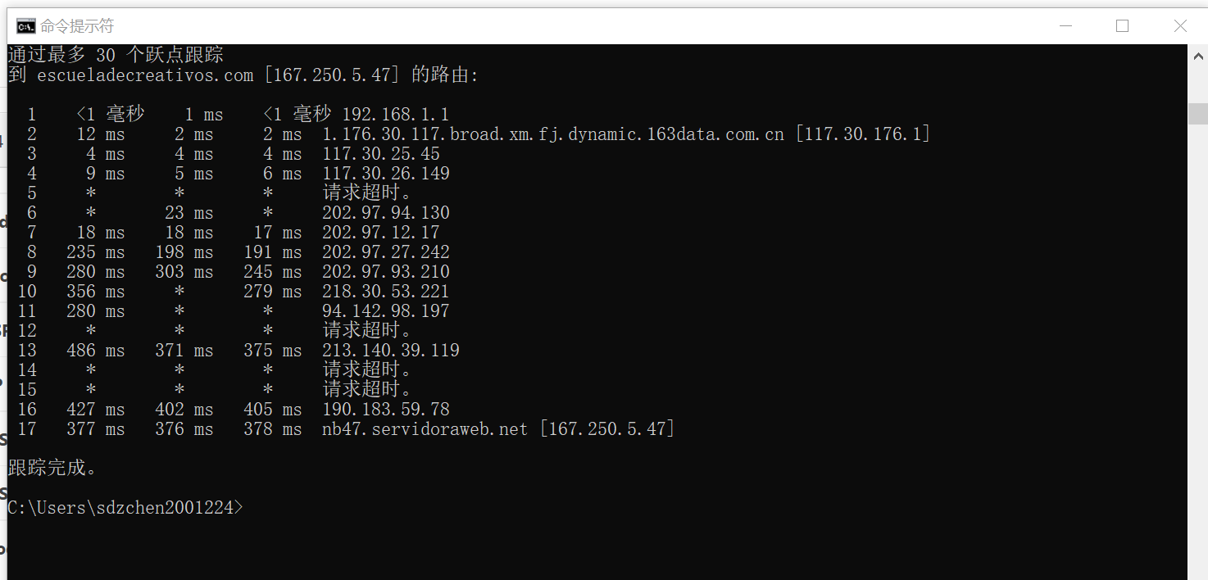

This one:1-9:China Telecom;10-12:level 3 Communications;13:GoDaddy.com,LLC;14-16：Media Temple

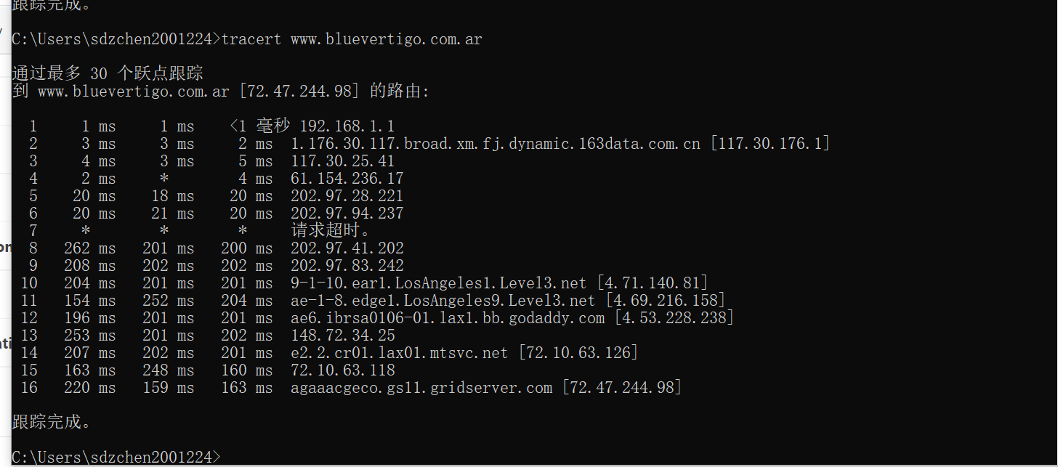

Strategy:when doing the first question,use the website:https://ip.sb/ip to look up the information of ip.Try one by one.

