https://lh5.googleusercontent.com/-5VBUiN2sVuwPeycIQ9M1vF896a6GqDd_WIcRpwvJeucsNLShquJZbnG8FvktazvczcxYkE2VoTg6hXFD0bDODU_HQ7-nzPIbFSO9xFH7YJTD3iXCxldGbF7gAV7DhOiFHgq4UUZ



**Project 3**

04.05.2017

**─**

Mustafa Ahmed Mustafa #4435

Ahmed Mahmoud Abdo #4534

Ahmed Mohmmed Ismail #4506

Moatassem Abd-Elhaleem #4497

**Overview**

Implementing a single-player 2D game known as Circus of Plates, using a Game Engine created by our one and only, Dr. Mohammed Saad.

**Design overview:**

Our designs uses the GameObject and World interfaces in order to build our game’s universe, and allows the GameEngine to bring it into life. The clown object is inherited from the ImageObject class which is used to represent most of our game’s objects (The clown/playable character, and the plates). The world gives the GameEngine how the game works. By calling the World class and constructing it, it introduces to the Engine the game’s rules and how everything must move and interact with one another.

**Sequence diagram:**

**A picture of the program’s sequence diagram:**

**Design patterns used:**

**Singleton:**

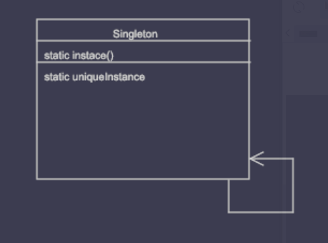

**Factory:**

**We have used this along with Flyweight in order to generate plates.**

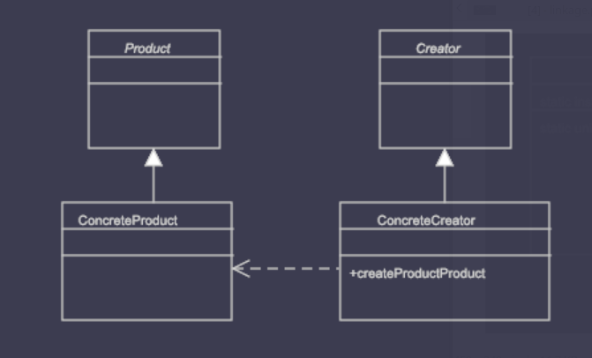

**Iterator:**

**Similar to an enhanced for loop.**

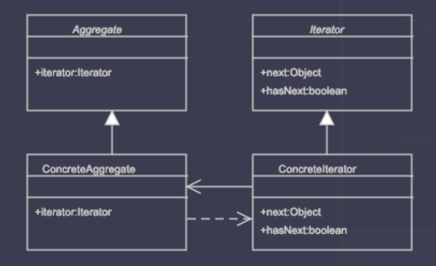

**Dynamic Linkage:**

**We have written this class in order to provide extension support.**

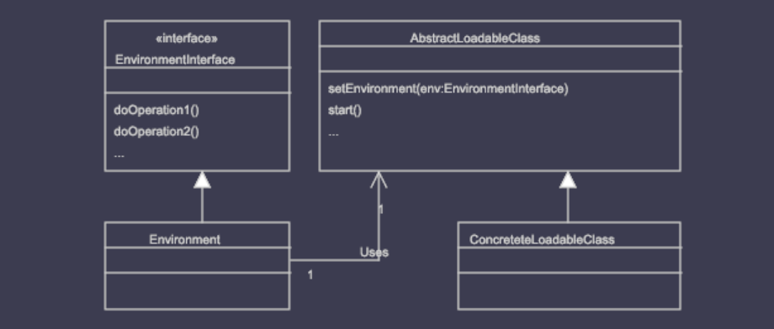

**Snapshot:**

**To pause the game.**

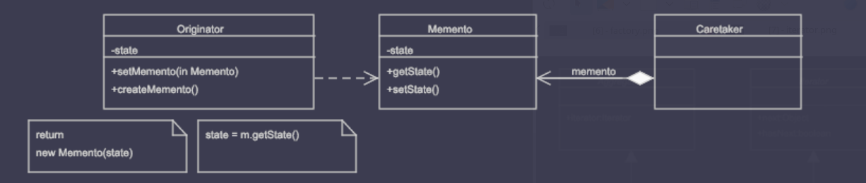

**State:**

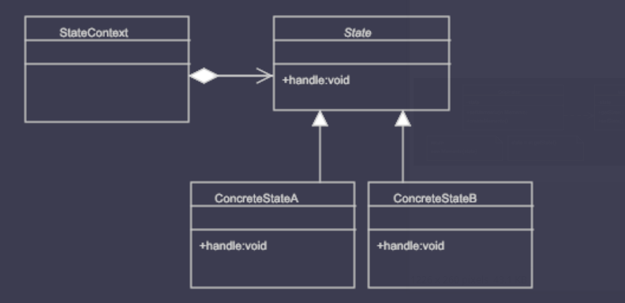

**Strategy:**

**Difficulty levels.**

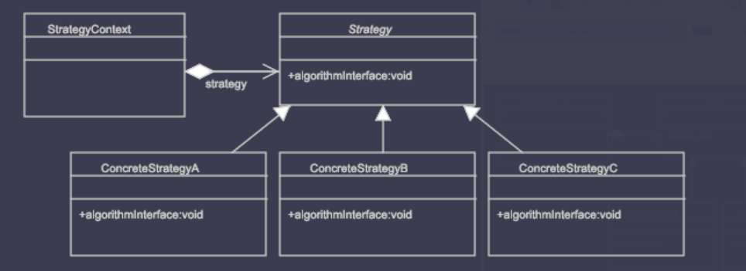

**Flyweight:**

**Used with factory in order to generate and reuse plates efficiently.**

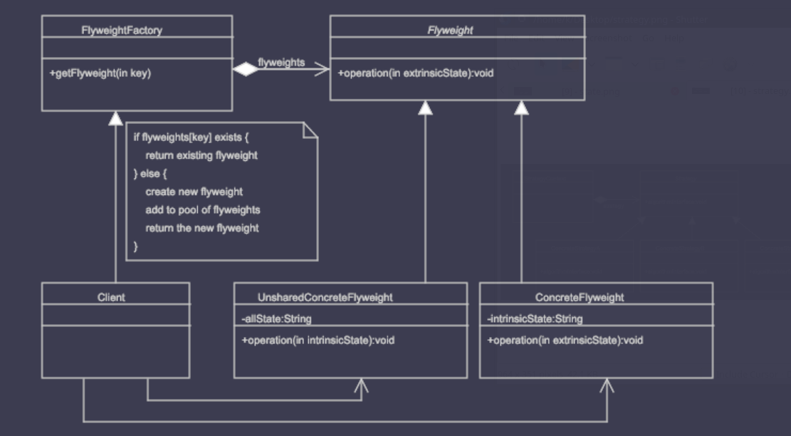

**Observer:**

**Used in order to execute game conditions.**

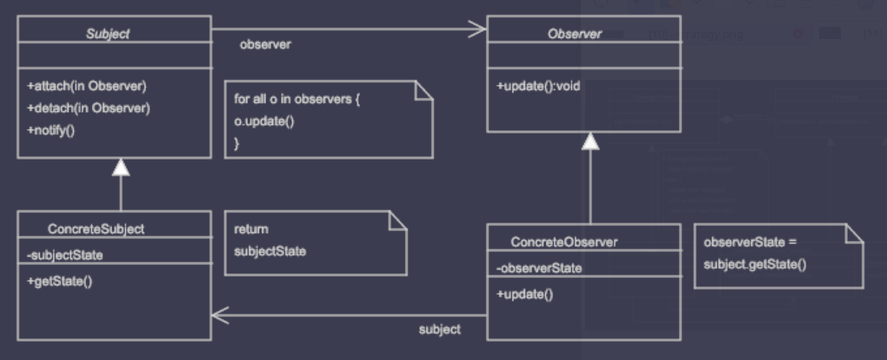

**Design decisions:**

**We have added an extra feature for the game, that is, by pressing the Up analog key, a player can choose to sacrifice some of their score in order to get rid of one plate.**