
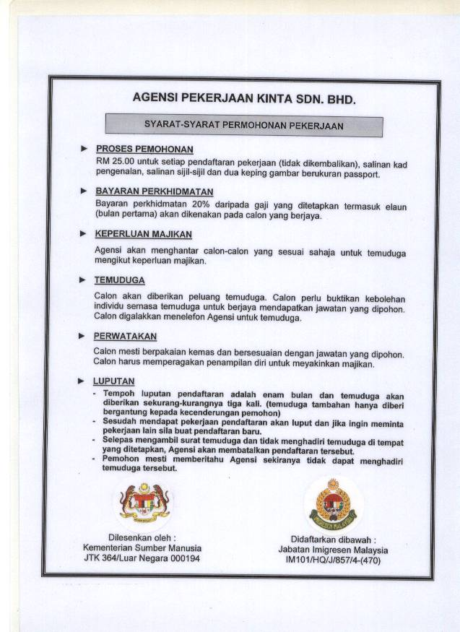
AGENSI PEKERJAAN KINTA SDN.BHD.(460487- X)
Phone: 605-5286725/5285707
Fax: 605-2360081
Email: info@kintaemployment.com
Web site: www.kintaemployement.com

APPLICATION TO EMPLOY A FOREIGN DOMESTIC MAID
REG. NO: ______________________ DATE: ____________________

EMPLOYER’S DETAIL |  |  |  | SPOUSE’S DETAIL
Name of Employer: |  |  |  | Name of spouse:
Passport or I/C No: |  |  |  | Passport or I/C No:
Age: |  |  |  | Age:
Race: |  |  |  | Race:
Nationality: |  |  |  | Nationality:
Residential Address: |  | Business Address: |  | Business Address:
Tel No (H): |  | Tel No (O): |  | Office Tel No:
Occupation: |  | No. of family members: |  | Handphone No:
Religion: |  | Family income/month |  | Occupation:
No. of children: |  | Age (s): |  | Religion:
No. of elderly: |  | Age (s): |  | Is there anyone at home during the day time?
Any Handicap/Invalid?
What type of maid are you looking for?
(Sri Lanka, Indonesia, Cambodia, Philippines)
(Age, Height, Weight, Complexion, Religion, Education, etc
RESIDENCE
Type of house: |  | No. of rooms
Area of compound: |  | Swimming pool:
Dialect: |  | Language
No. of cars: |  | Animals reared:
No. of maids required:
Salary offered:
Agreed rest day:
When can maid start work?
State the type of work you require the maids to do:* |  |  |  | We hereby agree to choose Ms: ____________________________________  Passport No: ___________________ as our soon to be domestic maid for us.  ___________________________ __________________________
* ( / ) Tick where applicable
Laundry & Ironing |  | Cleaning
Cooking |  | Gardening
Care of children |  | Baby sitting
Care of invalids |  | General housework
Mopping/Vacuum |  |  |  | Employer | Spouse

