**How To Run This Program**

**Import SQL Database**

* Import Database using workbench
  1. Open mysql workbench
  2. Open your database
  3. Click administration beside schemas menu
  4. Click Data Import/Restore
  5. Choose directory with name employee-database
  6. Click start import

* Import Database using Cmd
  1. open employee-database folder and open cmd in that place
  2. run this command--> mysql -u (username)
  3. run this command--> CREATE DATABASE employee
  4. run this command--> exit
  5. import my sql database using this command--> mysql -u (username) -p(PlainPassword) employee < (filename.sql)
  6. <username> is your username mysql, <PlainPassoword> is your password mysql. If your mysql dont have password just write -p
  7. example command--> mysql -u root -p employee < employee_t1_position.sql
  8. run that command 2 times, first import employee_t1_position.sql and then import employee_t2_employee

**Run Backend**

1. Before you run backend make sure you have import database, read step-run-program.docx

2. install jdk 8

3. install maven

4. open employee-backend using document reader

5. open \employee-backend\src\main\resources\application.properties

6. setting spring.datasource.username base on your mysql database username

7. setting spring.datasource.password base on your mysql database password

8. open cmd

8. write mvn clean install on your cmd

9. go to \employee-backend\target

10. write java -jar employee-0.0.1-SNAPSHOT

now backend is running in port 8080

**Run Frontend**

1. before you run frontend you should finish import database and run backend

2. install node

3. install npm

4. open folder employee-angularjs

5. open cmd in that place

6. npm install

7. npm start

this program run in localhost:8000

**Run Application**

1. open browser

2. go to localhost:8000 first you will see the data tabel

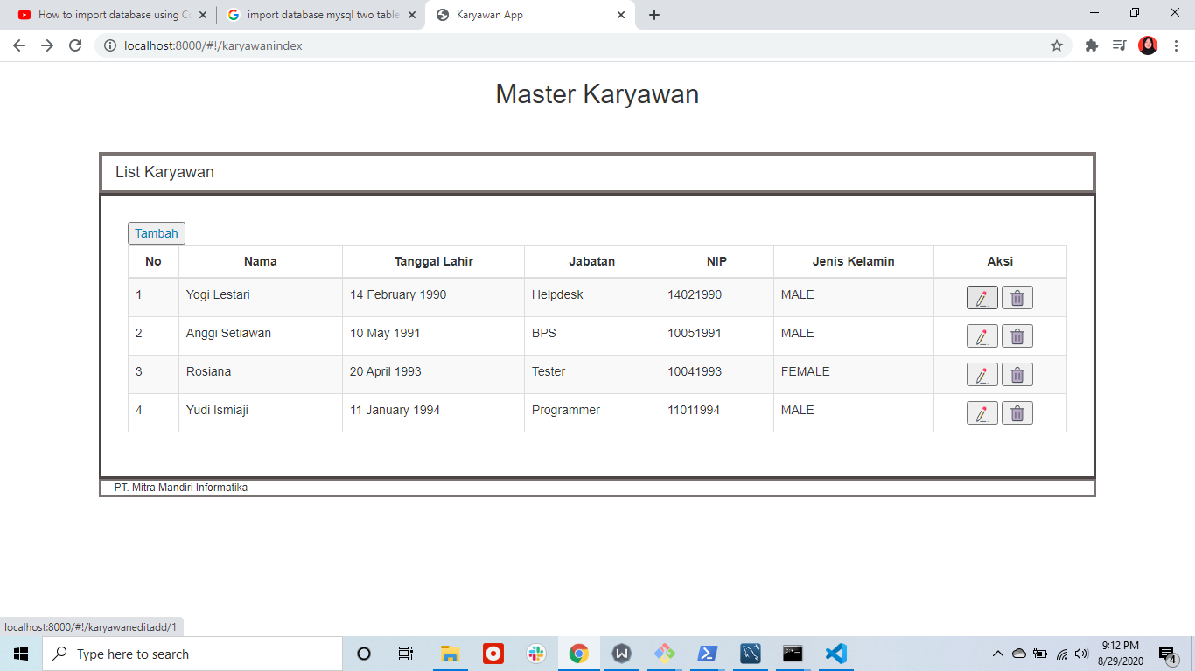

3. if you want to add the data you can click "tambah" button

4. Insert form data and click "simpan", a new data will be store in database and form will reset, you can add the data again or back to list

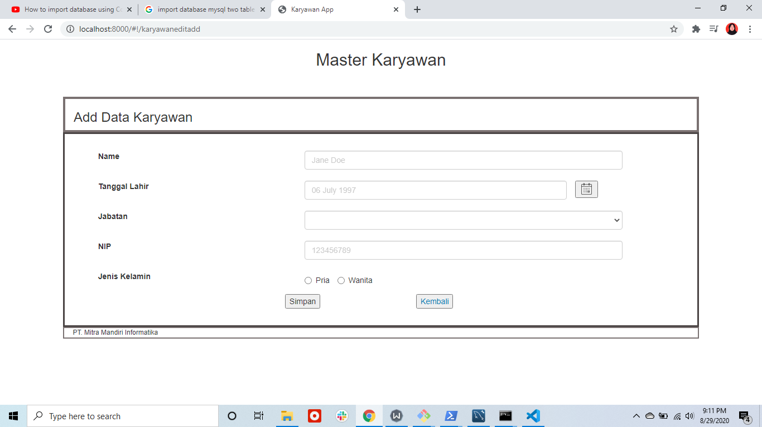

5. click "kembali" button if you want to back to employee list

6. If you want to edit the data you can click icon edit in the right coloumn in an employee that you want to edit and you can edit data and save, after you click save you will be directed to employee list

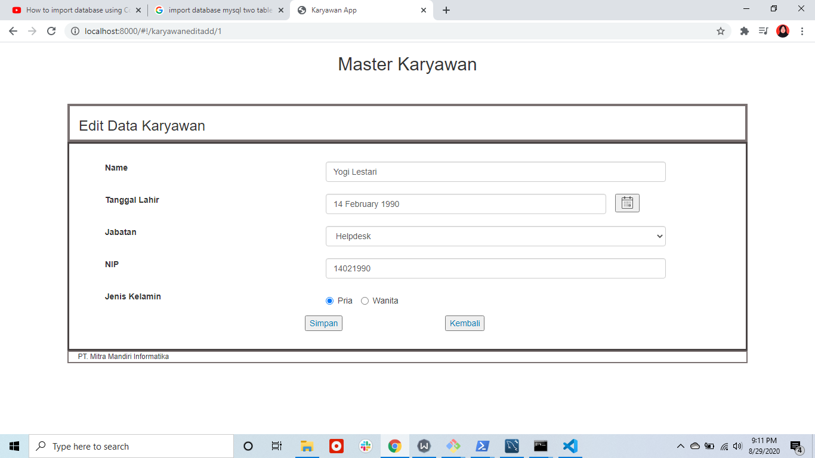

7. If you want to delete an employee, you can click trash icon in the right coloumn in an employee that you want to delete. delete succes and the employee list will be refresh

