VERIFICATION TEST PLAN
Fundamentals of Pre-Silicon Validation Spring-2024
Implementation and Verification of UART using both Class-based and UVM methodologies Date:04-24-2024

Contents
- Introduction 2
- Verification Requirements 3
- Required Tools 4
- Risks and Dependencies 4
- Functions to be verified 5
- Tests and Methods 5
- Resources Requirements 6
- Schedule 6
- References 7

Introduction
  - Objective of the Verification Plan
This document establishes the verification plan for the UART design specified in the requirement specification. It identifies the features to be tested, the test cases, the expected responses, and the methods of test case application and verification.

  - Block diagram

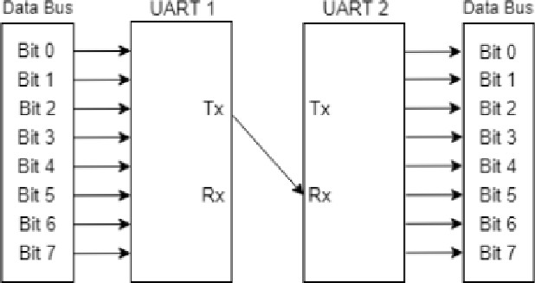

  - Specifications
    - Programmable baud rate: 1200, 2400, 4800, 9600, and 115200 bps.
    - Implementation of parity bit for error.
    - Stop bits considered are one.

Verification Requirements
  - Module Hierarchy

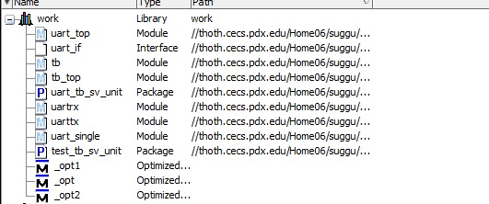

Each module and its specifications
Module UARTTX:

- clk_tx: transmitter clock in the uart with 50Mhz frequency.
- rst : reset signal.
- tx_data: input data consists of 8 bits of data lines ,1 bit of start signal,1 bit of stop.
- en_tx: when enabled, transmission of data to transmitter, 1 bit signal.
- tx: output data to be transmitted by the transmitter, it consists of input data streamed and it also consists of 8 bits of input data.
- donetx: flag to confirm the data is transmitted by the transmitter. Its one-bit signal.
- Newd : Signal indicating the input of data

Module UARTRX:

- clk_rx: receiver clock in the uart with 50Mhz frequency
- rst : reset signal.
- rx_data: output data from receiver consists of 8 bits of data lines,1 bit of start signal, 1 bit of stop.
- en_rx: enable receiving of data to receiver 1,1-bit signal.
- rx: input data to receiver from the transmitter, it consists of output data streamed and it also consists of 8 bits of output data.
- donerx: flag to confirm the data is received completely. It’s one-bit signal.

Module UART_SINGLE:
Uart_single consists of both transmitter and receiver.

- clk : Clock signal
- rst : Reset signal
- dintx : input, 8 bits data
- Newd : Signal indicating the input of data

- en_tx: when enabled, transmission of data to transmitter, 1 bit signal.
- en_rx: enable receiving of data to receiver,1-bit signal.
- tx: output data to be transmitted by the transmitter, it consists of input data streamed and it also consists of 8 bits of input data.
- doutrx : output, 8 bits of data
- donetx: flag to confirm the data is transmitted by the transmitter. Its one-bit signal.
- donerx: flag to confirm the data is received completely. It’s one-bit signal.

Module UART_TOP:
- clk : Clock signal
- rst : Reset signal
- din : input, 8 bits data
- Newd : Signal indicating the input of data.
- en_tx1: when enabled, transmission of data to transmitter 1, 1 bit signal.
- en_tx2: when enabled, transmission of data to transmitter 2, 1 bit signal.
- en_rx1: enable receiving of data to receiver 1,1-bit signal.
- en_rx2: enable receiving of data to receiver 2,1-bit signal.
- donetx1: flag to confirm the data is transmitted by the transmitter 1. Its one-bit signal.
- donerx1: flag to confirm the data is received completely by the receiver. It’s one-bit signal.
- donetx2: flag to confirm the data is transmitted by the transmitter 2. Its one-bit signal.
- donerx2: flag to confirm the data is received completely by the receiver 2. It’s one-bit signal.
- dout: output, of 8 bits data.
- tx1rx2: Data transfer from transmitter 1 to Receiver 2.
- tx2rx1: Data transfer from transmitter 1 to Receiver 2.

Required Tools
  - Software and Hardware tools
Tool used for design and Verification: Questa Sim Revision control Tool: GITHUB
(https://github.com/ismavayrus/team_07_UART/tree/team_07_UART/M1)
  - Directory structure of your runs
The directory structure for the verification runs will be organized for clarity and ease of access. Below is a proposed directory structure:
Verification_plan
/testbench uart_tb.sv
/modules
uart_master.sv uart_slave.sv

​Risks and Dependencies
There are several risks and dependencies that can impact the project. Here are some potential risks and dependencies to consider:
- Technical Risks:
  - Complexity of UART Design: The UART design might be more complex than anticipated, leading to difficulties in implementation and verification.
  - Baud Rate Accuracy: Achieving accurate baud rates across different configurations might pose a challenge, especially in FPGA implementations.
  - Parity Bit Handling: Implementing parity bit functionality could introduce additional complexity and potential bugs.
- Schedule Risks:
-Design Iterations: Iterative design changes and debugging might extend the project timeline, delaying milestone completions.
-Verification Time: Comprehensive verification may take longer than estimated, potentially delaying project milestones.

- Dependencies:
  - Tool Dependencies:Dependency on specific EDA tools for synthesis, simulation, and verification may introduce compatibility issues and workflow constraints.
  - External Interfaces: Dependencies on external components or interfaces, such as clock sources or test equipment will impact design and verification activities.

- Quality and Compliance Risks:
  - Functional Correctness: Ensuring the design meets all functional requirements, including baud rate accuracy, error handling, and compliance with UART standards.
  - Compliance Verification: Verifying compliance with industry standards and protocols,

Functions to be Verified
Several functionalities of the UART design can be tested using the provided testbench. Here are some key functionalities that can be verified:
- The test includes to check the data is transmitted from the 1st UART and is received by the second UART.
- To check input data is streamed by the transmitter.
- To check the transmitted data is streamed by the receiver.

Tests and Methods
  - Testing methods to be used: Black/White/Gray Box.
Black Box Testing: Functional verification based on specifications.
White Box Testing: Code coverage analysis and assertion-based verification.
Gray Box Testing: Scenario-based testing for corner cases.
  - ​Checking methodology
- Self-Checking Testbench: Automates the process of stimulus generation and response verification without manual intervention, using a testbench that compares the DUT's outputs against expected results.
- Assertion-Based Checking: Employs conditional checks within the simulation to ensure the DUT's behavior aligns with specified design properties and constraints.
- Score boarding: Utilizes a reference model to predict outputs, facilitating comparison against actual DUT responses for validation of correct behavior.

- Coverage Analysis: Meaures the extent to which the DUT's state space is exercised by the testbench, aiming to identify untested parts of the design.
- Randomized Testing: Generates random inputs to stress-test the DUT across a broad range of scenarios, often uncovering edge cases not considered in directed testing.
- Directed Testing: Focuses on specific and critical DUT functionalities by crafting targeted test cases, ensuring that behaviors are correctly implemented.
- Simulation Control: Manages the execution flow of the simulation environment, such as clock cycles and reset sequences, to emulate realistic operating conditions.
- Logging and Error Reporting: Captures and outputs simulation data and error messages to track test progress and facilitate debugging of failed checks.

Resources Requirements

No | Task | Actual  Start Date | Responsible person | Target Completion date & Status |  | Comments
1 | High Level Design  Specification  (HLDS) | 12/4/2024 | PRASANNA KUMAR | 16/4/24 | Completed | Understanding and finding Design  specifications  documentation
1.1 | Design spec  calculation and Implementation | 17/4/2024 | SURYA VAMSI | 19/4/24 | Completed | Comprehending modules and  devising a plan for their design,  followed by the  division of modules.
1.2 | Transmitter  &Receiver Design | 20/4/4 | SUGGU SAI TAGORE | 23/4/24 | Completed | Crafted the code for both the transmitter and receiver UART modules ensuring  functionality for both sending and receiving data via UART
1.3 | Baud Rate  Calculation, Test Bench Plan | 21/4/24 | SUSRITHA | 23/4/24 | Completed | Calculation for  required Baud Rate along with planning

 |  |  |  |  |  | testing Scenarios, for Testbench.
2 | Class based Test Bench | 25/4/24 | SUGGU SAI TAGORE | 26/4/24 | Completed | Updating the class based test bench.
2.1 | Completed Transactions and Generator | 27/4/24 | PRASANNA | 28/4/24 | Completed | Writing transactions and generator.
2.2 | Drivers, verification of data bursts | 29/4/24 | SUSRITHA | 1/5/24 | Completed | Creating Drivers and verification of data bursts.
2.3 | Interfaces, Updating verification Plan | 1/5/24 | SURYA VAMSI | 3/5/24 | Completed | Updating the verification plan, spec doc along with Interfaces.

Schedule
- Week 1-2 (until 04-24-2024): High-level design Specification, testing strategy, and drafting verification plan. Designing the basic UART.
- Week 3-4 (until milestone 2): Converting this basic testbench to a class-based testbench. Verifying with a randomized burst of data, updating the verification plan accordingly
- Week 5-6 (until milestone 3): Complete class-based verification to the updated RTL if any and maximize the code coverage and functional coverage. Inclusion of specific corner cases in the testbench
- Week 7-8 (until milestone 4): Complete implementation of UVM architecture and creating log files.
- Week 9-10 (until milestone 5): Finalize documentation, prepare all the deliverables, and submit.

References
- Open AI, "Chat GPT," [Online].
- Verification academy for detailed coverage requirements of UART
(https://verificationacademy.com/cookbook/coverage/uart-example-test-plan/ )
- Online learning video System Verilog for Verification Part2: Projects from Udemy ( https://www.udemy.com/course/systemverilog-for-verification-part-2-projects/ )
- Spear, Chris, Tumbush, Greg, “SystemVerilog for Verification” Book.
- Yamini R, Ramya M V, “Design And Verification Of Uart Using System verilog ”, IJEAT,2020.

