
Department Of Computer
Science
University Of Engineering and Technology, Lahore

AICT Final Project

Skill-Bridge Tech

Course:
Application Of Information and Communication Technology

Group Members:
- Nabeeha Shoaib 2025-CS-190
- Alishba Bibi 2025-CS-203
- Isma Wasif 2025-CS-226
- Kainat Nasir 2025-CS-232
- Anfaal Abbas 2025-CS-233

Instructor Name:
Miss Ramsha Khalid

Submission Date: 05/01/2026

Executive Summary about Website:
Skill-Bridge Tech is an online learning platform designed to help people gain the practical skills they need for today’s job market. Many students and professionals struggle to keep up with fast-changing technology, so we built this website to provide clear, hands-on training in high-demand fields. Our courses focus on Web Development, Microsoft Office, and Digital Marketing, giving users a mix of technical and creative tools to succeed. By offering a user-friendly interface and quality content, Skill-Bridge Tech aims to turn beginners into skilled professionals who are ready to take on new career challenges in the digital world. Overall, the website serves as a digital bridge between learners and essential technology skills needed for academic and career development.

Objectives:
The main objectives of the Skill-Bridge Tech website project are as follows:
- To design a professional educational website that represents Skill-Bridge Tech as a reliable digital skills training company.
- To provide structured learning opportunities in website development, covering essential front-end and basic back-end concepts.
- To offer practical training in Microsoft Office applications, including MS Word, Excel, and PowerPoint, to improve productivity skills.
- To introduce students to professional platforms such as GitHub and LinkedIn for portfolio building, version control, and career development.
- To promote awareness of digital marketing skills, including basic online promotion and digital presence strategies.
- To create a user-friendly and accessible platform suitable for students and beginners with different learning levels.
Scope Of Skill-Bridge Tech:
The scope of the Skill-Bridge Tech website project covers the planning, design, and development of a professional educational website aimed at promoting digital skill development among students. The website serves as an informational and learning-oriented platform that presents the company profile, training objectives, and available courses in a clear and structured manner. The project focuses on applying standard web design principles to ensure usability, consistency, and accessibility for learners of different age groups and skill levels.
The scope of Skill-Bridge Tech includes the following aspects:
- Development of a multi-page website representing Skill-Bridge Tech as a professional skills training company.
- Presentation of course offerings related to website development, including core web technologies and practical skill-building concepts.
- Inclusion of training information for Microsoft Office applications such as MS Word, Excel, and PowerPoint.
- Coverage of professional development tools and platforms, including GitHub for version control and LinkedIn for professional networking and portfolio building.
- Introduction of basic digital marketing concepts to support learners’ understanding of online branding and digital presence.
- Design of a clean, responsive, and user-friendly interface with consistent layout and easy navigation.
- Focus on educational and informational content without implementing advanced backend features such as online enrollment, assessments, or payment systems.
Provision of a scalable structure that allows future expansion of courses, features, and learning modules.
Site Structure and Navigation
The Skill-Bridge Tech website follows a logical and user-friendly structure designed for easy navigation. The site is divided into five main sections:
Global Navigation: A fixed navigation bar at the top allows users to access the Home, About, Courses, Training, and Contact pages from anywhere on the site.
Page Hierarchy: * Home: Highlights the value proposition and includes app download links.
About & Training: Uses structured lists and accordions to explain the company’s mission and teaching methodology.
Courses: Organizes programs into clear categories (Web Dev, MS Office) using a grid layout for readability.
Contact: Features a streamlined form for direct user inquiries.
Navigation Flow:
The site uses a "Linear Journey" approach. It leads the user from learning about the company (About) to exploring options (Courses) and finally taking action (Enroll/Contact) via clear Call-to-Action (CTA) buttons.
Design Choices:
The design of Skill Bridge focuses on professionalism and student-friendly aesthetics. The primary font used across all pages is Times New Roman, with a sans-serif fallback to ensure readability on different devices. A gradient background using shades of blue, purple, and pink is applied to create a modern and energetic look that appeals to students. The layout follows a card-based design for courses, making information easy to read and visually separated.
The home page features the Skill Bridge logo at the top to establish branding and identity. The first page introduces the platform and clearly presents course options with different fees and durations. The sign-in interface is kept minimal and clean, prioritizing usability over complexity. The contact us page includes a styled form with input fields and a submit button, allowing users to easily send inquiries. The about us page explains the purpose of Skill Bridge and its mission to support students by providing useful skills during their free time.
Assets Used:
The website uses custom-written HTML and CSS code without external frameworks or libraries. All course data, including skill names, durations, and fees, is directly embedded in the HTML files.
The Skill Bridge Tech website offers a diverse range of industry-relevant courses organized under Web Development Skills, Microsoft Office Skills, and Additional & Supporting Skills. The Web Development Skills category includes HTML5, which focuses on the structure and layout of modern websites with a duration of one month and a fee of PKR 3,500; CSS3, covering styling, colors, layouts, and responsiveness over a period of 1.5 months with a fee of PKR 4,000; Responsive Web Design , aimed at creating mobile-friendly and flexible layouts with a duration of 1.5 months and a fee of PKR 4,000; and a Portfolio for freelancing and job opportunities, offered for one month at a fee of PKR 3,500.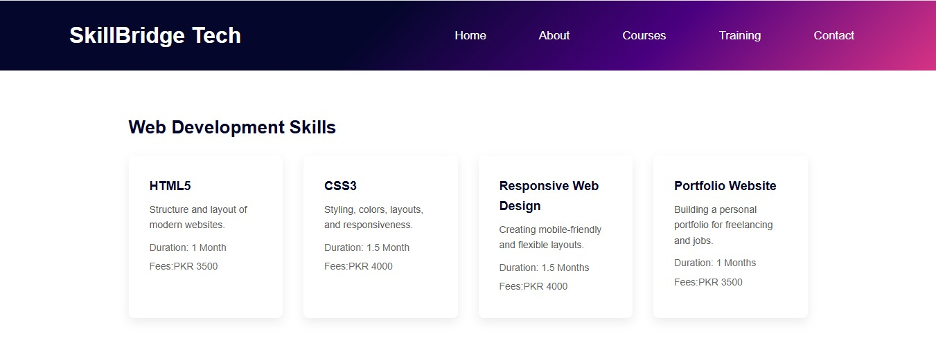
The Microsoft Office Skills category includes Microsoft Word, which teaches professional documentation and report writing in three weeks for a fee of PKR 2,000; Microsoft Excel, focusing on data handling, formulas, and basic analysis over one month with a fee of PKR 2,500; and Microsoft PowerPoint, which covers professional presentation and slide design in two weeks for a fee of PKR 2,000. Additionally, the Supporting Skills section offers Git & GitHub for version control and project collaboration with a duration of two weeks and a fee of PKR 2,000; Digital Marketing Basics, introducing online marketing, social media promotion, and audience engagement over one month for a fee of PKR 3,000; and Resume & LinkedIn Optimization, which helps learners build a strong professional online presence in one week at a fee of PKR 1,000. 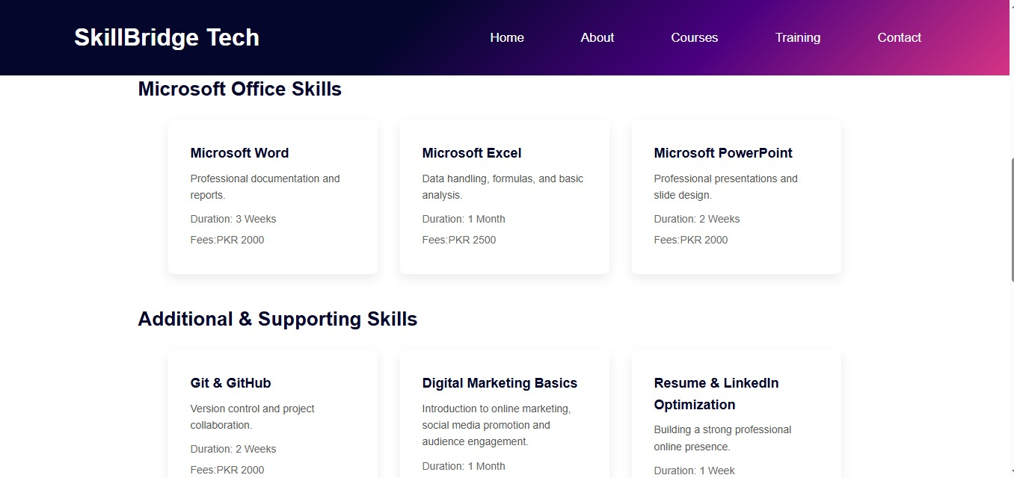

How to Run / Publish the Site:
To run the Skill Bridge website locally, the user can open to run the website locally, the user needs to open the project folder and double-click the courses.html file in any modern web browser such as Chrome, Edge, or Firefox. To publish the website online, all project files can the project folder and launch the main HTML file in any modern web browser such as Chrome, Edge, or Firefox. To publish the website online, all project files can be uploaded to a hosting service such as GitHub Pages or a basic web hosting platform. Once published, the website can be accessed using a public URL.
Reflection:
Through this project, valuable experience was gained in structuring HTML documents and applying CSS for layout, styling, and responsiveness. The project improved understanding of design consistency, color usage, and user interface principles. Future improvements could include adding JavaScript for interactivity, implementing form validation, and connecting the website to a backend system for dynamic content and user authentication.
Working on the Skill Bridge project provided valuable experience in structuring HTML pages and applying CSS for layout, design, and responsiveness. The project improved understanding of typography, color selection, and user interface consistency. It also highlighted the importance of designing websites with a clear target audience. In the future, the project can be enhanced by adding JavaScript for interactivity, implementing user authentication, and connecting the website to a backend system for managing enrollments.
Screenshots & Live URL:
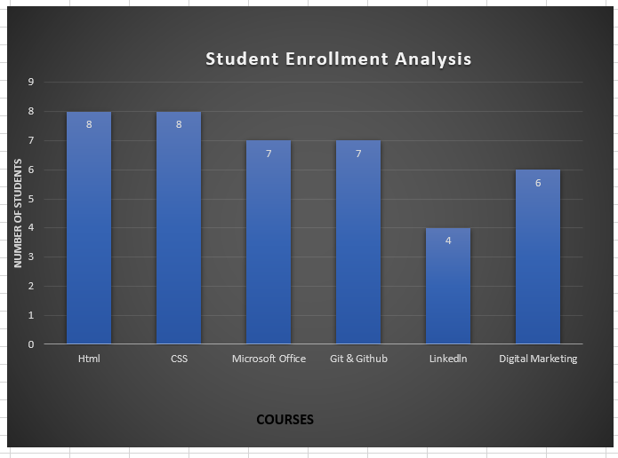
The chart illustrates the student enrollment distribution across six different technical and professional courses, showing that HTML has the highest popularity with 8 students while LinkedIn has the lowest with 4.
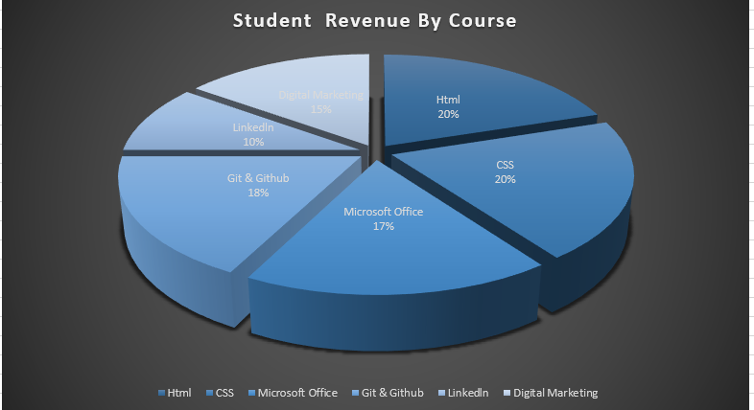
The charts show that HTML is the most popular and highest-earning course, while LinkedIn has the fewest students and the lowest revenue.
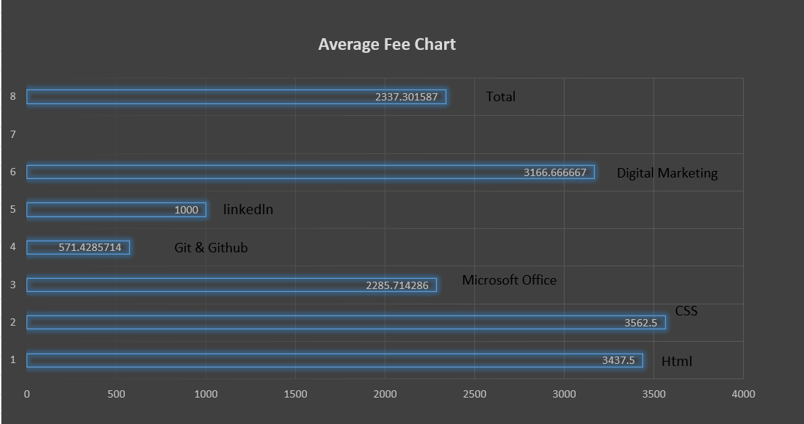

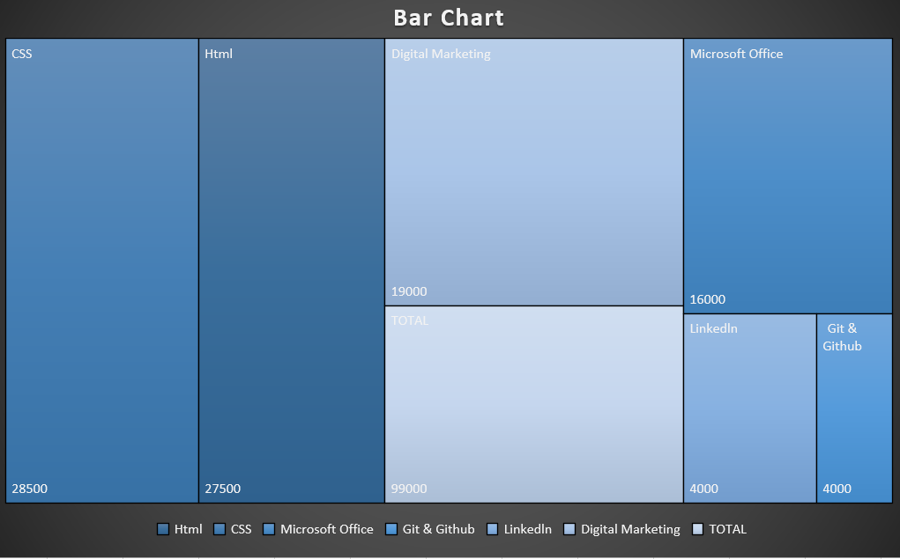

URL:
https://github.com/NabeehaShoaib/SkillBridge-Tech-Project.git

