Problem statement
Title: The Ghost Economy & The Paperless Blindspot
- The Scale: India’s 400-million informal workforce operates entirely via unrecorded transactions, making them deeply vulnerable to systemic exploitation.
- The Three Core Vulnerabilities:
  - Dynamic Legal Obscurity: Labor mandates change frequently (e.g., dynamic semi-annual minimum wage spikes like Delhi's ~₹710–₹783+/day thresholds and strict 60-hour weekly caps). Workers have zero visibility into these numbers.
  - The Proof Void: Employment at physical "Labour Chowks" is entirely paperless and cash-driven. There are no contracts, wage slips, or digital footprints—making legal enforcement impossible.
  - The Dialect & Literacy Barrier: Existing government grievance portals require structured text inputs in formal English/Hindi. A distressed worker communicating in local regional dialects (Bhojpuri, Maithili, or colloquial slang) is rendered voiceless by keyword-based legacy search systems.
- 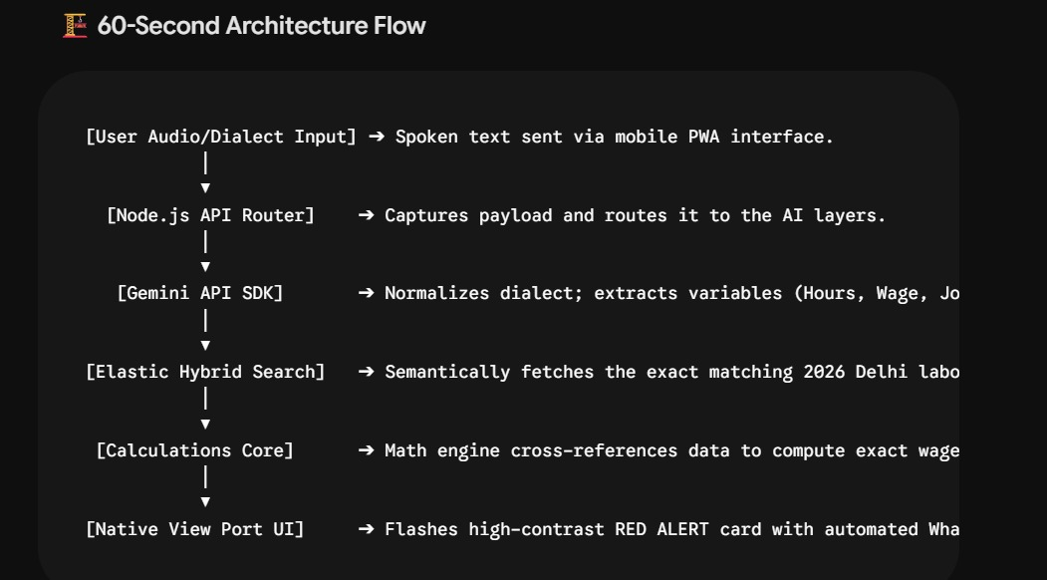

Slide 2: The Solution (Nyaya Setu)
Title: Nyaya Setu – The World’s First Semantic, Zero-Friction Labor Trust Ledger
- Zero-Friction Voice Interface: A text-less, mobile-first design where workers tap a single button and state their problem naturally in their native dialect (e.g., "Okhla chowk se contractor le gaya, 12 ghante kaam karwaya aur ₹450 diya").
- Contextual Intelligence Engine: Combines Gemini API for multi-dialect speech parsing and parameter extraction with Elasticsearch AI operating as a production-grade Vector Database.
- Tamper-Proof Enforcement: Instantly calculates underpayments or overtime theft based on live statutory rules and automatically compiles a formal legal claim PDF along with a one-tap WhatsApp alert sent straight to labor unions and regulatory commissioners.
- Decentralized Trust Network: Aggregates unstructured crowdsourced audio reviews to dynamically build a semantic reputation directory of contractors and work sites, eliminating information asymmetry forever.

Judging criterion
  - Real world Impact and Relevance
  - Data Efforts
  - Actionability and security Practice
  - Data Usage
  - Demo quality and storytelling

