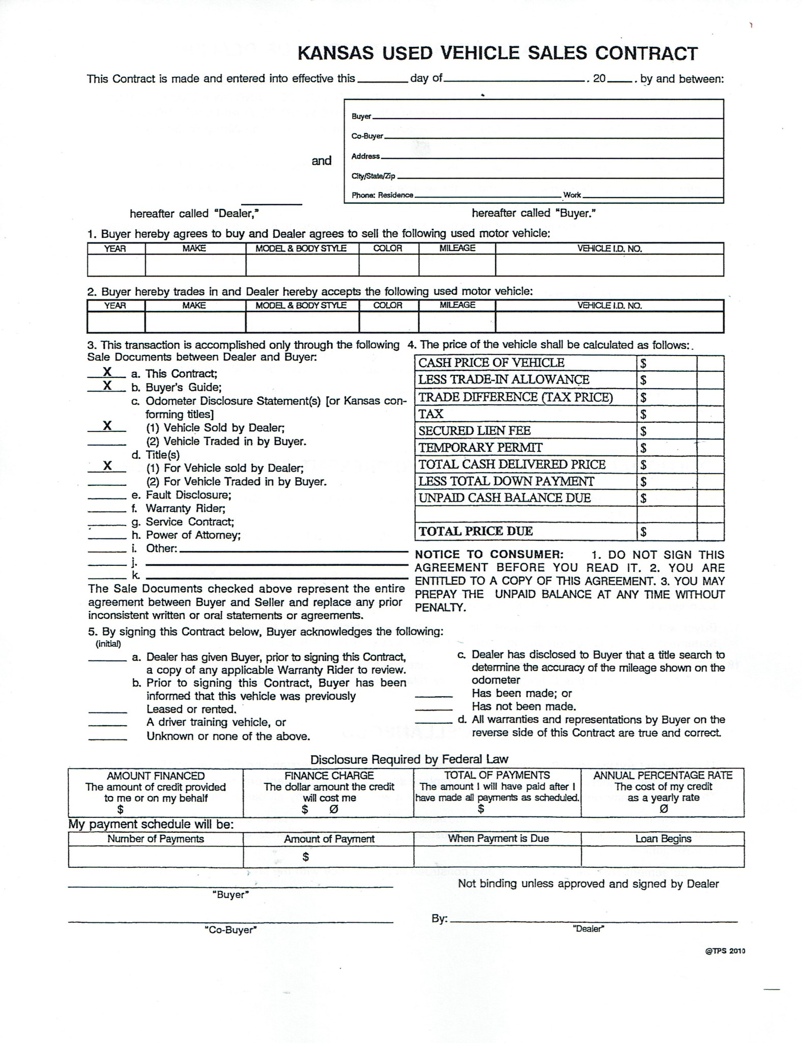

[NextDate]

[Phone]

[City-State-Zip]

[Year]

[Co-Buyer]

[Address]

[Buyer]

[Date]

[Payment]

[P_Amount]

[Due]

[Due]

[Due]

[Due]

[Down]

[Total]

[Tag]

[Lien]

[Tax]

[Difference]

[Trade]

[Price]

[Yr]

[Month2]

[Day]

Lopez Auto Sales  
515 Albert St  
Emporia, KS, 66801  
(620) 208 - 6250

[Make]

[Model]

[Color]

[Mileage]

[VIN]

[Mileage2]

[VIN2]

[Color2]

[Model2]

[Make2]

[Year2]