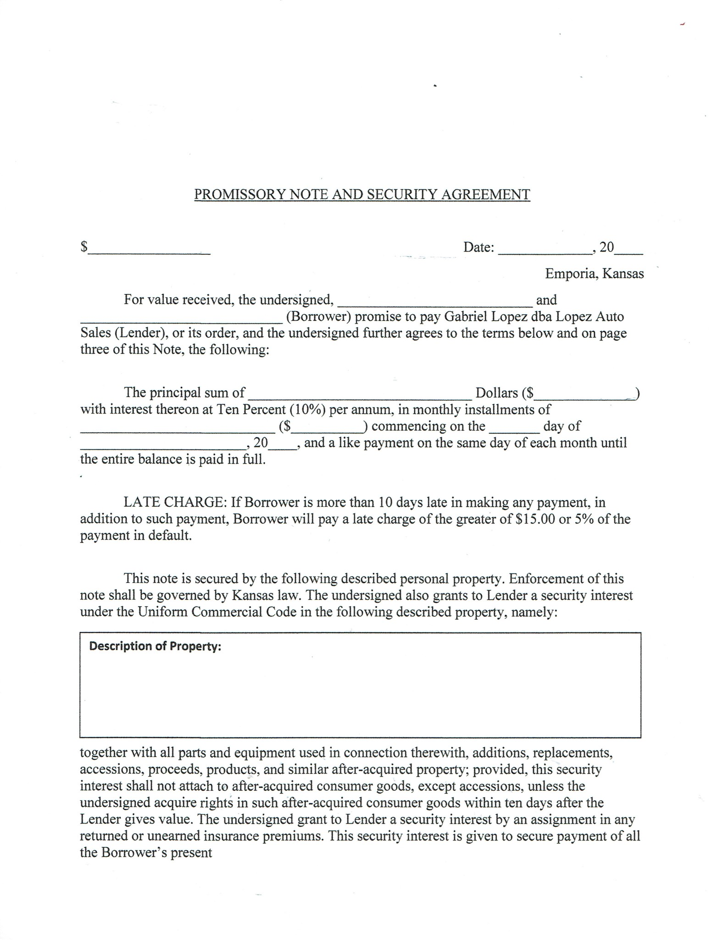

[Mileage]

[VIN]

[Car]

[Yr]

[Month2]

30th

[Payment]

[Due]

[Co-Buyer]

[Buyer]

[Date]

[Due]

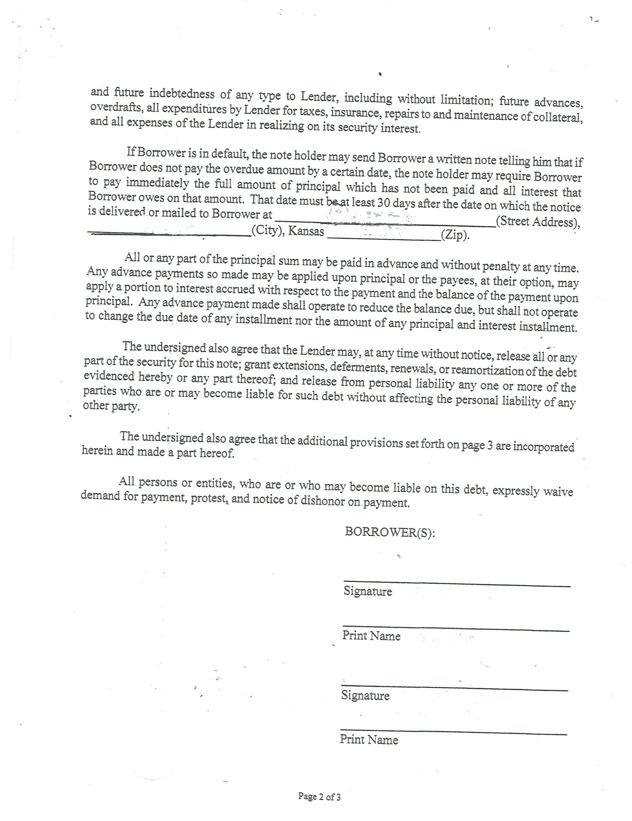

[City]

[ZIP]

[Address]