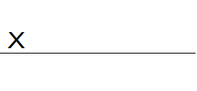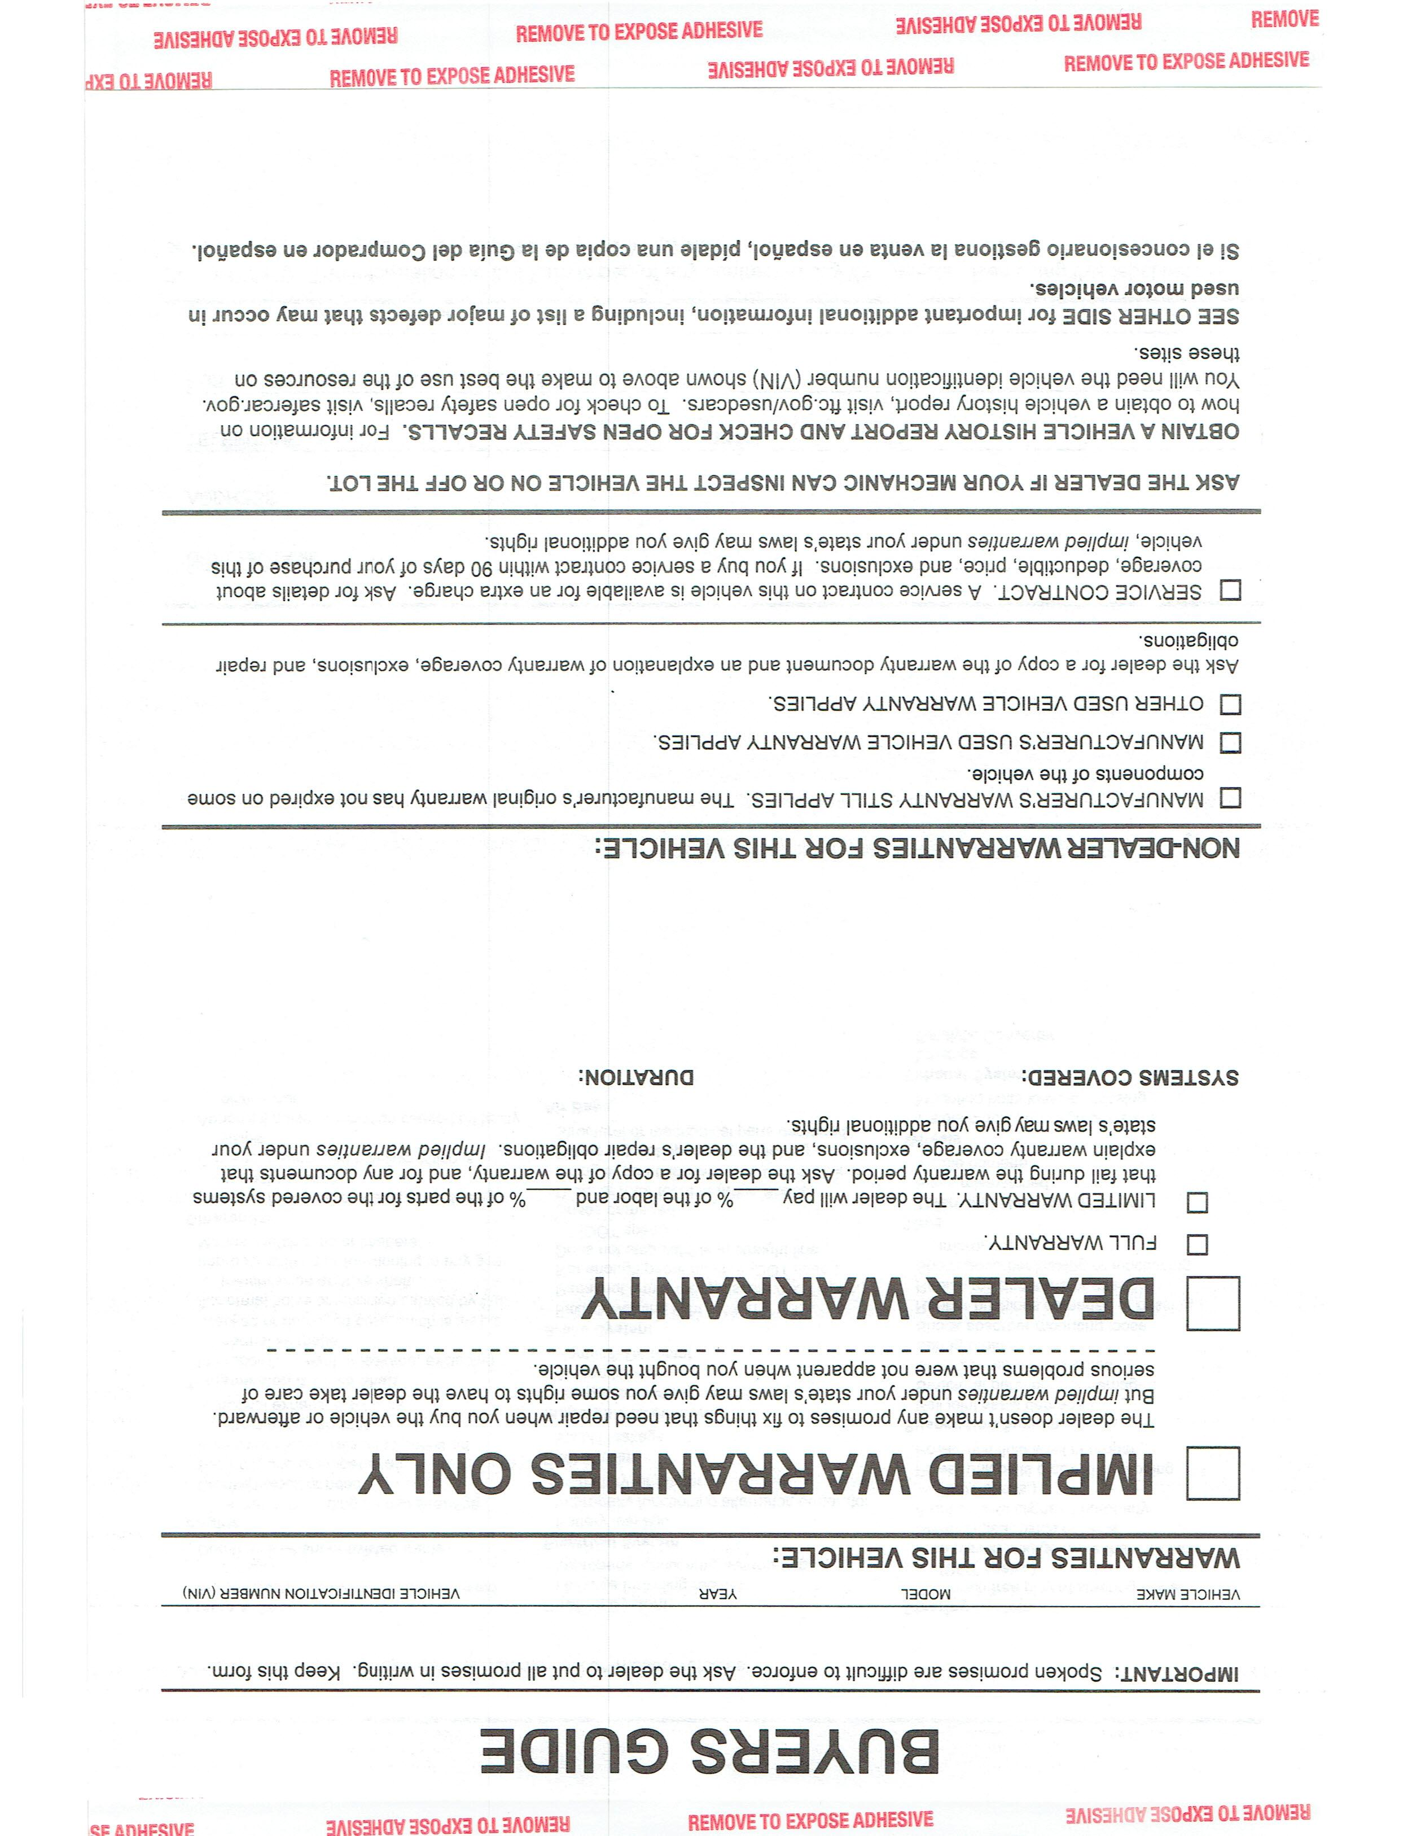

**30 days or 1000 miles, whichever occurs first.**

**Engine  
Transmission  
Differential  
Internal Oiling Parts Only  
No Electric Parts  
Work to be done in our shop.**

[Percent]

[Percent]

**X**

**X**

[Make]

[Model]

[VIN]

[Year]

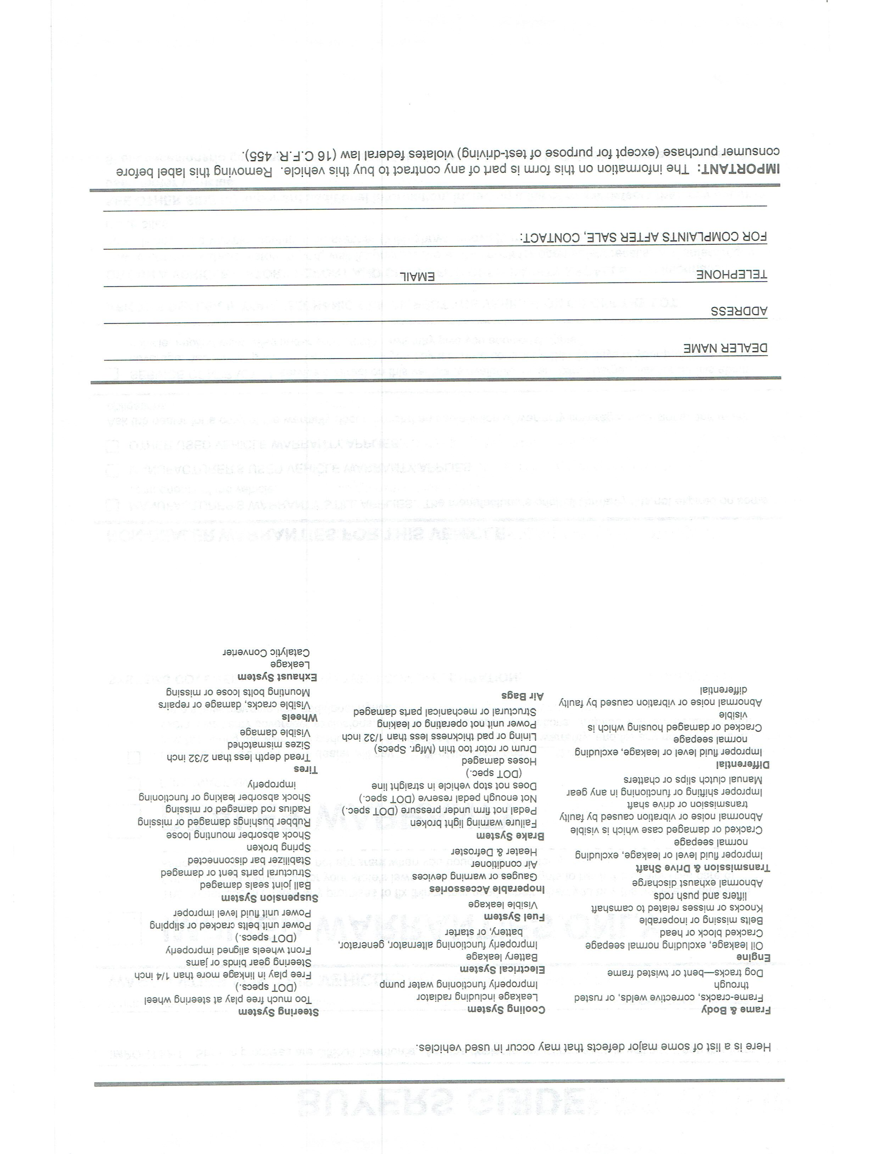

(620) 208-6250

lopezauto@outlook.com

(620) 208-6250

515 Albert St

Lopez Auto Sales