Xaria Deployment Plan

Created by:

Christopher Smith

Gabe Lopez

Shuai Deng

Xaria is a fun and challenging game that has a lot of potential. Taking these into account, the plan for getting it to market and out to the public can go one of two ways. There is an inexpensive route, and a more expensive route. As you’d expect, the inexpensive route costs less, but has less reward. The expensive route costs more at the start, but has much more payout in the end (if everything is successful, of course). For payment for the employees (us), we will estimate the amount of time it will take for us to complete all the following tasks, use an average salary for computer scientists, then estimate the costs to pay us. The same will be done for other employees that are not computer scientists. To account for the expensive and inexpensive routes, we will be stating the more expensive costs as “optional” costs.

Before we continue, we must get a registered copyright and patent for our work, as well as a trademark for the name Xaria. Assuming we either have a copyright lawyer, or will consult one for free, the copyright will not cost anything. All that is needed is to ensure our product is viable for a copyright, and a simple application will suffice. Next a trademark for the name is required. A federal trademark costs $275 to $375. Now the expensive part is here, the patent. Patent fees can cost anywhere from $5000 - $15,000, depending on the complexity of the project. This will be an optional cost for a smaller company due to such a high price, but should be obtained whenever possible. Once all of this is done, Xaria is ready to move towards more developing.

Now we start working on how to get Xaria onto the app stores. Our app is built for android devices, but we will want to expand it to Apple devices, but we will get to that later.How do we get Xaria to the play store then? Well it's simple, we follow the steps google wants us to take to get the most perfect app running. First we must create a “release.” A release is build artifacts we create to help prepare the app to be placed in one of the three following stages: production, alpha, or beta. I would say our app is almost in the alpha stage, almost complete but hasn’t been tested with too many employees, only us three developers. Once we test it more with other employees, then adjust it and repeat until we get the app as perfect as we can, we can move it on into the beta stage. I would say this process would take about a month.

Now our app has reached the Beta stage. For one to improve their app, they must listen to user feedback. We don’t want to fully release this app to the whole public, so we can select a group of consumers where we see the least bias in prefered games as well as receiving enough users to get strong feedback on our product. We will need marketing research, so a marketer must decide where we will release the app and the best means of doing so. This shouldn’t take the marketer more than a week, if that. Once the demographic for the release is decided, we can release the beta to them. Now a very key thing that we must absolutely focus on is consumer feedback. Consumer feedback will tell us exactly how to make the game better. Now there are different ways we can receive this feedback. We can either just use the play store’s comment feedback section, which is free, or we can go all by buying a Xaria domain and using it. This domain name from godaddy.com costs $24,950 + $14.99/year, so we will list this as an optional cost. This domain name would allow us to set up a website that can receive survey information that we could either set up through the app, or just on the website. Doing both would be more ideal and much more beneficial. Setting all of this up could take 12 - 16 weeks, maybe even longer. Now the company can either set up this site in its own hands (which I assume it would considering it has the computer scientists for it), or it could hire another professional company. Not many developers give an average cost to building a website because different sites require different attention, so it is an option, but most likely not occurring. The design costs about $40 a month from a professional, but the design shouldn’t take longer than a month.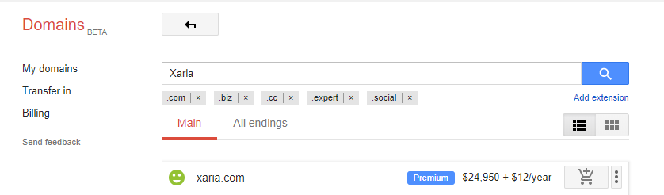

Once the website is set up and we receive feedback from consumers, we will continue development until we create the game we want. This development, besides the adjustments the consumers direct us towards, will include adding an endless wave mode, adding more sound effects, extending weapons, increasing player count and levels. All of this would take a lot of effort, and would take about 6-8 months. During this time, the company will want to set up advertising efforts. For a small business, only 2% of the budget will be used for marketing, while larger businesses use between 9-12% of the budget for marketing as a whole. Again, there is no specific cost for paying for advertisement. There are lots of free video editing services, such as Adobe Creative Cloud, that we can use for creating the advertisements. If we want better editing software, we should consider softwares such as Adobe Premiere Pro CC, Corel VideoStudio Ultimate X10, Apple Final Cut Pro X, Magix Movie Edit Pro Premium, or other preferred softwares. These softwares can range from around $20 up to $300, and we will list this as another optional cost. Paying for this advertisement and an advertisement team would be ideal to maximize efficiency of the advertisement. The job titles that need to be filled for this team would include but are not limited to Advertising Copywriter, Advertising Manager, Advertising Sales Representative, Graphic Designer(s), and a marketing Associate. All these roles create a system of checks and balances between themselves while creating great ads.

An advertisement for a game is much easier to create than an advertisement requiring actual filming due to lack of necessity for a setting and all the camera crew and such. Once the video is created, rights are needed to be secured for anything used in the video that is not created by the company, a common example being music. For any music used, we must get a Synchronization License and a Master Use License by the copyright owner(s) of the music. It again all depends on what the owner of the music wants and what product is being used. We will assume this price will be around $10,000 as an optional cost. This music can not only be used for the commercial but also be used in the game. The other less costly route is to find a piece of music in which we can have full rights to use.

App conventions are a necessity so that we can not only get our word out to the public, but may receive and give insight from and to other companies. The largest app conferences are the App Promotion Summit, GMASA, Mobile Growth Summit, and MobileTech Conference 2017. The average cost for a portable booth is around $10,000, which includes the chairs and tables. Lots of these conferences, if not all, are outside of the US. Most tend to happen in Germany, so we will be using the costs of flights to Germany. A Round trip from Kansas City to Munich costs about $1131. Assuming only three people are going, the total costs are $3393. Hotel costs range from $75 to $500 a night. Our optional cost will be about $300 per person, the cheaper will be about $100. Assuming food will be at most $100 per person, the cost of going to one conference is $13,993 with an optional cost of $14,593 instead.

Whenever the company decides to, either in the beta phase or afterwards, development for iOS devices will be set into play. After following the guidelines apple sets for creating an app, we will submit it for review. The steps are about the same as making an app for the play store, with a little extra specifics for the stages, but nothing that adds costs. This should take an estimated time of ⅔’s of the time it took to create the app, so about 6-8 months in total.

Now that all the advertising is settled, we can focus on what to do to once Xaria’s beta stage has finished. It will be released to the public as a full fledged app. If the demand is high enough, Xaria’s full game production can begin. The table to the side describes disc duplication prices. We will most likely go with the highest quantity for the best value, but the amount to print is truly unknown without being able to estimate the amount of demand there is for Xaria. Distribution costs will be included too. Again, it is impossible to estimate distribution costs without knowing the quantity being distributed. All the rights to distribute the copies have already been obtained, so all that is left is contracts with the distribution company as well as contracts with the company that will be printing these, unless of course our company already has the means to do so. The amount of time to produce the full fledged game is estimated to be 1.5 - 2 years.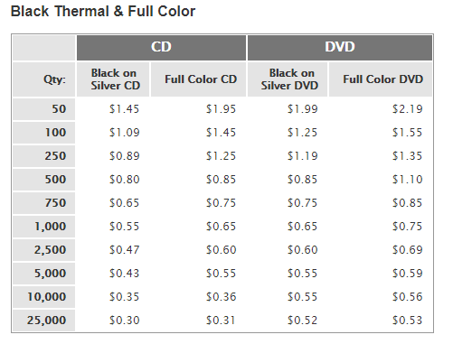

With the least amount of money being put into the game, the costs for a copyright as well as payroll for the employee's (assuming the only computer scientists working on the project are just us) total to around $214,915.5. If we include advertisements, the total cost rises to about This is just to get the game out of the beta stage. The total cost for the first conference to go to totals around to $13,993 with an optional cost of $14,593, and each conference after around $3,993 with an optional cost of $14,593. If we want to go all out when putting Xaria onto the play store and the app store, without creating a full Xaria game for PC, the estimated cost is $406,649.9. The highest cost is paying the computer scientists. If we want to include creating Xaria into a full fledged game for the PC, the estimated cost is around for that is about $468,252, with a total cost of around $875501.9. It is pricy to make a game, but the payout is very much worth it.

<https://support.google.com/googleplay/android-developer/answer/7159011>

<https://www.payscale.com/research/US/Job=Computer_Scientist/Salary>

<https://www.payscale.com/research/US/Job=Marketing_Manager/Salary>

<https://liftinteractive.com/blog/how-long-does-it-take-to-design-and-build-a-websi/>

<https://www.legalzoom.com/articles/cost-of-marketing-what-is-the-average-budget>

<http://www.porettaorr.com/tradeshowexhibitmoney/>

<http://www.invents.com/how-much-does-a-patent-cost/>

<http://www.quickturnduplication.com/html/pricing.php>