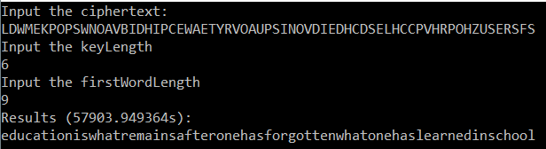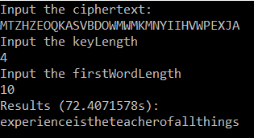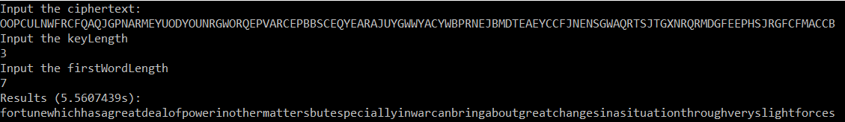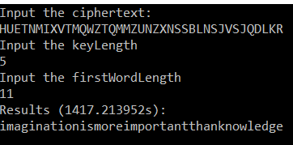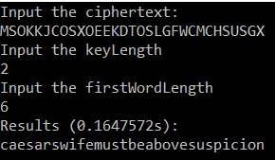

The performance of brute force password cracking is highly dependent on your processing power, data structure efficiency, and key length. In my project solution, I utilized my computer’s full processing power by implementing a parallel loop on translation. My data structure efficiency could be improved; I stored dictionary words into a list and simply checked if the translated string was contained in the list. The key lengths give an estimated amount of work 26^n.