Project Overview
- System name (Web App + Mobile-Responsive App): University Academic Questionnaire System (UAQS)
- Purpose (what problem it solves): Resolves the lack of real-time, interactive assessment tools in the classroom and simplifies the manual aggregation of academic feedback data.
- Target users: University Faculty (Administrators/Instructors) and Students (Participants).
- Short description of what it does: A synchronized platform where instructors launch interactive questionnaires and students participate in real-time via their mobile browsers.

System Features
Main Features:
- Interactive Questionnaire Creator with multiple question types
- Real-time Session Synchronization and Navigation
- Low-friction Student Onboarding via Access Codes
- Live Analytics Dashboard with Dynamic Visualization
- Professional PDF Academic Report Generation
- Auto-save Draft Management (Local Vault)

System Architecture
The system is designed with a serverless architecture to ensure high availability and real-time data flow. Below is a visual representation of how the Web and Mobile components interact through the cloud.
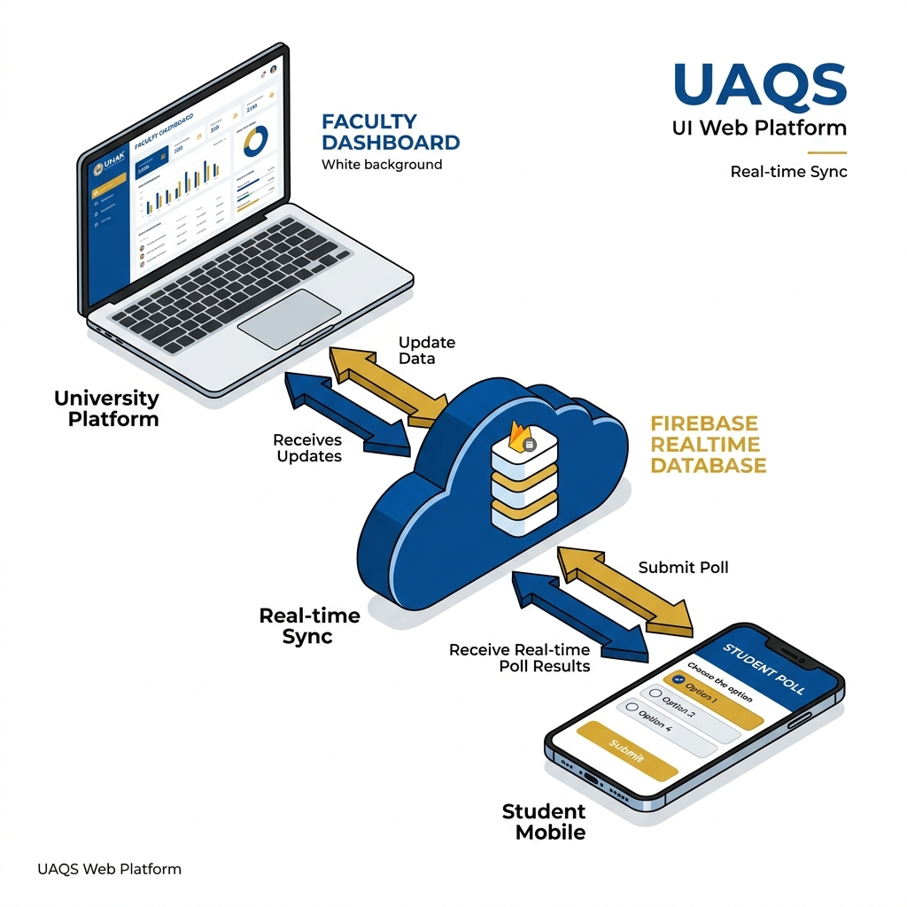
- Web app: The primary management interface for Faculty to create assessments and control sessions.
- Mobile application: UAQS uses a mobile-optimized web interface (Web App) that students access on their phones, removing the need for an app store installation.
- Backend / API: Firebase services manage real-time event signaling and authentication tokens.
- Database: Firebase Realtime Database handles live session state and student response storage.

Tech Stack
- Frontend: React 18, TypeScript, Tailwind CSS
- Backend: Firebase Realtime Database, Firebase Auth
- Database: Firebase Realtime Database (JSON NoSQL)
- Tools: Figma, VS Code, Git
- Hosting Tool: Firebase Hosting

User Flow / Process Flow
- Step 1: Faculty logs in and designs a questionnaire using the Creator Tool.
- Step 2: Faculty starts a session and shares the generated 4-digit code.
- Step 3: Students enter the code on their mobile devices to join the room.
- Step 4: Faculty controls the progress; students' screens update instantly.
- Step 5: Students submit their responses which are aggregated in real-time.
- Step 6: Faculty closes the session and exports a structured PDF report.

Screens / UI Overview
The system features a modern, clean UI optimized for both desktop management and mobile participation.
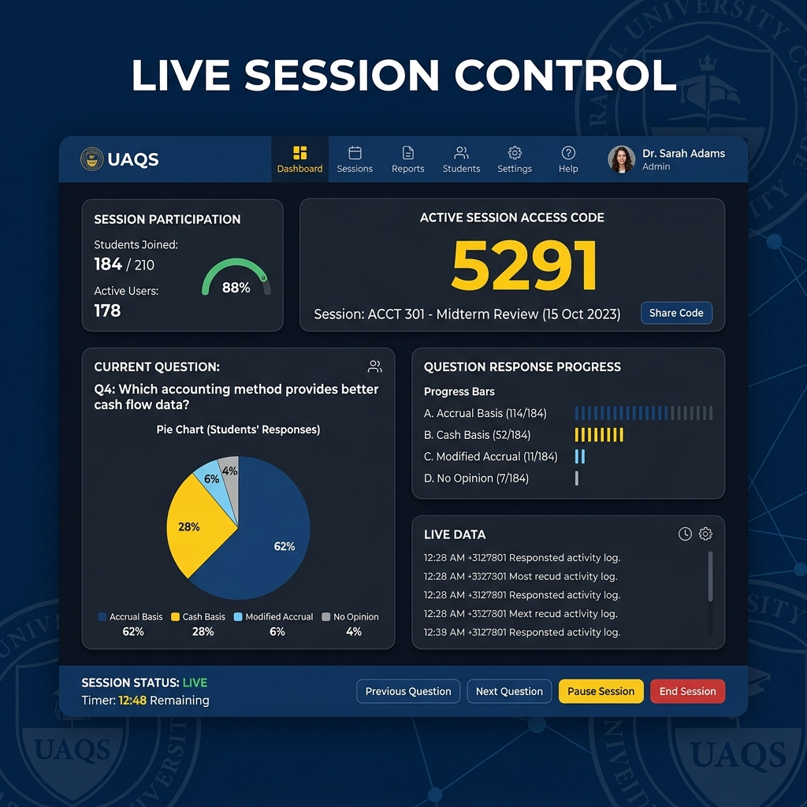
- Home Screen: The central entry point providing dual portals for Faculty management and Student participation.
- Questionnaire Creator: An intuitive workspace designed for building complex assessments with custom formatting.
- Faculty Dashboard: A hub for organizing saved assessments and accessing ongoing drafts.
- Live Session Controller: The instructor's control panel for monitoring participation and navigating the assessment flow.
- Student Response View: A minimalist, mobile-optimized screen focused on clear question display and input.

Database / Data Structure
Main collections/tables:
- bundles: Primary questionnaire data (Example fields: id, title, questions, creatorId).
- sessions: Live state tracking (Example fields: code, activeIndex, startTime, status).
- responses: Aggregated submissions (Example fields: participantName, timestamp, answers).

Key Functionalities Explanation
1. Real-time Synchronization
- What it does: Synchronizes the student's screen with the instructor's view instantly.
- How it works: A persistent websocket connection in the database triggers UI updates on all student clients whenever the instructor navigates to a new question.
2. Automated PDF Reporting
- What it does: Transforms raw session data into a formatted, University-branded document.
- How it works: The system processes the response JSON and uses a client-side rendering engine to create tabulated summaries and charts.

Challenges & Solutions
- Problem we encountered: Potential data loss during the assessment creation process due to browser crashes or network issues.
- How we solved it: Implemented a Local Vault system using Browser LocalStorage that automatically caches drafts every second.

Future Improvements
- Features to add: University SSO integration for automated verified student identification.
- Possible optimizations: Implementation of cloud-side draft synchronization for multi-device collaboration.

Conclusion
- Why the system is useful: It bridges the communication gap in large classrooms, providing instructors with instant diagnostic data on student understanding.
- Impact on users/business: Enhances academic engagement and provides a modern, paperless solution for university-wide data collection.

