PowerShell Troubleshooting and Debugging Lab

Project Summary
Objective | Troubleshoot and repair a broken PowerShell script so it creates a structured project folder.
Tools Used | PowerShell, Visual Studio Code, Windows File Explorer
Result | The corrected script validates input, creates src/lib/docs folders, generates README.md and Main.java, and saves a transcript log.

Corrected PowerShell Script
# Prompt user for project name
$projectName = Read-Host "Enter the project name"
# Prompt user for project start date
$startDate = Read-Host "Enter the project start date (yyyy-mm-dd)"
# Prompt user for app name
$appName = Read-Host "Enter the app name"
# Specify the parent directory where the main folder will be created
$parentDirectory = "C:\Users\ismet\Desktop"
# Check if the entered date is in the correct format
if ($startDate -notmatch '^\d{4}-\d{2}-\d{2}$') {
Write-Host "Invalid date format. Please use the format yyyy-mm-dd."
exit
}
# Combine the inputs to create the main folder name with date before project name
$mainFolderName = "$startDate - $projectName - $appName"
# Combine the parent directory and main folder name to create the full path
$fullPath = Join-Path -Path $parentDirectory -ChildPath $mainFolderName
# Check if the folder already exists
if (Test-Path $fullPath) {
Write-Host "Folder already exists: $fullPath. Please use a different project name."
exit
}
# Create the main folder and subfolders
New-Item -ItemType Directory -Path $fullPath | Out-Null
New-Item -ItemType Directory -Path (Join-Path $fullPath "src") | Out-Null
New-Item -ItemType Directory -Path (Join-Path $fullPath "lib") | Out-Null
New-Item -ItemType Directory -Path (Join-Path $fullPath "docs") | Out-Null
# Start transcript to record actions in a log file
Start-Transcript -Path (Join-Path $fullPath "log.txt")
# Create README.md
$readmeContent = @"
## $appName
This is a Java application project named $projectName.
Start Date: $startDate
"@
$readmePath = Join-Path -Path $fullPath -ChildPath "README.md"
$readmeContent | Set-Content -Path $readmePath
# Create Java source file
$javaSourceContent = @"
public class Main {
public static void main(String[] args) {
System.out.println("Hello, World!");
}
}
"@
$javaSourcePath = Join-Path -Path (Join-Path $fullPath "src") -ChildPath "Main.java"
$javaSourceContent | Set-Content -Path $javaSourcePath
# Display confirmation
Write-Host "Folder structure created successfully."
Write-Host "Project Name: $projectName"
Write-Host "Start Date: $startDate"
Write-Host "App Name: $appName"
Write-Host "Main Folder Path: $fullPath"
Write-Output "Folder structure created: $fullPath"
Write-Output "Project Name: $projectName"
Write-Output "Start Date: $startDate"
Write-Output "App Name: $appName"
# Stop transcript
Stop-Transcript

Debugging and Fix Summary
- Moved input validation before folder creation so an invalid date stops the script early.
- Used Join-Path consistently to avoid path formatting problems.
- Changed transcript handling so Start-Transcript and Stop-Transcript run in a clear sequence.
- Used Out-Null to keep the terminal output cleaner while creating folders.
- Created README.md and Main.java after the folder structure exists.
- Updated the parent directory to a local Desktop path for easy testing and screenshots.

Screenshot 1 - Script Running Successfully
The terminal output shows the script accepted the project name, start date, and app name, then created the project folder and transcript log successfully.
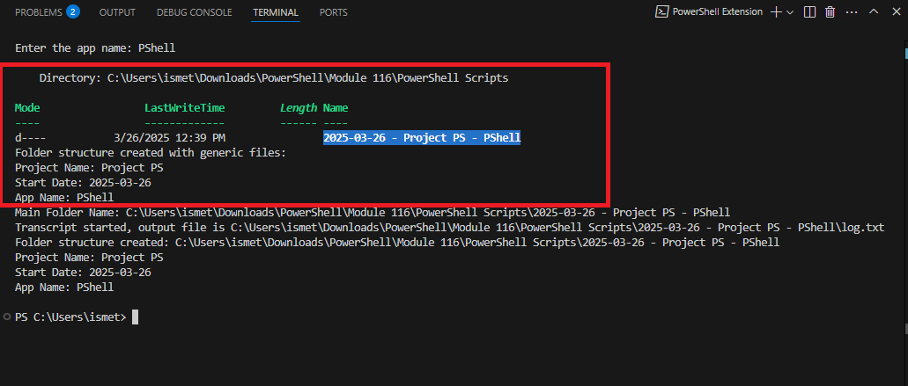

Screenshot 2 - Folder Structure Created in File Explorer
The File Explorer screenshot verifies that the expected files and folders were created: log.txt, README.md, docs, lib, and src.
