PowerShell Working with XML
Lab Execution and GitHub Publishing — Step-by-Step Guide

Part 1: Running the Lab
Walk through each step in order, running the corresponding script section and capturing the listed screenshot before moving on. Run everything from the project root folder so relative paths like .\data\students.xml resolve correctly.

Step 01 — Create the Project Folder
Create a dedicated folder for this lab. This keeps scripts, XML data, CSV output, and screenshots organized.
mkdir PowerShell-Working-with-XML
cd PowerShell-Working-with-XML
mkdir scripts, data, screenshots, docs
Open the folder in File Explorer or VS Code (code .) and confirm you see scripts, data, screenshots, and docs subfolders.
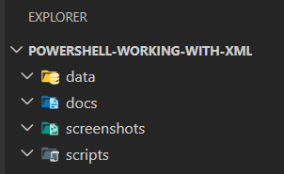
File Explorer showing this folder structure.

Step 02 — Create the Sample XML File
In VS Code, create data\students.xml and paste in the fictional sample data (John Micheal, Jon Mike, Sara Ahmed). Save it.
<?xml version="1.0" encoding="UTF-8"?>
<students>
<student>
<id>1</id>
<name>John Micheal</name>
<age>20</age>
<grade>A</grade>
</student>
<student>
<id>2</id>
<name>Jon Mike</name>
<age>21</age>
<grade>B</grade>
</student>
<student>
<id>3</id>
<name>Sara Ahmed</name>
<age>19</age>
<grade>A</grade>
</student>
</students>

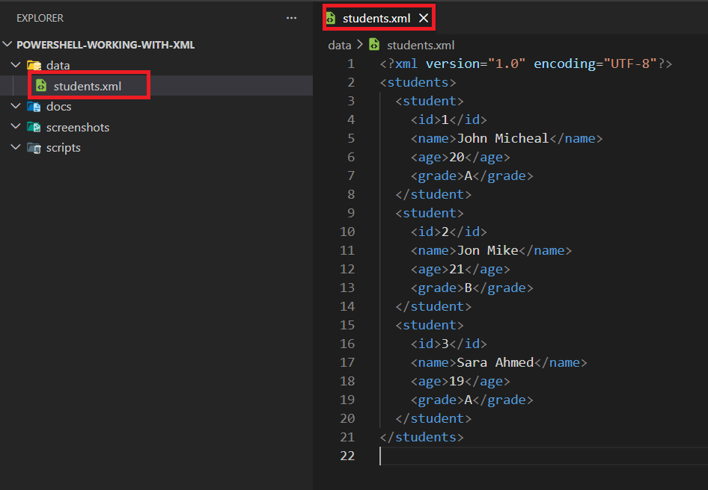students.xml open in VS Code (or visible in File Explorer).

Step 03 — Load the XML in PowerShell
Create scripts\Task1-Query-XML.ps1 and add the loading portion first to confirm it works. Run it from the project root.
$xmlPath = ".\data\students.xml"
$xmlData = [xml](Get-Content -Path $xmlPath)
$xmlData
Expected: no errors, and PowerShell prints the XML object structure.
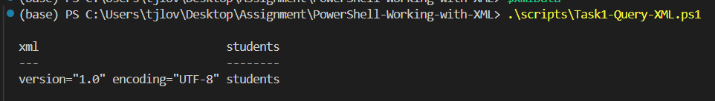Terminal showing the XML loaded cleanly.

Step 04 — Query Student Names and Ages

Add the query loop to the Task1 script and rerun it.
# Display names and ages of all students
$students = $xmlData.SelectNodes("//student")
foreach ($student in $students) {
$name = $student.SelectSingleNode("name").InnerText
$age = $student.SelectSingleNode("age").InnerText
Write-Host "Name: $name, Age: $age"
}
# Find and display grade by student ID
$studentId = "1"
$student = $xmlData.SelectSingleNode("//student[id='$studentId']")
if ($student) {
$grade = $student.SelectSingleNode("grade").InnerText
Write-Host "Student with ID $studentId has a grade of $grade"
} else {
Write-Host "Student with ID $studentId was not found."
}

Name: John Micheal, Age: 20
Name: Jon Mike, Age: 21
Name: Sara Ahmed, Age: 19
This is the expected console output.
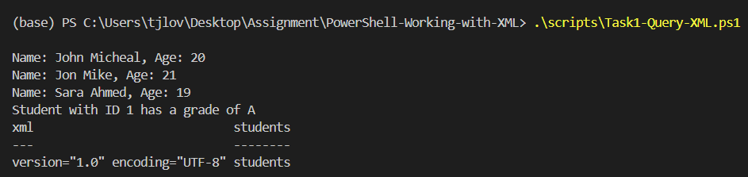
Terminal output listing student names and ages.

Step 05 — Find a Student Grade by ID
Still in Task1, add the ID lookup block ($studentId = "1"). Run and confirm the result.
Student with ID 1 has a grade of A
Expected console output.
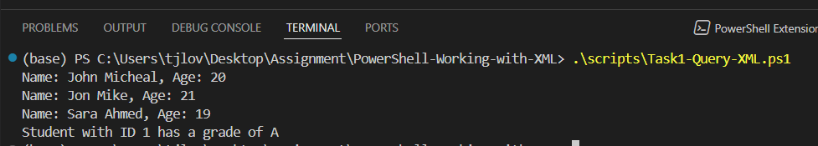
Terminal output showing a grade for the selected student ID.

Step 06 — Add a New Student Record
Create scripts\Task2-Modify-XML.ps1 and paste the "Add a new student record" block. Run it.
New student added.
At this point Mariam Ali (ID 4) exists only in memory — it is not yet saved to disk. That happens in Step 09.
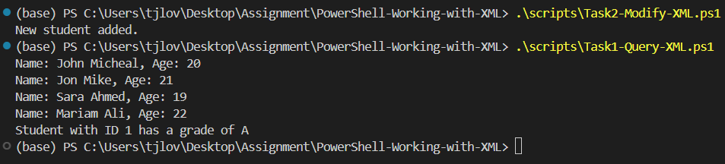
Script or terminal output showing a new student record was added.

Step 07 — Update an Existing Student Age
Add the "Update age" block to the same Task2 script. Run it.
Student ID 2 age updated to 22.
Expected console output.
Terminal output showing the age was updated successfully.

Step 08 — Remove a Student Record
Add the "Remove a student record" block. Run it.
Student ID 3 removed.
Expected console output.
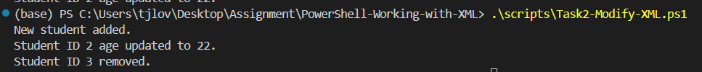Terminal output showing the selected student was removed.

Step 09 — Save the Modified XML File
Add the final $xmlData.Save(...) line and run the full Task2 script end-to-end (all four operations in sequence).
New student added.
Student ID 2 age updated to 22.
Student ID 3 removed.
XML data saved to .\data\students.xml.
Open students.xml in VS Code afterward and confirm: Mariam Ali is present, Omar's age is 22, and Sara is gone.
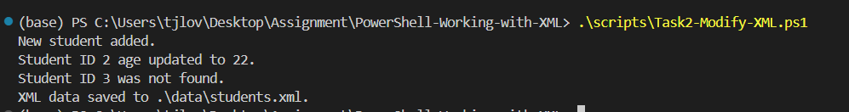
VS Code or File Explorer showing the modified students.xml file.

Step 10 — Export XML Data to CSV
Create scripts\Task3-Export-XML-to-CSV.ps1 with the export block. Run it.
CSV data saved to .\data\students.csv.
Expected console output.
Terminal output showing CSV data saved successfully.

Step 11 — Verify CSV Output
The Task3 script ends with Import-Csv -Path $csvPath | Format-Table. Confirm the output table looks correct.
ID Name Age Grade
-- ---- --- -----
1 Aisha Rahman 20 A
2 Omar Khan 22 B
4 Mariam Ali 22 A
Expected table output.
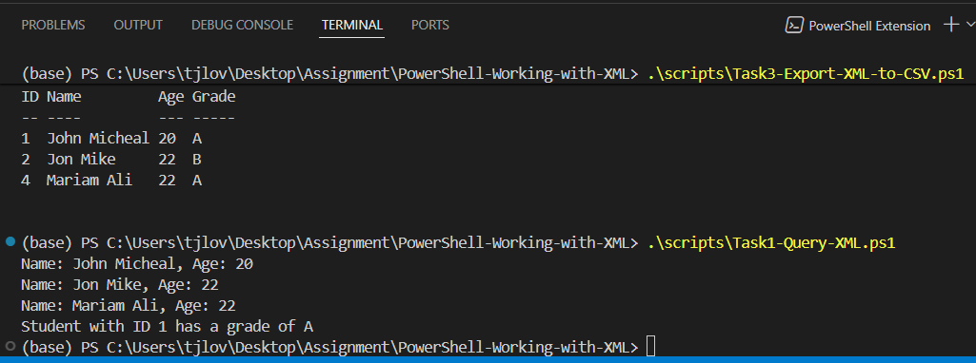PowerShell output showing columns such as ID, Name, Age, and Grade.

Step 12 — Verify Final Files
Open File Explorer at the project root and confirm scripts/ has all 3 .ps1 files, data/ has both students.xml and students.csv, and screenshots/ has all your captures.
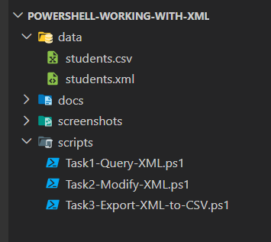
File Explorer showing the final repository folder structure.

Sample XML Data (students.xml)
<?xml version="1.0" encoding="UTF-8"?>
<students>
<student>
<id>1</id>
<name>John Micheal</name>
<age>20</age>
<grade>A</grade>
</student>
<student>
<id>2</id>
<name>Jon Mike</name>
<age>22</age>
<grade>B</grade>
</student>
<student>
<id>4</id>
<name>Mariam Ali</name>
<age>22</age>
<grade>A</grade>
</student>

</students>

PowerShell Script 1 - Load and Query XML
# Task 1: Load and query XML data

$xmlPath = ".\data\students.xml"
$xmlData = [xml](Get-Content -Path $xmlPath)

# Display names and ages of all students
$students = $xmlData.SelectNodes("//student")

foreach ($student in $students) {
$name = $student.SelectSingleNode("name").InnerText
$age = $student.SelectSingleNode("age").InnerText
Write-Host "Name: $name, Age: $age"
}

# Find and display grade by student ID
$studentId = "1"
$student = $xmlData.SelectSingleNode("//student[id='$studentId']")

if ($student) {
$grade = $student.SelectSingleNode("grade").InnerText
Write-Host "Student with ID $studentId has a grade of $grade"
} else {
Write-Host "Student with ID $studentId was not found."
}

PowerShell Script 2 - Modify XML Data

# Task 2: Modify XML data
$xmlPath = ".\data\students.xml"
$xmlData = [xml](Get-Content -Path $xmlPath)

# Add a new student record only if ID 4 does not already exist
$existingStudent = $xmlData.SelectSingleNode("//student[id='4']")

if (-not $existingStudent) {
$newStudent = $xmlData.CreateElement("student")

$id = $xmlData.CreateElement("id")
$id.InnerText = "4"

$name = $xmlData.CreateElement("name")
$name.InnerText = "Mariam Ali"

$age = $xmlData.CreateElement("age")
$age.InnerText = "22"

$grade = $xmlData.CreateElement("grade")
$grade.InnerText = "A"

$newStudent.AppendChild($id) | Out-Null
$newStudent.AppendChild($name) | Out-Null
$newStudent.AppendChild($age) | Out-Null
$newStudent.AppendChild($grade) | Out-Null

$xmlData.students.AppendChild($newStudent) | Out-Null

Write-Host "New student added."
} else {
Write-Host "Student ID 4 already exists."
}

# Update the age of an existing student
$studentIdToUpdate = "2"
$newAge = "22"

$studentToUpdate = $xmlData.SelectSingleNode("//student[id='$studentIdToUpdate']")

if ($studentToUpdate) {
$studentToUpdate.SelectSingleNode("age").InnerText = $newAge
Write-Host "Student ID $studentIdToUpdate age updated to $newAge."
} else {
Write-Host "Student ID $studentIdToUpdate was not found."
}

# Remove a student record by ID
$studentIdToRemove = "3"

$studentToRemove = $xmlData.SelectSingleNode("//student[id='$studentIdToRemove']")

if ($studentToRemove) {
$studentToRemove.ParentNode.RemoveChild($studentToRemove) | Out-Null
Write-Host "Student ID $studentIdToRemove removed."
} else {
Write-Host "Student ID $studentIdToRemove was not found."
}

# Save the modified XML file
$xmlData.Save((Resolve-Path $xmlPath))
Write-Host "XML data saved to $xmlPath."

PowerShell Script 3 - Export XML to CSV

# Task 3: Export XML data to CSV
$xmlPath = ".\data\students.xml"
$csvPath = ".\data\students.csv"

$xmlData = [xml](Get-Content -Path $xmlPath)

$students = $xmlData.SelectNodes("//student")

$csvData = foreach ($student in $students) {
[PSCustomObject]@{
ID = $student.SelectSingleNode("id").InnerText
Name = $student.SelectSingleNode("name").InnerText
Age = $student.SelectSingleNode("age").InnerText
Grade = $student.SelectSingleNode("grade").InnerText
}
}

$csvData | Export-Csv -Path $csvPath -NoTypeInformation

Write-Host "CSV data saved to $csvPath."
# Verify CSV output
Import-Csv -Path $csvPath | Format-Table

Part 2: Publishing to GitHub
Only begin this part once all 12 steps above are complete and verified — scripts run cleanly, students.xml and students.csv are correct, and every screenshot is saved.

1. Add the README
Create README.md at the project root with an overview, skills demonstrated, tools used, and a note that this repo uses fictional sample data only.

2. Run a final sensitive-content check
Before pushing anything public, confirm: only your own screenshots are included; no original course handouts are included; no personal info, emails, passwords, or access tokens appear anywhere; sample data is fictional; and any DOCX/PDF files don't expose private metadata (Word: File > Info > Inspect Document).

3. Initialize Git
git init
git add .
git commit -m "Initial commit: PowerShell Working with XML lab"

4. Create the GitHub repository
On GitHub, create a new empty repository named PowerShell-Working-with-XML. Do not initialize it with a README or license, since you already have your own.

5. Connect and push
git remote add origin https://github.com/<your-username>/PowerShell-Working-with-XML.git
git branch -M main
git push -u origin main

6. Confirm on GitHub
Refresh the repo page and confirm scripts/, data/, screenshots/, docs/, and README.md all appear, and that the README renders correctly on the repo home page.

