PowerShell Introduction Lab
Mapping classic Windows CMD commands to their PowerShell equivalents

Project Summary
This lab demonstrates basic Windows command-line usage and the matching PowerShell cmdlets for file system navigation, file creation, copying, deletion, and output display. Each step below shows a short instruction, the exact command to run, and a screenshot of the expected result.

Before You Start
- Windows 10 or 11. No administrator rights are needed.
- Open Command Prompt for Part 1, and PowerShell for Parts 2 and 3.
- Replace <YourUsername> in every path with your own Windows account name. To find it, run the command below.
# Show your username and home folder path
echo %USERNAME%
echo %USERPROFILE%
Create the two sample files this lab uses. Run this first, or the copy and delete steps will fail.
# Setup - create the sample files
cd C:\Users\<YourUsername>\Documents
echo Hello from PowerShell > file1.txt
echo Hello from PowerShell > file2.txt

Command Mapping
A quick reference for every command used in this lab.
Task | CMD Command | PowerShell Equivalent
List files and folders | dir | Get-ChildItem
Change directory | cd | Set-Location
Copy a file | copy | Copy-Item
Delete a file | del | Remove-Item
Print a message | echo | Write-Host / Write-Output
Create a folder | mkdir | New-Item -ItemType Directory
Create an empty file | type nul > file | New-Item -ItemType File
Read a file | type | Get-Content

Part 1 - CMD Commands
Open Command Prompt (press Windows key, type cmd, press Enter) and run each command in order.

Step 1 - dir
List every file and folder in the current directory.
# List the contents of the current folder
dir
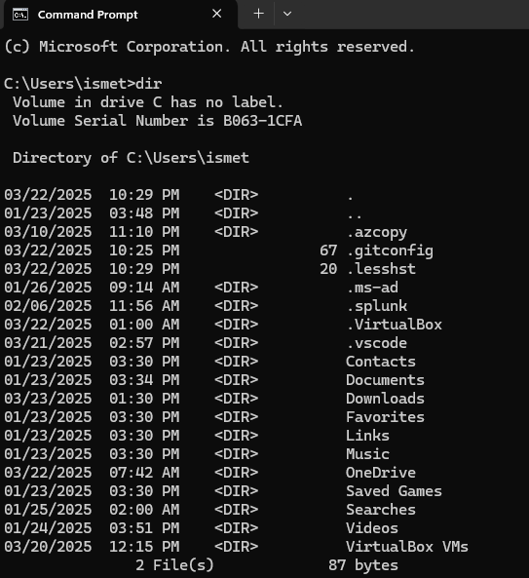
dir output showing the contents of the user folder

Step 2 - cd
Move into the Documents folder. This becomes your working directory for the rest of Part 1.
# Change directory
cd C:\Users\<YourUsername>\Documents
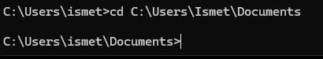
The prompt changes to show the new location

Step 3 - copy
Make a duplicate of file2.txt and name the copy file3.txt.
# Copy a file to a new name
copy "C:\Users\<YourUsername>\Documents\file2.txt" "C:\Users\<YourUsername>\Documents\file3.txt"

# Confirm the copy exists
dir
Note: Always wrap a path in double quotes if it contains a space.
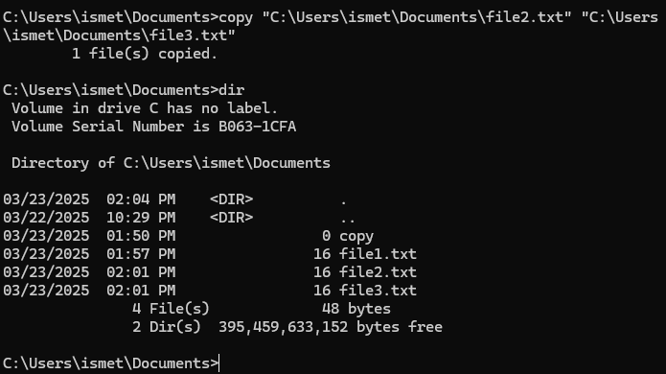
One file copied, then dir confirms file3.txt exists

Step 4 - del
Delete file2.txt. Use the full path so the command works from any directory.
# Delete a file
del C:\Users\<YourUsername>\Documents\file2.txt
Note: In the screenshot the first attempt fails because the prompt had moved up a level with cd .. and the relative path no longer resolved. Giving the full path fixes it.
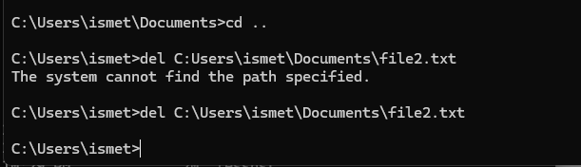
The first attempt fails, the second succeeds

Step 5 - echo
Print a message to the screen.
# Print text to the console
echo Hello, World!
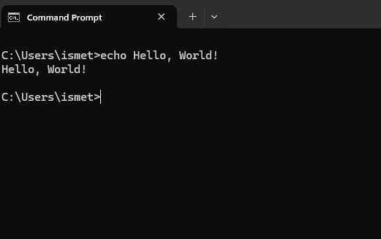
echo prints the message back

Step 6 - mkdir and type nul
Create a new folder, then create an empty file inside it.
# Create a folder
mkdir "C:\Users\<YourUsername>\Documents\CMD Scripts"

# Create an empty file inside it
type nul > "C:\Users\<YourUsername>\Documents\CMD Scripts\test.txt"

# Verify
dir "C:\Users\<YourUsername>\Documents\CMD Scripts"
Note: type nul > filename is the CMD trick for creating a zero-byte file. There is no dedicated command for it.

Part 2 - PowerShell Equivalents
Close Command Prompt and open PowerShell (press Windows key, type powershell, press Enter). Run the same tasks using cmdlets.

Step 7 - Get-ChildItem
List the contents of a folder. This is the PowerShell replacement for dir.
# List files and folders
Get-ChildItem

# dir and ls are built-in aliases for the same cmdlet
dir
ls
Note: Get-ChildItem returns objects, not plain text. That is why you can sort and filter the results with the pipeline.
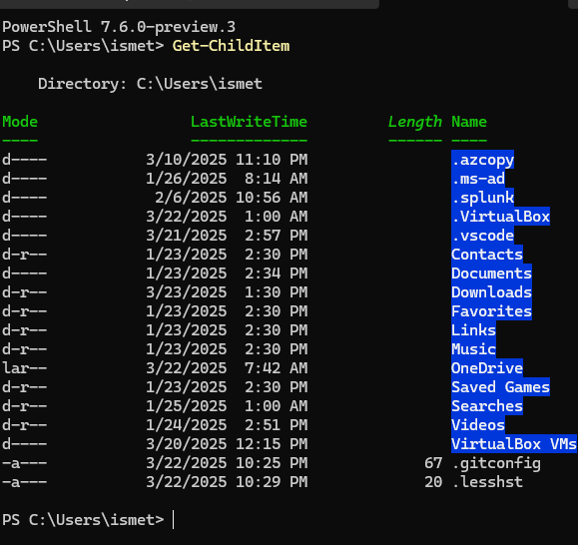
Get-ChildItem returns objects with Mode, LastWriteTime, Length and Name

Step 8 - Set-Location
Change the working directory. This is the PowerShell replacement for cd.
# Change directory
Set-Location C:\Users\<YourUsername>\Documents

# Confirm where you are
Get-Location
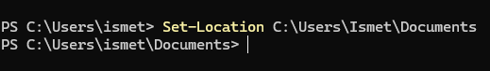
The prompt updates to the new path

Step 9 - Out-File and Get-Content
Write text into a new file, then read it back.
# Write text to a file
"Hello-World" | Out-File -FilePath C:\Users\<YourUsername>\Documents\file10.txt

# Read the file back
Get-Content C:\Users\<YourUsername>\Documents\file10.txt
Note: type and cat are both aliases for Get-Content, so all three commands do the same thing.
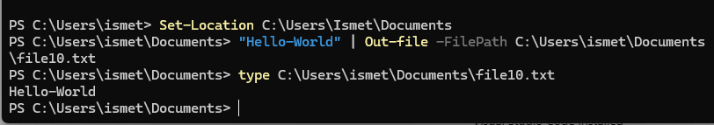
The file is written, then read back with type (an alias for Get-Content)

Step 10 - Remove-Item
Delete the file you just created, then confirm it is gone.
# Delete a file
Remove-Item C:\Users\<YourUsername>\Documents\file10.txt

# Try to read it - an error here proves the delete worked
Get-Content C:\Users\<YourUsername>\Documents\file10.txt
Note: To delete a folder and everything inside it, add -Recurse. Add -Force to remove hidden or read-only items.
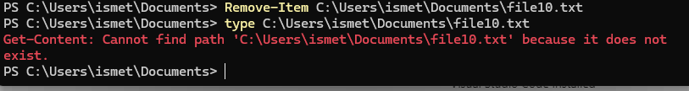
The "cannot find path" error confirms the file was deleted

Step 11 - Write-Host and Write-Output
Print a message to the screen.
# Print straight to the console
Write-Host "Hello World!"

# Send the value down the pipeline so it can be captured
Write-Output "Hello World!"
Note: Use Write-Output when the value needs to be reused. Use Write-Host only for screen-only messages such as coloured status text.
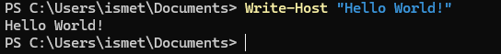
Write-Host prints the message

Part 3 - Create a Folder and File

Step 12 - New-Item
Create a folder named "PowerShell Scripts", move into it, and create an empty test.txt inside.
# Go to Documents
Set-Location C:\Users\<YourUsername>\Documents

# Create the folder
New-Item -Name "PowerShell Scripts" -ItemType Directory

# Move into it - quotes are required, the name has a space
Set-Location "C:\Users\<YourUsername>\Documents\PowerShell Scripts"

# Create an empty file
New-Item -Name "test.txt" -ItemType File

# Verify
Get-ChildItem
Note: If you run cd PowerShell Scripts without quotes, PowerShell reads "Scripts" as a second argument and returns "A positional parameter cannot be found that accepts argument 'Scripts'". Quoting the full path fixes it. This error is visible in the screenshot below.
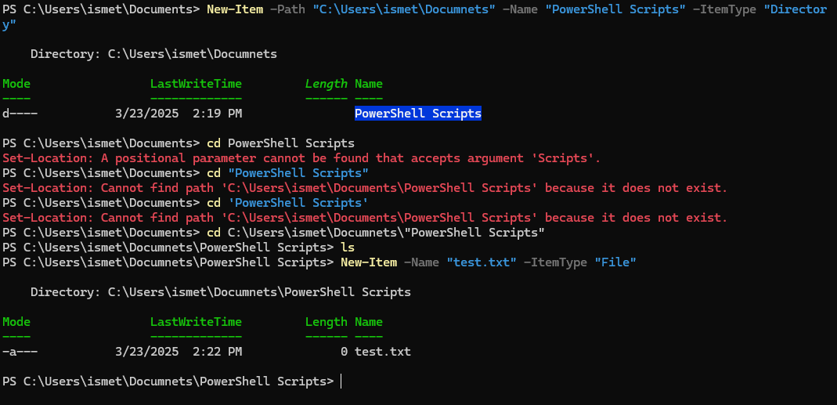
The quoting errors, then the successful folder and file creation

Step 13 - Verify in File Explorer
Open the folder in File Explorer to confirm the work outside the terminal.
# Open the folder in File Explorer
Invoke-Item "C:\Users\<YourUsername>\Documents\PowerShell Scripts"
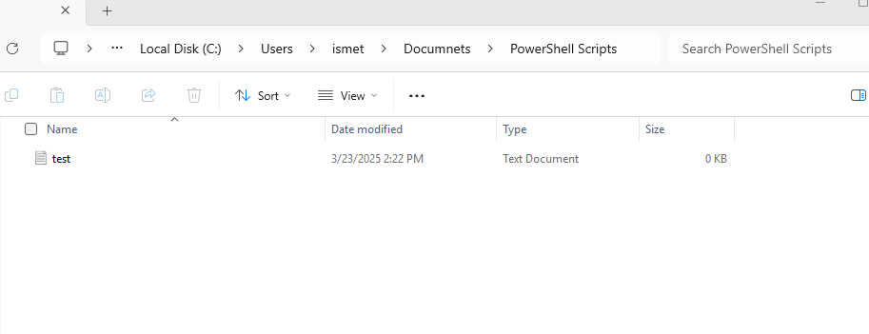
test.txt visible in File Explorer, 0 KB as expected

Step 14 - Cleanup
Remove everything the lab created so you can run it again from a clean state.
# Move out of the folder first, or the delete will fail
Set-Location C:\Users\<YourUsername>\Documents

# Delete the lab files
Remove-Item file1.txt, file2.txt, file3.txt, file10.txt -ErrorAction SilentlyContinue

# Delete the lab folders and everything inside them
Remove-Item "PowerShell Scripts" -Recurse -Force -ErrorAction SilentlyContinue
Remove-Item "CMD Scripts" -Recurse -Force -ErrorAction SilentlyContinue

Useful Commands for Going Further
These four cmdlets let you discover the rest of PowerShell without leaving the terminal.
# See worked examples for any cmdlet
Get-Help Get-ChildItem -Examples

# Find every cmdlet that acts on items
Get-Command -Noun Item

# Discover which cmdlet a familiar command maps to
Get-Alias dir

# Inspect the properties available on an object
Get-ChildItem | Get-Member

Learning Outcome
After completing this lab, I practiced mapping CMD commands to PowerShell cmdlets, navigating the Windows file system, creating folders and files, handling paths that contain spaces, and verifying work in both the terminal and File Explorer.

