**HOTEL MANAGEMENT SYSTEM**

Our project is about basic hotel management system.In this system there will be permanent tables such as ROOM ,EMPLOYEE_WORK and PRODUCT.We are going to have certain number of rooms and products. We are also going to hold each reservation and customer informations.Customer table will hold the informations about customer and reservation table will hold the informations about reservation.Spendings while reserving room will be calculated and holded in reservation table.Reservation table will also have 5 different reservation type with different prices that created in the table RESERVATION_TYPE.There will be product-order relation related to customer.When customer orders a product there will be ORDER and ORDER_DETAILS records created.This is simple order-product procedure as usual.order will hold totalPaid which will be calculated from order details.Also our system will keep track of employees and managers of the hotel.Managers are responsable for managing employees and reservatıons.For each employee there is EMPLOYEE_WORK record which holds salary,duty and calendar for it.

**DATA AND REQUIREMENT ANALYSES WITH DEFFINITIONS**

We are basically going to hold single hotel management system.

-We used usually smallint for ids because of IDs are decimal number increased sequentially. We also used smallint for age and price . We used nvarchar(50) for email,address and phone number because of this datas’ lenghts are excess. We used nvarchar(25) for shorter lenght of other strings. We used smalldatetime for data including date. We used bit for gender. If value is 0, it represented to man and if value is 1 then it represented to woman.

-Customers that are fundamental to our system have some attiributes such as tc no, name, gender, phone number, age, adress and email. Tc no is identifier . Name is composite attiribute that contains first name and last name. CustTC’s type is smallint, fname and lname’s type are nvarchar(25), gender’s type is bit, age’s type is smallint, adress,phoneNumber and email’s types are nvarchar(50).

-We've created a room table because it is a system based on the customer retention system of the room. Room entity have identifical room id, price, capacity and luxary. We changed type of capacity from composite to atomic values such as single room, double room, french room, twinbed room, triple room , quad room. And we also changed type of luxuary from composite to atomic values such as junior, suite, presidental. RoomID type and price type’ are smallint. Capacity and luxuary’s types are nvarchar(25).

-Our system built on reservation. Reservation is supertype and have identical restID , date, custTC,TotalSpend,TotalPaid,roomID,manID,resType. CustTC,roomID,manID and resType are foreign keys. Reservation consist of supertype-subtype relations. Relation is between reservation, directly and online. resID type’s and price’s type are smallint.

-Directly have resID,check-in and check-out date. resID is identifier and type is smallint.Check-in and check-out types are smalldatetime.

-Online have resID, arrival date, departure date and dawnpayment. resID is identifier and type is smallint. ArrivalDate and departure date type’ are smalldatetime. DawnPayment type’s is smallint.

-Reservation_Type consists of resType and price. resType is identifier and type is smallint. resType may be only bed, bed and breakfast, halfboard, fullboard,all inclusive. Price type’s smallint.

-Employee informations will be kept in our system.Table employee is going to have Employee ID as identifier,name of employee,duty,work calendar composed of days and hours,salary,age,email,address phone number,manıD and duty. empID and age’s types are smallint. Name’s type is nvarchar(25). PhoneNumber, email and adress types are nvarchar(50). manID and duty are foreign keys. manID’s type is smallint and duty’s type is nchar(10).

-Employee_Work consists of duty, salary,workHours,workDays and hourly_Date. Duty’s type is nchar(10) and is is primary key. Other data types are smallint. workHours is weekly working hours of employee and workDays is weekly days of employee. We product of workDays and workHours and then divide of salary to result. Thus we calculated hourly_Date. So hourly_Date is computed column.

-There will be manager that manages the distrubution of work in the hotel.Managers are going to have ManID as identifier,name of manager,gender,age,email,address and phone number. manID and age’s types are smallint. Name’s type is nvarchar(25). Gender type’s is bit. Email,adress and phone number types are nvarchar(50).

-There will be order for ordering purpose.Order includes orderID as identifier, custTC, totalSpend and totalPaid. orderID , custTC, totalPaid and totalSpend types are smallint.

-Order_Details consists of orderID,productID and count. OrderID and productID are primary keys and types are smallint. Count is number of products in the order and type is smallint.

-Product consist of productID as primary key and price. The datas’ types are smallint.

-Bill information is kept in our system. We’ve created a table for bill. This table contains identifical billD, date, paid amount, payment type and custTC. BillID is primary key and type is smallint. Date type’s is smalldatetime.custTC’s and paidamaount’s types are smallint. PaymentType’s type is nchar(10).

-Customer will be invoiced by bill after he pays.Customer must have at least 1 bill but,bill can be invoiced to only 1 customer.

-There will be relationship called ordering between order and customer.Customer can order many items but doesnt have to do so.In other case,an order must have only one customer.For each ordering totalspend and totalpaid will be kept on relationship.

-Order related to product. Order has at least one product but product doesn’t has to belong a order.

-Reservation is related to reservation_type. Reservation has relationship only one reservation_type.

-Reservation is supertype and related to directly and online.

-Customers are going to have reservations related reservation table.A customer must have at least one reservation but reservation can be reserved by only one customer.For each reservation customer have totalspend and total paid will be kept on relationship.

-Between room and reservation tables there will be relationship called have.Room may or may not have any reservation and no more than one reservations it can have but reservation must be reserved on only one room.

-There will be only one manager that managing reservation works and considering we have only 1 reservation department,there will be only one manager for each reservation.

-Managers will also manage employees.Manager must have at least 1 employee to manage his/her work,at the sametime employee can managed by different managers for different purposes.

-Employee is related to employee_work. Employee has one employee_work.

IDENTİTİES

We use identities on some primary keys. Starting form 1 increasing by one.

INDICES

When we create primary key, indices has already created.

CHECK CONSTRAINTS

We used sql commands to apply check constraints for reservation’s totalspend and totalpaid which ensures that they are greater than 0. Also the same thing for order’s totalspend and totalpaid.

DEFAULTS

We assigned the values about payments to zero as default.

COMPUTED COLUMNS

We product of workDays and workHours and then divide of salary to result. Thus we calculated hourly_Date. So hourly_Date is computed column.

PRIMARY KEYS AND FOREIGN KEYS

-Each customer will be recorded and duplicate records are unexpectable for us.

-For reservation there must be specific record for each customer so there is primary key.In each reservatıon we must hold manager,room,customer,reservatıon type records must be kept.So primary keys of each table are used as foreıgn key ın reservation table.

-For manager we used manID primary key to specify each manager.

-For employee we used empID as primary key to again specify each employee, manID as foreign key to keep track of manager information of employee.Also we used duty as foreign key to store duty information of each employee inside the table.

-We used roomID as a primary key to specify each room.

-We used orderID as a primary key to specify each order.. And also custTC as a foreign key to hold whom this order belongs to.

- We used productID as a primary key to specify each product.

-We used productID and orderID as foreign key in order_details table to holds containings of order and number of product.

- We used billID as a primary key to specify each bill. And also custTC as a foreign key to hold whom this bill belongs to.

- There is constraints between reservation and the tables online, directly. So directly and online tables must contain the primary key of reservation which is supertype.

- We used resID as a primary key to specify each reservation type.

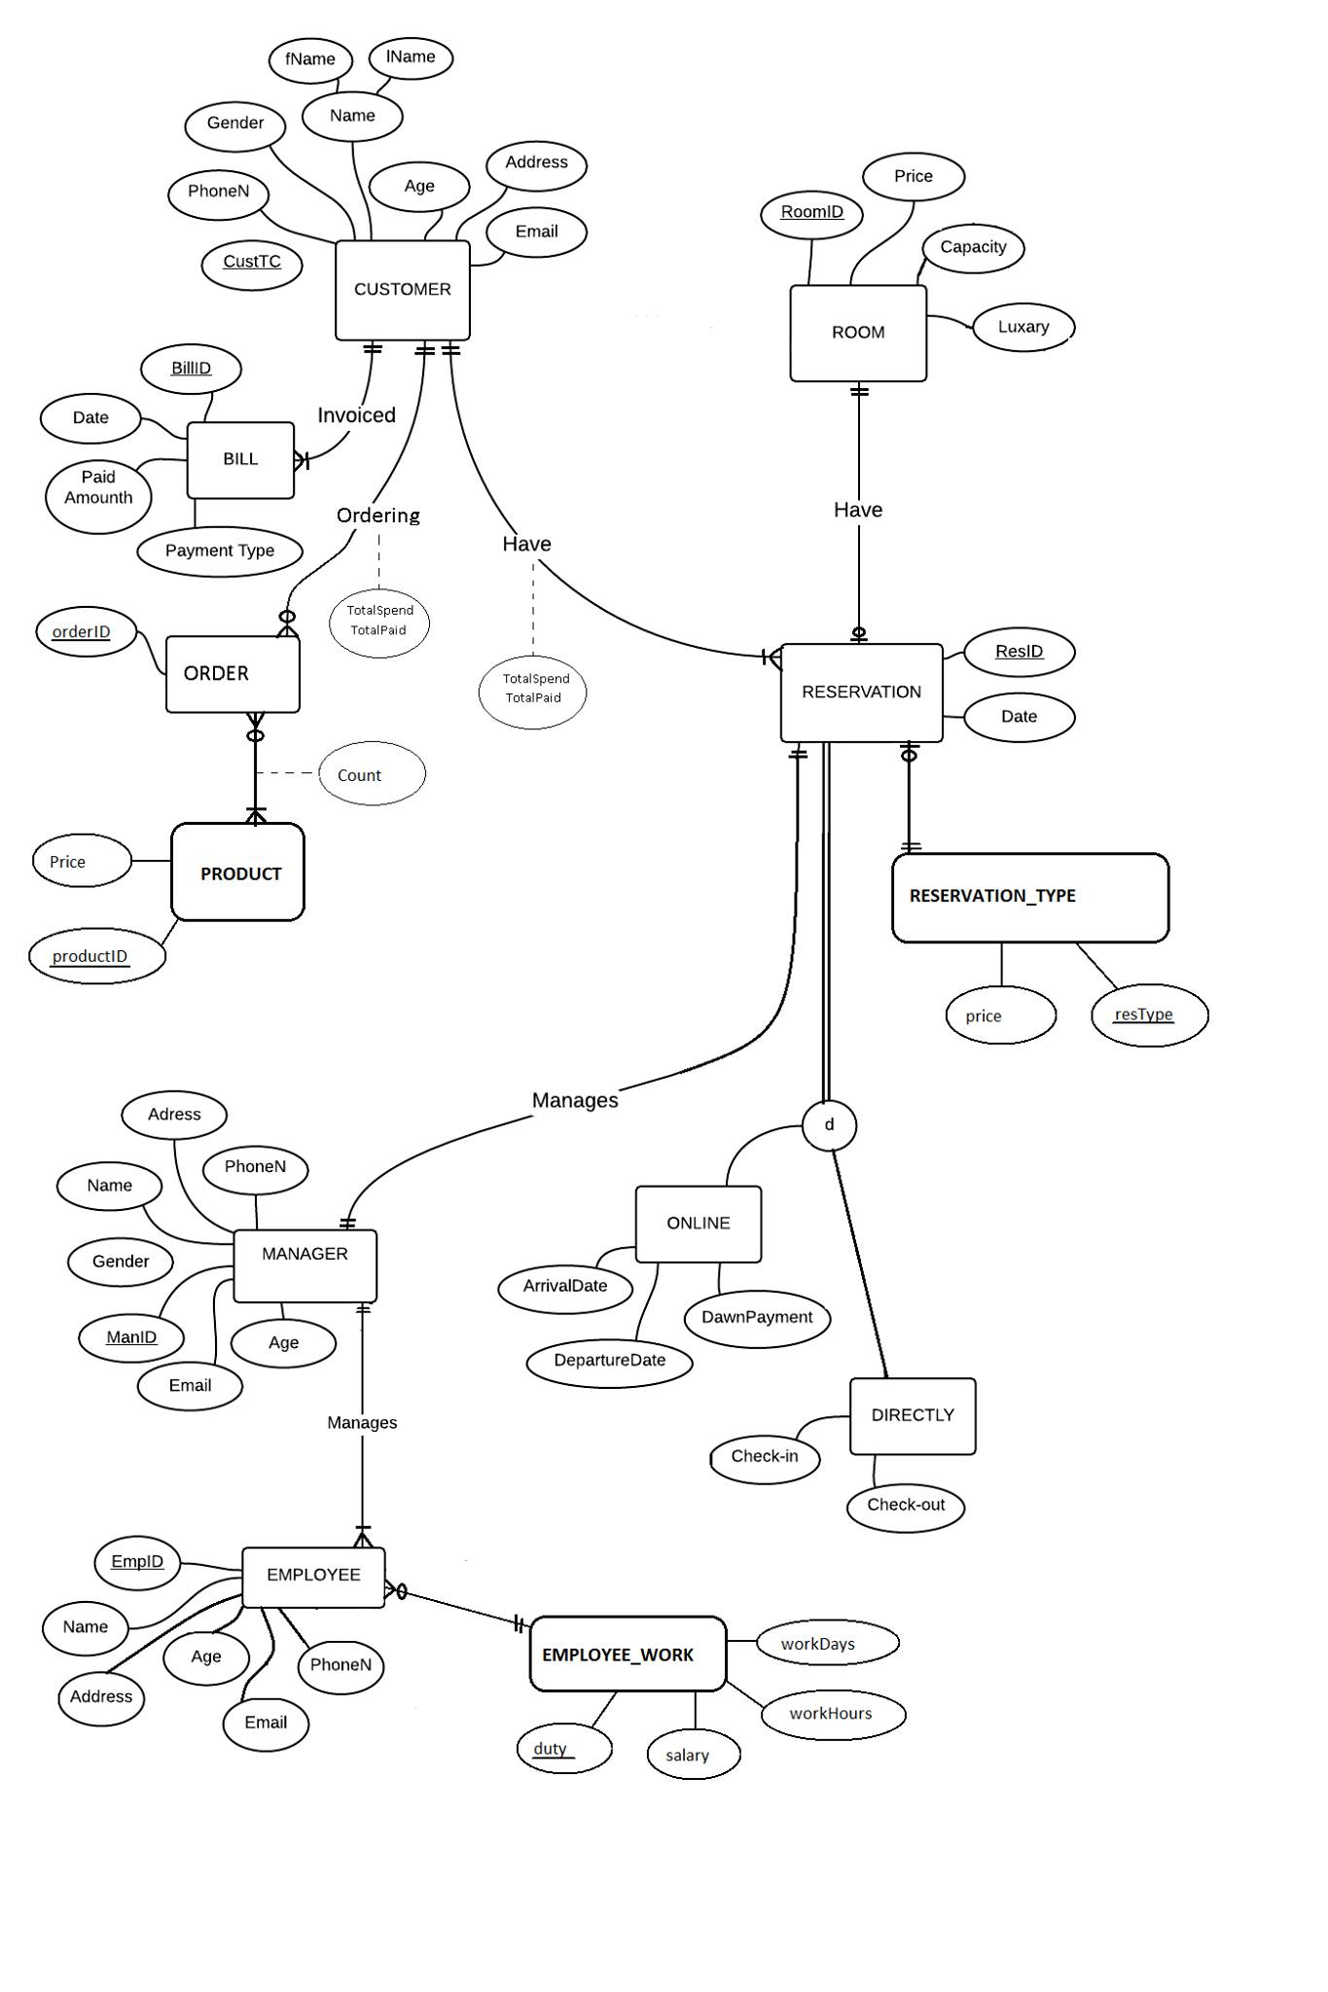

**PROCEDURES & VIEWS & TRIGGERS**

create procedure sp_extendReservatıon

In this procedure we take two arguments which are days to be extended and customerTC whom this extention is made for.Firstly we check whether customer exists or not and if it exists we found the latest reservation date of given customer and again check if its active or not for extention.If no error occur during these lines,we add the @days on check-out date and update it from the table DIRECTLY.

create procedure sp_updateSalaryOFHardWorkers

In this precedure we found the “hardworker” duties for the employees that are working more than 50 hours per weak and taking a salary which is less than 1500.Afterwards we increase the salary of that duty by its twenty percent amount and update it from the table EMPLOYEE_WORK.

create proc sp_billUpdate

This precedure is used for updating the firstly created bill records.For each bill record in the table,we calculate the total paid amount of each customer and store that information into the relevant bill of customer.At first,there is only one bill record for each customer and not for all customers.Afterwards we will create bill table just after updating the totalPaid of the table RESERVATION or ORDER using trigger.

create proc sp_AddCustomer

This precedure is used for making reservation for a customer.Firstly we check whether given room is available or not by comparing its check –in and check-out dates by current date.If room is available we insert into tables customer and reservationwith given parameters .

create procedure deleteOldRecords AS

This procedure is used for deleting 3 years old reservations.After deleting reservation we also delete the relevant subtype class which are online and directly.After these deleting operations we also check ıf there s any customer who has no reservatıon record,if so we also delete that customer.

create view showAvailableRooms AS

We display the available rooms at that moment comparing the the check-in ,check-out dates with current date ‘getdate()’ recorded for the rooms.

create view showTotalSpends AS

This view is used for calculating and displaying the total spends of both RESERVATION and ORDER table.For reservation totalSpend we used ROOM price and resType price,for order totalSpend we used PRODUCT price and PRODUCT_DETAILS count.

create view showGenerousCustomers AS

This view is used for displaying the generous customers for last 6 months for each room.We firstly found the customers for those who have record in last 6 months and their total paid amount using BILL table using grouped by customer.And for each room,we found the generous customer for that room which has the highest total paid amount.

create view showTopManagers AS

This view is used for displaying the top 3 managers that managed the highest number of reservations and their top reservated rooms with the count.We firstly found the top 3 managers that has highest reservation number and set the results to the variables to use them later on.And then,we searched the rooms that the manager reservated and count them and find the highest reservated room for each manager.At the end,we display all 3 of them.

CREATE TRIGGER createBILL ON RESERVATION

This trigger is used for creating BILL record after updating the RESERVATION totalPaid which is billing the customer after he pays in other words.We checked if the update on RESERVATIONS ıs about totalPaid or not with if statement “IF(i.totalPaid=d.totalPaid) “

If no error occurs,we insert in top BILL with the values getdate(),i.custTC,i.totalPaid-d.totalPaid and NULL

create trigger RemoveRoom

This trigger shows message as ‘You cannot delete rooms ’ when use delete operation on room table and it makes undo the operation done with rollback transaction.