STAT101 Mini Project

İsmet Eren – 2561249

Bülent Coşkun - 2561124

We have a dataset recorded when people listen to music. Our dataset includes people's ages, favorite genres, listening times, platform they use, and two psychological variables. Below is the data from this dataset. Below we have illustrated and interpreted some measures of variables and created two research questions. Afterwards, we supported these questions with visuals and interpreted them.

**Measurement Scales of Variables:**

Age: Ratio

Primary Streaming Service: Nominal

Hours Per Day: Ratio

While Working: Nominal

Fav Genre: Nominal

BPM: Interval

Frequency: Ordinal

Anxiety: Ordinal

Depression: Ordinal

**Descriptive Statistics of Variables:**

Age: Mean: 24 Mode: 18 Standart Deviation: 9,1 Range: 13 – 64

We have 200 participants, most of whom are 18 years old, with an average age of 24. Their ages range from 13 to 64. As we understand from the standard deviation, the diversity is also high.

Primary Streaming Service: There are 4 different streaming services. The most popular one is Spotify while the least popular one is Pandora.

Hours Per Day: Mean: 3,7 Median: 3 Mode: 2 Standart Deviation: 2,7

Most of participants listen 2 hours per day. Diversity is normal.

While Working: 157 of 200 participants listen music while working. It means most of participants listen music while working.

Favorite Music Genre: There are 16 different genres that participants listen. Rock is the most popular one while Gosspel is the least popular one.

BPM: Mean: 125 Standart Deviation: 31 Range: 52 – 200

We can say that the listeners average heart rate while listening music is 125. BPM is also highly variable among participants.

Anxiety: Mean: 6 Mode: 7 Standart Deviation: 2,7 Range: 0 – 10

Anxiety has given in a range of values from 0 to 10. Despite this small range, it is quite variable. It’s average seems high. Most of the participants suffer from anxiety.

Depression: Mean: 5 Mode: 8 Standart Deviation: 3 Range: 0 – 10

Depression is also given in a range between 0 to 10. It is more variable than anxiety levels.

**Research Questions:**

1: How music genres affects the human psychology?

2: Does the platform change according to age groups?

**Some Correlations:**

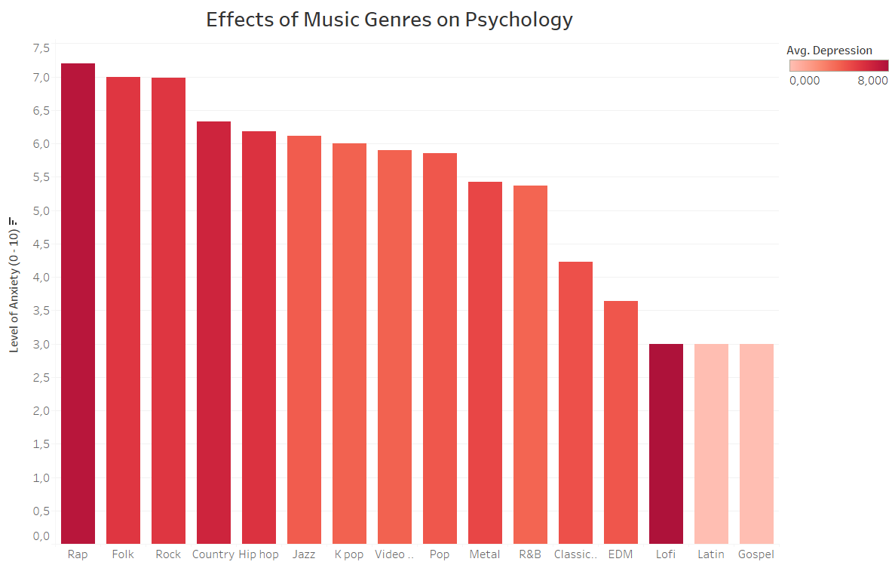

In this chart, we examined whether music genres influence people's psychology based on their anxiety and depression levels. When we examine in general terms, we see that especially rap listeners have high depression and anxiety levels. Also Lofi listeners suffers from depression while they don’t suffer from anxiety so much. We can observe that the psychological problems of gospel and latin listeners are also much lower compared to other genres.

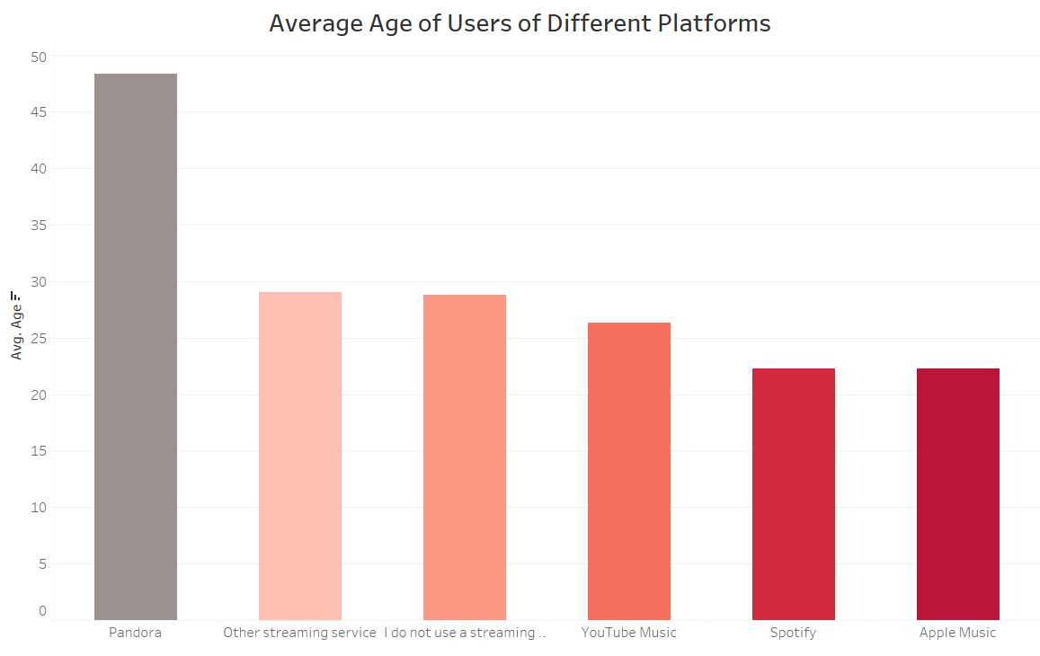

From this graph, it is seen that the elderly people prefer the Pandora platform. Middle-aged people generally do not use music platforms or prefer lesser-known platforms. We can observe that young people prefer Apple Music and Spotify.