

**Azure Resource Group**

**Azure Cloud**

Key Vault

**Schwarz Website**



Key Vault

|  |  |
| --- | --- |
|  | **Validate the new vendor from existing vendor data** |

**Azure Function App**

Trigger

|  |  |
| --- | --- |
|  | **Supplier E- Registration portal** 301 v1 |

**Azure App Service**

(URI Endpoint)

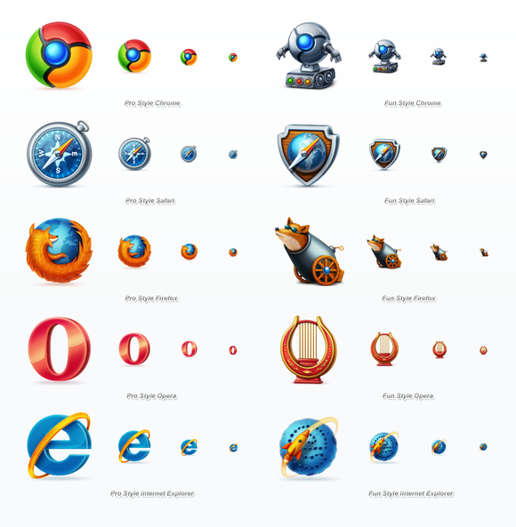

|  |  |
| --- | --- |
|  | **ASP.Net CORE MVC** |

|  |  |
| --- | --- |
|  | **Email to manager with details of Vendor**  (New or Duplicate) |

(URI Endpoint)

|  |  |
| --- | --- |
|  | **Supplier E- Registration portal** 302 V2 |

**Ariba/ Dynamics**

Trigger

|  |  |
| --- | --- |
|  | **Add the New Vendor to the Existing Vendor List** |

**Azure Function App**

No

|  |  |
| --- | --- |
|  | Email to Vendor  (Status of Application) |

|  |  |
| --- | --- |
|  | **Manager Approves the Vendor** |

**Azure Logic Apps**

|  |  |
| --- | --- |
|  | **SAP Connector For Azure Logic App  (RFC, BAPI, IDOC) Create Vendor** |

**Azure Function App**

Odata API **POST** new Vendor

201

V1 301

**New ecord Trigger**



**Vendor Record Created   
in SAP**