PAPER TEMPLATE FOR ISMIR 2023 LBD

|  |  |  |
| --- | --- | --- |
| First author | Second author | Third author |
| Affiliation1  author1@ismir.edu | **Retain these fake authors in  submission to preserve the formatting** | Affiliation3  author3@ismir.edu |

ABSTRACT

The abstract should be placed at the top left column and should contain about 150–200 words. LBD submissions are submitted as extended abstracts and should not be anonymized. Please note that extended abstract is not a conference paper. Therefore, it will not be part of the official ISMIR 2023 proceedings, and should not be cited as such.

1. INTRODUCTION

This template includes all the information about formatting Late-Breaking Demo manuscripts for the ISMIR 2023 Conference. Please follow these guidelines to give the final proceedings a uniform look. Most of the required formatting is achieved automatically by using the supplied style file (LATEX) or template (Word). If you have any questions, please contact the LBD Program Committee ([ismir2023-papers@ismir.net](mailto:ismir2023-papers@ismir.net)). This template can be downloaded from the ISMIR 2023 web site (https://ismir2023.ismir.net).

1. PAPER LENGTH & File Size

We adopt a “(2+1)-page policy” for Late-Breaking Demo (LBD) papers in ISMIR 2023. That is, LBD papers are extended abstracts that may have a maximum of 2 pages of technical content (including figures and tables) one optional page that contains only references and acknowledgments.

Paper should be submitted as PDFs and the file size is limited to 10MB. Please compress images and figures as necessary before submitting.

1. PAGE size

The proceedings will be printed on portrait A4-size paper (21.0cm x 29.7cm). All material on each page should fit within a rectangle of 17.2cm x 25.2cm, centered on the page, beginning 2.0cm from the top of the page and ending with 2.5cm from the bottom. The left and right margins should be 1.9cm. The text should be in two 8.2cm columns with a 0.8cm gutter. All text must be in a two-column format. Text must be fully justified.

1. Typeset Text
   1. Normal or Body Text

Please use a 10pt (point) Times font. Sans-serif or non-proportional fonts can be used only for special purposes, such as distinguishing source code text.

The first paragraph in each section should not be indented, but all other paragraphs should be.

* 1. Title and Authors

The title is 14pt Times, bold, caps, upper case, centered. Authors’ names are omitted when submitting for double-blind reviewing. The following is for making a camera-ready version. Authors’ names are centered. The lead author’s name is to be listed first (left-most), and the co-authors’ names after. If the addresses for all authors are the same, include the address only once, centered. If the authors have different addresses, put the addresses, evenly spaced, under each authors’ name.

 © F. Author, S. Author, and T. Author. Licensed under a Creative Commons Attribution 4.0 International License (CC BY 4.0). **Attribution:** F. Author, S. Author, and T. Author, “Paper template for ISMIR 2023LBD”, in *Extended Abstracts for the Late-Breaking Demo Session of the 22nd Int. Society for Music Information Retrieval Conf.*, Online, 2023.

* 1. First Page Copyright Notice

Please include the copyright notice exactly as it appears here in the lower left-hand corner of the page. It is set in 8pt Times. After your extended abstract is accepted, you will need to insert the appropriate author names and paper title in the copyright notice when submitting the camera-ready version. For LaTeX users, this will be handled by the template automatically. For Word users, this has to be done manually.

* 1. Page Numbering, Headers and Footers

Do not include headers, footers or page numbers in your submission. These will be added when the publications are assembled.

* 1. Line Numbers

Line numbers should be included in your originally submitted manuscript, for reference during screening. However, after your extended abstract is accepted, you must remove all line numbers from the final camera-ready version. This can be done in LaTeX by commenting out the command \linenumbers on Line 22. This can be done in Microsoft Word by selecting Layout > Line Numbers > None.

1. First level headings

First level headings are in Times 10pt bold, centered with 1 line of space (12pt) above the section head, and 1/2 space (6pt) below it. For a section header immediately followed by a subsection header, the space should be merged.

* 1. Second Level Headings

Second level headings are in Times 10pt bold, flush left, with 1 line of space (12pt) above the section head, and 1/2 space (6pt) below it. The first letter of each significant word is capitalized.

* + 1. Third Level Headings

Third level headings are in Times 10pt italic, flush left, with 1/2 line of space (6pt) above the section head, and 1/2 space (6pt) below it. The first letter of each significant word is capitalized.

Using more than three levels of headings is highly discouraged.

1. Footnotes and Figures
   1. Footnotes

Indicate footnotes with a number in the text.[1] Use 8pt type for footnotes. Place the footnotes at the bottom of the page on which they appear. Precede the footnote with a 0.5pt horizontal rule.

* 1. Figures, Tables, and Captions

All artwork must be centered, neat, clean, and legible. All lines should be very dark for purposes of reproduction and art work should not be hand-drawn. The proceedings are not in color, and therefore all figures must make sense in black-and-white form. Figure and table numbers and captions always appear below the figure. Leave 1 line space between the figure or table and the caption. Each figure or table is numbered consecutively. Captions should be Times 10pt. Place tables/figures in text as close to the reference as possible. References to tables and figures should be capitalized, for example: see Figure 1 and Table 1. Figures and tables may extend across both columns to a maximum width of 17.2cm.

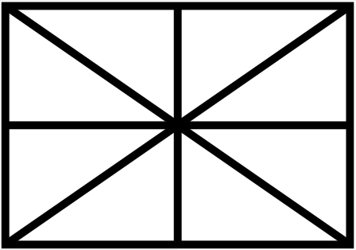

**Figure 1.** Figure captions should be placed below the figure.

|  |  |
| --- | --- |
| String value | Numeric value |
| Hello ISMIR | 2023 |

**Table 1.** Table captions should be placed below the table.

1. Equations

Equations should be placed on separate lines and numbered. The number should be on the right side, in parentheses, as in Eqn (1).

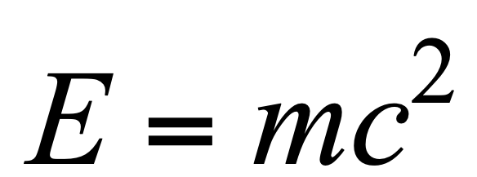 (1)

1. Citations

All bibliographical references should be listed at the end of the submission, in a section named “REFERENCES,” numbered and in the order that they first appear in the text. Formatting in the REFERENCES section must conform to the IEEE standard (https://ieeeauthorcenter.ieee.org/wp-content/uploads/IEEE-Reference-Guide.pdf). Approved IEEE abbreviations (Proceedings → Proc.) may be used to shorten reference listings. All references listed should be cited in the text. When referring to documents, place the numbers in square brackets (e.g., [1] for a single reference, or [2-4] for a range).

1. REFERENCES
2. A. Author and B. Author, “The title of the conference paper,” in Proc. of the 18*th* Int. Society for Music Information Retrieval Conf., Suzhou, China, 2017, pp. 111–117.
3. A. Someone, B. Someone, and C. Someone, “The title of the journal paper,” Journal of New Music Research, vol. A, no. B, pp. 111–222, September 2010.
4. O. Person, Title of the Book. Montréal, Canada: McGill-Queen’s University Press, 2021.
5. F. Person and S. Person, “Title of a chapter in this book,” in A Book Containing Delightful Chapters, A. G. Editor, Ed. Tokyo, Japan: The Publisher, 2009, pp. 58-102.

1. This is a footnote.