

**Proceedings of the 21st International Society for Music Information Retrieval Conference**

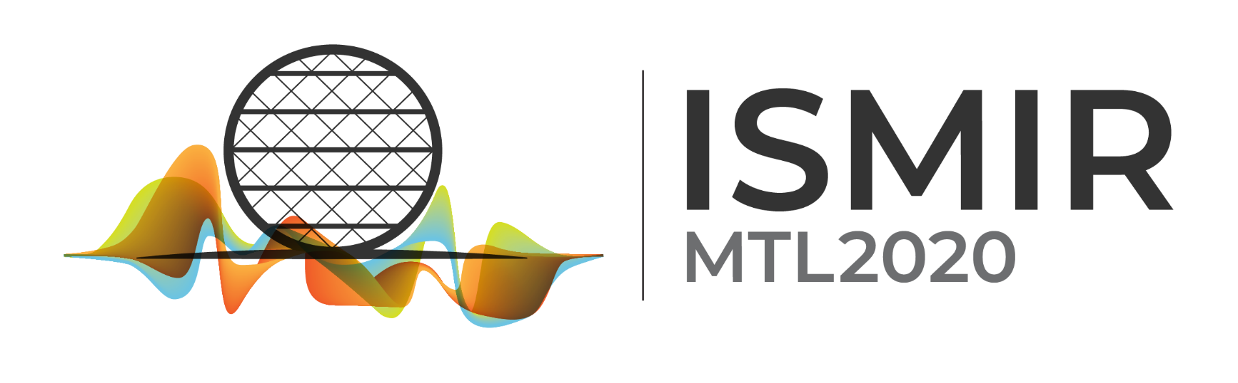

Montréal, Québec, Canada

*Virtual Conference*

11 to 16 October 2020

