**ISMIR Organizers**







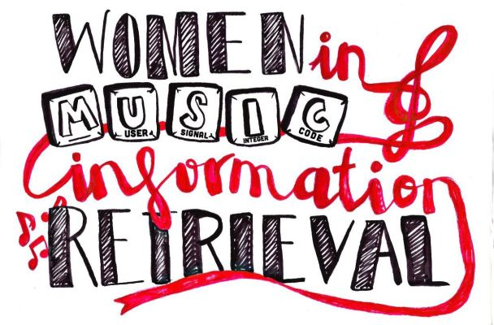



**ISMIR Sponsors**

Funder



Platinum Sponsors





Gold Sponsors





Silver Sponsors







Bronze Sponsors















**WiMIR Sponsors**

Patrons





Contributors





Supporters



