**​​ISMIR Sponsors**

**Platinum Sponsors**



**Gold Sponsors**

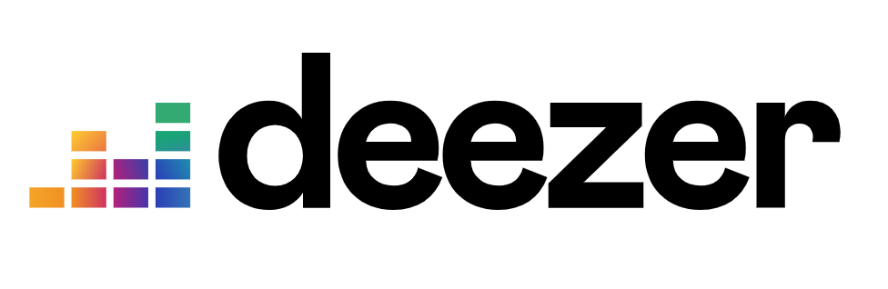

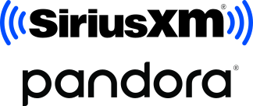

**Silver Sponsors**



**Supporters**

