Batch normalization

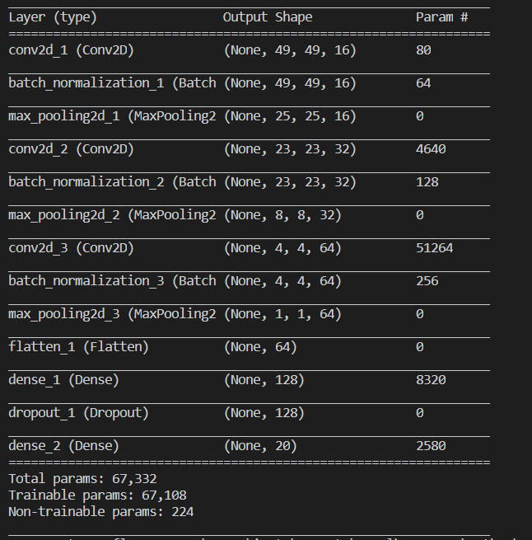

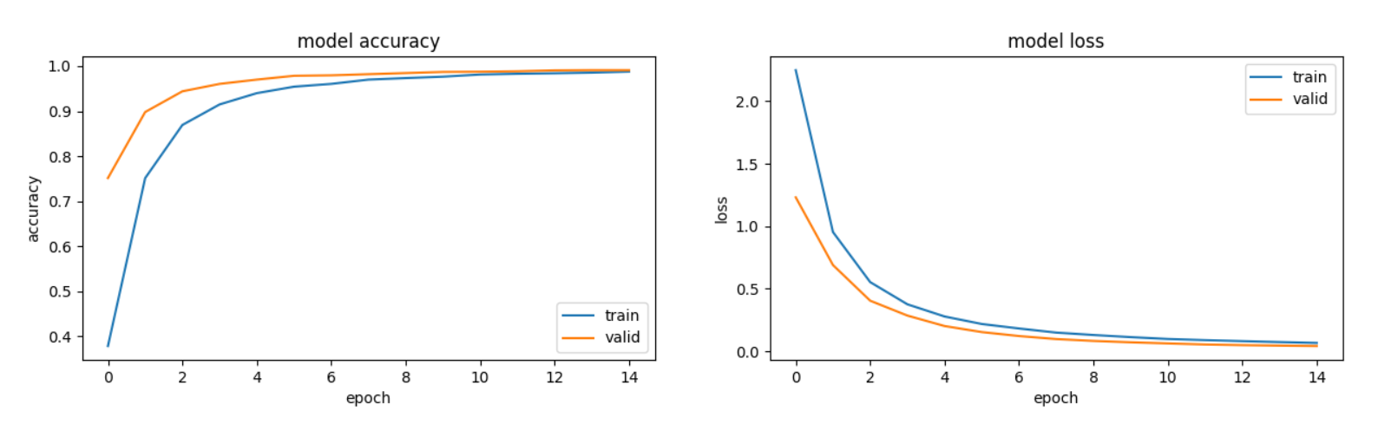

Train on 20000 samples, validate on 2000 samples

Epoch 1/15

20000/20000 [==============================] - 207s 10ms/step - loss: 2.2473 - acc: 0.3786 - val_loss: 1.2310 - val_acc: 0.7515

Epoch 00001: val_acc improved from -inf to 0.75150, saving model to cnn_model_keras2_norm.h5

Epoch 2/15

20000/20000 [==============================] - 142s 7ms/step - loss: 0.9536 - acc: 0.7513 - val_loss: 0.6898 - val_acc: 0.8980

Epoch 00002: val_acc improved from 0.75150 to 0.89800, saving model to cnn_model_keras2_norm.h5

Epoch 3/15

20000/20000 [==============================] - 144s 7ms/step - loss: 0.5534 - acc: 0.8693 - val_loss: 0.4048 - val_acc: 0.9440

Epoch 00003: val_acc improved from 0.89800 to 0.94400, saving model to cnn_model_keras2_norm.h5

Epoch 4/15

20000/20000 [==============================] - 194s 10ms/step - loss: 0.3760 - acc: 0.9149 - val_loss: 0.2859 - val_acc: 0.9605

Epoch 00004: val_acc improved from 0.94400 to 0.96050, saving model to cnn_model_keras2_norm.h5

Epoch 5/15

20000/20000 [==============================] - 182s 9ms/step - loss: 0.2786 - acc: 0.9399 - val_loss: 0.2022 - val_acc: 0.9700

Epoch 00005: val_acc improved from 0.96050 to 0.97000, saving model to cnn_model_keras2_norm.h5

Epoch 6/15

20000/20000 [==============================] - 167s 8ms/step - loss: 0.2186 - acc: 0.9543 - val_loss: 0.1540 - val_acc: 0.9785

Epoch 00006: val_acc improved from 0.97000 to 0.97850, saving model to cnn_model_keras2_norm.h5

Epoch 7/15

20000/20000 [==============================] - 204s 10ms/step - loss: 0.1827 - acc: 0.9605 - val_loss: 0.1223 - val_acc: 0.9795

Epoch 00007: val_acc improved from 0.97850 to 0.97950, saving model to cnn_model_keras2_norm.h5

Epoch 8/15

20000/20000 [==============================] - 217s 11ms/step - loss: 0.1498 - acc: 0.9700 - val_loss: 0.0982 - val_acc: 0.9820

Epoch 00008: val_acc improved from 0.97950 to 0.98200, saving model to cnn_model_keras2_norm.h5

Epoch 9/15

20000/20000 [==============================] - 206s 10ms/step - loss: 0.1307 - acc: 0.9734 - val_loss: 0.0832 - val_acc: 0.9845

Epoch 00009: val_acc improved from 0.98200 to 0.98450, saving model to cnn_model_keras2_norm.h5

Epoch 10/15

20000/20000 [==============================] - 186s 9ms/step - loss: 0.1137 - acc: 0.9765 - val_loss: 0.0723 - val_acc: 0.9870

Epoch 00010: val_acc improved from 0.98450 to 0.98700, saving model to cnn_model_keras2_norm.h5

Epoch 11/15

20000/20000 [==============================] - 199s 10ms/step - loss: 0.0989 - acc: 0.9813 - val_loss: 0.0633 - val_acc: 0.9875

Epoch 00011: val_acc improved from 0.98700 to 0.98750, saving model to cnn_model_keras2_norm.h5

Epoch 12/15

20000/20000 [==============================] - 190s 10ms/step - loss: 0.0896 - acc: 0.9830 - val_loss: 0.0548 - val_acc: 0.9885

Epoch 00012: val_acc improved from 0.98750 to 0.98850, saving model to cnn_model_keras2_norm.h5

Epoch 13/15

20000/20000 [==============================] - 146s 7ms/step - loss: 0.0816 - acc: 0.9841 - val_loss: 0.0497 - val_acc: 0.9905

Epoch 00013: val_acc improved from 0.98850 to 0.99050, saving model to cnn_model_keras2_norm.h5

Epoch 14/15

20000/20000 [==============================] - 172s 9ms/step - loss: 0.0741 - acc: 0.9855 - val_loss: 0.0458 - val_acc: 0.9910

Epoch 00014: val_acc improved from 0.99050 to 0.99100, saving model to cnn_model_keras2_norm.h5

Epoch 15/15

20000/20000 [==============================] - 191s 10ms/step - loss: 0.0672 - acc: 0.9877 - val_loss: 0.0425 - val_acc: 0.9910

Epoch 00015: val_acc did not improve from 0.99100

CNN Error: 1.00%

Dropout 0.5

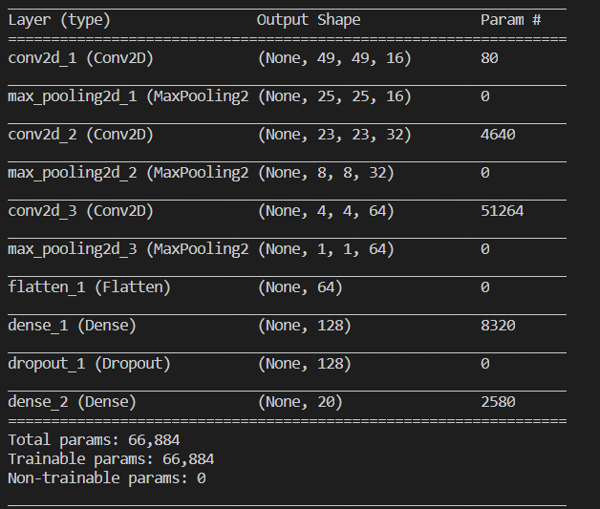

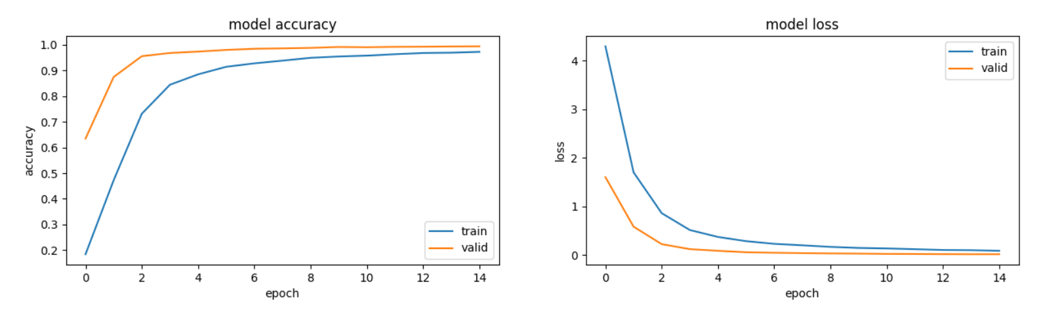

Train on 20000 samples, validate on 2000 samples

Epoch 1/15

20000/20000 [==============================] - 48s 2ms/step - loss: 4.2902 - acc: 0.1842 - val_loss: 1.6016 - val_acc: 0.6350

Epoch 00001: val_acc improved from -inf to 0.63500, saving model to cnn_model_keras2_more_dropout.h5

Epoch 2/15

20000/20000 [==============================] - 83s 4ms/step - loss: 1.7007 - acc: 0.4726 - val_loss: 0.5836 - val_acc: 0.8750

Epoch 00002: val_acc improved from 0.63500 to 0.87500, saving model to cnn_model_keras2_more_dropout.h5

Epoch 3/15

20000/20000 [==============================] - 100s 5ms/step - loss: 0.8610 - acc: 0.7317 - val_loss: 0.2245 - val_acc: 0.9560

Epoch 00003: val_acc improved from 0.87500 to 0.95600, saving model to cnn_model_keras2_more_dropout.h5

Epoch 4/15

20000/20000 [==============================] - 95s 5ms/step - loss: 0.5146 - acc: 0.8447 - val_loss: 0.1218 - val_acc: 0.9685

Epoch 00004: val_acc improved from 0.95600 to 0.96850, saving model to cnn_model_keras2_more_dropout.h5

Epoch 5/15

20000/20000 [==============================] - 95s 5ms/step - loss: 0.3724 - acc: 0.8852 - val_loss: 0.0876 - val_acc: 0.9740

Epoch 00005: val_acc improved from 0.96850 to 0.97400, saving model to cnn_model_keras2_more_dropout.h5

Epoch 6/15

20000/20000 [==============================] - 97s 5ms/step - loss: 0.2858 - acc: 0.9147 - val_loss: 0.0576 - val_acc: 0.9805

Epoch 00006: val_acc improved from 0.97400 to 0.98050, saving model to cnn_model_keras2_more_dropout.h5

Epoch 7/15

20000/20000 [==============================] - 98s 5ms/step - loss: 0.2309 - acc: 0.9281 - val_loss: 0.0477 - val_acc: 0.9850

Epoch 00007: val_acc improved from 0.98050 to 0.98500, saving model to cnn_model_keras2_more_dropout.h5

Epoch 8/15

20000/20000 [==============================] - 96s 5ms/step - loss: 0.2004 - acc: 0.9387 - val_loss: 0.0397 - val_acc: 0.9865

Epoch 00008: val_acc improved from 0.98500 to 0.98650, saving model to cnn_model_keras2_more_dropout.h5

Epoch 9/15

20000/20000 [==============================] - 101s 5ms/step - loss: 0.1682 - acc: 0.9497 - val_loss: 0.0337 - val_acc: 0.9885

Epoch 00009: val_acc improved from 0.98650 to 0.98850, saving model to cnn_model_keras2_more_dropout.h5

Epoch 10/15

20000/20000 [==============================] - 98s 5ms/step - loss: 0.1466 - acc: 0.9549 - val_loss: 0.0298 - val_acc: 0.9920

Epoch 00010: val_acc improved from 0.98850 to 0.99200, saving model to cnn_model_keras2_more_dropout.h5

Epoch 11/15

20000/20000 [==============================] - 101s 5ms/step - loss: 0.1360 - acc: 0.9582 - val_loss: 0.0240 - val_acc: 0.9910

Epoch 00011: val_acc did not improve from 0.99200

Epoch 12/15

20000/20000 [==============================] - 102s 5ms/step - loss: 0.1207 - acc: 0.9638 - val_loss: 0.0220 - val_acc: 0.9925

Epoch 00012: val_acc improved from 0.99200 to 0.99250, saving model to cnn_model_keras2_more_dropout.h5

Epoch 13/15

20000/20000 [==============================] - 104s 5ms/step - loss: 0.1043 - acc: 0.9685 - val_loss: 0.0191 - val_acc: 0.9930

Epoch 00013: val_acc improved from 0.99250 to 0.99300, saving model to cnn_model_keras2_more_dropout.h5

Epoch 14/15

20000/20000 [==============================] - 105s 5ms/step - loss: 0.1000 - acc: 0.9697 - val_loss: 0.0174 - val_acc: 0.9940

Epoch 00014: val_acc improved from 0.99300 to 0.99400, saving model to cnn_model_keras2_more_dropout.h5

Epoch 15/15

20000/20000 [==============================] - 126s 6ms/step - loss: 0.0872 - acc: 0.9730 - val_loss: 0.0174 - val_acc: 0.9945

Epoch 00015: val_acc improved from 0.99400 to 0.99450, saving model to cnn_model_keras2_more_dropout.h5

CNN Error: 0.55%

less train: batchsize=500, epoch=15 -> batchsize=500, epoch=10

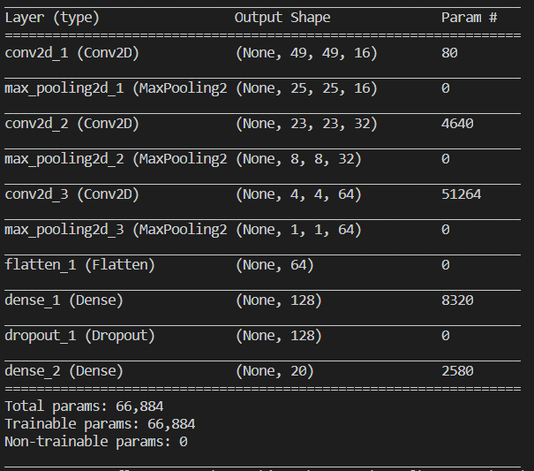

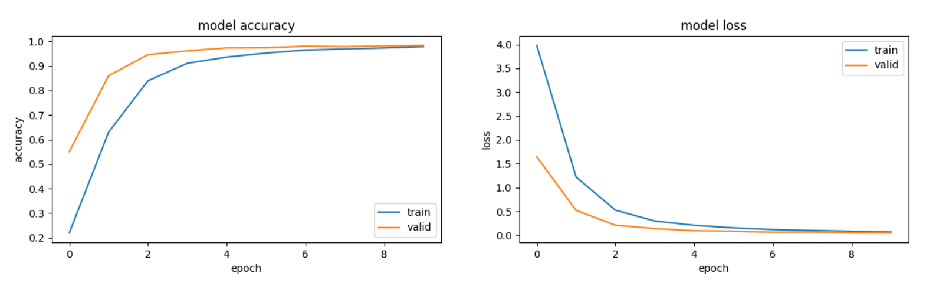

Train on 20000 samples, validate on 2000 samples

Epoch 1/10

20000/20000 [==============================] - 45s 2ms/step - loss: 3.9816 - acc: 0.2195 - val_loss: 1.6447 - val_acc: 0.5505

Epoch 00001: val_acc improved from -inf to 0.55050, saving model to 'cnn_model_keras2_less_train.h5'

Epoch 2/10

20000/20000 [==============================] - 38s 2ms/step - loss: 1.2202 - acc: 0.6301 - val_loss: 0.5220 - val_acc: 0.8600

Epoch 00002: val_acc improved from 0.55050 to 0.86000, saving model to 'cnn_model_keras2_less_train.h5'

Epoch 3/10

20000/20000 [==============================] - 38s 2ms/step - loss: 0.5251 - acc: 0.8396 - val_loss: 0.2103 - val_acc: 0.9460

Epoch 00003: val_acc improved from 0.86000 to 0.94600, saving model to 'cnn_model_keras2_less_train.h5'

Epoch 4/10

20000/20000 [==============================] - 38s 2ms/step - loss: 0.2973 - acc: 0.9107 - val_loss: 0.1400 - val_acc: 0.9615

Epoch 00004: val_acc improved from 0.94600 to 0.96150, saving model to 'cnn_model_keras2_less_train.h5'

Epoch 5/10

20000/20000 [==============================] - 42s 2ms/step - loss: 0.2088 - acc: 0.9361 - val_loss: 0.0939 - val_acc: 0.9735

Epoch 00005: val_acc improved from 0.96150 to 0.97350, saving model to 'cnn_model_keras2_less_train.h5'

Epoch 6/10

20000/20000 [==============================] - 45s 2ms/step - loss: 0.1544 - acc: 0.9526 - val_loss: 0.0845 - val_acc: 0.9740

Epoch 00006: val_acc improved from 0.97350 to 0.97400, saving model to 'cnn_model_keras2_less_train.h5'

Epoch 7/10

20000/20000 [==============================] - 38s 2ms/step - loss: 0.1187 - acc: 0.9647 - val_loss: 0.0623 - val_acc: 0.9805

Epoch 00007: val_acc improved from 0.97400 to 0.98050, saving model to 'cnn_model_keras2_less_train.h5'

Epoch 8/10

20000/20000 [==============================] - 38s 2ms/step - loss: 0.1004 - acc: 0.9690 - val_loss: 0.0641 - val_acc: 0.9785

Epoch 00008: val_acc did not improve from 0.98050

Epoch 9/10

20000/20000 [==============================] - 49s 2ms/step - loss: 0.0832 - acc: 0.9734 - val_loss: 0.0505 - val_acc: 0.9815

Epoch 00009: val_acc improved from 0.98050 to 0.98150, saving model to 'cnn_model_keras2_less_train.h5'

Epoch 10/10

20000/20000 [==============================] - 50s 3ms/step - loss: 0.0695 - acc: 0.9788 - val_loss: 0.0476 - val_acc: 0.9840

Epoch 00010: val_acc improved from 0.98150 to 0.98400, saving model to 'cnn_model_keras2_less_train.h5'

CNN Error: 1.45%

Original

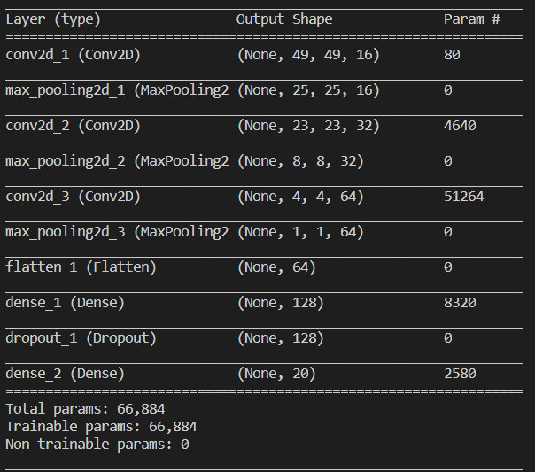

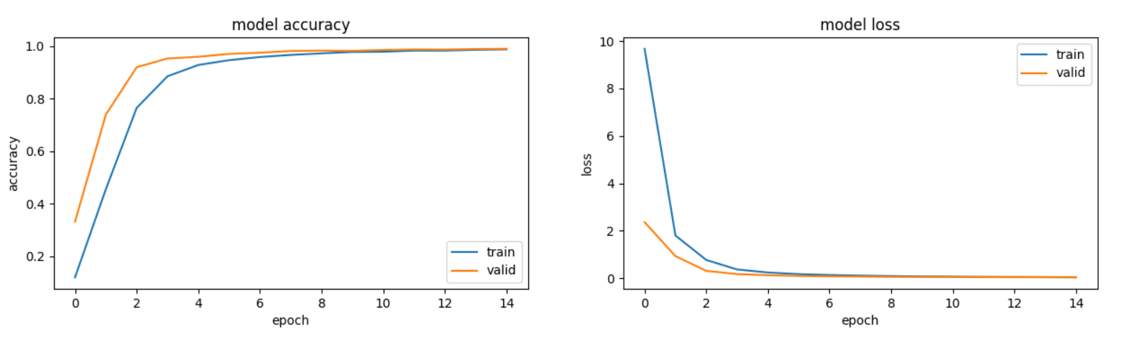

Train on 20000 samples, validate on 2000 samples

Epoch 1/15

20000/20000 [==============================] - 105s 5ms/step - loss: 9.6749 - acc: 0.1186 - val_loss: 2.3621 - val_acc: 0.3310

Epoch 00001: val_acc improved from -inf to 0.33100, saving model to cnn_model_keras3.h5

Epoch 2/15

20000/20000 [==============================] - 96s 5ms/step - loss: 1.8008 - acc: 0.4547 - val_loss: 0.9309 - val_acc: 0.7395

Epoch 00002: val_acc improved from 0.33100 to 0.73950, saving model to cnn_model_keras3.h5

Epoch 3/15

20000/20000 [==============================] - 97s 5ms/step - loss: 0.7685 - acc: 0.7650 - val_loss: 0.3083 - val_acc: 0.9200

Epoch 00003: val_acc improved from 0.73950 to 0.92000, saving model to cnn_model_keras3.h5

Epoch 4/15

20000/20000 [==============================] - 98s 5ms/step - loss: 0.3679 - acc: 0.8856 - val_loss: 0.1728 - val_acc: 0.9535

Epoch 00004: val_acc improved from 0.92000 to 0.95350, saving model to cnn_model_keras3.h5

Epoch 5/15

20000/20000 [==============================] - 96s 5ms/step - loss: 0.2395 - acc: 0.9287 - val_loss: 0.1244 - val_acc: 0.9600

Epoch 00005: val_acc improved from 0.95350 to 0.96000, saving model to cnn_model_keras3.h5

Epoch 6/15

20000/20000 [==============================] - 99s 5ms/step - loss: 0.1704 - acc: 0.9471 - val_loss: 0.0941 - val_acc: 0.9710

Epoch 00006: val_acc improved from 0.96000 to 0.97100, saving model to cnn_model_keras3.h5

Epoch 7/15

20000/20000 [==============================] - 102s 5ms/step - loss: 0.1322 - acc: 0.9591 - val_loss: 0.0749 - val_acc: 0.9755

Epoch 00007: val_acc improved from 0.97100 to 0.97550, saving model to cnn_model_keras3.h5

Epoch 8/15

20000/20000 [==============================] - 96s 5ms/step - loss: 0.1089 - acc: 0.9671 - val_loss: 0.0677 - val_acc: 0.9820

Epoch 00008: val_acc improved from 0.97550 to 0.98200, saving model to cnn_model_keras3.h5

Epoch 9/15

20000/20000 [==============================] - 105s 5ms/step - loss: 0.0905 - acc: 0.9730 - val_loss: 0.0573 - val_acc: 0.9835

Epoch 00009: val_acc improved from 0.98200 to 0.98350, saving model to cnn_model_keras3.h5

Epoch 10/15

20000/20000 [==============================] - 101s 5ms/step - loss: 0.0733 - acc: 0.9785 - val_loss: 0.0538 - val_acc: 0.9825

Epoch 00010: val_acc did not improve from 0.98350

Epoch 11/15

20000/20000 [==============================] - 104s 5ms/step - loss: 0.0652 - acc: 0.9792 - val_loss: 0.0473 - val_acc: 0.9860

Epoch 00011: val_acc improved from 0.98350 to 0.98600, saving model to cnn_model_keras3.h5

Epoch 12/15

20000/20000 [==============================] - 115s 6ms/step - loss: 0.0561 - acc: 0.9835 - val_loss: 0.0429 - val_acc: 0.9880

Epoch 00012: val_acc improved from 0.98600 to 0.98800, saving model to cnn_model_keras3.h5

Epoch 13/15

20000/20000 [==============================] - 112s 6ms/step - loss: 0.0523 - acc: 0.9836 - val_loss: 0.0418 - val_acc: 0.9875

Epoch 00013: val_acc did not improve from 0.98800

Epoch 14/15

20000/20000 [==============================] - 69s 3ms/step - loss: 0.0464 - acc: 0.9865 - val_loss: 0.0404 - val_acc: 0.9895

Epoch 00014: val_acc improved from 0.98800 to 0.98950, saving model to cnn_model_keras3.h5

Epoch 15/15

20000/20000 [==============================] - 40s 2ms/step - loss: 0.0409 - acc: 0.9882 - val_loss: 0.0347 - val_acc: 0.9905

Epoch 00015: val_acc improved from 0.98950 to 0.99050, saving model to cnn_model_keras3.h5

CNN Error: 1.15%