

|  |  |
| --- | --- |
| Project Proposal : Smart Pantry Personal Assistant  Date : 15th August 2017  Project team members: Glenn Marks, Shaun Soo, Abbas Ahmadi | v1 |

**1.0 Issue**

A pantry is the area specifically designed or used to store food. Nows a day, refrigeration has also integrated and become part of pantry. The dietary of a whole household is centralized at this area, Pantry. We all know and understand the importance of our nutrition in our everyday lives in every household.

A family can either understock, overstock, confused with different brands nor able to keep diet under control.

We want to take away the stress and to offer a driverless solution ensuring the dietary needs to be recognized to keep the family healthy. We want to promote and support a well organised pantry a happy family.

**2.0 Pantry Workflow**

**Current**

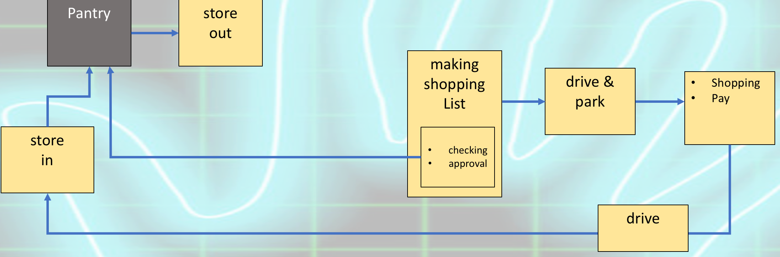

To gain the control of the whole pantry process flow, we have outlined the typical challenges faced by families

1. How to know when the conflict box is nearly empty.
2. How to capture the expiry date
3. Save money by bulk buying specials
4. Dietary information
5. Stock-in and stock-out
6. Stock consumption - estimation algorithm
7. Weekly or monthly
8. Simulating our terminal in a tablet
9. Favourite food
10. Notification system/method
11. Graphic mapping
12. Most healthiest in the top and less in the bottom
13. Classification of products/food pyramid
14. Suggested ingredient mix
15. Scanner in the door
16. Splurge items

**What we want to achieve after the implementation**

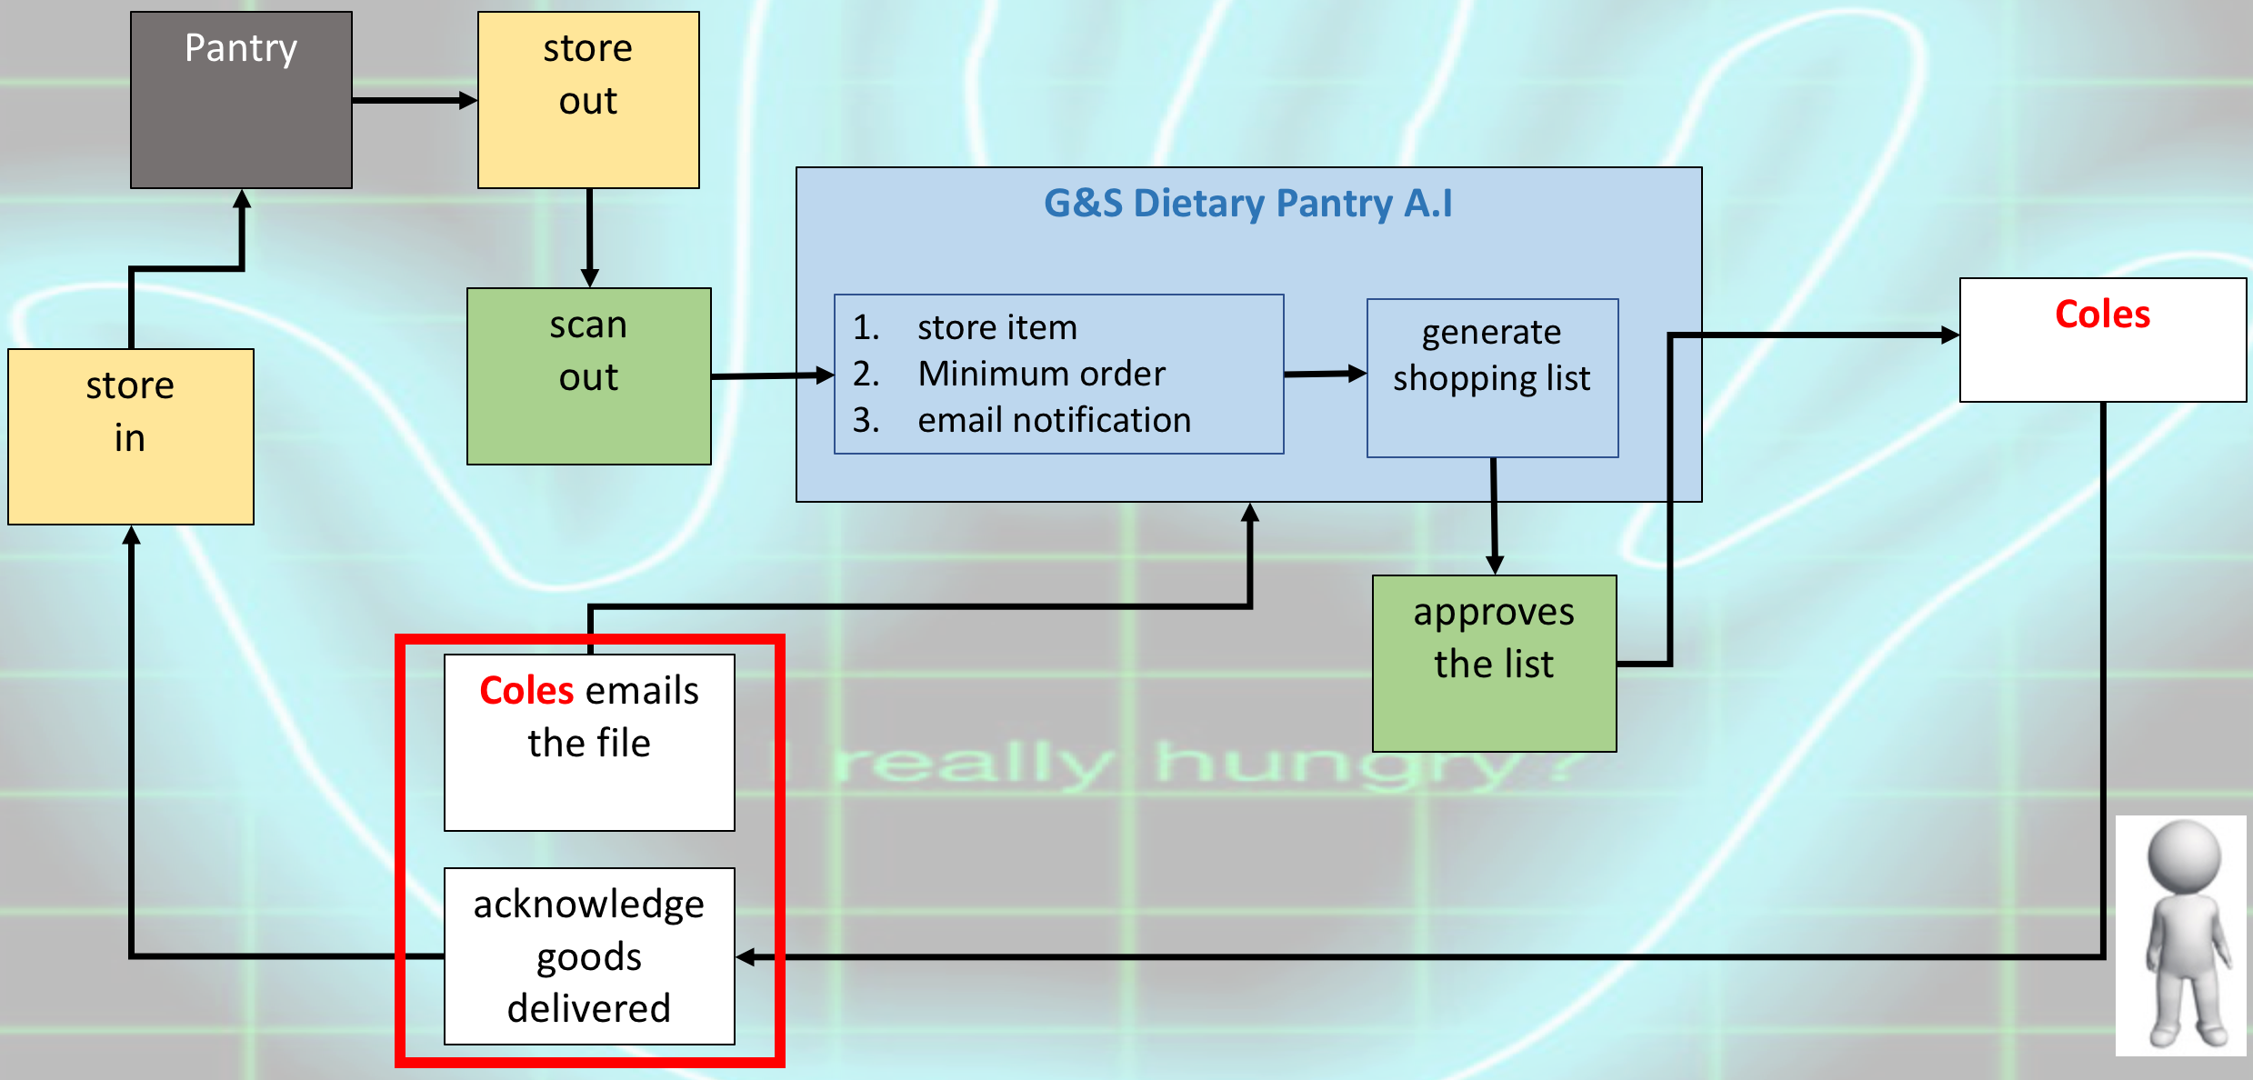

**3.0 Development and Technical Solution**

We outline what information/data is needed to ensure the terminal is able to offer the driveless solution and support to a family.

Mini warehouse:

1. items,
2. quantities,
3. barcode,
4. brand,
5. category,
6. rating,
7. expiry date,
8. content list (salt, sugar),
9. supplier,
10. notifications (monthly, weekly or daily - user defined),
11. GPS locator,
12. pricing + costing calculator

We translate above items into different classes with the corresponding instance variables and attributes using sudo code method.

Classes:

Content:

Name

quantity/%

Item:

Id

Barcode - int

Name - string

Quantity - int

Brand - string

Rating - int

Expiry date - date

Content list - array/hash

Consumption % per serve

Date in - date (do we need?)

Inventory:

Items id - int

Quantity - float

Minimum stock level - float

Supplier:

id

Name

Items - {item id => price}

location

Pantry:

Inventories - array of inventory

Suppliers - array of supplier

Master item list - array of item

def partial_consumption

Days

Quantity

Item id

def Notification

def api_to_suppliers

Approval:

Approval

API to Coles

**3.1 Work Flow**

* User Process

**Set up**

* Configure wifi for tablet
* On tablet (attached to pantry) press icon to start app
* Enter email
* It will ask you for shopping cycle in days and start date
* It will ask you to scan all the items in the pantry
* Exit to menu
* It will then display a menu and enter scan mode
* Enter scan out mode (90 to exit to menu)

**Daily routine**

* Scan each item using the smart scanner when taking out from pantry

**During shopping cycle / when minimum stock level is low**

* Receive shopping list
* Approve the shopping list
* Make payment

**Acknowledgement of goods receipt**

* Coles pinpad

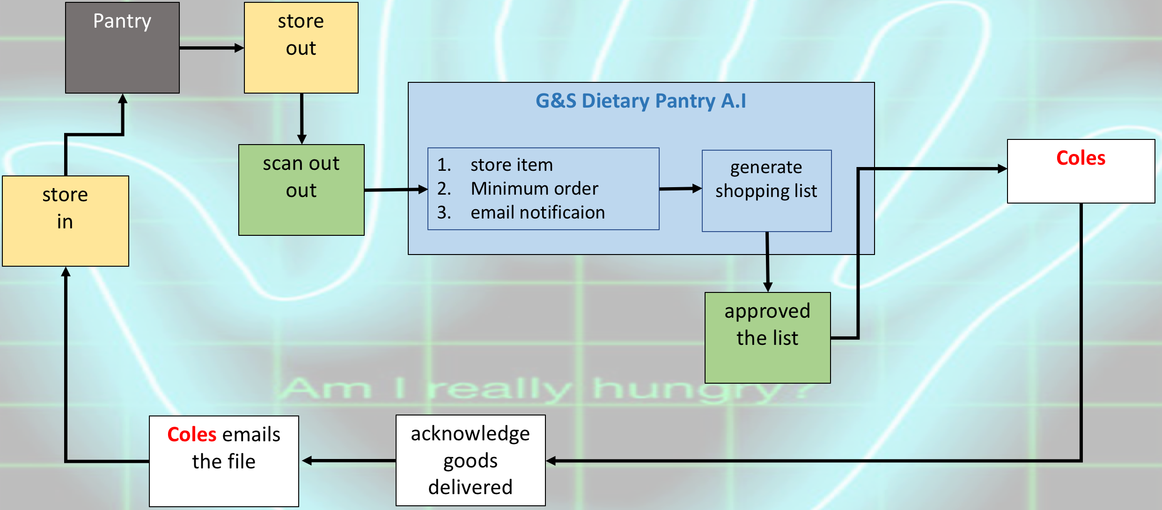

* Technical process

**On start up** - Set up mode

* Setup suppliers
* Run api to get master stock list from suppliers
* Estimate minimum order quantitiers (based on rules)
* Ask for shopping cycle
* Scan all existing stock in pantry (one off only)
* Run consumption algorithm
* Notification
* Enter scan mode (display menu on screen as well)
* Set up the order quantity

**Minimum Order Quantity**

Item comes out of pantry (scanned by barecode reader)

If minimum_order_qty < 1 ( a % 0.2 etc)

Partial_consumption

Notification

Else

Sub 1 from inventory qty

Notification

**Shopping Day Frequency**

On designated day (day before shopping)

Build shopping list

Loop over inventory to calc and construct shopping list (catagorising/priority)

Send to mobile

**Stock adjustment**

**Stock In ⇐== to api to Coles goods acknowledgement system**

ID

Name

Quantity

**Stock Out**

ID

Name

Quantity

**Approval**

Stock Order **⇐== to api to Coles online ordering system**

Payment

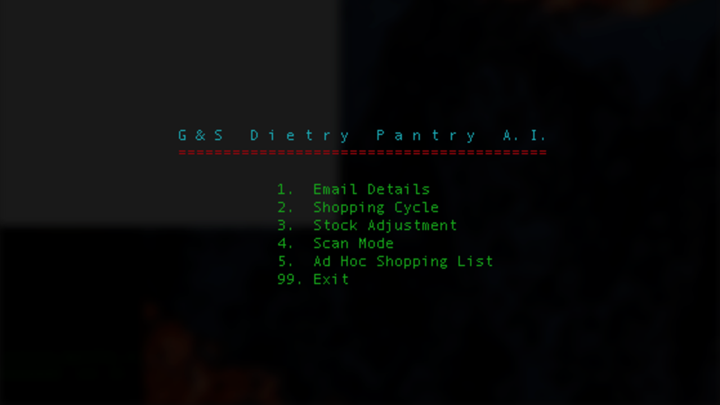

**Gems**

Colorize

Terminal_table

Cursor