Setup
The Husqvarna Robot is designed to work with Ubuntu 16.04 and ROS kinetic (follow the instructions here http://wiki.ros.org/kinetic/Installation/Ubuntu), and Ubuntu 16.04. These should both be installed on your computer or in a virtual machine. After installing ROS, the following packages are also recommended installation material (Note: replace indigo with kinetic).
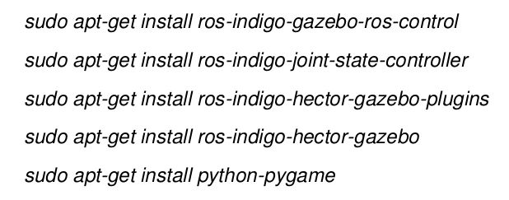

Important Information from the beginner tutorials
Install the beginner tutorials package (replace distro with kinetic)
Add the following to your .bashrc file (located at ~/.bashrc) so you don’t have to re-run these commands each time you want to use ROS.
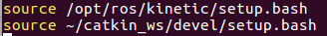

These can also be added using the command line
$ echo “source /opt/ros/kinetic/setup.bash” >> ~/.bashrc
$ echo “. ~/catkin_ws/devel/setup.bash” >> ~/.bashrc
Note: any commands in bashrc don’t take effect in open terminals unless reloaded with source ~/.bashrc )

Create your catkin workspace
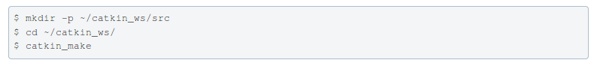
This can also be done using
Whenever you want to re-build the catkin workspace run:
All new ROS workspaces should be placed inside the src folder of catkin_ws. For example to create a beginner tutorials workspace run inside ~/catkin_ws/src
There is more information about using ROS Nodes in beginner tutorials. Doing the Beginner Tutorials on ROS is a good idea (http://wiki.ros.org/ROS/Tutorials).

Get the HRP files
1. Go to the Husqvarna Github page (https://github.com/HusqvarnaResearch/hrp) and copy the link to clone their files
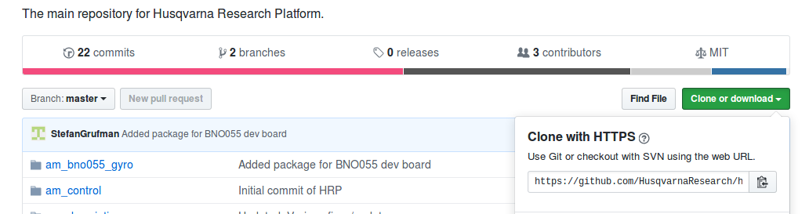
2. It might be useful to download and save the “Start-up Guide HRP” file, which has Husqvarna’s instructions for running the lawn mower.
3. Navigate to ~/catkin_ws/src your catkin workspace and run the following (i.e. copy the git repository into this folder)
$ git clone https://github.com/HusqvarnaResearch/hrp.git
Troubleshooting
- Check that you have git installed (sudo apt-get install git), or replace the URL with the one you copied in step 1.
4. Navigate back to catkin_ws and run catkin_make
- This will very likely fail, with some error message about not being able to find a configuration file from a certain ROS package. Google that package, and install it.
- If it fails in another manner, try the forums

Note: you can skip to controlling the lawnmower at this point

Github for version control
- Initial Setup
- Create an account and repository online in Github
- Navigate to catkin_ws/src, and run git clone <your repository url> to copy the Github repository to your local computer. If the repository is private, you will need to enter the user name and password of one of the editors
Troubleshooting: make sure you enter the newly downloaded folder/ git repository or you’ll get the error: “not a git repository”
- Set the remote Github repo as the origin using git remote add <your repository url>
  - git remote -v will verify if this has worked, confirming you can fetch and push to this origin.
  - If you are using forks, you may also want to set it as the upstream branch (https://webkul.com/blog/syncing-local-repository-with-remote-repository-on-github/)
- Note: This can also be done in reverse, creating a local repository and then uploading it to the Github page (https://readwrite.com/2013/10/02/github-for-beginners-part-2/).
- Pushing changes from local to Github
- To add files to Git’s list use git add yourfilename
  - To add all changes use git add --all or git add .
- To commit these changes run git commit -m “your message”
Troubleshooting:
    - The first name, you may need to set user.name and user.email.
- Run git push
  - To push directly into the master branch run git push origin master
  - To push into a different branch run git push <your filename>
Note: git status is useful in providing lists of files to be added/committed
Pulling from Github to local
- To pull from Github run git pull origin master inside the local repository that needs updating

Creating your own catkin package
- Create the package
  - Run catkin_create_pkg <package_name> [depend1] [depend2] [depend3]
  - This will create a package in your current folder with the above name and dependencies (each package must have its own folder). It will also automatically create a package.xml file and a CmakeLists.txt file, which are required components of a ROS package.
- package.xml file
  - This file defines properties about the package such as the package name, version numbers, authors, maintainers, and dependencies on other catkin packages. Catkin_create package usually produces a skeleton version which must be filled in.
  - There are a number of required tags.
    - <package> this root tag encloses all other tags, with an attribute specifying format
    - <name> This must be the name of the package
    - <description> should contain a description of what the package does
    - <maintainer> your name, as the maintainer of the package. Usually also specifies an email attribute
    - <license> pick an open source license (most of the tutorials use BSD)
  - Any package dependencies must be specified in tags
    - <buildtool_depend> all packages have this dependency on the tool needed to build the package (generally catkin).
    - <build_depend> specify which packages are needed to build this package. This is the case when any file from these packages is required at build time.
    - <build_export_depend> specify which packages are needed to build libraries against this package.
    - <exec_depend> specify which packages are needed to run code in this package. This is the case when you depend on shared libraries in this package
    - <depend> specifies that a dependency is a build, export, and execution dependency
    - <test_depend> specify only additional dependencies for unit tests (no duplicates that are already build dependencies).
    - <doc_depend> specify documentation tools which this package needs to generate documentation (not used much)
  - Sometimes an <export> tag is used if the package is to be a meta-package
  - Example
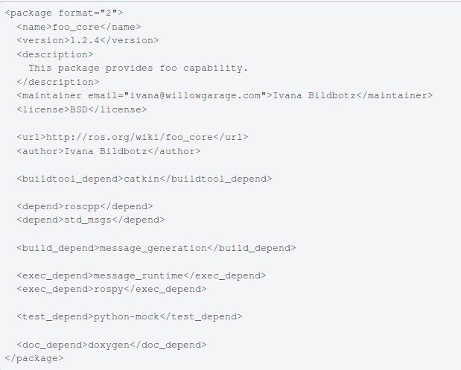
  - Resources
    - http://wiki.ros.org/ROS/Tutorials/CreatingPackage
    - http://wiki.ros.org/catkin/package.xml

- CmakeLists.txt file
  - The file CMakeLists.txt is the input to the CMake build system for building software packages. Any CMake compliant package contains one or more CMakeLists.txt file that describe how to build the code and where to install it to. The CMakeLists.txt file used for a catkin project is a standard vanilla CMakeLists.txt file with a few additional constraints.
  - Required components
    - cmake_minimum_required(VERSION 2.8.3) the version
    - project(<package name>) the name of the package
  - Package dependencies
    - find_package(catkin REQUIRED) catkin is required to build the package
    - find_package(catkin REQUIRED COMPONENTS <depends>) any packages listed as build dependencies in package.xml should be listed here. They could be found using find_package(<depends>), but the other way is recommended.
    - catkin_package() is a catkin-provided CMake macro used to specify catkin-specific information to the build system. It takes five optional arguments, and must be called before declaring targets, ex. with add_library() or add_executable()
      - INCLUDE_DIRS The exported include paths (i.e. cflags) for the package
      - LIBRARIES The exported libraries from the project
      - CATKIN_DEPENDS Other catkin projects that this project depends on
      - DEPENDS Non-catkin CMake projects that this project depends on.
      - CFG_EXTRAS Additional configuration options
  - Build targets
    - set_target_properties() ex. Can be used to rename a target, or customize the output directory (although the default is usually fine)
    - Prior to specifying targets, you need to specify where resources can be found for said targets.
      - include_directories(<dir1>, <dir2>,…)
      - link_directories(<dir1>,<dir2>,…) (not recommended)
    - add_executable() To specify an executable target that must be built, we must use this CMake function. This is generally used f0r .cpp files (c++ is being used)
    - add_library() CMake function is used to specify libraries to build. By default catkin builds shared libraries.
    - target_link_libraries() function to specify which libraries an executable target links against. This is done typically after an add_executable() call. Add ${catkin_LIBRARIES} if ros isn’t found.
  - Messages, services and actions: there are three macros provided to handle them.
    - add_message_files() contains the path from the package folder to all the message files that need to be built
    - add_service_files() all service files
    - add_action_files all action files
    - generate_messages() must follow the three above marcos to invoke generation
    - Note: all of these must be placed before catkin_package(),catkin_package() macro must have a CATKIN_DEPENDS dependency on message_runtime, and find_package() must have the package message_generation
  - Enable python
    - If your ROS package provides some Python modules, you could create a setup.py file and call catkin_python_setup()before the call to generate_messages() and catkin_package().
  - (Optional) Tests to build
    - catkin_add_gtest()
  - Install rules
    - install() takes in
      - TARGETS which targets to install
      - ARCHIVE_DESTINATION Static libraries and DLL (Windows) .lib stubs
      - LIBRARY_DESTINATION Non-DLL shared libraries and modules
      - RUNTIME_DESTINATION Executable targets and DLL (Windows) style shared libraries
    - header files can be installed with something similar to
      - install(DIRECTORY include/${PROJECT_NAME}/
DESTINATION ${CATKIN_PACKAGE_INCLUDE_DESTINATION}
PATTERN ".svn" EXCLUDE)
    - Other resources like launchfiles can be installed to
      - install(DIRECTORY launch/
DESTINATION ${CATKIN_PACKAGE_SHARE_DESTINATION}/launch
PATTERN ".svn" EXCLUDE)
  - Installing python files
    - Python files aren’t added with add_library() or add_executable(), but with
      - catkin_install_python(PROGRAMS scripts/myscript
DESTINATION ${CATKIN_PACKAGE_BIN_DESTINATION})
      - install(PROGRAMS scripts/myscript
DESTINATION ${CATKIN_PACKAGE_BIN_DESTINATION})
  - Example
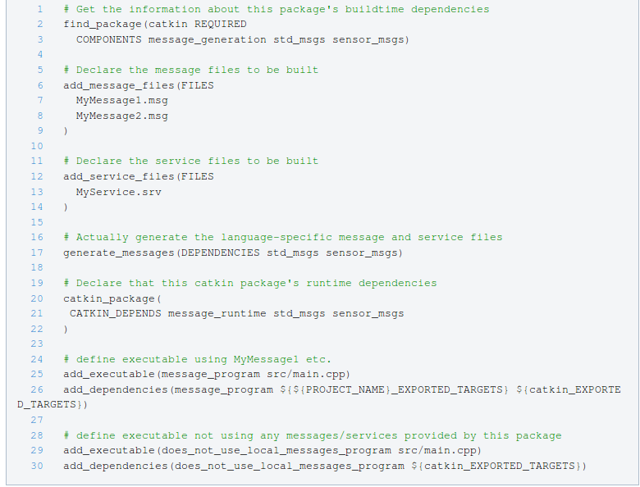
  - Resources
    - http://wiki.ros.org/ROS/Tutorials/CreatingMsgAndSrv
    - http://wiki.ros.org/catkin/CMakeLists.txt

Controlling the Lawnmower Through Wifi
1. Connect to the Husqvarna Wifi
- The Network will be titled: HRP_LTH_1
- The password is 1234567890
Troubleshooting:
- If you cannot see the wifi: wait a few moments (it may take time to boot up). If this doesn’t work, disassemble the robot (remove the charging cord, take the black lid off and unscrew the top part of the gray casing). The device emitting the wifi is a USB key plugged into the beagle-bone black. Press the WPS button on this until the blue light on the USB turns on.
- The password doesn’t work or it won’t connect: This is probably not because the password is wrong, but because some computers/operating systems/ wireless cards don’t want to/ can’t connect to WPS wifi (some security protocol? They only work with WPA? Not sure why). Try another operating system or computer.
  - MAC OS: doesn’t work (both iphones, macs, and macs running a Linux virtual machine)
  - Android phone: Works
  - Windows running Ubuntu virtual machine: Works
  - Ubuntu: sometimes works.
- It says connected, but no Internet: this is fine. You can’t use a browser, but you can operate the robot.
2. Start the lawnmower
- Turn on the lawn mower using the on switch and open the control panel lid
- Activate the robot by entering the pin: 1111
- Enter menu

- To set it up so it doesn’t need a boundary wire press and hold the buttons 7 and 9 simultaneously until the following symbol for the tools menu appears
- Press Start
- Close the control panel lid
3. SSH into the Robot
- ssh into the robot on your computer using
ssh ubuntu@192.168.100.1
  - The password is: ubuntu (no capitals)
Troubleshooting:
- The following error, ssh: connect to host 192.168.100.1 port 22: No route to host is shown.
  - CHECK that you are sshing to the right IP address.
  - If you are working in a virtual machine: Check that your IP address begins with 192.168. You must be using a bridged adapter connection which allows the virtual machine to have a distinct IP address from the host computer. Try restarting the virtual machine – sometimes it takes longer to recognize a change in wifi networks than the host.
  - Try opening the casing and making sure the USB is plugged into the Beaglebone properly. You could also press the WPS button on the USB key a few times.
4. Launch the master node
- In the terminal of the lawnmower (i.e. the one in which you are ssh) run:
- $ roslaunch am_driver_safe automower_hrp.launch
5. Configure the network
- Only necessary if you haven’t connected to the robot before
- Open a new terminal (i.e. a non lawn mower terminal)
- Add the following lines to the end of your /.bashrc file (where 192.168.X.X is your IP address)
export ROS_MASTER_URI=http://192.168.100.1:11311
export ROS_IP=192.168.X.X
export ROS_HOST_NAME=”192.168.X.X”
- Run the source ~/.bashrc command in your terminal
- Close the terminal
Troubleshooting
    - ifconfig should produce your IP address. Your can also try hostname -I
6. Launch nodes
- Open a new terminal on your computer
- Launch your chosen node
- Examples
  - rosrun am_driver hrp_teleop.py
Troubleshooting
- Can’t find master node: the ROS_MASTER_URI was probably set incorrectly. Try printenv ROS_MASTER_URI to check the value.
- If the robot doesn’t move after the node is launched, open the lid, press start and close it again.
- Warning: Clock skew detected. This won’t harm anything, but you can run
sudo date MMDDhhmmyyyy.ss
  - You can also try the following if there is Internet, (install ntp first)
ntpdate -s ntp.ubuntu.com Controlling the Lawnmower Through A USB Cable
- This error will probably appear in the lawnmower terminal– it is because the hrp files downloaded on the beaglebone or lawnmower system are an older version than the ones you cloned to your computer. DON’T WORRY about it. It shouldn’t cause any problems (at least, it didn’t at the time I was using it). If it begins to, you may needed to open the casing, connect the beaglebone to the Internet and re-download the files from Github into the appropriate folder.
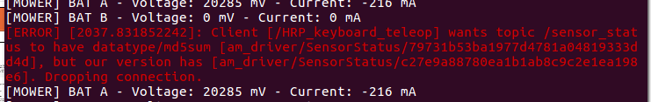

Controlling the Lawnmower Through A USB Cable
sudo gpasswd --add ${USER} dialout
Starting the mower
- Access the control panel by pressing the STOP button
- Enter the PIN securities setting and enter the pin 1111
- Press the "MENU" button once to access the menu
- Press and hold "7" and "9" simultaneously until a new item pops up in the menu in the shape of a wrench (press down twice to see it)
- Press "OK" to access the hidden menu
- Navigate to "Special Settings" and press "OK"
- Press "OK" to select "Override loop detection"
- Press "OK" to confirm this setting
- Plug one end of the USB cable into the bottom of the robot (the square end), and the other into your laptop
- Press "BACK" multiple times until you are back to the main menu
- roslaunch am_driver_safe automower_hrp.launch
- rosrun am_driver hrp_teleop.py / chmod +x controller.py
+ rosrun simple_controller controller.py
- Press the "START" button
- Close the lid to reload the STOP button

Running the Robot
Gazebo
- Run Gazebo simulation:
roslaunch am_gazebo am_gazebo_hrp.launch gui:=true
rosrun am_driver hrp_teleop.py
The Lidar
- Run hector slam roslaunch hector_slam_launch tutorial.launch
- Can also run
roslaunch rplidar_ros view_rplidar.launch
roslaunch rplidar_ros rplidar.launch
Resources
https://github.com/Slamtec/rplidar_sdk
https://github.com/slamtec/rplidar_ros
https://github.com/NickL77/RPLidar_Hector_SLAM (Scan with lidar into hectorslam)
http://lup.lub.lu.se/luur/download?func=downloadFile&recordOId=8915402&fileOId=8915426 (Thesis on SLAM algorithms)
Tutorial:
http://wiki.ros.org/action/fullsearch/ROS/Tutorials/WritingPublisherSubscriber%28c%2B%2B%29?action=fullsearch&context=180&value=linkto%3A%22ROS%2FTutorials%2FWritingPublisherSubscriber%28c%2B%2B%29%22

Gmapping
- Read the laser and transforms from robot → create a occupancy grid map (OGM)
roslaunch gmapping slam_gmapping_pr2.launch

Rviz
- Run rosrun rviz rviz
- Add LaserScan then add /scan as topic

RQT
- To see how nodes and topics relate run rqt

Map from logged data
- use catkin_make instead of rosmake gmapping
- when generating the data use: rosbag record -O mylaserdata /base /tf
- rosrun gmapping slam_gmapping scan:=scan (maybe unnecessary)
- Then sudo apt-get install ros-<distro>-map-server
- To get info from bag: rosbag info mylaserdata2.bag
Resources
http://wiki.ros.org/cn/slam_gmapping/Tutorials/MappingFromLoggedData#record

ROS tf tree:
- rosrun tf view_frames,
evince frames.pdf
- To view the tree:
runsomething
rosrun tf view_frames

Google Catogorpher
- Install the program sudo apt-get install -y python-wstool python-rosdep ninja-build
- wstool init ~/Documents/HusqvarnaMowerProject/catkin_ws/src
- wstool merge -t src
- wstool update -t src
- src/cartographer/scripts/install_proto3.sh
- sudo rosdep init
- rosdep update
- Do NOT use: rosdep install --from-paths src --ignore-src --rosdistro=${ROS_DISTRO} -y
Use: rosdep install --from-paths src --ignore-src -r -y
Resources
https://raw.githubusercontent.com/googlecartographer/cartographer_ros/master/cartographer_ros.rosinstall
https://google-cartographer-ros.readthedocs.io/en/latest/compilation.html#system-requirements

Navigation
- Find the git sources code and run git clone https://github.com/ros-planning/navigation.git
- Install these packages before catkin_make:
sudo apt-get install ros-kinetic-tf2-sensor-msgs
sudo apt-get install ros-kinetic-move-base-msgs
Navigation stack:01

