Setup
Assemble the crazyflie
https://www.bitcraze.io/getting-started-with-the-crazyflie-2-0/
- Follow the instructions to assemble the quadcopter (although it is probably already assembled)
- Download the appropriate software for your computer/ mobile phone. The recommended way is installing the crazyflie virtual machine, but installing the software on Linux also works (note: windows doesn’t provide development capability)
  - For the virtual machine
    - first download virtual box from https://www.virtualbox.org/wiki/Downloads. Also download the extension pack – this is necessary to enable USB support.
    - Then download the crazyflie virtual machine from bitcraze https://github.com/bitcraze/bitcraze-vm/releases/.
    - Double click the “Update all projects” desktop icon to pull the most recent version of the Github code to your computer.
    - Download the appropriate USB driver for the crazyradio for the OS the virtual machine is being run on
      - For windows: https://wiki.bitcraze.io/doc:crazyradio:install_windows_zadig
  - For Linux
    - install info: https://github.com/bitcraze/crazyflie-clients-python/blob/master/README.md.
    - Main firmware: https://github.com/bitcraze/crazyflie-firmware.
    - Communicate with the drone: https://github.com/bitcraze/crazyflie-lib-python
- Configure the Client
  - Start the Crazyflie client
  - Configure your Input Device
    - Xbox360: plug in, it should recognize it
    - HTC Vive controller
      - This takes more work – see setup the lighthouse
Fly the Crazyflie with controller
- Right click the usb botton on the bottom right of the VM screen (or in settings) and check both the Radio PA and your controller (otherwise the VM can’t see those things plugged into the USB port) have a check mark next to them.
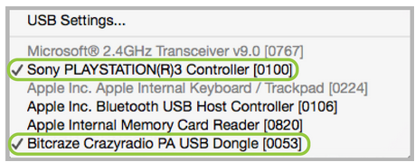

- Open the Crazyflie client inside the virtual machine (there should be a desktop shortcut)
  - Click scan, hopefully your drone will appear
  - Click connect to connect to the drone
  - Use the controller to fly the drone
- You may need to update the crazyflie firmware.
  - Get the file
    - Option A: Download the latest version from bitcraze, and keep it as a zip file on your computer https://github.com/bitcraze/crazyflie-release/releases.
    - Option B: If you have modified the firmware, and used the “make” command to compile it, it should be stored as cf2.bin inside projects/crazyflie-firmware
  - Press the power button on the crazyflie for three seconds to turn it on in bootloader mode. You should be disconnected from the drone.
  - Go to Connect → bootloader mode. Select the package to flash (probably one of the ones mentioned above) and then click “initiate bootloader cold boot”. Then click “program”.
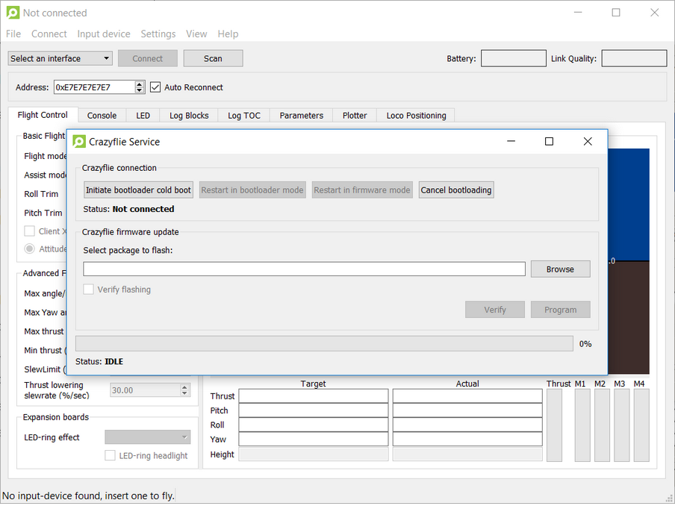

Setup the Lighthouse deck
- Install the following
- Install Python 2.7+ or 3.5+
- Install HTC Vive Stream: https://store.steampowered.com/about/ (you will have to create an account).
  - Once installed, open Steam and navigate to Library > Tools and scroll down until you find SteamVR. Double-click on SteamVR, select your install path and then hit the Next button
- Configure SteamVR to work without a headset (only necessary if you do not intend to use a headset)
- Locate this configuration file <Steam Directory>/steamapps/common/SteamVR/drivers/null/resources/settings/default.vrsettings and open it with a text editor
    - Change “enable” to true and save the file
- Locate this configuration file <Steam Directory>/steamapps/common/SteamVR/resources/settings/default.vrsettings
    - Change the “requireHmd” key under “steamvr”, to “false”
    - Change the “forcedDriver” key value to “null”.
    - Change the “activateMultipleDrivers” key value to “true”.
    - Save and close the file
- Download the crazyflie firmware to the steamVR computer https://github.com/bitcraze/crazyflie-firmware
    - open a command line window and navigate to the Crazyflie firmware.
    - Run python3 -m pip install openvr
Resources:
https://wiki.bitcraze.io/doc:lighthouse:setup
http://help.triadsemi.com/articles/836917-steamvr-tracking-without-an-hmd

Using the Lighthouse deck
- Setup the bases
- Mount the base stations in opposite corners of the flight space, angled 30-40 degrees down, two meters apart
- Set one base station to mode b and one to mode c by clicking the button on the back. Both stations should display a green light when working.
- Get the position of the two bases
- Launch SteamVR
Troubleshooting:
    - if it requires you to connect a headset, then repeat the configuration to work without a headset step above.
    - Without an HMD the master base station (the one in Mode B) will be at the origin of the space.
    - The base stations and controller/ HMD should be solid green and “tracking” according to SteamVR
- If using an HMD
  - Place the HMD at the desired origin of the space. The x-axis of the space will be facing forward out of the HMD, and the origin will be 40cm above the HMD. Raise the display 1.5-2 cm to align the z-axis properly
  - Open SteamVR settings → developer.
    - Hit quick calibrate to set the coordinate system. Ensure the system is working correctly by opening Room overview and moving the headset/ controllers about
- Navigate to crazyflie-firmware/tools/lighthouse and run python3 get_bs_position.py
- This should produce some lines of code, with the position of the lighthouse bases, resembling the following. Copy the last two lines of code.
- Inside the bitcraze VM or the bitcraze client (whichever you are using) navigate to crazyflie-firmware/src/deck/drivers/src, open lighthouse.c and paste these two lines in place of whatever is insider the baseStationsGeometry[] function. Also comment out the line #define DISABLE_LIGHTHOUSE_DRIVER.
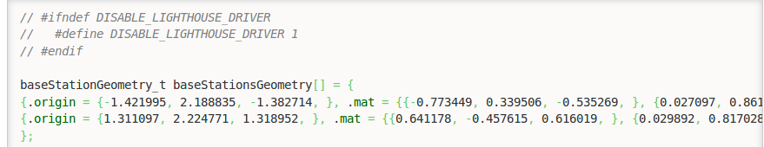

The SteamVR can be closed, and the VR kit unplugged. The crazyflie radio should be plugged in.

- Compile and upload the firmware
- Navigate to crazyflie-firmware in the terminal and run the command make
- Upload the file crazyflie-firmware/cf2.bin to all drones
Troubleshooting
    - If you are not using the bitcraze VM, various things must be installed (see the readme file https://github.com/bitcraze/crazyflie-firmware)
- Verify positioning
- Go into the plotter tab (which can be enabled using View→ Tabs → Plotter)
- The safest way to verify the orientation of the space is to look at the estimated position. In the client you can create a new log block in “settings/logging configuration” containing “stateEstimate.x/y/z”.
- The positions from the state estimate x y z should correspond to the global x y z
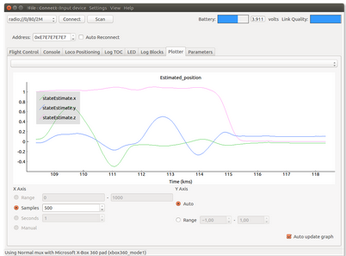

crazyflie for ROS
http://wiki.ros.org/crazyflie
https://github.com/whoenig/crazyflie_ros

Useful Resources
