Paper Title (U.S. letter size)

Chris Brown*a, Henry Williamsb   
aDepartment of Data Science, University of West America, 345 Deep Learning Drive, Los Angeles, CA, USA 55555-0123; bDepartment of Statistics, University of Central America, 9876 Convolutional Ave., Philadelphia, PA USA 55555-1234

Abstract

Begin the abstract two lines below author names and addresses. The abstract summarizes key findings in the paper. It is a paragraph of 250 words or less.For the **keywords**, select up to 8 key terms for a search on your manuscript's subject.

**Keywords:** Times Roman, image area, acronyms, references

# INTRODUCTION

Begin the Introduction two lines below the Keywords. The manuscript should not have headers, footers, or page numbers. It should be in a one-column format. References are often noted in the text1 and cited at the end of the paper.

## Margins

If the paper does not have the margins shown in Table 1, it will not upload properly.

Table 1. Margins and print area specifications.

**PAPER MARGINS**

A4 Letter

Top margin 2.54 cm  *(1in.)* Top margin 1.0 in.  *(2.54 cm)*

Bottom margin 4.94 cm *(1.95 in.)* Bottom margin 1.25 in. *(3.17 cm)*

Left, right margin 1.925 cm *(.76 in.)* Left, right margin .875 in.  *(2.22 cm)*

Printable area--all text, figures and footnotes:   
A4: 17.15×22.23 cm Letter : 6.75×8.75 in.

## Fonts

Table 2 shows the font sizes and highlighting in a typical manuscript. These font "styles" are contained with this sample manuscript and Section 4 below explains how to use them. Use Times Roman or another standard font to avoid font errors.

*chris@uwa.edu; phone 1 222 555-1234; fax 1 222 555-876  
Table 2. Manuscript font sizes and formatting. This Microsoft Word template includes these formats as automated "styles,” which can be selected in the Format menu -- Styles and Formatting. (9pt)

## Preformatted JDSAI Template Styles

## *Manuscript component Description*

## JDSAI paper title 16 pt. bold, center

## JDSAI authors/affiliations 12 pt., center

**Keywords:** *Keywords* 10 pt., left justify

### JDSAI ABSTRAC**T TITLE** 11 pt. BOLD, center

JDSAI abstract body text 10 pt., justify

### JDSAI SECTION HEADING 11 pt. BOLD, center, whole numbers

**1.1 Heading 2, JDSAI subsection heading 10 pt. bold, left justify, subsection numbers**

JDSAI body text 10 pt., justify

JDSAI figure caption 9 pt., justify below figure

JDSAI table caption 9 pt., justify above figure

JDSAI footnote text 9 pt., justify, numbered

**REFERENCE HEADING 11 pt. BOLD, center**

1. JDSAI reference listing 10 pt., justify, numbered in brackets

# Formatting of manuscript components

## Title

Center the paper title at the top of the page in 16-pt. bold. Only the first word, proper nouns, and acronyms are capitalized. Keep titles brief and descriptive. Spell out acronyms unless they are widely known. Avoid starting with articles or prepositions, e.g., “The study of … ,” or, “On the ….”

## Author affiliations

The author list is in 12-pt. regular, centered. Omit titles and degrees such as Dr., Prof., Ph.D., etc. The list of affiliations follows. Each author's affiliation should be clearly noted.

## Section headings

Section headings are 11-pt. bold capitals, centered. Sections numbers have whole numbers, e.g., 1, 2, 3… Don't number the "Acknowledgements" and "References." Headings often used are: 1. Introduction, 2. Methodology, 3. Data, 4. Results, and 5. Conclusions**.**

## Subsection heading

Subsection headings are left-justified, 10-pt. bold. Capitalize the first word, acronyms, and proper nouns.

## Paragraphs

Add a blank line above and below section headings and between paragraphs. Avoid headings or one-line paragraphs at the top or bottom of a page by using page breaks or extra blank lines. One method to preserve page breaks is to make the bottom margin a little larger than the specifications. Indentation is optional. This spacing is automatic if you are using the JDSAI "section" styles in Word.

## Text

Text is 10 point and justified. Each sentence ends with a period and a single space before the next sentence.

## Figures and captions

Figures are centered. Use or insert .jpg, .tiff, or .gif illustrations instead of PowerPoint or graphic constructions. Captions go below figures. Indent 5 spaces from left margin and justify.

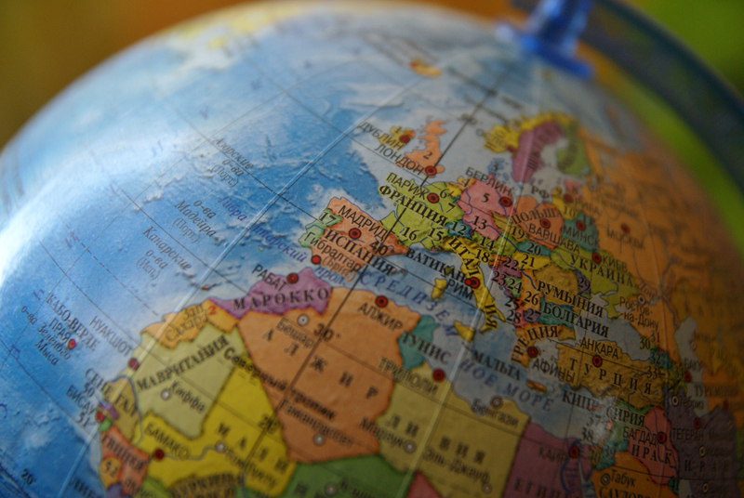

Figure 1. Figure captions are indented 5 spaces and justified. If you are familiar with Word styles, you can insert a field code called Seq figure which automatically numbers your figures.

## Tables and captions

Tables are centered. The caption goes above the table. The caption text should indent 5 spaces from left margin and justify. Table examples are on page 1 and 2 and below.

# Mathematical Equations

Use common fonts like Times Roman in your math equations. A math reference in a paragraph sentence such as  is not numbered. The steps of a mathematical argument can be numbered using a right-aligned tab for clarity, for example

α =  (1)

and

*ρ*=. (2)

References

1. I. Goodfellow, Y. Bengio, and A. Courville, [Deep Learning], MIT Press, Cambridge, 50-58 (2016).
2. Y. Lecun, L. Bottou, Y. Bengio, and P. Haffner, “Gradient-based learning applied to document recognition,” Proceedings of the IEEE, vol. 86, no. 11, pp. 2278–2324, Nov 1998.
3. A. Krizhevsky, I. Sutskever, and G. E. Hinton, “Imagenet classification with deep convolutional neural networks,” pp. 1097–1105, 2012.
4. K. Simonyan and A. Zisserman, “Very deep convolutional networks for large-scale image recognition,” vol. abs/1409.1556, 2014. [Online]. Available: http://arxiv.org/abs/1409.1556
5. C. Szegedy, W. Liu, Y. Jia, P. Sermanet, S. Reed, D. Anguelov, D. Erhan, V. Vanhoucke, and A. Rabinovich, “Going deeper with convolutions,” in 2015 IEEE Conference on Computer Vision and Pattern Recognition (CVPR), vol. 00, June 2015, pp. 1–9. [Online]. Available: doi.ieeecomputersociety.org/10.1109/CVPR.2015.7298594
6. C. Szegedy, V. Vanhoucke, S. Ioffe, J. Shlens, and Z. Wojna, “Rethinking the inception architecture for computer vision,” in 2016 IEEE Conference on Computer Vision and Pattern Recognition (CVPR), June 2016, pp. 2818–2826.
7. K. He, X. Zhang, S. Ren, and J. Sun, “Deep residual learning for image recognition,” 2016 IEEE Conference on Computer Vision and Pattern Recognition (CVPR), pp. 770–778, 2016. [12] C. Szegedy, S. Ioffe, V. Vanhoucke, and A. A. Alemi, “Inception-v4, inception-resnet and the impact of residual connections on learning,” in AAAI, 2017.
8. F. Chollet, “Xception: Deep learning with depthwise separable convolutions,” 2017 IEEE Conference on Computer Vision and Pattern Recognition (CVPR), pp. 1800–1807, 2017.
9. G. Huang, Z. Liu, L. v. d. Maaten, and K. Q. Weinberger, “Densely connected convolutional networks,” in 2017 IEEE Conference on Computer Vision and Pattern Recognition (CVPR), July 2017, pp. 2261–2269.

[10] B. Zoph, V. Vasudevan, J. Shlens, and Q. V. Le, “Learning transferable architectures for scalable image recognition,” vol. abs/1707.07012, 2017. [Online]. Available: http://arxiv.org/abs/1707.07012