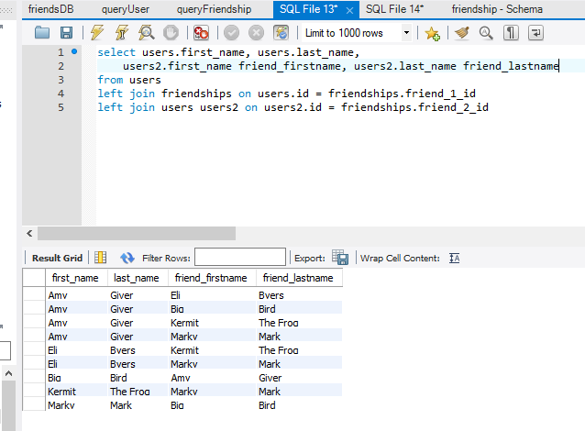

1. Return all users who are friends with Kermit, make sure their names are displayed in results.

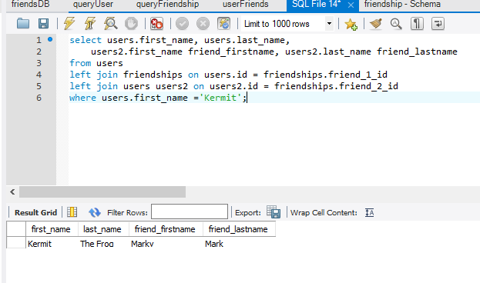

1. Return the count of all friendships

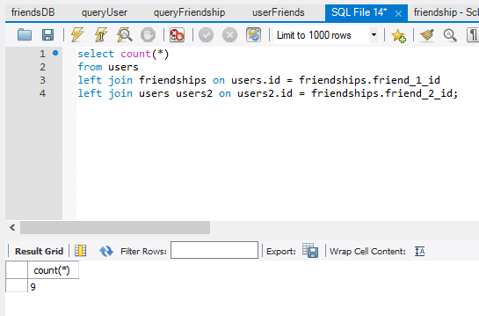

1. Find out who has the most friends and return the count of their friends.

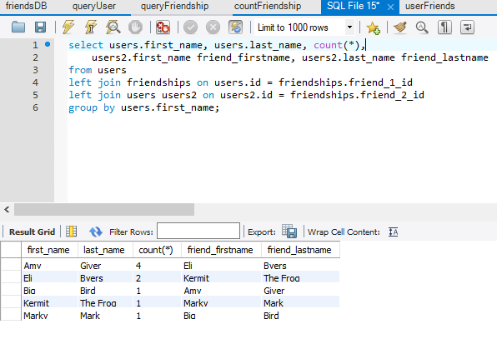

1. Create a new user and make them friends with Eli Byers, Kermit The Frog, and Marky Mark

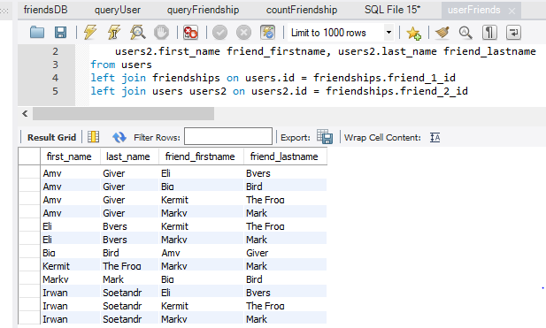

1. Return the friends of Eli in alphabetical order

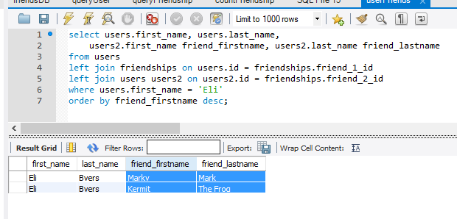

1. Remove Marky Marky from Eli’s friends.

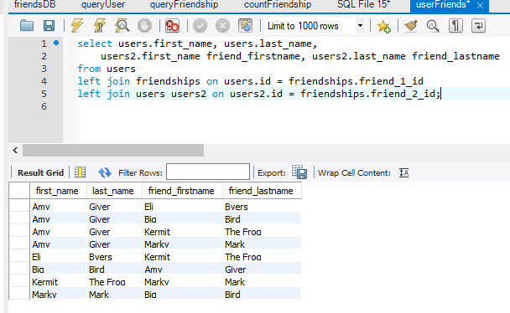

1. Return all friendships, displaying just the first and last name of both friends