1. Query World Language ‘Slovene’

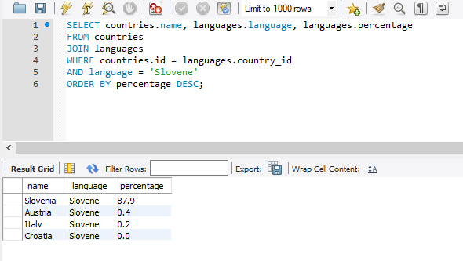

1. Total number of cities for each country.

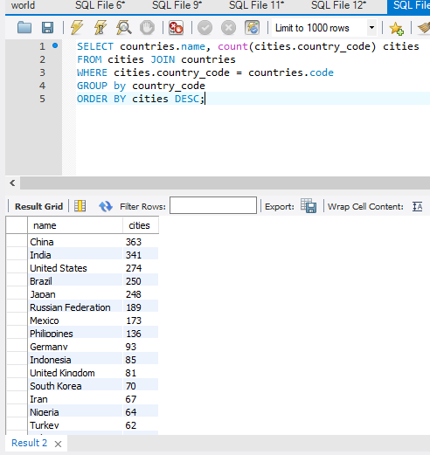

1. cities in Mexico with a population of greater than 500,000

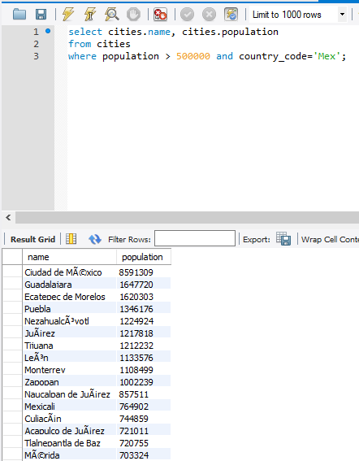

1. all languages in each country with a percentage greater than 89%

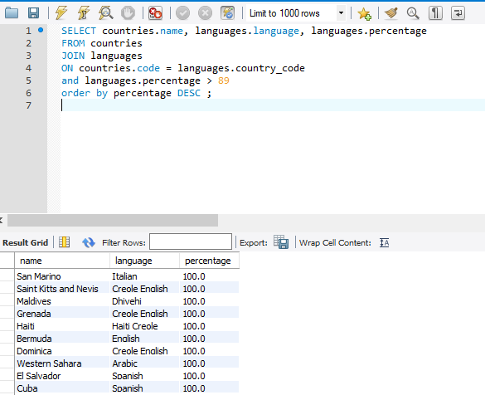

1. countries with Surface Area below 501 and Population greater than 100,000

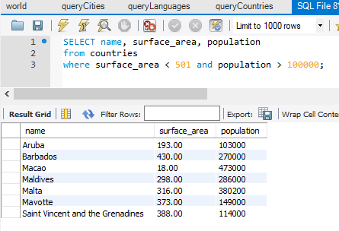

6. What query would you run to get all Constitutional Monarchy Countries with a capital greater than 200 and a life expectancy greater than 75 years.

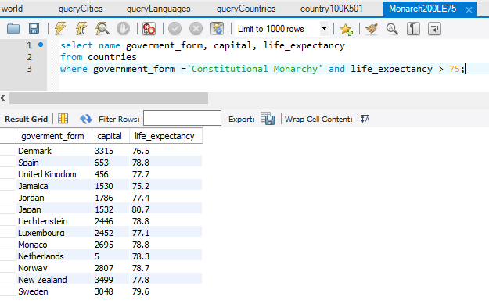

7. What query would you run to get all the cities of Argentina inside the Buenos Aires district and have population greater than 500, 000. The query should return the Country Name, City Name, District and Population.

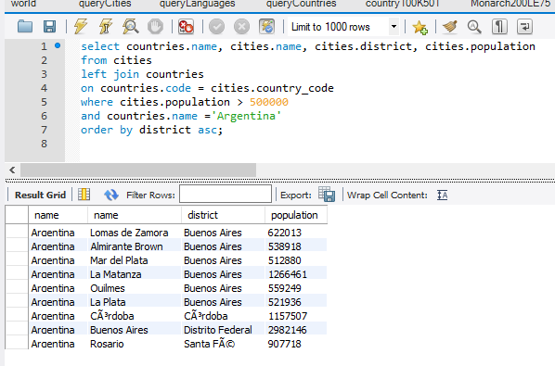

8. What query would you run to summarize the number of countries in each region. The query should display the name of the region and the number of countries. Also, the query should arrange the result by number of countries in descending order.

