1. What query would you run to get all the customers inside city_id = 312? Your query should returm customer first name, last name, email, and address.

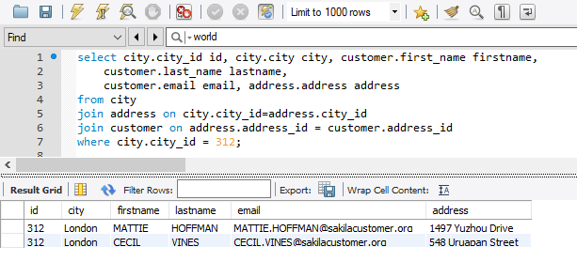

1. What query would you run to get all comedy films? Your query would return film title, description, release year, rating, special features and genre.

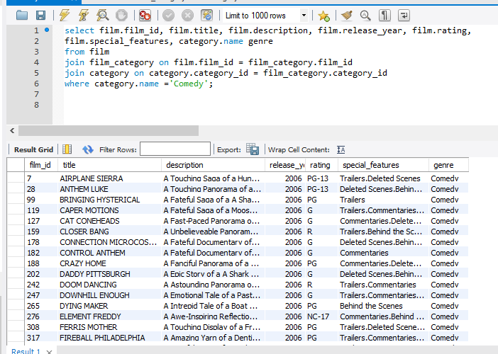

1. What query would you run to get all the films joined by actor_id=5? Your query shoud return the film title, description and release year.

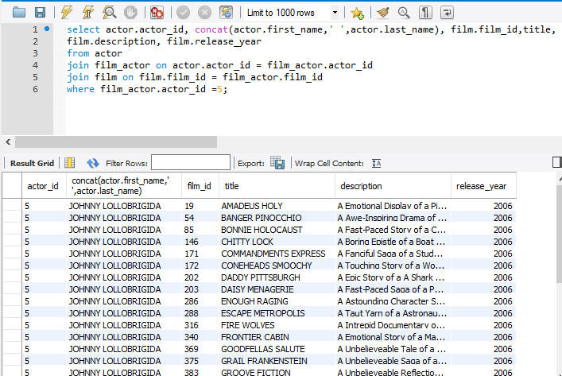

1. What query would you run to get all the customers in store_id = 1 and inside these cities (1, 42, 312 and 459)? Your query should return customer first name, last name, email, and address.

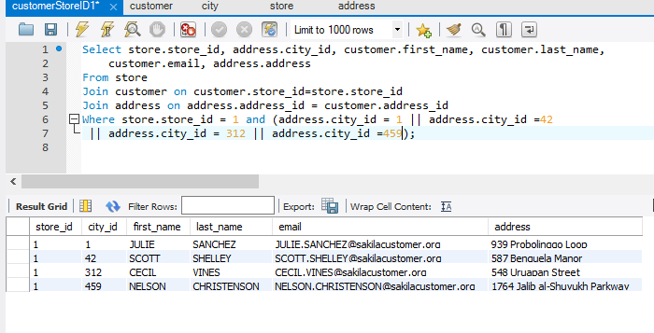

1. What query would you run to get all the films with a rating = G and special feature = behind the scenes, joined by actor_id = 15? Your query shoud return the film title, description, release year, rate and special feature.

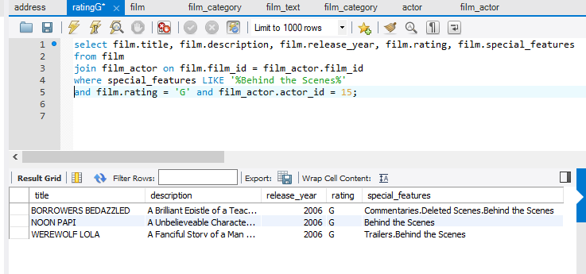

1. What query would you run to get all the actors that joined in the film_id = 369? Your query should return the first_name, last name and last_update of the actors.

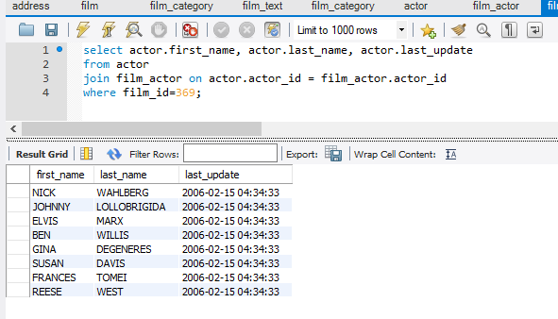

1. What query would you run to get all drama films with a rental rate of 2.99 ? Your query should return film title, description, release year, rating, special features and genre.

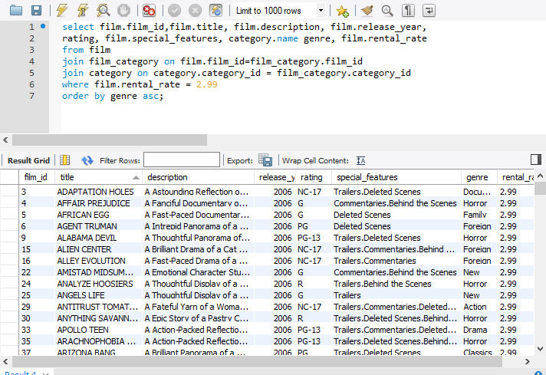

1. What query would you run to get all the action films joined by SANDRA KILMER. Your query should return film title, description, release year, rating, special features, genre and actor's first name and last name

