Order-Inventory-System-Evidence

Contents
1. Project Setup and Build 2
Pod running in k8s 3
2. Service Discovery (Eureka) 3
3. API Gateway Routing 4
4. IAM Service (Authentication) 5
5. Order Service 6
Placing the order: 6
Placing the order:- 6
Fetching the order 7
Update Order 8
6. Inventory Service 8
Show all the products 9
Update the existing product: 9
Adding new Product 10
Deduct Stock 10
warning when inventory is low. 11

- Project Setup and Build
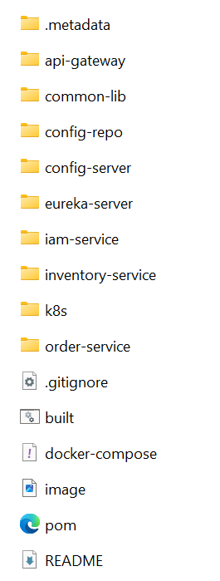

mvn clean package -DskipTests
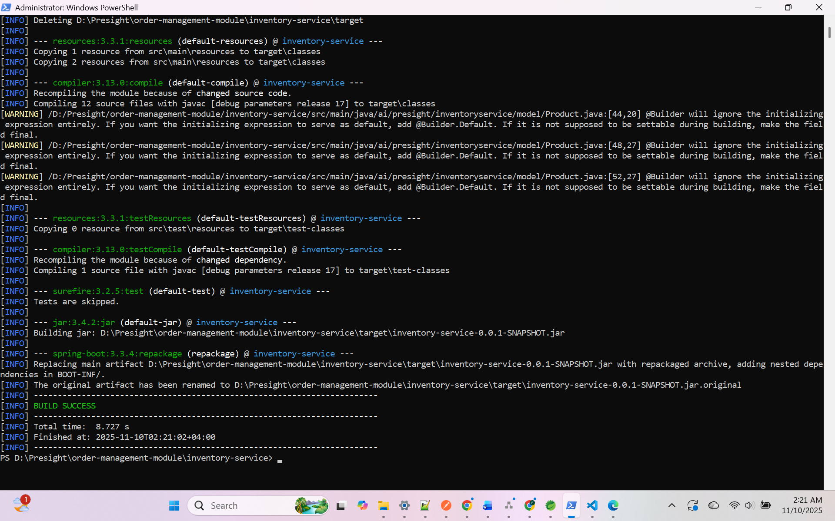

Pod running in k8s
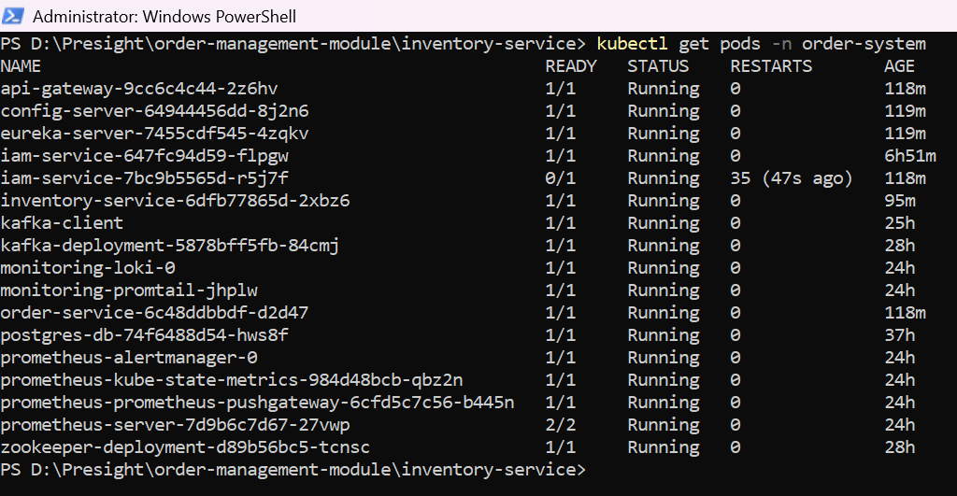

- Service Discovery (Eureka)
All microservices successfully registered with the Eureka server for dynamic service discovery.
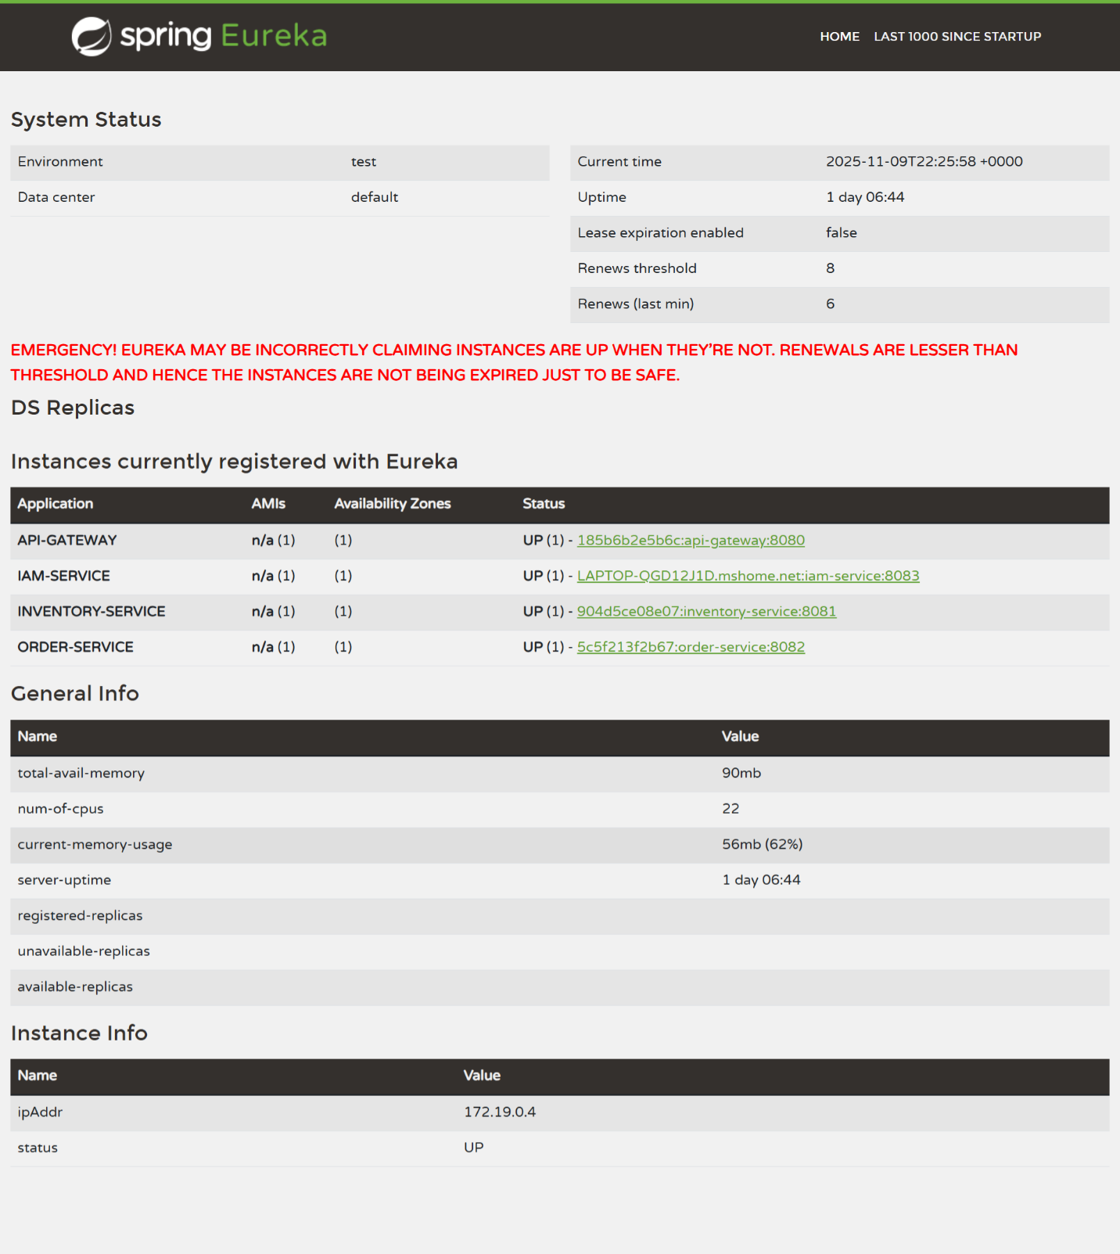
- API Gateway Routing

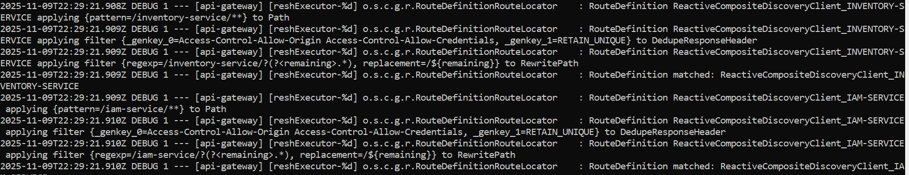

- IAM Service (Authentication)
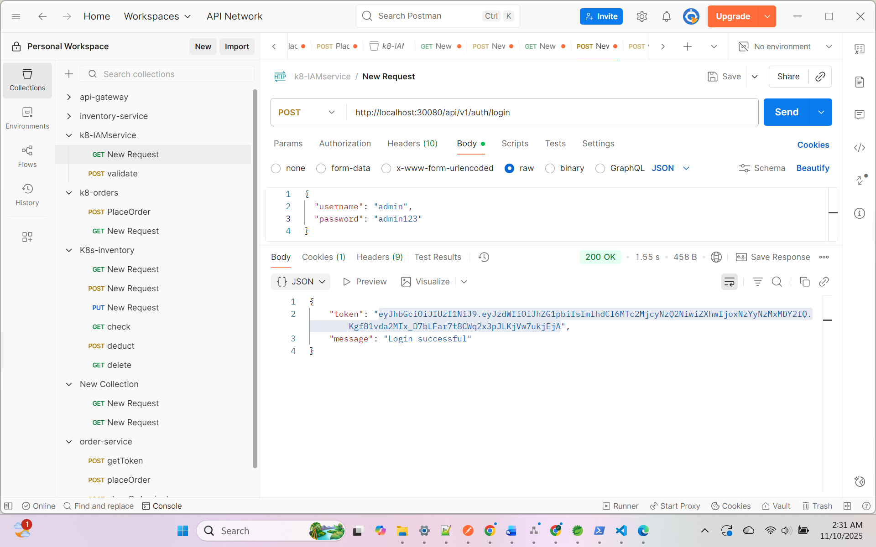
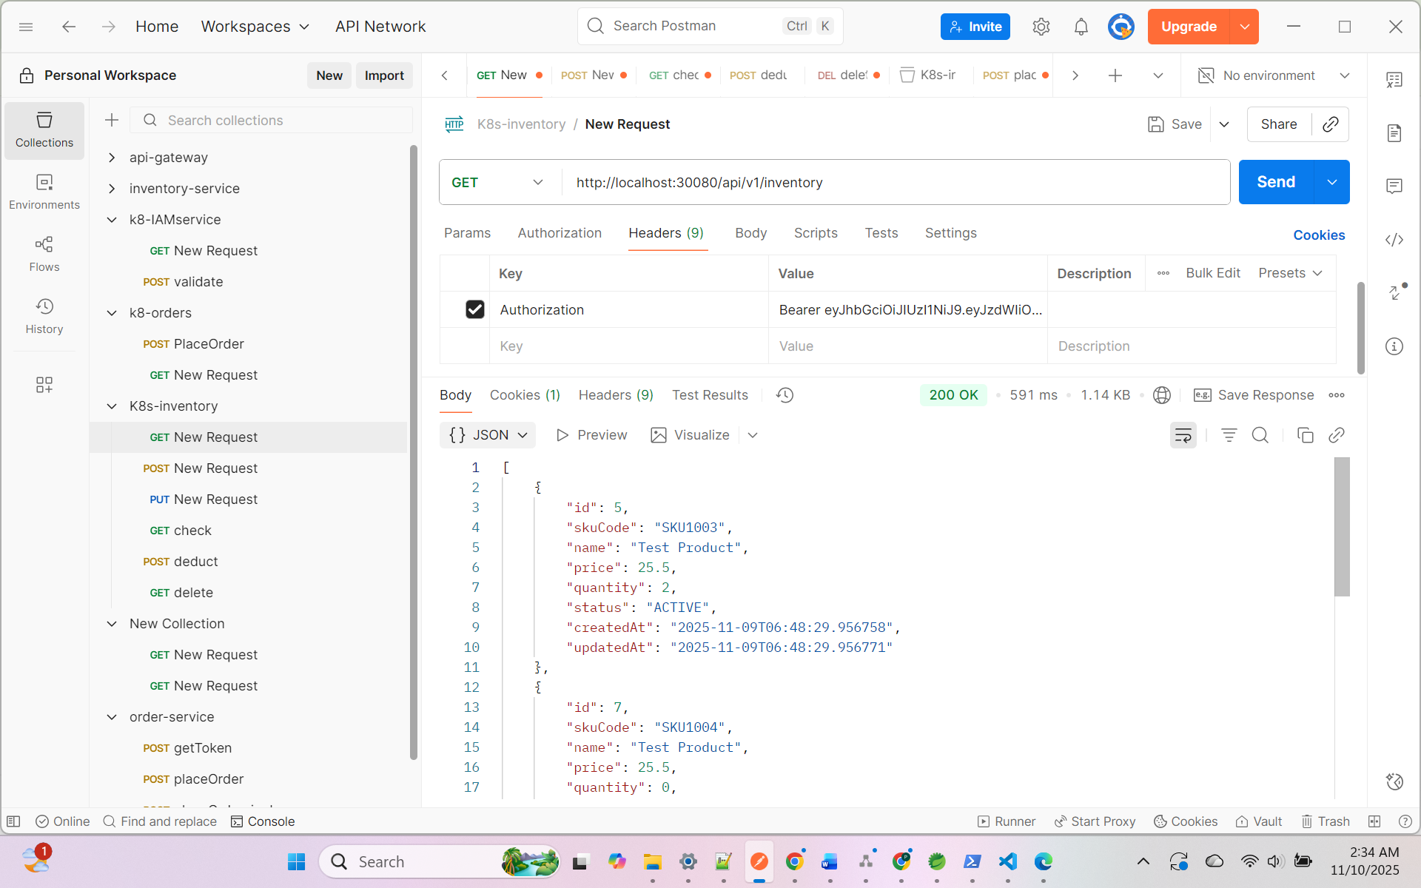

- Order Service

Placing the order:

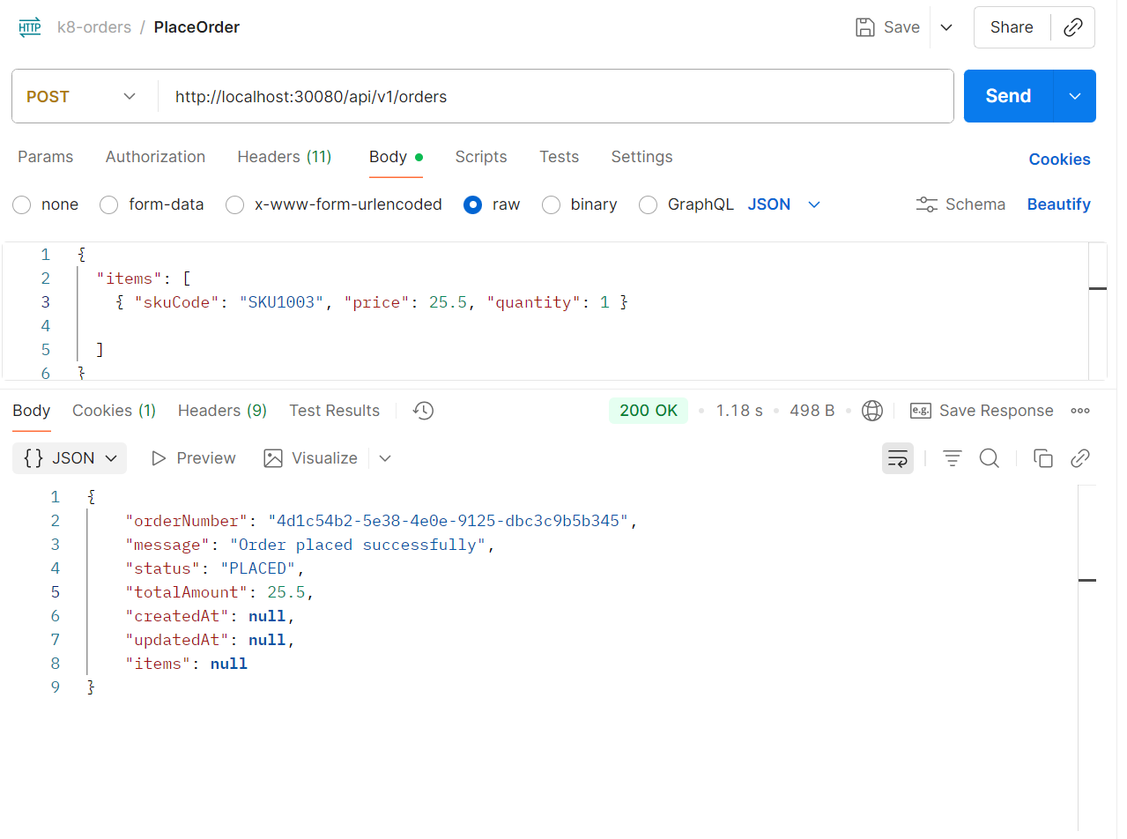
Placing the order:-
With out JWT token by disabling the Authorization – Error scenario

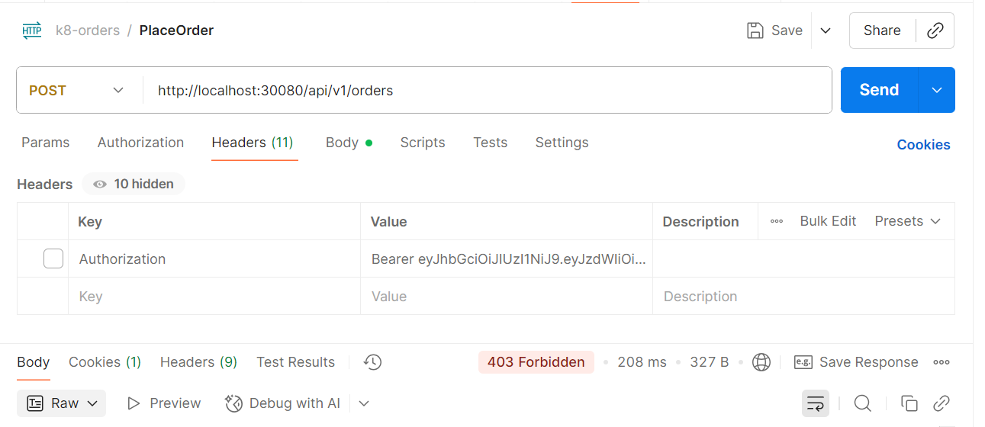

Fetching the order

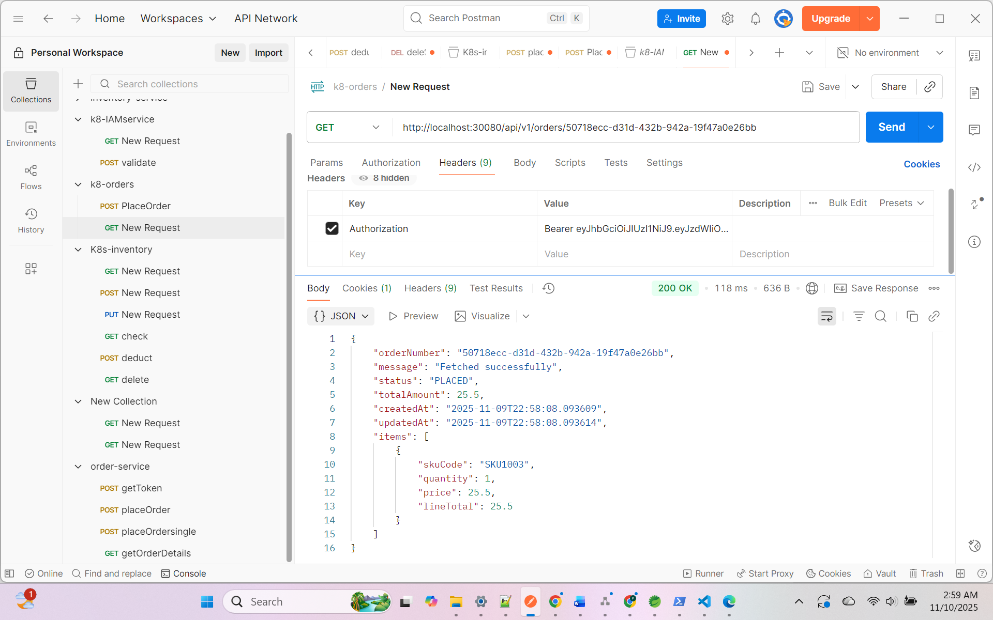

Update Order

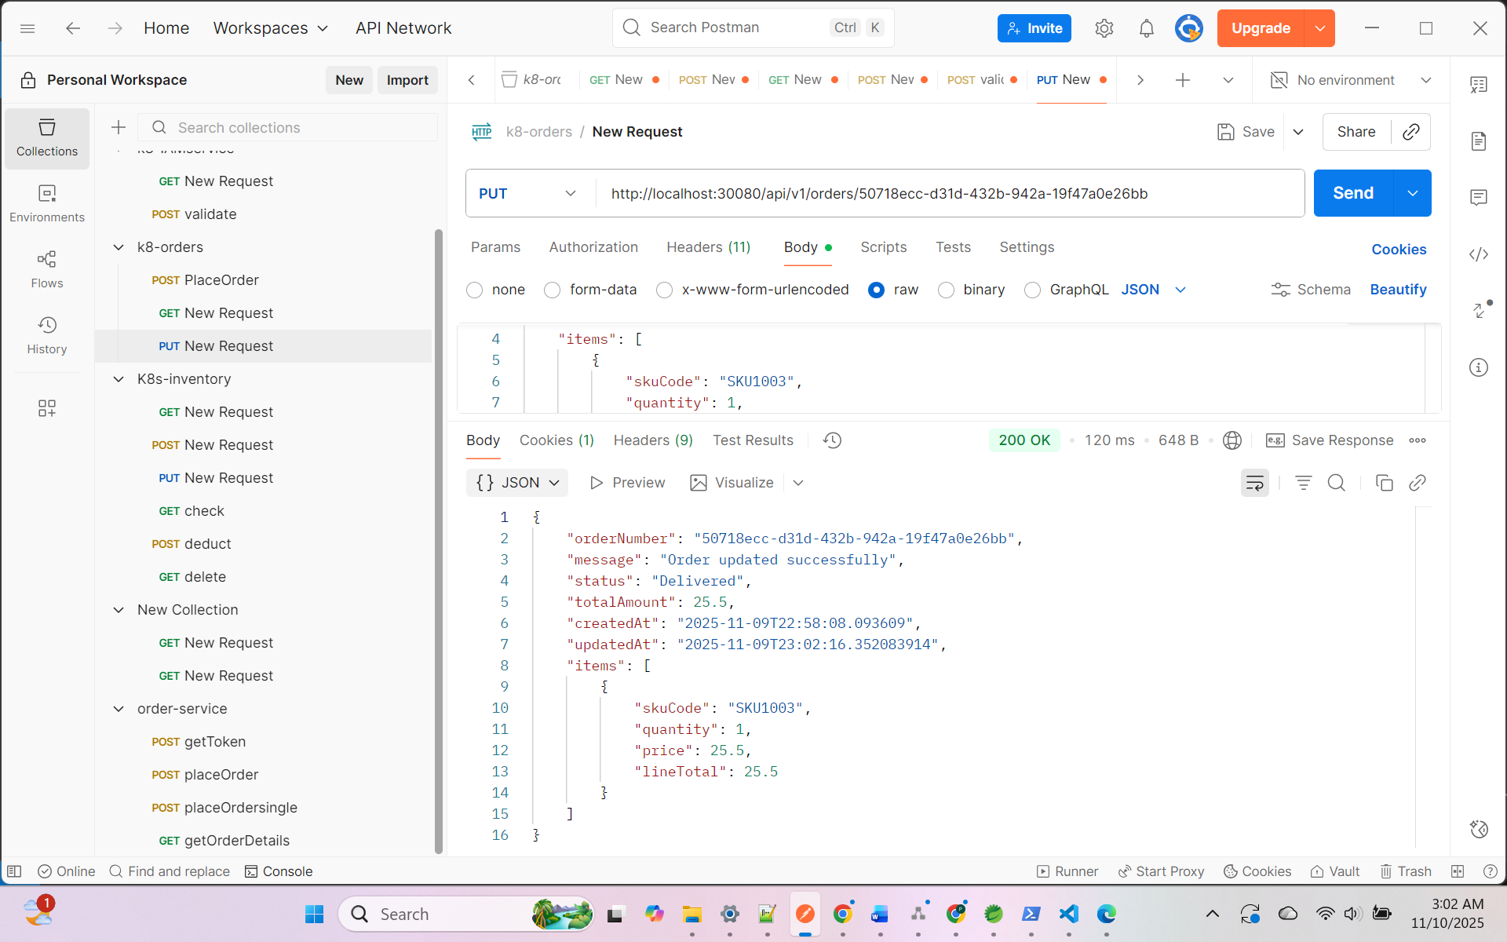

- Inventory Service

Show all the products
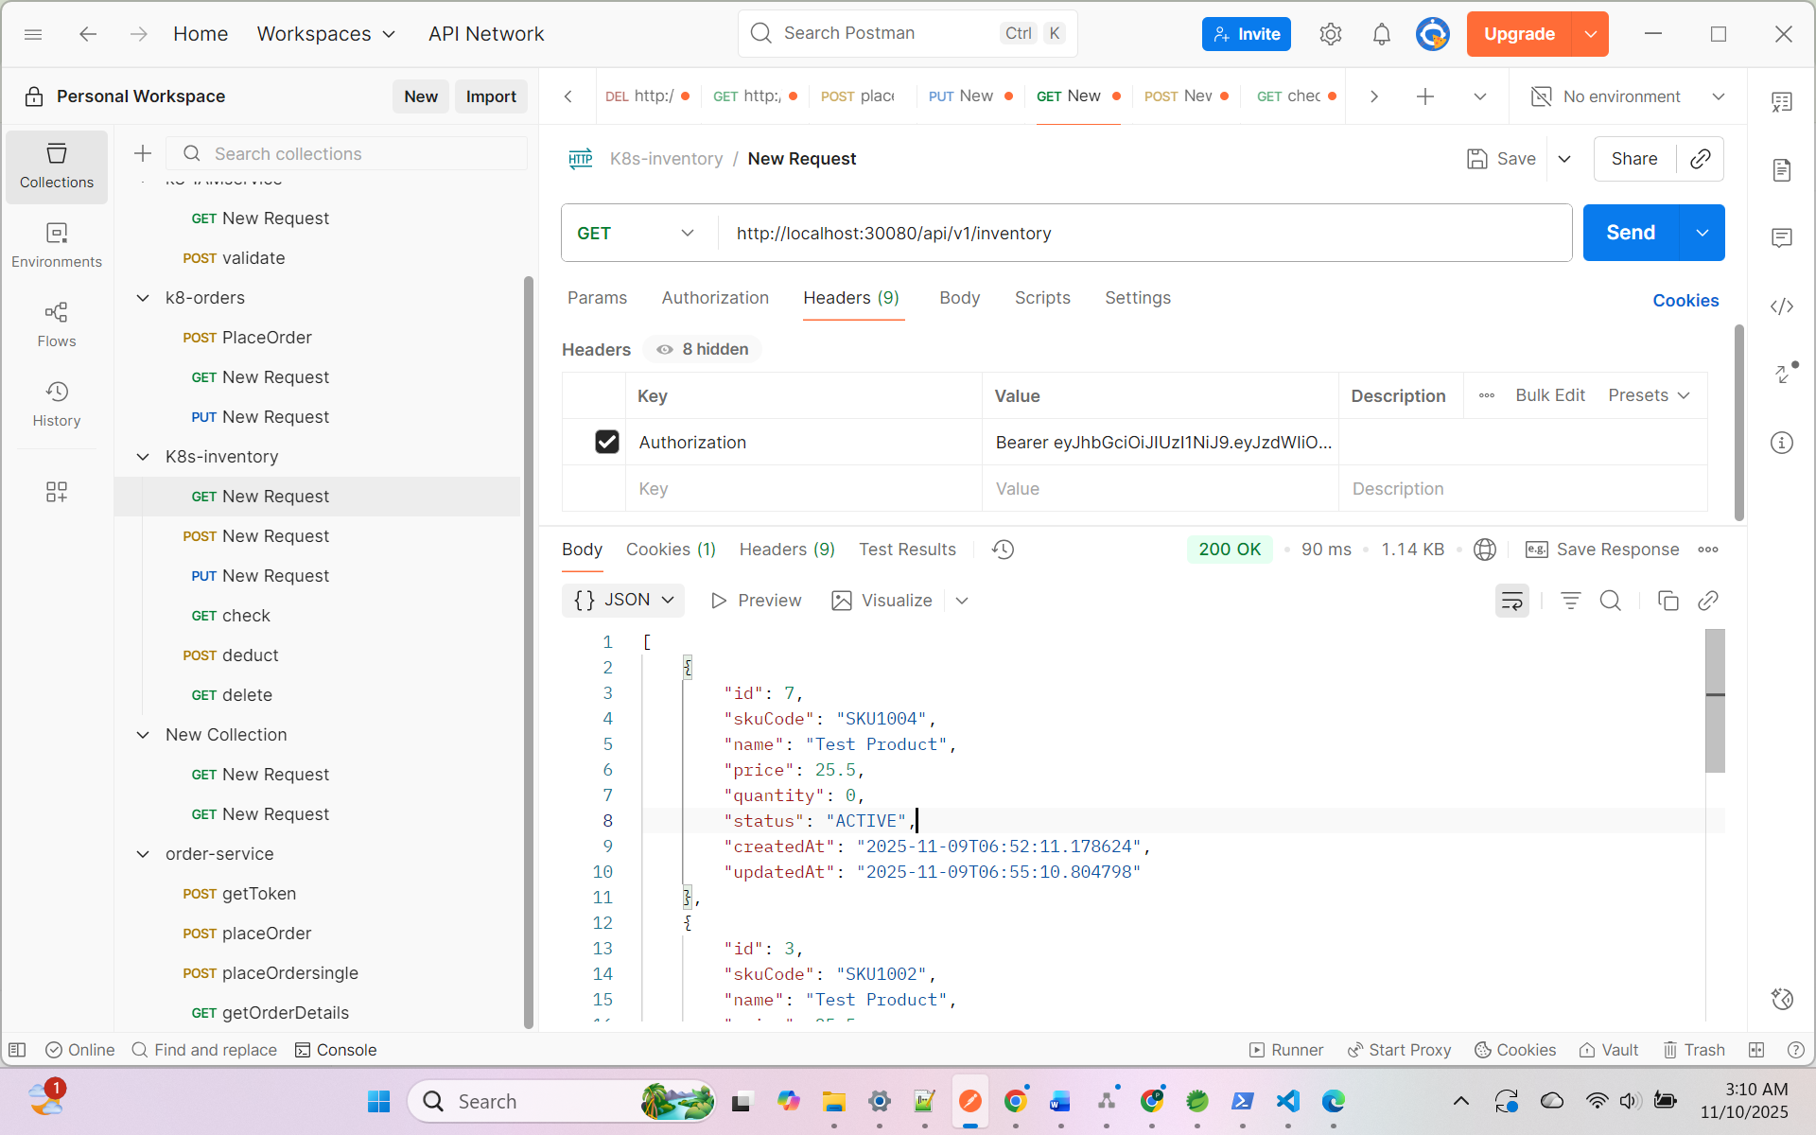

Update the existing product:
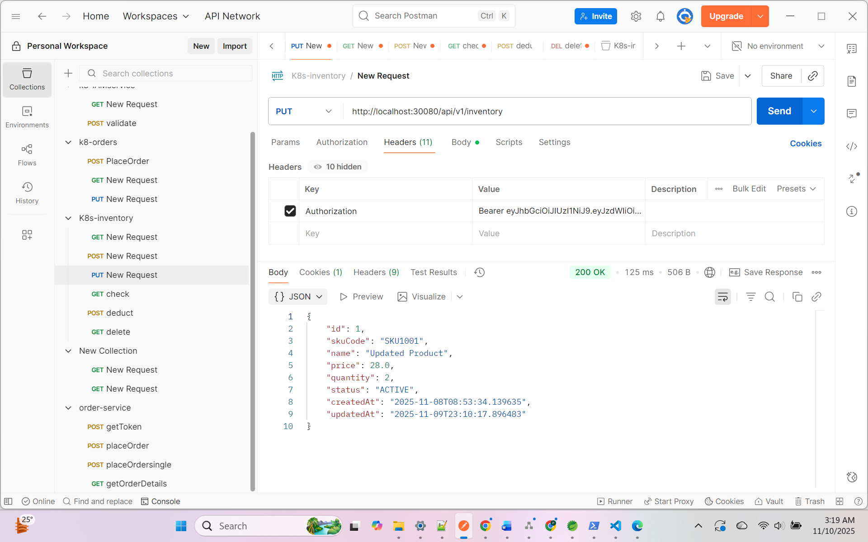

Adding new Product
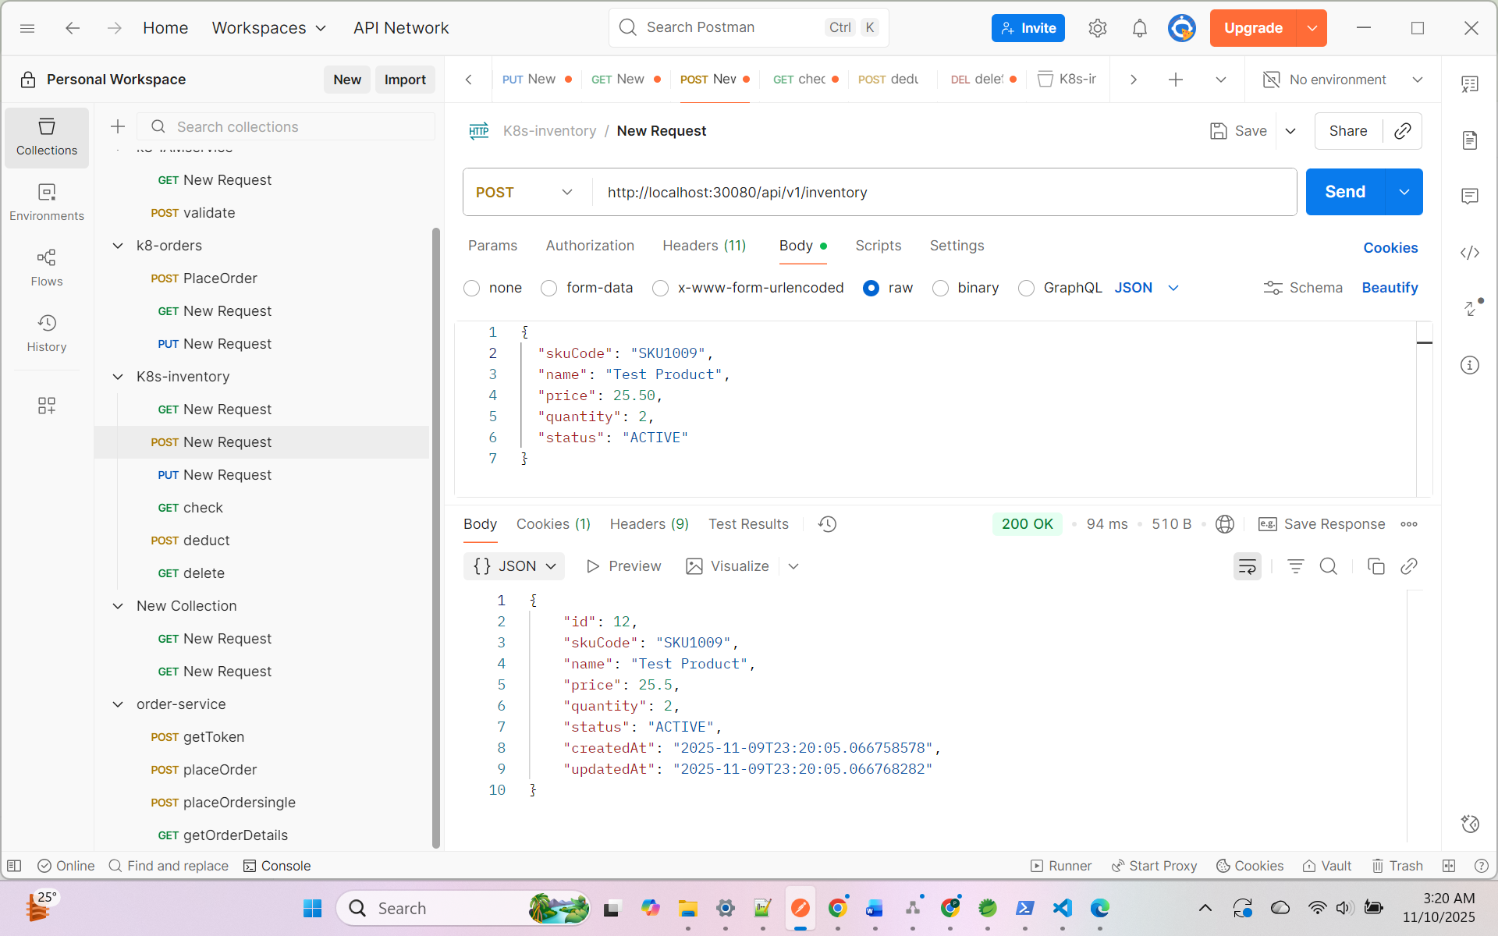

Deduct Stock

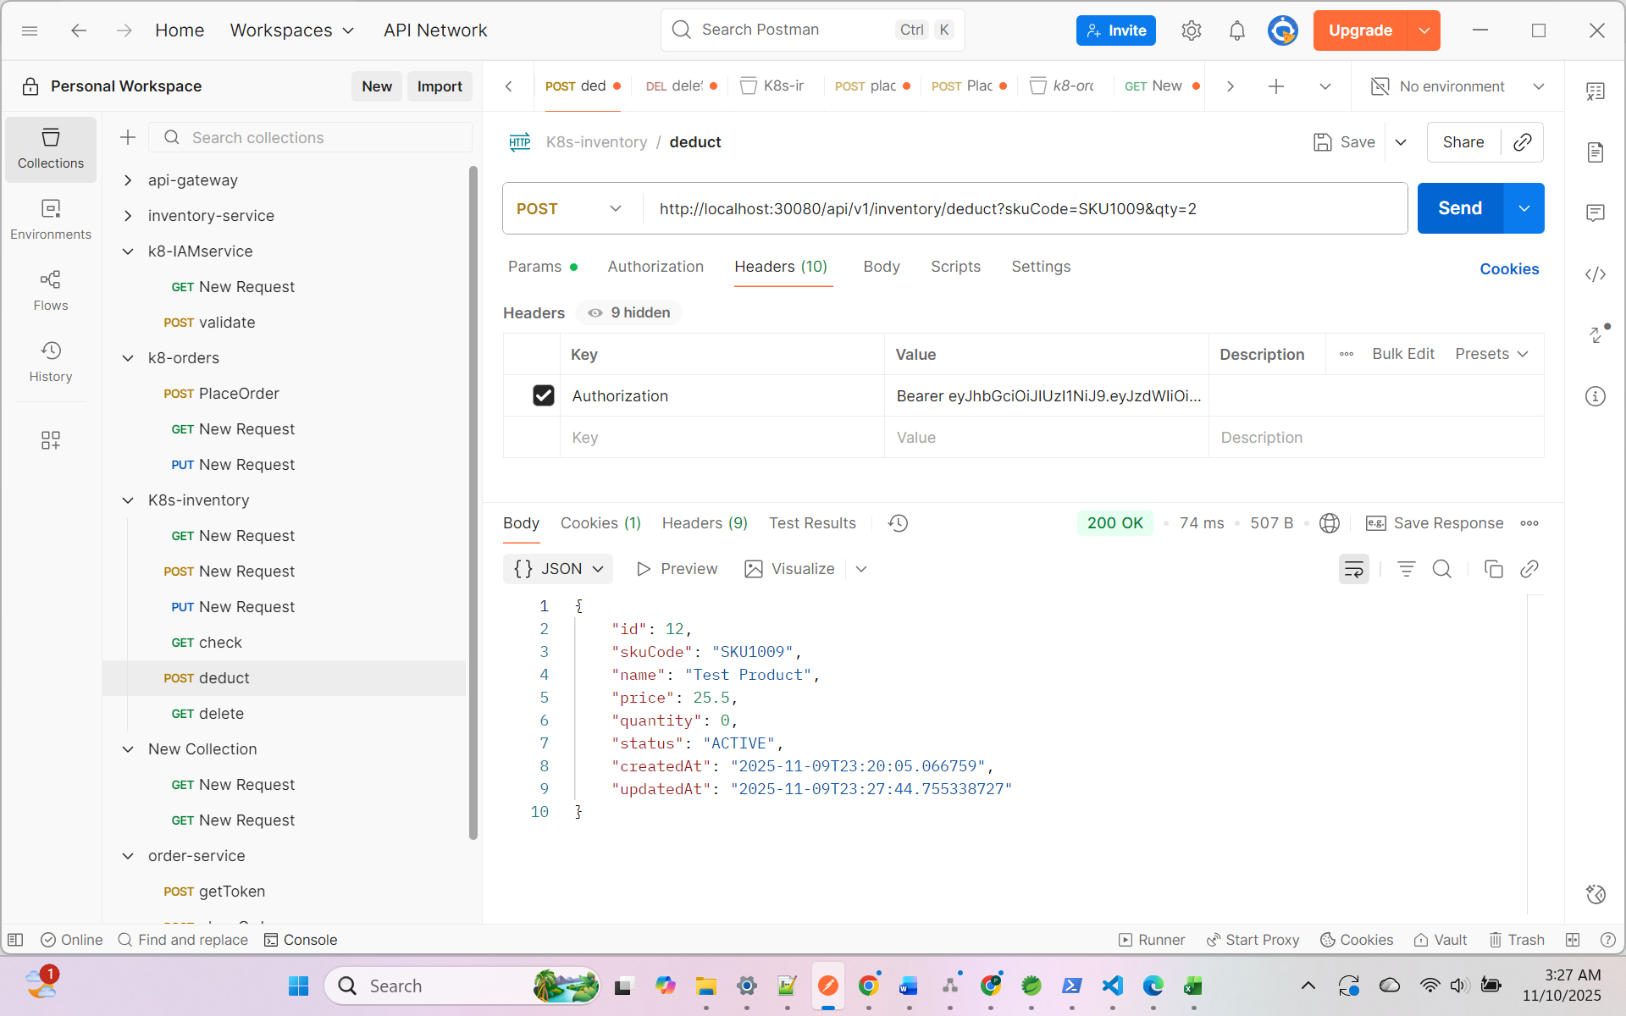

Warning when inventory is low.

2025-11-09T23:27:44.759Z INFO 1 --- [inventory-service] [nio-8081-exec-8] a.p.i.controller.ProductController : Stock deducted for SKU [SKU1009], remaining quantity: 0
2025-11-09T23:27:44.762Z INFO 1 --- [inventory-service] [nio-8081-exec-8] a.p.i.config.InventoryJwtAuthFilter : 🔚 [InventoryJwtAuthFilter] Completed filtering for /api/v1/inventory/deduct
2025-11-09T23:27:44.766Z INFO 1 --- [inventory-service] [vice-producer-1] a.p.i.event.LowStockPublisher : ✅ LowStockEvent sent successfully: LowStockEvent(skuCode=SKU1009, remainingQty=0)

