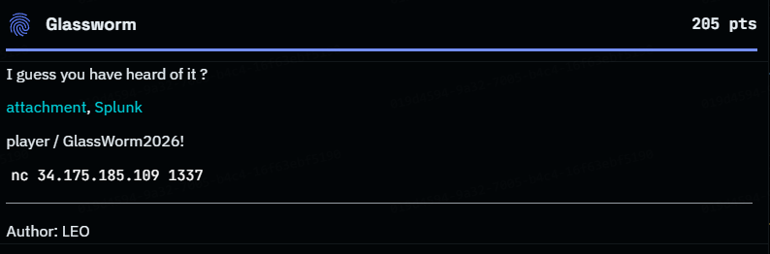

FLAG: CITEFLAG{f9c2d1b8e4a7365b9d2f8e1a4c7b0d9e}

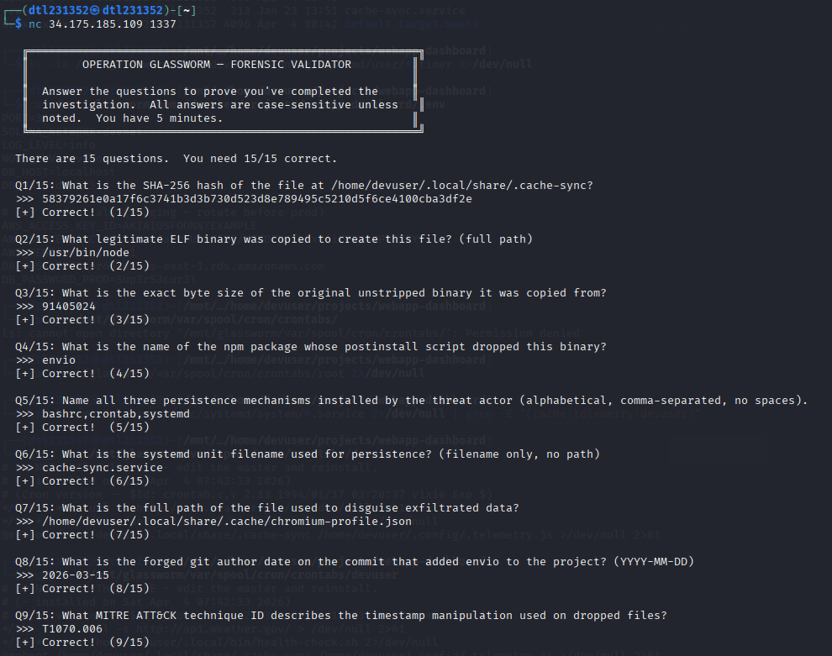

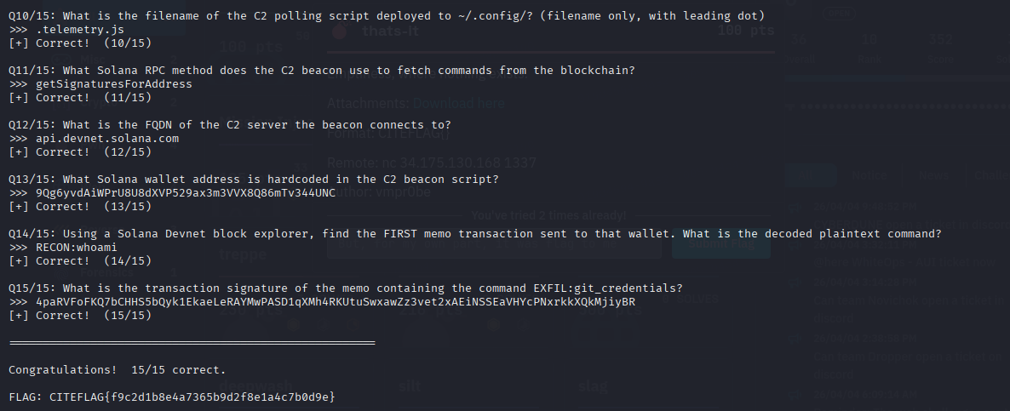

┌──(dtl231352㉿dtl231352)-[~]
└─$ nc 34.175.185.109 1337

╔══════════════════════════════════════════════════════════╗
║ OPERATION GLASSWORM — FORENSIC VALIDATOR ║
║ ║
║ Answer the questions to prove you've completed the ║
║ investigation. All answers are case-sensitive unless ║
║ noted. You have 5 minutes. ║
╚══════════════════════════════════════════════════════════╝

There are 15 questions. You need 15/15 correct.

Q1/15: What is the SHA-256 hash of the file at /home/devuser/.local/share/.cache-sync?
>>> 58379261e0a17f6c3741b3d3b730d523d8e789495c5210d5f6ce4100cba3df2e
[+] Correct! (1/15)

Q2/15: What legitimate ELF binary was copied to create this file? (full path)
>>> /usr/bin/node
[+] Correct! (2/15)

Q3/15: What is the exact byte size of the original unstripped binary it was copied from?
>>> 91405024
[+] Correct! (3/15)

Q4/15: What is the name of the npm package whose postinstall script dropped this binary?
>>> envio
[+] Correct! (4/15)

Q5/15: Name all three persistence mechanisms installed by the threat actor (alphabetical, comma-separated, no spaces).
>>> bashrc,crontab,systemd
[+] Correct! (5/15)

Q6/15: What is the systemd unit filename used for persistence? (filename only, no path)
>>> cache-sync.service
[+] Correct! (6/15)

Q7/15: What is the full path of the file used to disguise exfiltrated data?
>>> /home/devuser/.local/share/.cache/chromium-profile.json
[+] Correct! (7/15)

Q8/15: What is the forged git author date on the commit that added envio to the project? (YYYY-MM-DD)
>>> 2026-03-15
[+] Correct! (8/15)

Q9/15: What MITRE ATT&CK technique ID describes the timestamp manipulation used on dropped files?
>>> T1070.006
[+] Correct! (9/15)

Q10/15: What is the filename of the C2 polling script deployed to ~/.config/? (filename only, with leading dot)
>>> .telemetry.js
[+] Correct! (10/15)

Q11/15: What Solana RPC method does the C2 beacon use to fetch commands from the blockchain?
>>> getSignaturesForAddress
[+] Correct! (11/15)

Q12/15: What is the FQDN of the C2 server the beacon connects to?
>>> api.devnet.solana.com
[+] Correct! (12/15)

Q13/15: What Solana wallet address is hardcoded in the C2 beacon script?
>>> 9Qg6yvdAiWPrU8U8dXVP529ax3m3VVX8Q86mTv344UNC
[+] Correct! (13/15)

Q14/15: Using a Solana Devnet block explorer, find the FIRST memo transaction sent to that wallet. What is the decoded plaintext command?
>>> RECON:whoami
[+] Correct! (14/15)

Q15/15: What is the transaction signature of the memo containing the command EXFIL:git_credentials?
>>> 4paRVFoFKQ7bCHHS5bQyk1EkaeLeRAYMwPASD1qXMh4RKUtuSwxawZz3vet2xAEiNSSEaVHYcPNxrkkXQkMjiyBR
[+] Correct! (15/15)

======================================================

Congratulations! 15/15 correct.

FLAG: CITEFLAG{f9c2d1b8e4a7365b9d2f8e1a4c7b0d9e}

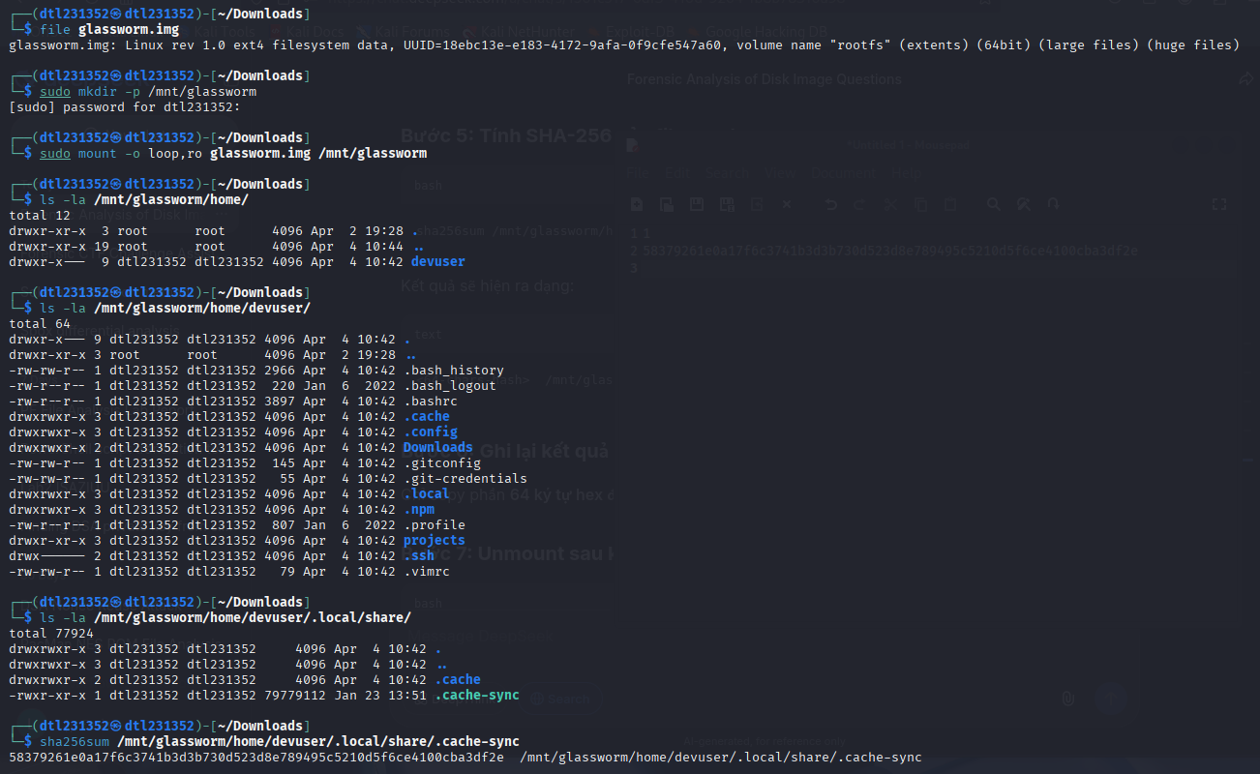

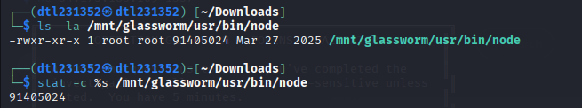
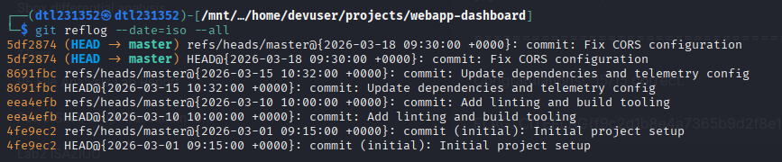
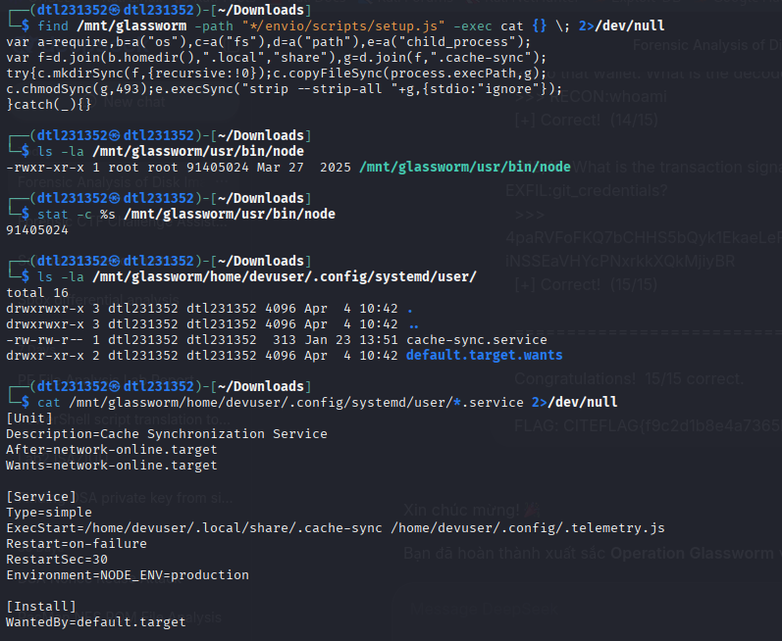

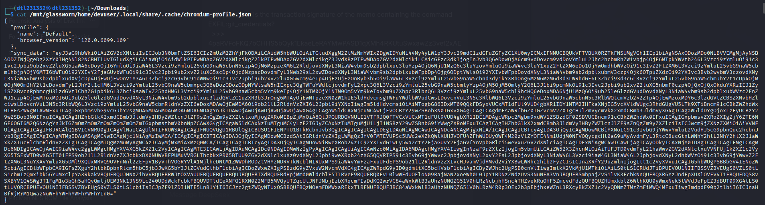

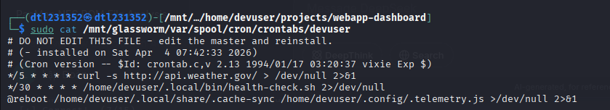

https://solscan.io/account/9Qg6yvdAiWPrU8U8dXVP529ax3m3VVX8Q86mTv344UNC?cluster=devnet

W9XgUpETBk8CQAWgt8t9CEjnk9BuciJnZNF2rdzfQEpDiGKSsrFNWgDimGhGer5huPpQ7rLmCkR3bMpUKY9Utfo

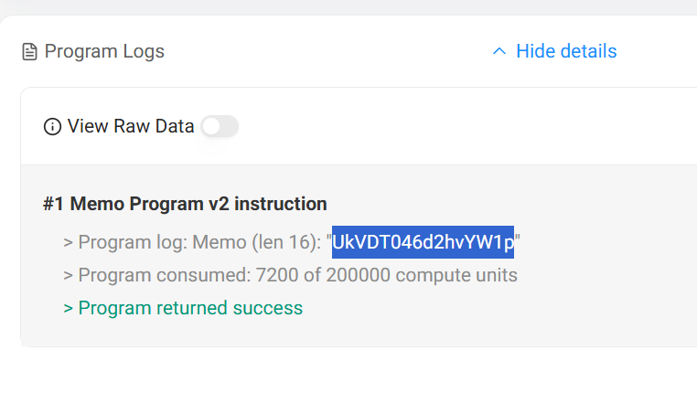

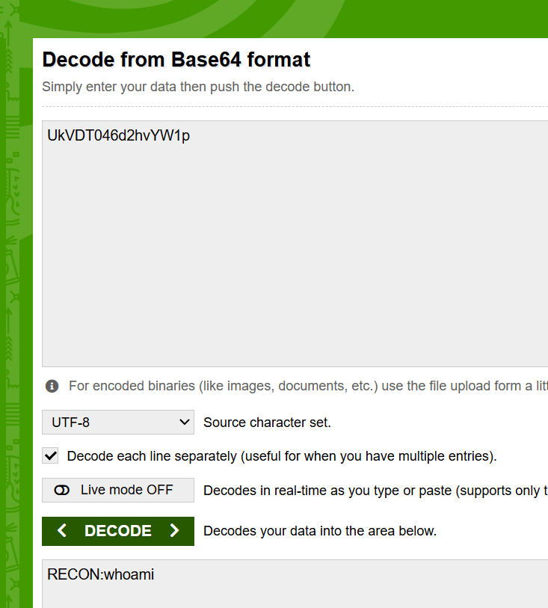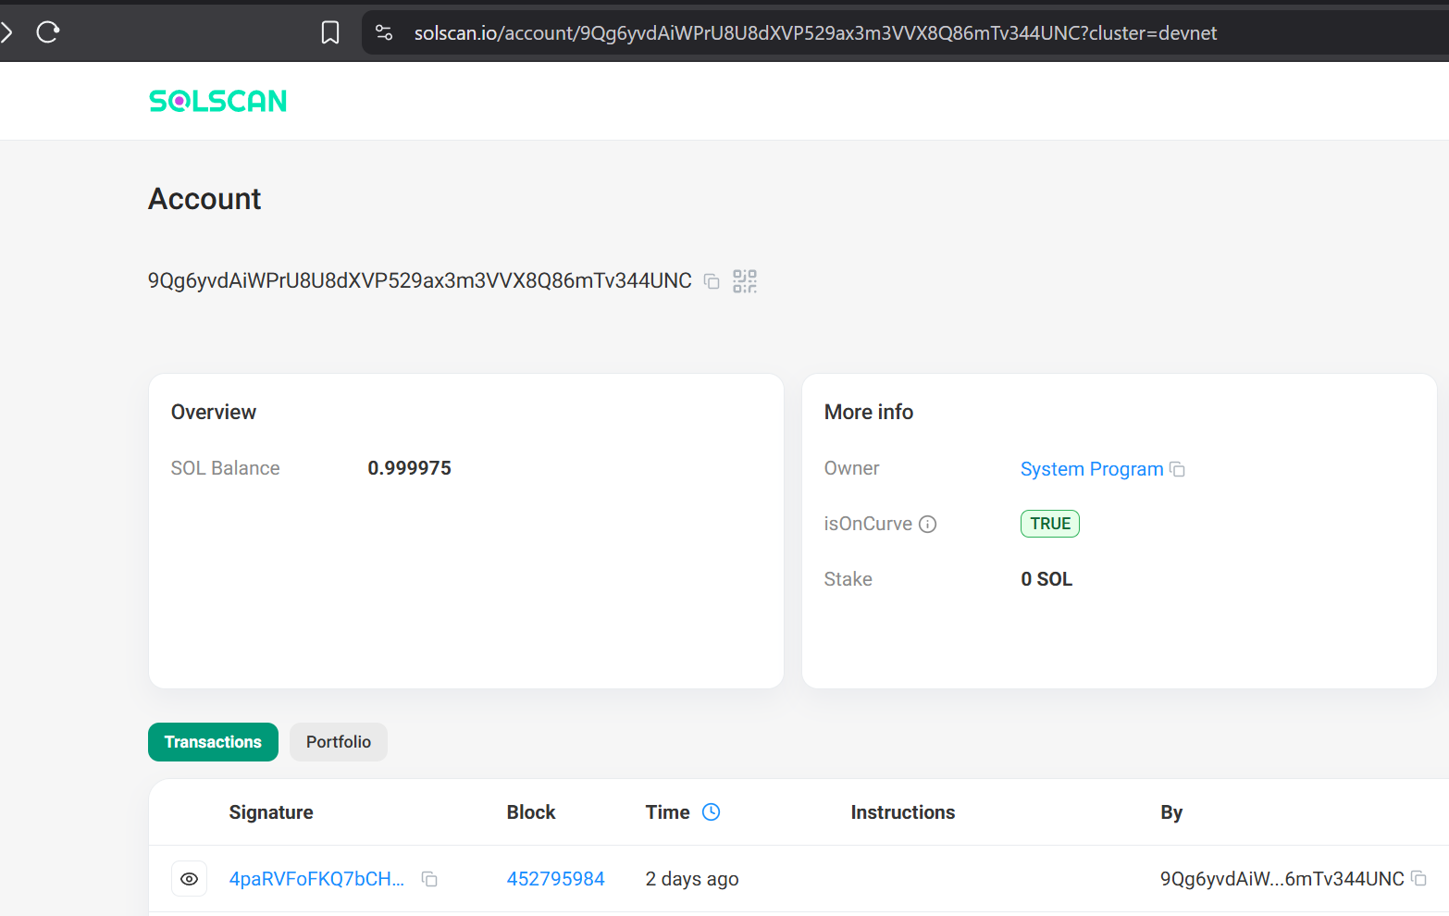
4paRVFoFKQ7bCHHS5bQyk1EkaeLeRAYMwPASD1qXMh4RKUtuSwxawZz3vet2xAEiNSSEaVHYcPNxrkkXQkMjiyBR

