**CIND 119: Introduction to Big Data Analytics**

**Assignment 2 (15% of the final grade)**

**Querying an RDBMS database using SQLiteStudio**

**Student: Isolda de Almirante Silva - 501241365**

**Question 1 and 2:**

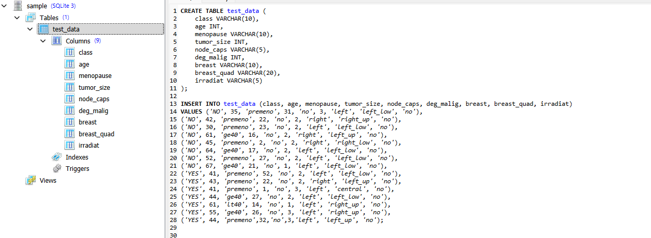

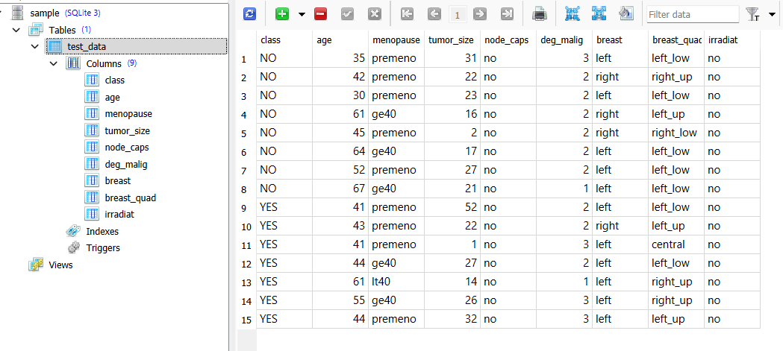

**Question 3:**

**a.**

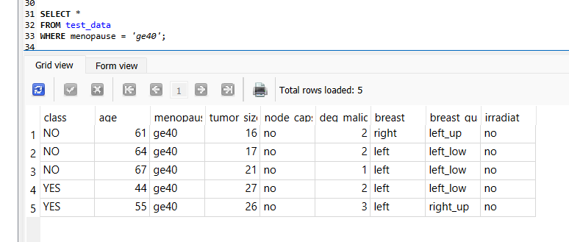

**b.**

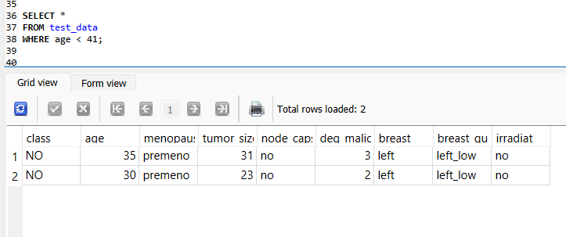

**c.**

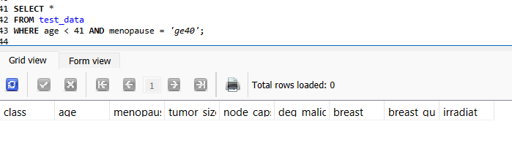

**d.**

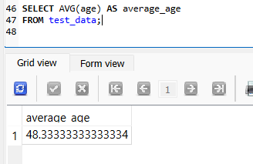

**e.**

