**CIND 119: Introduction to Big Data Analytics**

**Assignment 3 (15% of the final grade)**

**Querying a NoSQL database using MongoDB**

**Student: Isolda Veruska de Almirante Silva - 501241365**

**Questions 1 and 2:**

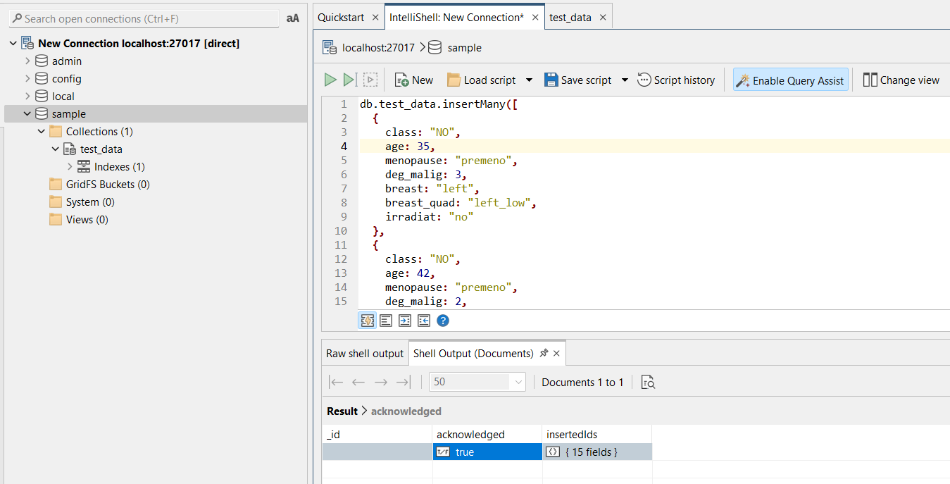

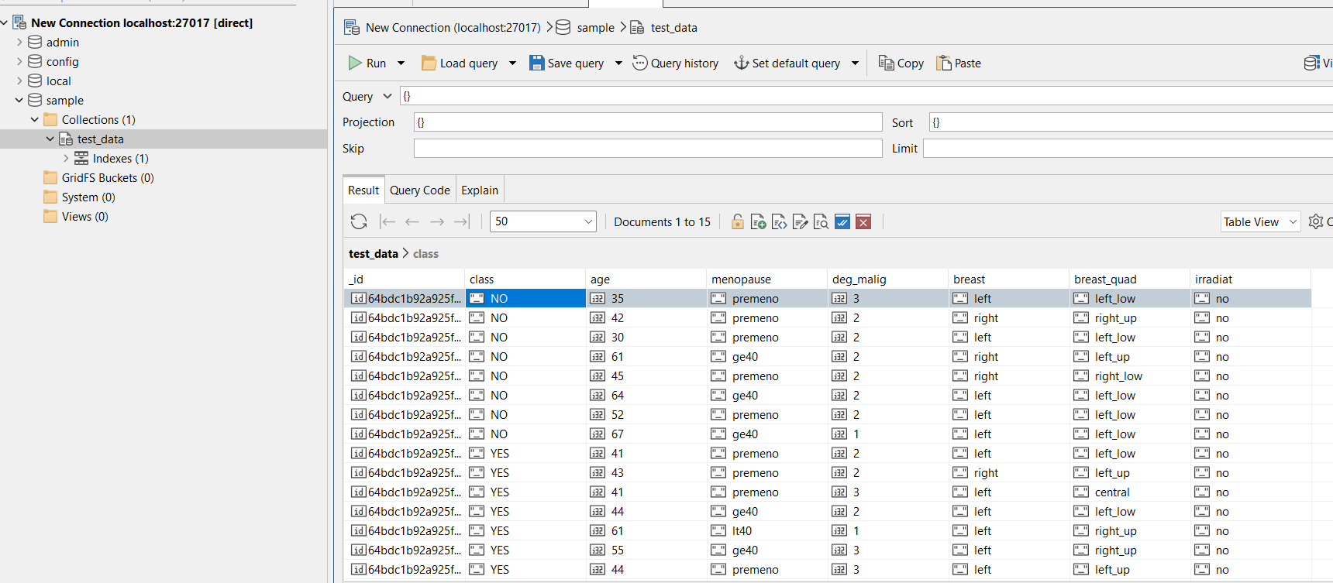

**Below is the entire code to create the test_data collection:**

db.test_data.insertMany**([**

**{**

class**:** "NO"**,**

age**:** 35**,**

menopause**:** "premeno"**,**

deg_malig**:** 3**,**

breast**:** "left"**,**

breast_quad**:** "left_low"**,**

irradiat**:** "no"

**},**

**{**

class**:** "NO"**,**

age**:** 42**,**

menopause**:** "premeno"**,**

deg_malig**:** 2**,**

breast**:** "right"**,**

breast_quad**:** "right_up"**,**

irradiat**:** "no"

**},**

**{**

class**:** "NO"**,**

age**:** 30**,**

menopause**:** "premeno"**,**

deg_malig**:** 2**,**

breast**:** "left"**,**

breast_quad**:** "left_low"**,**

irradiat**:** "no"

**},**

**{**

class**:** "NO"**,**

age**:** 61**,**

menopause**:** "ge40"**,**

deg_malig**:** 2**,**

breast**:** "right"**,**

breast_quad**:** "left_up"**,**

irradiat**:** "no"

**},**

**{**

class**:** "NO"**,**

age**:** 45**,**

menopause**:** "premeno"**,**

deg_malig**:** 2**,**

breast**:** "right"**,**

breast_quad**:** "right_low"**,**

irradiat**:** "no"

**},**

**{**

class**:** "NO"**,**

age**:** 64**,**

menopause**:** "ge40"**,**

deg_malig**:** 2**,**

breast**:** "left"**,**

breast_quad**:** "left_low"**,**

irradiat**:** "no"

**},**

**{**

class**:** "NO"**,**

age**:** 52**,**

menopause**:** "premeno"**,**

deg_malig**:** 2**,**

breast**:** "left"**,**

breast_quad**:** "left_low"**,**

irradiat**:** "no"

**},**

**{**

class**:** "NO"**,**

age**:** 67**,**

menopause**:** "ge40"**,**

deg_malig**:** 1**,**

breast**:** "left"**,**

breast_quad**:** "left_low"**,**

irradiat**:** "no"

**},**

**{**

class**:** "YES"**,**

age**:** 41**,**

menopause**:** "premeno"**,**

deg_malig**:** 2**,**

breast**:** "left"**,**

breast_quad**:** "left_low"**,**

irradiat**:** "no"

**},**

**{**

class**:** "YES"**,**

age**:** 43**,**

menopause**:** "premeno"**,**

deg_malig**:** 2**,**

breast**:** "right"**,**

breast_quad**:** "left_up"**,**

irradiat**:** "no"

**},**

**{**

class**:** "YES"**,**

age**:** 41**,**

menopause**:** "premeno"**,**

deg_malig**:** 3**,**

breast**:** "left"**,**

breast_quad**:** "central"**,**

irradiat**:** "no"

**},**

**{**

class**:** "YES"**,**

age**:** 44**,**

menopause**:** "ge40"**,**

deg_malig**:** 2**,**

breast**:** "left"**,**

breast_quad**:** "left_low"**,**

irradiat**:** "no"

**},**

**{**

class**:** "YES"**,**

age**:** 61**,**

menopause**:** "lt40"**,**

deg_malig**:** 1**,**

breast**:** "left"**,**

breast_quad**:** "right_up"**,**

irradiat**:** "no"

**},**

**{**

class**:** "YES"**,**

age**:** 55**,**

menopause**:** "ge40"**,**

deg_malig**:** 3**,**

breast**:** "left"**,**

breast_quad**:** "right_up"**,**

irradiat**:** "no"

**},**

**{**

class**:** "YES"**,**

age**:** 44**,**

menopause**:** "premeno"**,**

deg_malig**:** 3**,**

breast**:** "left"**,**

breast_quad**:** "left_up"**,**

irradiat**:** "no"

**}**

**]);**

**3.**

**a)** 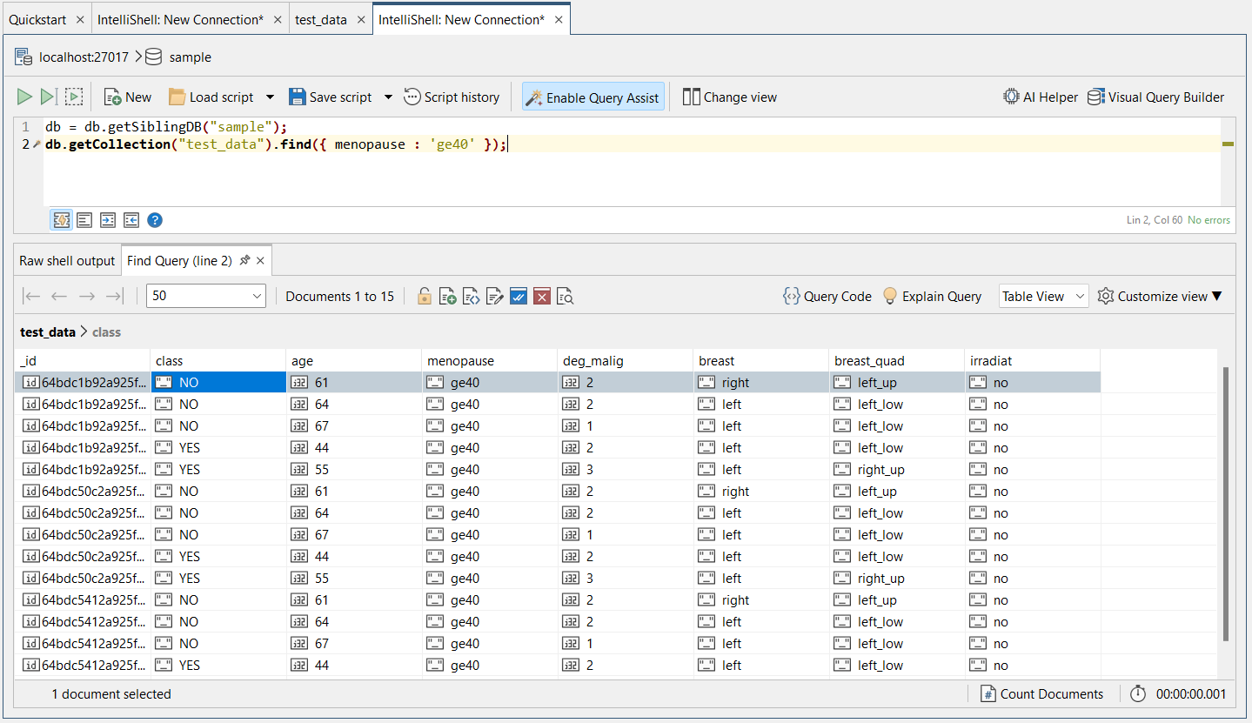

**b)**

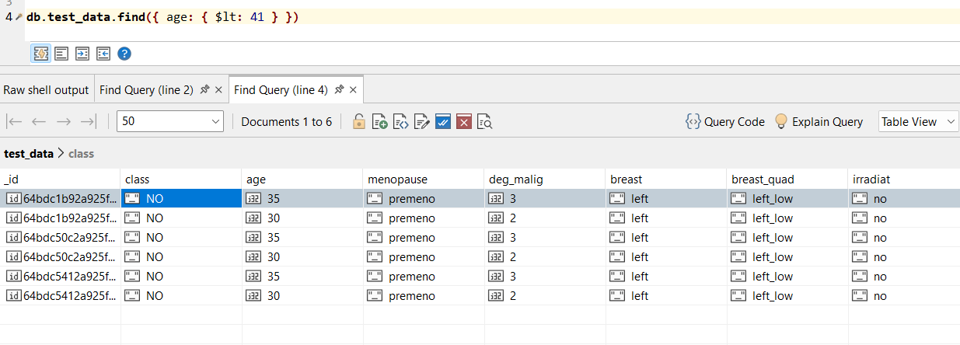

**c)**

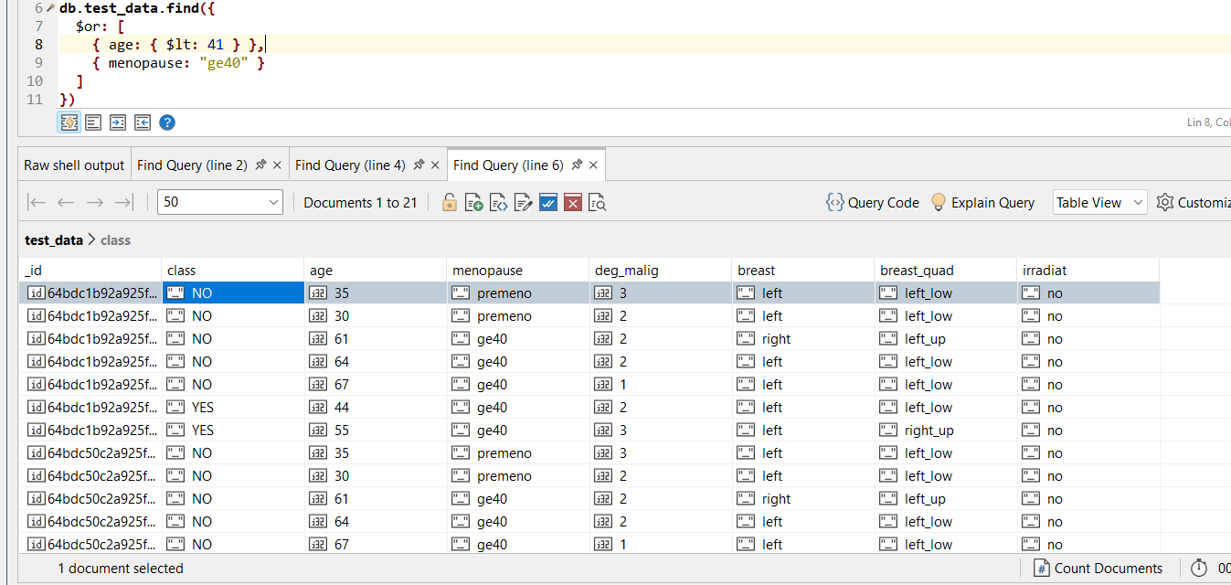

**d)**

