# «The scientific heritage»

Budapest, Kossuth Lajos utca 84, 1204

Official website: tsh-journal.com. Email: [public@tsh-journal.com](mailto:public@tsh-journal.com)

## CERTIFICATE

**ABOUT ACCEPTANCE OF ARTICLE FOR PUBLICATION**

Article: **«MANAGING INTERNATIONALIZATION IN HIGHER**

# EDUCATION»

## The authors: Amantai A., Kakharmanova A., Nyshanbek T., Tileubayeva M.

The article is accepted for publication in issue «113» (113) 2023 of the scientific journal

«The scientific heritage» (ISSN 9215 — 0365). Journal release date: 05/24/2023

The certificate is given for provision at a place of request.

« 11 » May 2023

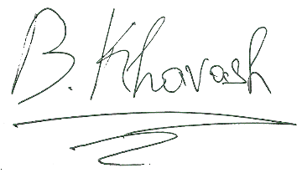Publication Manager Bernat Khavash