***Sociology and social psychology, Thursday 13.00-15.00***

**Kakharmanova Aruzhan 21B030839**

1. **How do people perceive the word `happiness`? The world happiness report, 2022.**

The perception of the word "happiness" varies from person to person, and can be influenced by factors such as cultural background, personal experiences, and individual beliefs.

Generally, happiness is seen as a positive emotion or state of being, characterized by feelings of contentment, joy, and satisfaction. It is often associated with fulfilling one's desires or achieving a sense of purpose or meaning in life. Some people may also associate happiness with external factors such as wealth, success, or material possessions.

However, there are also differing opinions on what constitutes true happiness.

True happiness means the satisfaction that you find worthy. The long-lasting true happiness comes from life experience, a feeling of purpose, and a positive relationship. Even the happiest people sometimes get discouraged, and the most unhappy experience delightful moments. Happiness does not arise because of us or circumstances, it obeys its own logic, and perhaps that is why we tend to underestimate it.

Happiness is a sense of well-being, joy, or contentment. When people are successful, or safe, or lucky, they feel happiness. The "pursuit of happiness" is something this country is based on, and different people feel happiness for different reasons. Whenever doing something causes happiness, people usually want to do more of it. No one ever complained about feeling too much happiness.

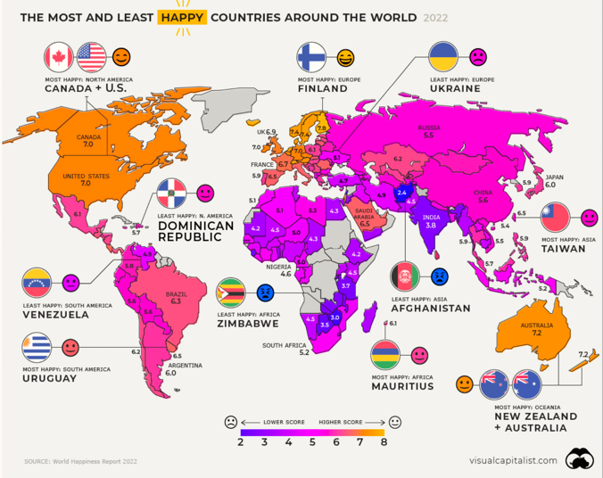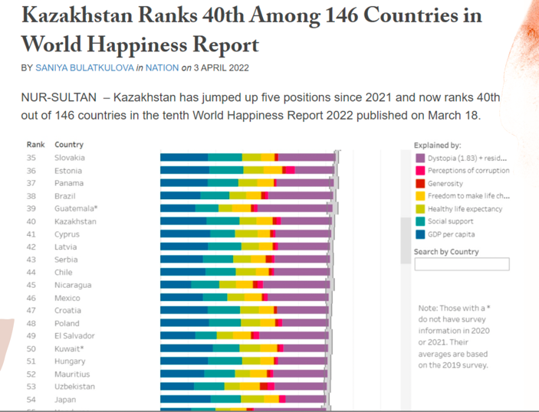

The latest available report is the World Happiness Report 2021, which brands Kazakhstan as the 63rd happiest country in the world out of 149 countries surveyed. Kazakhstan's ranking improved by three shots from the previous year's report, indicating an increase in the overall happiness of its citizens. The report success happiness based on factors such as income, social support, life expectancy, freedom to make life choices, generosity, and perceptions of corruption. As we can see in first picture, there are not all countries are really happy. Because of the quality of life in lots of meanings, it can be government that provides the high quality of life or the person’s own past that make him/her happy. Our country ranks 40th among 146 countries. It is the high indicator that means a lot. Because this value was increased by 4 places.