Intro and Standards in the IS field

1 Which of the following is NOT a key standard in the IS field?

A. ISO/IEC 27001

B. COBIT 5

C. ITIL v4

D. PCI DSS

Information security practice and trends

2 Which of the following is a best practice for preventing phishing attacks?

A. Use a strong password manager.

B. Be careful about clicking on links in emails or text messages.

C. Enable two-factor authentication on all of your accounts.

D. All of the above.

Answer: D

Autonomous systems, AI basics

3 What is the difference between machine learning and deep learning?

A. Machine learning uses algorithms to learn from data, while deep learning is a type of machine learning that uses artificial neural networks.

B. Machine learning is used for supervised learning, while deep learning is used for unsupervised learning.

C. Machine learning is used for classification tasks, while deep learning is used for regression tasks.

D. None of the above.

Answer: A

Requirements development

4 Which of the following is NOT a technique for gathering requirements?

A. Interviews

B. Focus groups

C. Use cases

D. Prototyping

Answer: D

5. **Five ITIL v3 Process Groups**: The five stages are Service Strategy, Service Design, Service Transition, Service Operation, and Continual Service Improvement.

6. **Purpose of an IS Policy**: It's to set standards, guidelines, and constraints within which everyone must operate to ensure information is secure and used properly. It helps in managing information security risks.

7. **Challenges in Managing Information Systems for Mining Companies**: These might include dealing with remote and harsh environments, ensuring data security, integrating disparate systems, and managing large volumes of data.

8. **Main Purpose of an ERP System**: ERP (Enterprise Resource Planning) systems integrate various functions like finance, HR, manufacturing, and supply chain into a single system to streamline processes and information across the organization.

9. **Difference Between ITIL v3 and ITIL v4**: ITIL v4 includes a shift towards a more holistic approach to service management and integrates concepts from other best practices like Lean, Agile, and DevOps, focusing more on the entire service value system.

10. **Role of the Service Desk in Change Management**: The Service Desk is typically involved in communicating changes to users, ensuring that the changes are understood and minimally disruptive, and sometimes in the actual rollout of changes.

11. **What are CDR Files?**: Call Detail Records (CDRs) are records of telephonic communications or other telecommunications transactions that pass through a facility or device.

12. **Four Core Components of the ITIL v4 Service Value Chain**: Plan, Improve, Engage, and Design & Transition.

13. **Most Important Step in Stakeholder Management**: Identifying all stakeholders and understanding their interests and influence is often considered the most critical step.

14. **What is JIRA Atlassian?**: JIRA is a popular project management tool designed by Atlassian, often used for bug tracking, issue tracking, and project management.

15. **Importance of CMDB**: A Configuration Management Database (CMDB) helps organizations understand the relationships between the components of a system and track their configurations. It's crucial for managing complex IT environments.

16. **Importance of CMMI for International IT Companies**: CMMI (Capability Maturity Model Integration) helps organizations improve their processes and is often a requirement for doing business in certain industries or with certain clients, especially on an international scale.

17. **BPM CBOK**: Business Process Management Common Body of Knowledge (BPM CBOK) is a standard for business process management practices and principles.

18. **Service Value Chain in ITIL v4**: It's a model describing the steps an organization takes to respond to demand and facilitate value creation through the management of products and services.

19. **Replacing All City Cameras in 10 Days**: It's likely impossible due to logistical challenges like procurement, installation, testing, and ensuring proper integration with existing systems, not to mention potential regulatory and compliance issues.

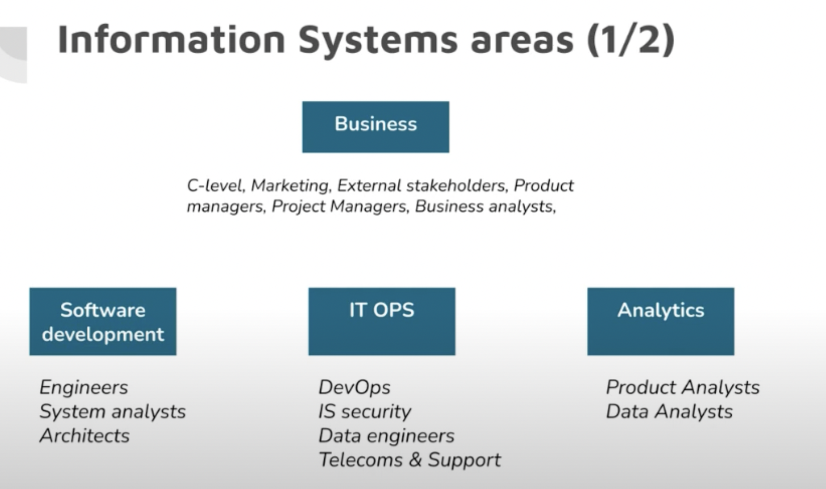

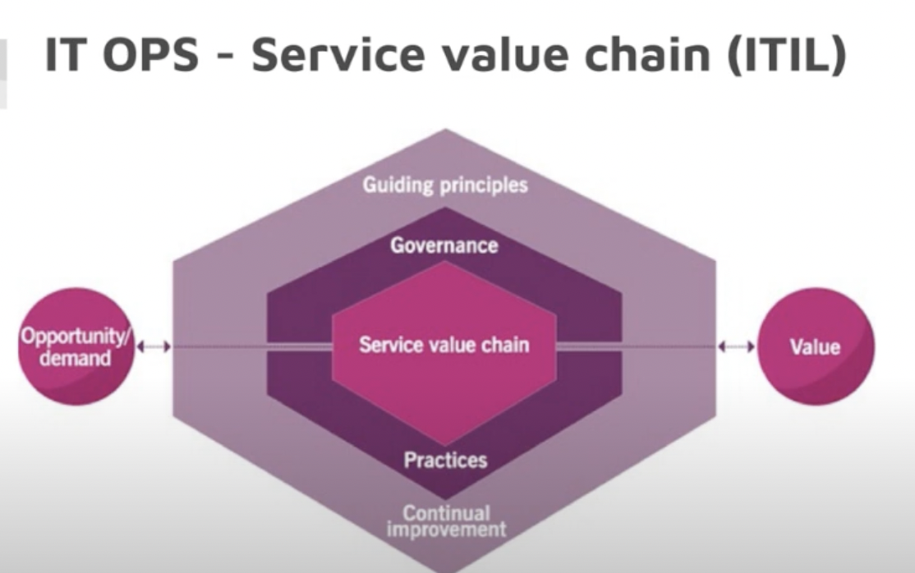

(a) Exploratory prototypes

**(a)   Exploratory prototypes** is not a requirement gathering technique. They serve as an idea generation tool that designers and developers use to generate new ideas and explore design possibilities.

**(b)   Facilitated workshops** can be used to gather requirements by bringing together stakeholders as well as users of the system. Facilitators should be trained to facilitate workshops and have the appropriate skills for each type of workshop.

(c)   Requirements gathering can be made easier by **reviewing existing code**. This technique is used often on software systems being redesigned or modified. This can be used to determine the purpose and function of the system. It also provides information about the system's capabilities and any modifications that may be required.

(d)  **Surveys** can be used to gather requirements. These surveys can be used to gather feedback from customers or users about the product and service.  Surveys are a method of gathering requirements. People answer questions by choosing from a set of choices and then answer questions. The data is then analyzed to identify patterns and make informed decisions about the next steps for the product or service.