# Information Visualization

# CHECKPOINT III: Visualization Sketch

G21-A

**1. Overview**

The visualization works in 2 modes. The first mode, when no country is selected, looks like this: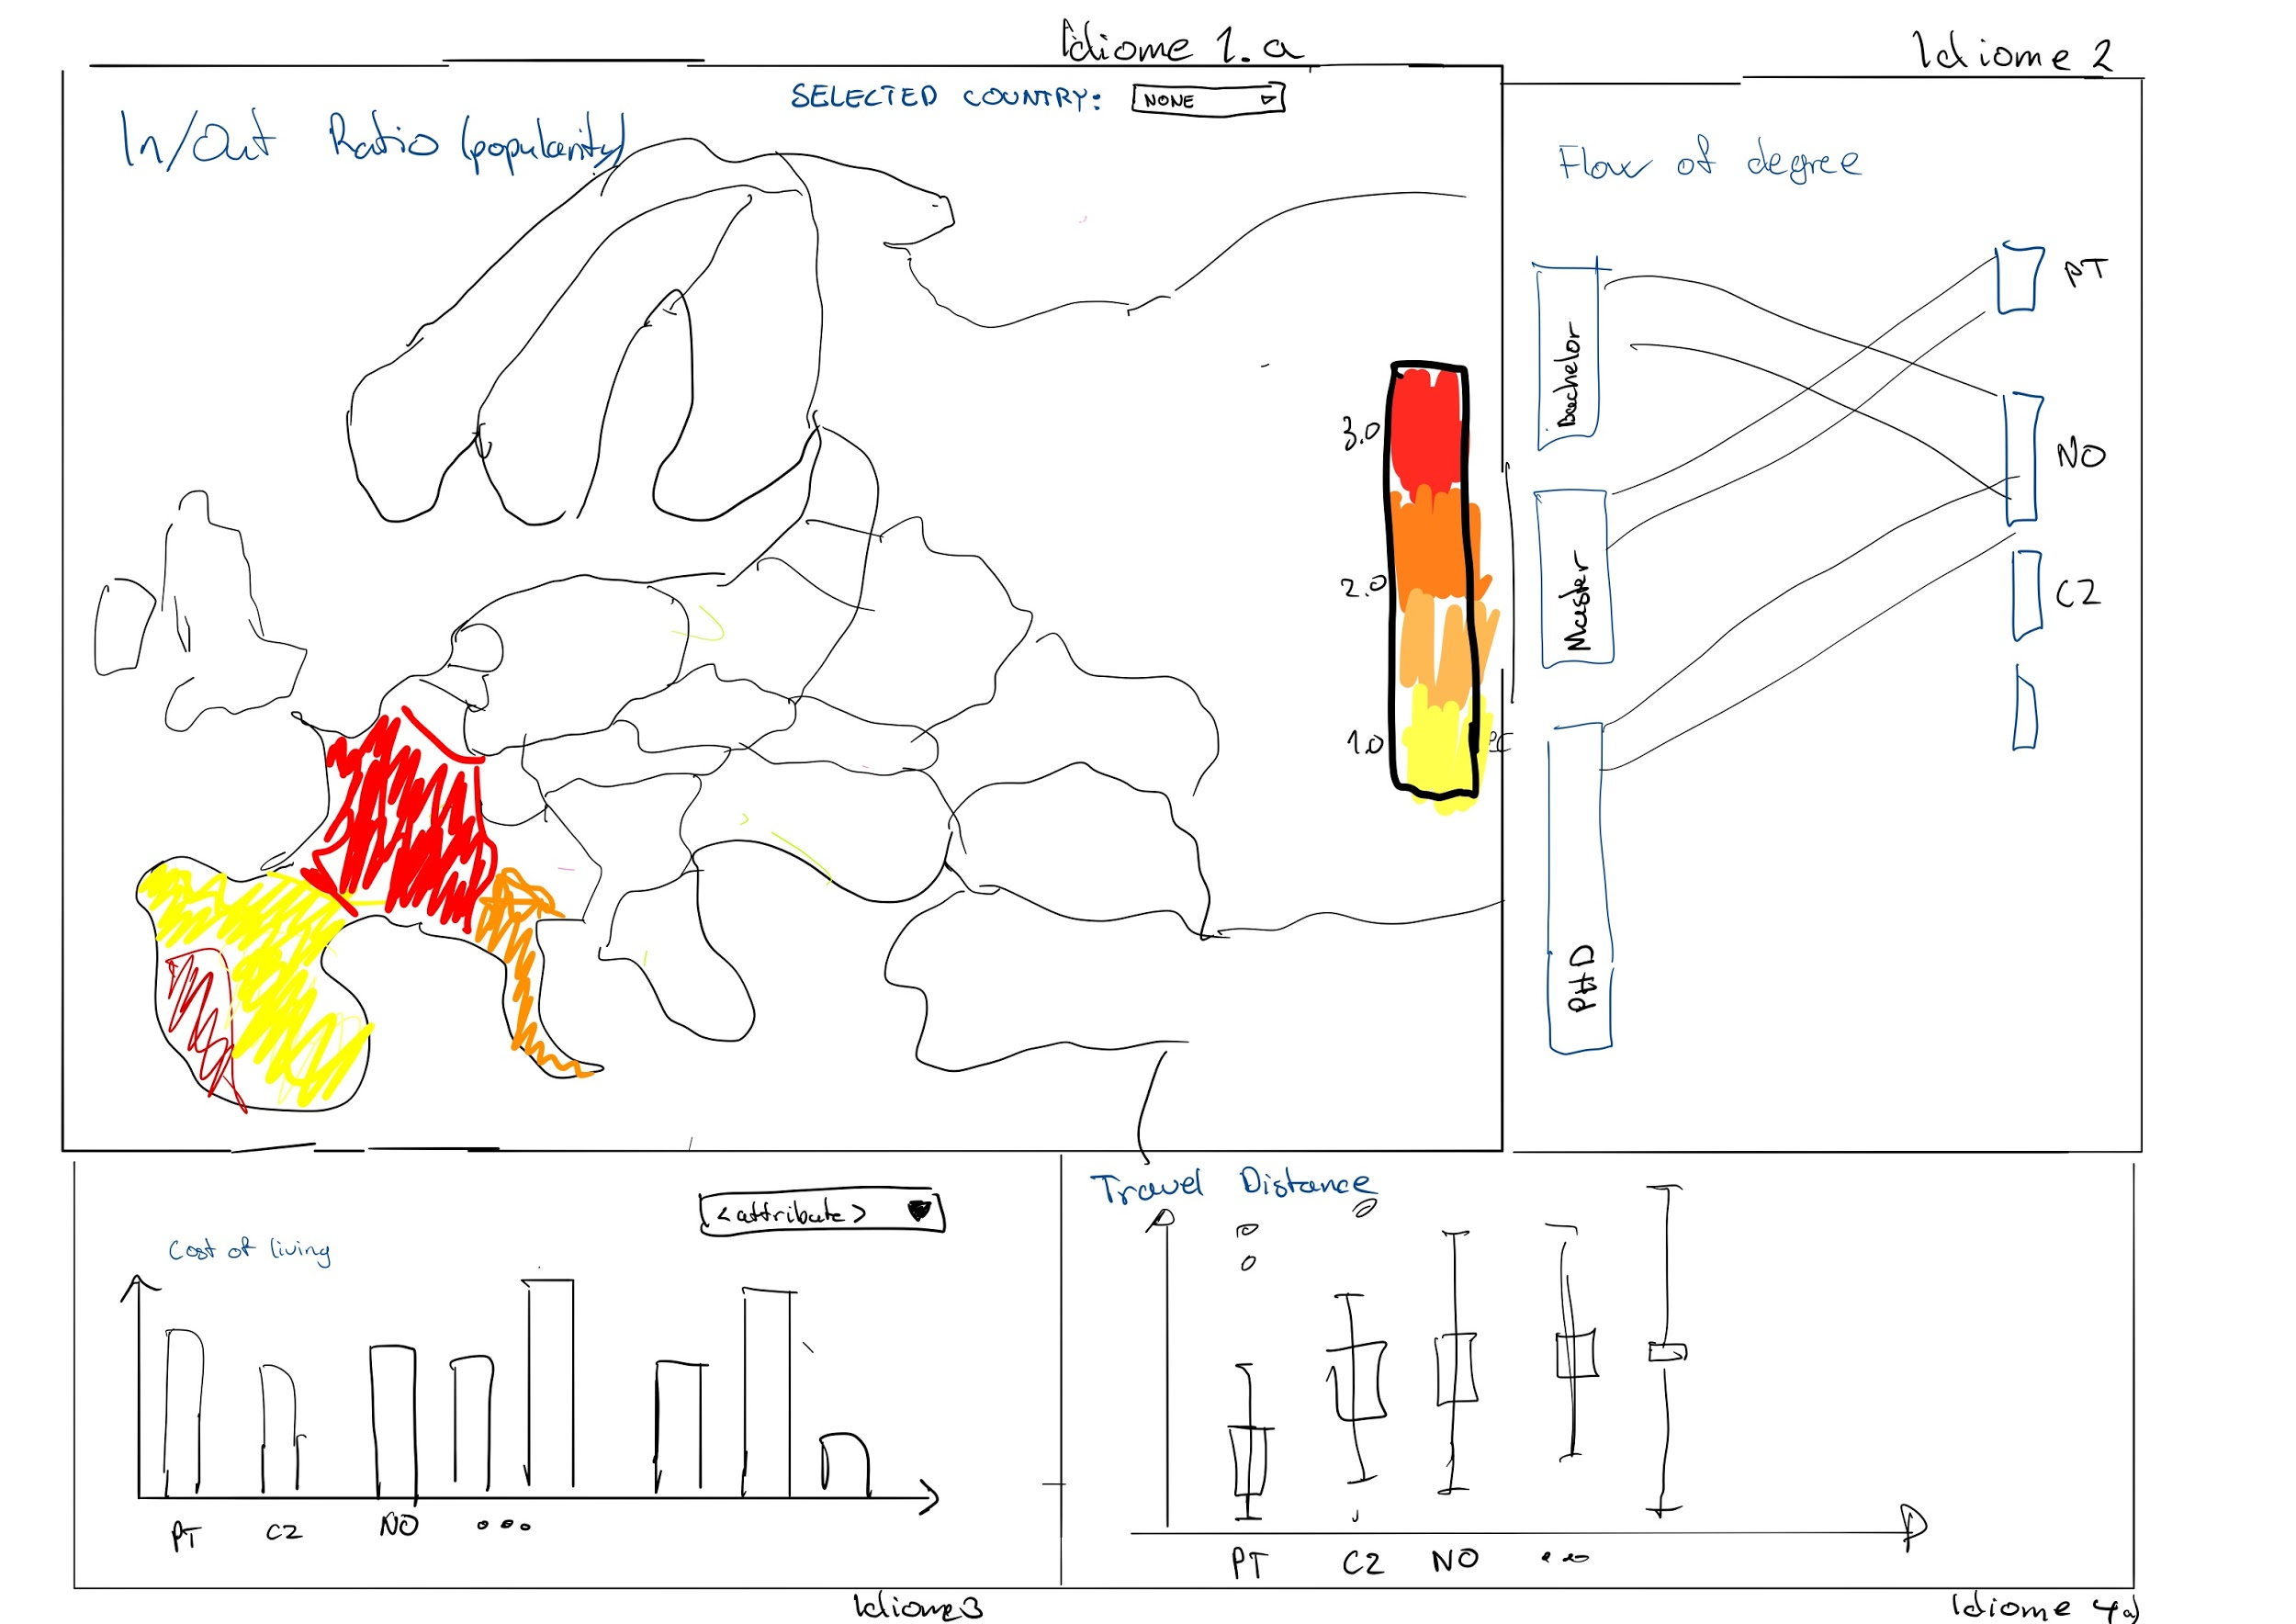

After a country is selected (either on map, or on one of the other visualizations), the whole visualization changes and shows information for outgoing (or incoming) students.

**2. Visual Encoding**

All of the visualizations (except for the map when no country is selected) work both in incoming or outgoing mode. In incoming mode, the visualizations describe the information about incoming students, in the outgoing mode, information about the outgoing students. User can switch between incoming and outgoing using a button.

The visualization can be in 2 states. When no country is selected, the visualizations show general information about ERASMUS students from all countries. When a country is selected, the visualizations change to show students filtered based on the selected country.

Selected country is what connects all of the visualizations together. User can select the country not only in the map, but also by clicking at any of the country labels present in any of the visualizations.

1. 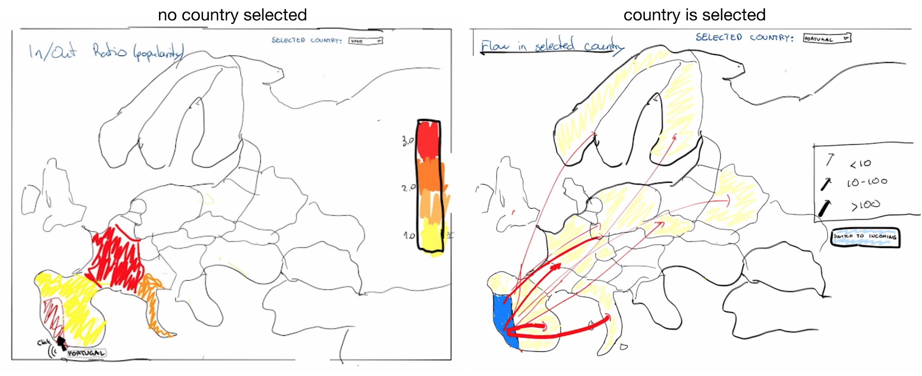**The map of Europe** - The map of Europe can be considered the centerpoint of our visualization. The map works in 2 modes. **No country is selected** - the map works as a choropleth map. We visualize the ratio of students outgoing and incoming. **Country is selected** - depending on the status of a (incoming/outgoing) button, the map either shows flow of students from, or into the selected country (a flow map). This idiome utilizes “*CoordinatesSending, CoordinatesReceiving*” as an arrow in the map for each student, and “*Country*” to show the country name.
2. **Parallel sets** - **No country is selected** - shows the student degrees on the left side and the respective countries of students on the right. **Country is selected** - the left side now represents students incoming into the selected country, the degrees are in the middle and right set describes the outgoing students. Utilizes “*StudentBachelorIncomingCount, StudentMasterIncomingCount, StudentPhDIncomingCount*” to obtain set sizes and “*Country*” to obtain the country name.
3. **Bar plot** - shows different price indexes of a country. User can select a particular index using a drop-down menu. **No country is selected** - shows information about all of the participating states. **Country is selected** - The x-axis is sorted based on the number of students which come (or go to) the particular country. Price index of the selected country is referenced using a horizontal line. Utilizes “*Cost.of.Living.Index*”, “Rent.Index” and “*Domestic Beer*”. The x-axis is sorted based on the “*StudentIncomingCount*”.
4. **Box plot** - is used to see the distance which students had to travel. **No country selected** - shows all of the countries. **Country is selected** - shows the comparison of boys and girls traveling into/out of the country. “*CoordinatesSending, CoordinatesReceiving*” are used to compute the distance between the countries. When a country is selected, the countries are sorted based on “*Gender*” attribute.

**3. Answering the questions**

1. Which countries do Portuguese bachelor students choose as an Erasmus destination in comparison to masters and PhDs?

Click on Portugal/or choose from drop down menu from idiome 1a) and analyse the flow of degree in idiome 2. Comparative size of each set can be compared by drawing them on each other with mouse. Storyboard is shown below: A map with text

1. Is it popular for Danish students to go to countries with same or lower cost of living?

Click on Denmark (or choose from drop down menu in idiome 1a), make sure that the visualization is in the outgoing mode, and analyse the barchart in idiome 3. Each bar represents a country. Countries are sorted based on the number of students outgoing from left to right.

1. Where do the Erasmus students from Portugal like to go on Erasmus?

Click on Portugal (or choose from drop down menu from idiome 1a), make sure that the vizualization is in the outgoing mode, and analyse which countries the arrows point to idiome 1b).

1. Do Czech females travel smaller distance to their target country than the Czech males?

Click on Czech/or choose from drop down menu from idiome 1a) and compare the two boxplots in idiome 4b).