# Information Visualization

# CHECKPOINT IV: First Prototype

G21 - A

**1. Layout**

The layout of our interface is divided into four views that are interconnected. Each of them shows information within a theme essential for an Erasmus stay. Each of the views changes when a country is selected and shows more information.

Each idiom is not given the same amount of space. The map (choropleth map and arrows) and the sankey diagram, showing the degree flow, has a bigger part of the screen than the barchart and the boxplot. The map is given more space since it shows two different charts and is a central piece of the visualization. The sankey diagram is even slightly wider than the map. This is because the map of Europe is not wide, and the Sankey diagram got more readable with more width. In addition, the map and the sankey diagram has smaller details which comes out more clearly if it is bigger, while the barchart and boxplot manage to convey the same information with less space.

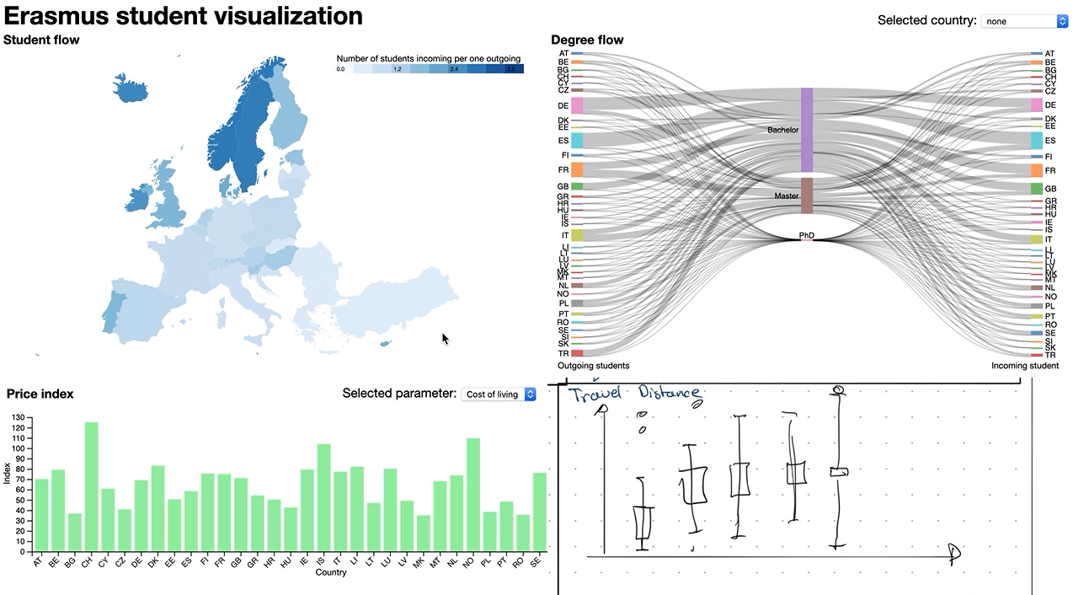

In the current state of the prototype, we have developed and mostly interlinked the sankey diagram and the map. The price index graph is developed and works when no country is selected. The boxplot idiom is yet to be implemented.

By looking at the flow map, user can notice that some of the lines are leaving the EU. We have explored the data, and we have noticed, that there are several territories of European countries such as Reunion or Guyana where it is also possible to go on Erasmus.

**2. Implemented Idioms**

### **Map**

1. The country idiom works in two modes. When **no country is selected**, the map shows the ratio of the number of incoming students per one outgoing. This is visualized through a color gradient which is also explained in the legend.
2. When the user **hovers over a country on the map**, the country gets highlighted and also a label showing the exact number is shown. This also triggers a highlight in the other idioms.
3. A screenshot of a cell phone

   Description automatically generatedWhen the user **selects the country**, individual lines between all of the country universities and incoming or outgoing universities are drawn. The drawing of the lines is animated to show the direction of the travel based on the selected student direction button state. When the user changes the state of the button, the lines are redrawn. Line width is modulated by the number of students going between the two universities.

If the user clicks to another country, it is selected, and the lines are redrawn. If the user clicks on the same country, the country gets unselected and the whole visualization goes to the “no country is selected” state.

### **Degree flow**

The degree flow shows the flow of Erasmus student to which degree. It has three states; a) no country selected, b) country selected with outgoing students and c) country selected with incoming students. You can change between the states by clicking on the incoming or outcoming button. To select a country, you can either use the dropdown menu or by clicking on the country node to select it. If you hover over the country nodes with the mouse the node will be highlighted and the links going out from it. You can also use the amount of student if you hover over the link.

|  |  |  |
| --- | --- | --- |
| a) | b) |**  |

### **Price Index**

The price index compares all Erasmus countries based on the prices. User can choose between the cost of living, the rental index and the beer price. It is possible to see the exact number by hovering the mouse over the bar of a specific country.

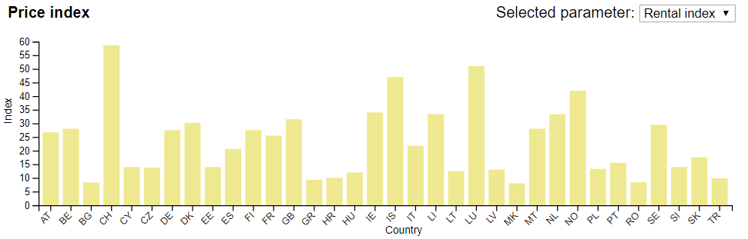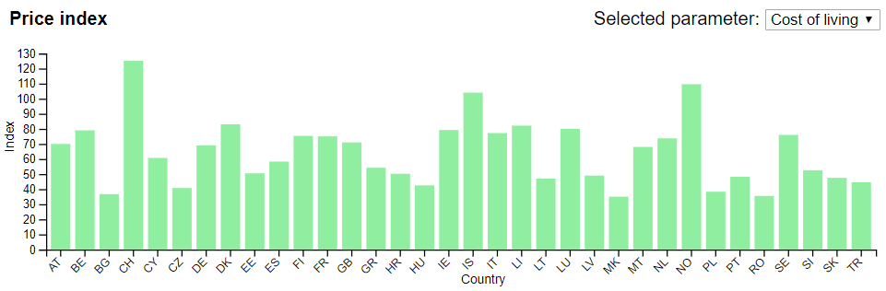In the future, the barplot will respond to selecting a country by sorting all countries based on the number of incoming (outgoing - based on the selected mode) students and drawing a line, which will symbolise the selected country.

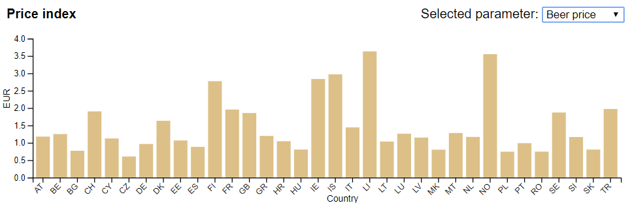

### **Travelled distance**

Travelled distances will be visualized by a boxplot. When no country selected there will be one boxplot per country. When a country is selected, the boxplot for this country will be divided onto two based on the gender of students.

**3. Implementation of Linking Mechanism**

1. The whole visualization works in two modes: a) without, or b) with a country selected. The user can select the country either by using a dropdown menu at the top of the screen or by clicking at the state in any of the idioms. The student direction is selected by using two buttons which are hidden when no country is selected.
2. A screenshot of a cell phone

   Description automatically generated
3. All of the views are linked by three global variables:
4. **highlightedCountry** – when the user hovers over the country on a map or in any of the other idioms, the hovered country is highlighted in all of the other idioms. In the map, the country is highlighted by changing the border, in the sankey diagram, we highlight the connections and in the barplot and boxplot, we highlight the country area (i.e.: bar in barplot) over the hovered country.
5. **selectedCountry** – when the user selects a country, all of the linked idioms change based on the selection. In map, we show the connections between universities, in sankey we only select the selected country and in barplot, we add a reference line and sort all of the bars. In boxplot we expand the boxplot to show different genders.
6. **studentDirection** – when a country is selected, the user can switch between the “incoming” and “outgoing” mode two buttons on the top of the screen.
7. Technical implementation is done through utilizing 4 different d3 events: *stateOnMouseOver, stateOnMouseOut, stateSelectedEvent* and *studentDirectionEvent*.These can be invoked from different idioms with the state code as their parameter. The global variables are updated based on these events.