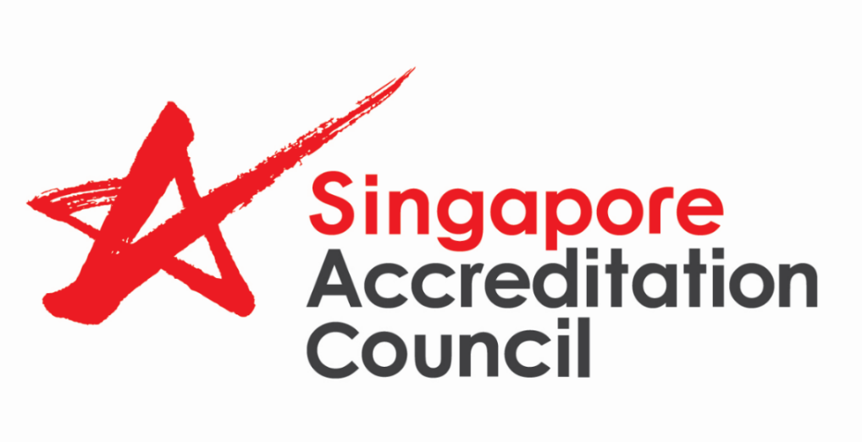

Accreditation Feedback Form

The Singapore Accreditation Council (SAC) welcomes your feedback on your experience in the recent assessment conducted. Your comments will help us to improve the performance of the assessment team as well as the assessment and accreditation processes.

With your invaluable inputs, we hope to strengthen what we do well and identify areas for improvement to ensure that the accreditation services are as effective and consistent as possible.

Organisation Name | :
Type of Scheme | : | Laboratory  (please indicate field of testing: )  Inspection body  (please indicate area of testing: )  Certification body  (please indicate certification scheme: )  Auditing organisation  Proficiency Testing Provider  Good Laboratory Practice (GLP)
Assessment Date(s) | :
Names of assessment team (optional) | :

(Please provide your comments and rating. 5 being excellent and 1 is poor)
 | Comments | Excellent Poor
 | Comments | 5 | 4 | 3 | 2 | 1
Pre-Assessment Preparation

- Was your organisation satisfied with the quality of service offered prior to the on site assessment?

- Promptness
(Responding to your queries on assessment arrangements, assistance on assessment related queries, etc)

- Adequacy of Information provided and logistic details
(Providing your organisation with the assessment programme, the details of witnessing of sites, tests, etc)

On Site Assessment

2. Does the team possess the appropriate knowledge and understanding of the applicable standards?

3. Was your organisation satisfied with the quality of questions and comments posed by the assessment team?
(clear and appropriate, value adding, helpful in the questions and comments)

4. Was the assessment conducted
comprehensively and
objectively?

5. Was your organisation given
appropriate opportunities for
comment and clarification on the
team’s findings?

Post-Site Assessment

6. Was your organisation satisfied with the quality of service for follow-up actions after the on site assessment?

- Timeliness
(Vetting of corrective actions & providing timely feedback; issuance of award letters, etc)

- Clarity & Professionalism of Reply

Other Comments

Management Representative |  | Date

Thank you for helping SAC to improve its quality of service to your organisation.

Please email the feedback form to sac@enterprisesg.gov.sg.

